# Does health insurance status influence the hospital length of stay for patients with asthma conditions?

# Naixin Zhang

**Objective**

~~Previous studies have demonstrated that nonclinical factors are associated with differences in clinical care, with uninsured patients receiving decreased resource use. Health care access, for such conditions as asthma is really important because lack of access leads to increased emergency department use, as well as what could be termed preventable hospitalizations[1]. Studies on trauma asthma populations have also shown unclear relationships between insurance status and hospital length of stay (LOS). The objective of this project is to investigate the relationship between health insurance status and LOS with trauma conditions.~~

Patient length of stay (LOS) is one of the biggest issues facing hospitals today. The national average length of stay in hospital is [4.5 days](https://www.hcup-us.ahrq.gov/reports/statbriefs/sb180-Hospitalizations-United-States-2012.pdf" \t "_blank), according to the Agency for Healthcare Research and Quality, at an average cost of $10,400 per day[1]. The LOS in a hospital is also used to represent the efficiency of a healthcare facility. The objective of this project is to investigate the differences in patients’ LOS in hospital between different insurance status.

The Data used for this research has been obtained from healthdata.gov website. This data contains basic record level details regarding the discharge of inpatients in the State of New York in different health service areas ~~in 2016~~ between 2014-2016. We used this dataset to compare differences in LOS with asthma conditions among three insurance groups: privately insured, publicly insured, and uninsured ~~trauma~~ asthma patients. ~~Hope this project can give the commercial insurance company or the government some reference to increase efficiency in the health care system, decrease costs.~~ If the LOC of publicly insured patients is longer than privately insured patients as expected, we will further investigate if the public health fund is abused or just the private insurance company has a pre-selection of the patients' health status. If the insured patients have a longer LOC compared with uninsured patients, we will further investigate if the uninsured patients have a higher mortality because of lacking adequate medical care. Hope this project will give some reference to healthcare policymakers to promote policy fairness. For example, since asthma is a chronic disease, it can't be cured, if the uninsured patients have a shorter LOC and mortality compared with uninsured patients, the policymaker may consider assigning more funds to cover more uninsured patients. If public insurance is less efficient than private insurance, the policymaker needs focus on improving public fund efficiency based on the experience of private insurance.

General Comment:

I think the question itself is interesting. However, I am not sure the data would provide strong enough support for your research purpose. Separating insurance type by self/public/uninsured does not seem to be able to provide much insights for insurance company. These insurance types may not be really choices. Those being self-insured are unlikely qualified for public support program and may at the marge choose between insured or uninsured; Those under public support would never choose the other two (or may not be able to afford the commercial plan); those who are uninsured are simply not qualified for public ones and cannot afford the private ones. It may makes more sense to focus on different insurance within the category. You will need to figure out whether there exists differences among different programs within each type…

Brief summary of the data between 2014-2016 for patients with asthma condition

payment method count of patients Applicable population:

Medicaid 35865 public for low income group

Medicare 10974 public for old people age>=65

Private Health Insurance 8313 private

Blue Cross/Blue Shield 6591 private non-profit organization

Self-Pay 1809 uninsured

Federal/State/Local/VA 402 public

Managed Care, Unspecified 342 drop HM0,PPO, POO

Unknown 159 drop

Miscellaneous/Other 144 drop

Department of Corrections 96 public

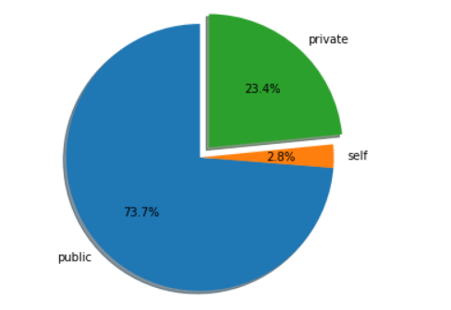

**Reference**

[1] Weiss, A. J., & Elixhauser, A. (2006). Overview of hospital stays in the united states, 2012: statistical brief #180.