**Regression result(revised)**

**Naixin Zhang**

**1.Data**

Table 1 Numerical variable statistical description

|  |  |  |  |  |
| --- | --- | --- | --- | --- |
| variable | mean | std | min | max |
| Length of stay in hospital | 3.12 | 2.57 | 1 | 20 |
| Age | 36.59 | 24.69 | 8 | 70 |
| Total charges | 22771 | 21403 | 1 | 602269 |

Table 2 Category variable statistical description

|  |  |  |  |  |
| --- | --- | --- | --- | --- |
| Variable name | | | Count of patients | Percentage |
| Demographic | gender | Female | 45859 | 59.5% |
| Male | 31208 | 40.5% |
| Race | Black | 28336 | 36.8% |
| White | 22245 | 28.9% |
| Multi-Race | 537 | 0.7% |
| Others | 25949 | 33.7% |
| Ethnicity | Spanish/Hispanic | 20770 | 26.9% |
| Not Span/Hispanic | 55854 | 72.5% |
| Multi-ethnic | 443 | 0.6% |
| Medical conditions | Admission Type | Urgent | 1993 | 2.6% |
| Emergency | 74454 | 96.6% |
| Elective | 620 | 0.8% |
| Severity code | 1 | 32864 | 42.6% |
| 2 | 33882 | 44.0% |
| 3 | 12602 | 16.4% |
| 4 | 1749 | 2.3% |
| Risk of Mortality | Minor | 55695 | 72.3% |
| Moderate | 13223 | 17.2% |
| Major | 7225 | 9.4% |
| Extreme | 924 | 1.2% |
| treatment method | Medical | 76801 | 99.6% |
| Surgical | 266 | 0.3% |
| Discharge year | year | 2014 | 30798 | 40.0% |
| 2015 | 26821 | 34.8% |
| 2016 | 19448 | 25.2% |
| insurance type | / | Private | 9248 | 12.0% |
| Medicaid | 40917 | 53.1% |
| Medicare | 19326 | 25.1% |
| Blue cross/shield | 7576 | 9.8% |

**2. Econometric Specification**

To investigate how the medicare insurance type influence the length of stay in hospital for asthma patients, we firstly consider the basic model:

${Length}_{i}$ = $α_{0}$ + $α_{1}{Demographic}_{i}$ + $β_{1}{Medical_condition}_{i}$ + ${γ_{1}Medicaid}_{i}$ + $γ_{2}{Medicare}_{i}$ + $γ_{3}{Private_Health}_{i}$ + $ε_{i}$

i = 1,2…. 81097

For patient i,the coefficient of the $α_{0}$ represent the length of stay in hospital for patients with black race, multi-ethnicity, extreme risk of mortality and self-selected into hospital and discharge in 2014, paid by private health care insurance.

Demographic includes the patient information, such as race, ethnicity, gender and age. Medical condition includes admission type, discharge year, severity of the illness, treatment method, total charges.

We can see the distribution of patients in each hospital from Figure1, most of the patients are in New York City. However, there are also many patients scattered in other counties. We want to control the characteristics of each hospital that might affect the length of stay in the hospital. For example, patients in urban hospitals might have higher quality medical facilities and income than in rural areas, which might influence the length of stay in the hospital. We know that regressions relying on across hospital variation are problematic due to potential omitted variable bias. Thus, we add hospital-level fixed effects to focus on within hospital variation.

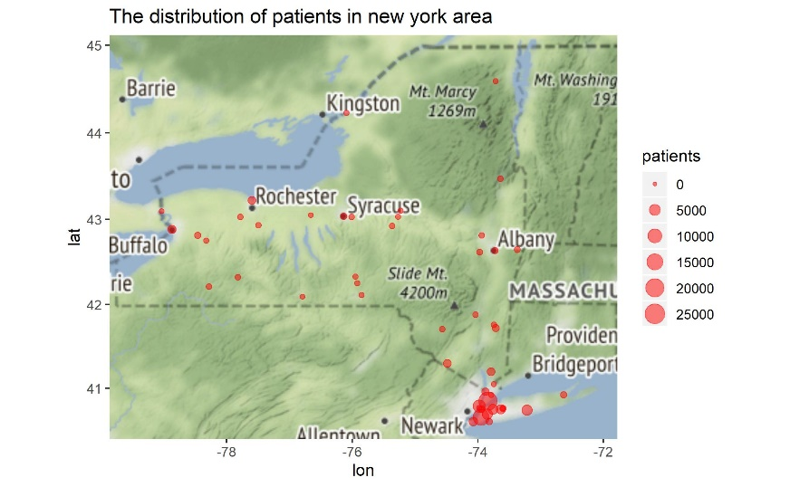

Figure1 The distribution of patients in hospitals for New York Area

Since we can see from Table3 below, in model 1, there is a time trend, with year goes by, the length of stay in hospital tends to decrease. We'd better control the time trend that are constant across patients but vary over time.

The specification is as follows:

${Length}_{iht}$ = $α_{0}$ + $α_{1}{Demographic}_{iht}$ + $β_{1}{Medical_condition}_{iht}$ + ${γ_{1}Medicaid}_{iht}$ + $γ_{2}{Medicare}_{iht}$ + $γ_{3}{Private_Health}_{iht}$ + $ε_{iht}$

i = 1,2…. 81097

t = 2014,2015,2016

h = hospital

Demographic variable includes the patient information, such as race, ethnicity, gender and age. Medical condition includes admission type, severity of the illness, treatment method, total charges.

**3.Regression Result**

As we can see from Table3, for model 2, after we control the characteristics of the hospital and time trend, if we keep other factors unchanged, compared with private health insurance type, patients with blue cross and blue shield health insurance status don't have a significant difference in length of stay in hospital. Patients with Medicare or Medicaid insurance have a significantly longer length of stay in hospital compared with private health insurance status. Generally, compared with private health insurance type, there is a 99.9% probability, patients with Medicare insurance tend to stay 0.21 days longer in hospital, and there is a 95% probability, patients with Medicaid insurance tend to stay 0.03 days longer in hospital.

It might result from two reasons. On the one hand, Blue Cross Blue Shield is a typical health insurance provider because it is neither a for-profit privately-owned company nor a program run by the federal government. Blue Cross Blue Shield has partnered with several private health insurance. It has little difference with some private insurance. On the other hand, different private health insurance in the various counties might have different terms or conditions, which leads to a different length of stay in the hospital. After we control these across county variation and focus on the within county variation, we get a different result.

Let's look at other factors that might influence the length of stay in hospital:

For demographic attributes, the race, in model 2, we can see white patients have a significantly longer length of stay in the hospital, patients whose race are white tends to stay in the hospital longer than black patients. However, ethnicity doesn't play a significant role in the length of stay in the hospital. Age and total charges play a significant role in the length of stay in the hospital. The older the patient, the longer they stay in the hospital.

For Medical condition attributes, the emergency type of admission has a significant influence on the length of the hospital. Compared with elective admission type of patients, if the patients have an emergency type of access, he tends to stay in hospital 0.21 days shorter. The regression result also shows the more severe the disease, the longer the length of stay in the hospital. For the risk of mortality, the higher risk of death, the longer length of stay in the hospital. For the treatment method, compared with patients who are treated as a medical method, patients who are treated as surgical tends to have a significantly two days shorter length of stay in the hospital. It might because patients who have conservative treatment tend to stay in the hospital for further observation.

Table3 Regression Result

|  |  |  |
| --- | --- | --- |
|  | Model 1 | Model 2 |
| (Intercept) | 1.11 *** |  |
|  | (0.11) |  |
| Multi-racial | -0.52 *** | 0.02 |
|  | (0.07) | (0.06) |
| Other Race | -0.14 *** | 0.00 |
|  | (0.01) | (0.01) |
| White | 0.13 *** | 0.06 *** |
|  | (0.01) | (0.01) |
| Not Span/Hispanic | 0.27 *** | -0.11 |
|  | (0.07) | (0.07) |
| Spanish/Hispanic | 0.20 ** | -0.10 |
|  | (0.07) | (0.07) |
| Emergency admission | -0.70 *** | -0.21 *** |
|  | (0.06) | (0.05) |
| Urgent admission | -0.44 *** | -0.11 |
|  | (0.07) | (0.06) |
| year2015 | -0.17 *** |  |
|  | (0.01) |  |
| year2016 | -0.37 *** |  |
|  | (0.01) |  |
| severity_2 | 0.09 *** | 0.10 *** |
|  | (0.01) | (0.01) |
| severity_3 | 0.40 *** | 0.28 *** |
|  | (0.02) | (0.02) |
| severity_4 | 0.23 *** | -0.22 *** |
|  | (0.05) | (0.04) |
| Major mortality | 0.04 | 0.29 *** |
|  | (0.05) | (0.05) |
| Minor mortality | -0.17 ** | 0.19 *** |
|  | (0.06) | (0.05) |
| Moderate mortality | -0.16 ** | 0.15 ** |
|  | (0.06) | (0.05) |
| Surgical treatment | -1.21 *** | -2.01 *** |
|  | (0.09) | (0.08) |
| Blue cross/ blue shield | 0.07 ** | 0.01 |
|  | (0.02) | (0.02) |
| Medicaid | 0.23 *** | 0.03 * |
|  | (0.02) | (0.01) |
| Medicare | 0.36 *** | 0.21 *** |
|  | (0.02) | (0.02) |
| Charges | 0.00 *** | 0.00 *** |
|  | (0.00) | (0.00) |
| Age | 0.01 *** | 0.01 *** |
|  | (0.00) | (0.00) |
| nobs | 77076 | 77076 |
| r.squared | 0.68 | 0.76 |
| adj.r.squared | 0.68 | 0.76 |
| sigma | 1.46 | 1.25 |
| statistic | 7057.56 | 1150.68 |
| p.value | 0.00 | 0.00 |
| df | 77052.00 | 76859.00 |
| df.residual | 77052.00 | 76859.00 |
| *** p < 0.001; ** p < 0.01; * p < 0.05. | | |

4.Hypothesis Test

Since we have known how different health insurance types influence the length of stay in hospital compared with private health insurance. We now further investigate the relationship between each of the two health insurance.

The first hypothesis is that: we assume that patients with Medicaid or Medicare insurance type have no significant influence on the length of stay in hospitals. The null hypothesis and alternative hypothesis are as follows:

$$H_{0}: γ_{1}=γ_{2}$$

$$H_{1}:γ_{1}≠ γ_{2}$$

The second hypothesis is that: we assume that patients with Private or Medicare insurance type has no significant influence on the length of stay in hospitals. The null hypothesis and alternative hypothesis are as follows:

$$H_{0}: γ_{2}=γ_{3}$$

$$H_{1}:γ_{2}≠ γ_{3}$$

The third hypothesis is that: we assume that patients with Private or Medicaid insurance type has no significant influence on the length of stay in hospitals. The null hypothesis and alternative hypothesis are as follows:

$$H_{0}: γ_{1}=γ_{3}$$

$$H_{1}:γ_{1}≠ γ_{3}$$

After doing the Wald test, we got this statistical result summarized in table 4. There is no significant difference in length of stay in the hospital for patients with The Blue Cross/Blue Shield and Medicaid insurance. However, patients with Medicare insurance type shows a significant difference in length of stay in hospital compared with patients with Blue cross/blue shield insurance.

Table 4 Wald test result for hypothesis

|  |  |  |  |  |
| --- | --- | --- | --- | --- |
| Insurance type | chi2 | df1 | qchisq(0.9,df1) | result |
| Blue cross/Blue shield and Medicaid | 1.6875 | 1 | 2.706 | Accept |
| Blue cross/Blue shield and Medicare | 1.025e+02 | 1 | 2.706 | Reject |
| Medicaid and Medicare | 1.461e+02 | 1 | 2.706 | Reject |

5. Conclusion and Application

Due to the time limit, I will work on this part in next few days.