Naiya Patel

Prof. Toegel

IT202-007

September 16, 2020

**[HW] Deployment Proof**

1. Pick a service and get it setup (tell me what you picked [Must not be local])

* NJIT AFS

2. Clone your repo to a folder under (inside) public_html (you can use the existing repo name so you url will be similar to "/IT202")

* 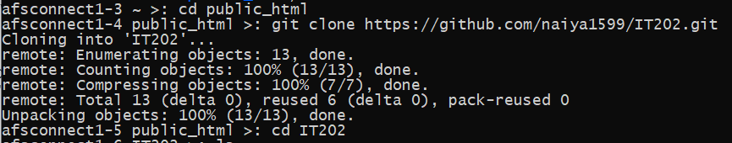

3. cd into the cloned folder and create a test.php file (with some echo statement)

* 

4. Add a screenshot of the file being accessed from the browser (include the url)

* 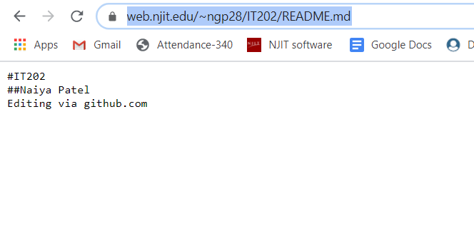

5. Add github link to the file (yes you need to commit it)

**Clarification**: upload file to github.com, navigate to the file and get the url that points to the specific file, add this url to the submission for the HW. It was brought to my attention that my choice of wording was quite ambiguous so thank you for letting me know!

6. Show screenshot of successful phpMyAdmin login

* 