Module (CSS and CSS 3) -2

• What are the benefits of using CSS?

Cascading Style Sheets offers a multiple of benefits for web developers and designers.

Consistency, flexibility and control, efficiency, responsive design, compatibility, Accessibility, scalability, Animation, and effects.

• What are the disadvantages of CSS?

Security issues

Creates confusion with overly complex styling

Cross-browser compatibility issues

Differences in display on various devices

Device-specific compatibility challenges

Potential for large and unoptimized stylesheets

Overhead in large and complex CSS files

Potential for slow page rendering

Limited support for older browsers

Challenges in achieving pixel-perfect design

Limited control over print styling

Potential for specificity conflict

Challenges in debugging complex layouts

• What is the difference between CSS2 and CSS3?

CSS2 (Cascading Style Sheets Level 2) and CSS3 (Cascading Style Sheets Level 3) are both versions of the CSS language used to style web documents. Here are some key differences between CSS2 and CSS3:

Modules: CSS3 is modularized, meaning it divided into separate modules that can be updated and expanded independently. This allows for more control and easier implementation of new features compared to the structure of CSS2.

New features: CSS3 introduces many new features and properties that were not available in CSS2. These include rounded corners, gradients, animations, transitions, Flexbox, CSS Grid, text shadows, and more.

Vendor prefixes: CSS3 introduces the concept of vendor prefixes to allow developers to experiment with new features before they become standardized. This allows for early adoption but can lead to browser compatibility issues if not used carefully.

Selectors: CSS3 expands the range of selectors available for targeting elements in a document, including attribute selectors, pseudo-classes, and pseudo-elements.

Media query: While both CSS2 and CSS3 support media queries, CSS3 introduces additional features to make responsive design easier, such as viewport-relative units and device-pixel-ratio queries.

• Name a few CSS style components

Tables: Properties for styling tables and table elements, including border-collapse, border-spacing, table-layout, and caption-side.

Lists: Properties for styling ordered and unordered lists, such as list-style-type, list-style-image, and list-style-position.

Positioning: Properties for positioning elements in the document flow, including top, bottom, left, and right, as well as z-index for controlling stacking order.

Effects: Properties for adding visual effects to elements, including box-shadow, text-shadow, transform, transition, and animation.

Box Model: Properties related to the box model, such as width, height, max-width, max-height, min-width, min-height, and overflow.

Borders: Properties for styling borders around elements, including border-width, border-style, border-colour, border-radius, and border-image.

Spacing: Properties for controlling spacing within and around elements, such as margin, padding, and box-sizing.

Layout: Properties for controlling the layout of elements, including display (block, inline, inline-block, flex, grid), position (relative, absolute, fixed), float (left, right), and the layout systems like Flexbox and CSS Grid.

• What do you understand by CSS opacity?

CSS opacity refers to the transparency level of an element on a web page. It allows you to control how transparent element and its contents are. The opacity property in CSS accepts values from 0 to 1, where:

0 means the element is completely transparent (invisible).

1 means the element is completely opaque (fully visible).

Values between 0 and 1 represent varying levels of transparency, where 0.5 would mean the element is 50% transparent, and so on.

• How can the background colour of an element be changed?

To change the background colour of an element in CSS, you can use the background-colour property.

Here how you can do it:

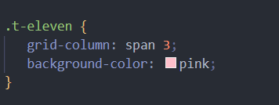

• How can image repetition of the backup be controlled?

Controlling image repetition in backups involves several strategies to ensure that redundant or unnecessary copies of images are minimized.

Snapshot-based backups: Utilizing snapshot technology allows capturing the state of a system at a particular point in time. Rather than creating multiple copies of the same image, snapshots can reference the original data and only store changes, minimizing repetition.

Incremental backups: Instead of performing full backups every time, incremental backups only store changes made since the last backup. This reduces the likelihood of storing repetitive images since only new or modified data is captured.

Compression: Compressing images before storing them in backups can help reduce redundancy by eliminating repetitive patterns within the image data. Compression algorithms remove unnecessary information, reducing the overall storage footprint.

Backup rotation: Implement rotation schemes for backups to ensure that older copies are replaced with newer ones, reducing the accumulation of redundant images over time.

• What is the use of the background-position property?

The background-position property in CSS is used to specify the initial position of a background image within its containing element. It determines where the background image is placed relative to the element's padding box or content box.

‘Top’ , ‘bottom’ , ‘left’ , ‘right’ , ‘center’ . These keywords position the background image accordingly within the containing element.

Percentages specify the position relative to the size of the containing element. For example, 50% 50% center the background image horizontally and vertically within the element.

You can also specify a combination of length and percentage values to position the background image precisely where desired. For example, ‘10% 20px’ positions the background image 10% from the top and 20 pixels from the left edge.

When using multiple background images, you can specify the position of each image individually by providing a position value for each image separated by commas.

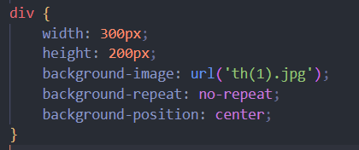

• Which property controls the image scroll in the background?

The property that controls image scroll in the background is background-attachment. This property determines whether a background image scrolls with the rest of the page's content or remains fixed in place as the user scrolls.

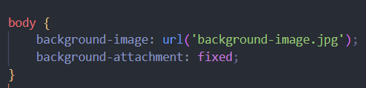

• Why should background and colour be used as separate properties?

Using background and colour as separate properties allows for greater flexibility and control over the styling of an element's background and text colour. Here are some reasons why it’s beneficial to use them separately:

Clarity and readability: Separating the background and colour properties makes the CSS code more readable and easier to understand, especially for developers who might be working on the codebase later. It clearly indicates which property is controlling the background and which one is controlling the text colour.

By separating background and colour properties, you can create reusable CSS classes that only modify one aspect of the element's styling. This modularity makes it easier to maintain and update the styles across your project.

Responsive design: When creating responsive designs, you may want to adjust the background or text colour based on the viewport size or other factors. Separating these properties allows you to apply different styles to the background and text colour independently, making it easier to create responsive layouts.

• How to center block elements using CSS1?

in CSS1, the options for centering block elements are limited compared to newer versions of CSS. However, you can still achieve centering using certain techniques. Here are two common methods:

Using auto margin:

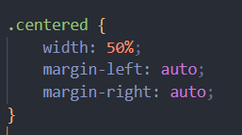

Using text alignment:

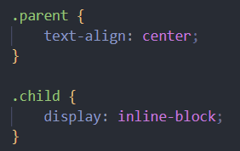

• How to maintain the CSS specifications?

Maintaining CSS specifications involves several best practices to ensure that your stylesheets remain consistent, compatible, and compliant with the standards set by the World Wide Web Consortium. Here how you can maintain CSS specifications effectively:

Stay informed

Use Valid CSS

Browser compatibility

Progressive enhancement

Documentation

Code reviews

Modularization

Version control

• What are the ways to integrate CSS as a web page?

Integrating CSS into a web page can be done using several methods, each with its own advantages and use cases. Here are the common ways to integrate CSS into web pages:

External CSS:

Create a separate CSS file with a .CSS extension containing all your styles.

Use the <link> element in the <head> section of your HTML file to reference the external CSS file:

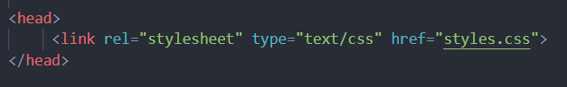

Internal CSS:

Internal CSS is defined within the <style> element in the <head> section of the HTML file.

Use this method when you have specific styles that are only applicable to a single page and don't need to be reused elsewhere.

Inline CSS:

Inline CSS is applied directly to HTML elements using the style attribute.

This method is suitable for applying styles to individual elements or small portions of content.



Imported CSS:

CSS files can be imported into other CSS files using the ‘@import’ rule.

This method is less commonly used compared to external CSS linking but can be useful for modularizing stylesheets.

• What is embedded style sheets?

Embedded stylesheets, also known as internal stylesheets, are CSS styles defined within the <style> element directly in the <head> section of an HTML document. This method allows you to apply CSS styles specifically to the HTML document where it is defined.

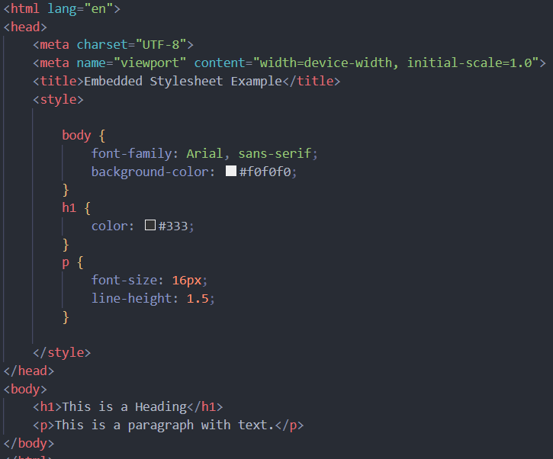

• What are the external style sheets?

External stylesheets are CSS files that contain styles separated from the HTML content. These CSS files are stored in external files with a .CSS extension and are linked to HTML documents using the <link> element in the <head> section.

Create CSS file:

Create a separate CSS file with a .CSS extension. This file will contain all your CSS styles.

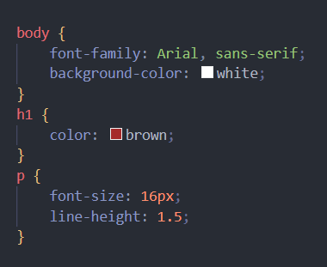

Link the CSS file to HTML:

In the <head> section of your HTML document, use the <link> element to reference the external CSS file.

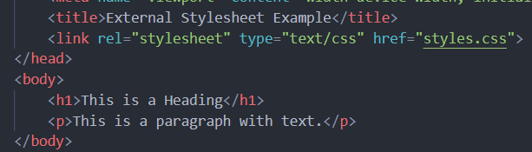

Benefits:

External stylesheets promote separation of concerns, keeping the HTML content separate from the CSS styles. This improves code organization and maintainability.

CSS files can be reused across multiple HTML documents, reducing redundancy, and making updates easier.

• What are the advantages and disadvantages of using external style sheets?

Using external stylesheets offers several advantages and disadvantages, which are important to consider when deciding how to structure and manage the styling of a web project.

Advantages:

Modularity and reusability:

External stylesheets promote modularity by separating the CSS code from HTML content. This allows CSS styles to be reused across multiple HTML documents, reducing redundancy and making updates more efficient.

Ease of maintenance:

With external stylesheets, you can centralize all CSS styles in one or more files. This makes it easier to maintain and update styles across the entire project, as changes made to the CSS file automatically apply to all linked HTML documents.

Improved organization:

Separating CSS styles into external files improves code organization and readability. It allows developers to focus on specific styling aspects without cluttering the HTML markup.

Browser caching:

External stylesheets can be cached by the browser, resulting in faster page load times for subsequent visits to the website. Once the CSS file is cached, it can be reused across multiple pages without needing to be downloaded again.

Accessibility and performance:

By reducing the size of HTML files, external stylesheets contribute to improved accessibility and performance. Smaller HTML files load faster, particularly on low-bandwidth connections or mobile devices.

Disadvantages:

Additional HTTP request:

Each external stylesheet requires a separate HTTP request, which can increase page load times, especially on websites with multiple CSS files. However, this can be mitigated through techniques like minification and bundling.

Dependency on external files:

External stylesheets introduce a dependency on external files, meaning that if the CSS file fails to load or is unavailable, the styling of the webpage may be compromised. This can occur due to network issues, server downtime, or incorrect file paths.

Global scope:

External stylesheets apply styles globally to all HTML elements within the document. While this provides consistency across the entire website, it can also lead to unintended side effects if styles are not properly scoped or overridden.

• What is the meaning of the CSS selector?

In CSS, a selector is a pattern used to select and style one or more HTML elements within a document. Selectors target specific elements based on their type, class, ID, attributes, or relationship with other elements. When a selector matches an HTML element, the associated CSS rules are applied to that element, defining its appearance, layout, or behaviour.

Here are some common types of CSS selectors:

Element selector:

P {

}

Class selector:

.my-class {

}

Id selector:

#my-id {

}

Pseudo-class selector:

a: hover {

}

Universal selector:

\*{

}

• What are the media types allowed by CSS?

CSS supports several media types, allowing styles to be applied selectively based on the device characteristics or presentation context. Here are the main media types allowed by CSS:

All: This is the default media type and applies to all devices. Styles defined within ‘@media all {}’ blocks are applied universally.

Screen: Styles within ‘@media screen {}’ blocks are applied to devices with a screen, such as computer monitors, smartphones, tablets, and TVs.

Print: Styles within ‘@media print {}’ blocks are applied when the document is printed. This media type is typically used to define print-specific styles, such as page breaks, margins, and font sizes optimized for print.

Projection: Styles within ‘@media projection {}’ blocks are applied to devices that project the document onto a surface, such as projectors or presentation screens. This media type is rarely used in practice.

Tv: Styles within ‘@media tv {}’ blocks are applied to television-type devices. This media type is rarely used in modern web design.

• What is the rule set?

In CSS, a rule set is a fundamental structure used to define styling rules that apply to specific HTML elements or groups of elements within a web page. A rule set consists of a selector and one or more declarations enclosed in curly braces ‘{}’.

Selector: The selector determines which HTML elements the styles should be applied to. It can be an element name, class, ID, attribute, or a combination of these.

Example selectors:

Element selector: p

Class selector: .my-class

ID selector: #my-id

Attribute selector: input[type="text"]

Declaration block: The declaration block contains one or more declarations, each consisting of a property and its corresponding value. Declarations are separated by semicolons;.

Property: The property specifies the aspect of the element's style that you want to change. It could be the colour, font size, margin, padding, etc.

Value: The value assigns the specific style to the property. For example, if the property is colour, the value could be red, #000, rgb(255, 0, 0), etc.

• Create Layouts

Creating layouts in CSS involves structuring HTML elements and applying styles to achieve the desired arrangement and presentation of content on a web page. There are various layout techniques available in CSS, including float-based layouts, flexbox layouts, and CSS grid layouts. demonstrate how to create a simple layout using each of these methods:

Float based layout:

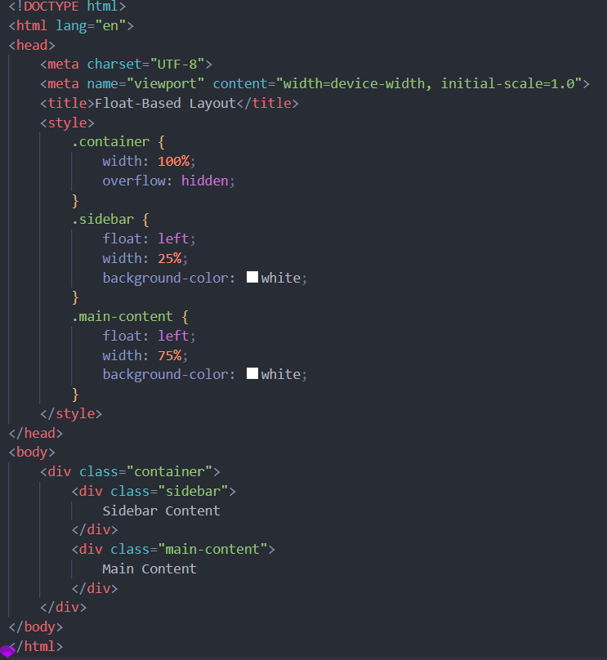

CSS grid layout:

