ASSIGNMENT-3

• What are the new tags added in HTML5?

<header>: Represents a group of introductory or navigational aids.

<footer>: Represents a footer for its nearest ancestor sectioning content or sectioning root element.

<nav>: Represents a section of the document intended for navigation links.

<article>: Represents a self-contained composition in a document, page, application, or site, which is intended to be independently distributable or reusable.

<section>: Represents a generic section of a document or application.

<aside>: Represents a portion of a document whose content is only indirectly related to the document's main content.

<main>: Represents the main content of the <body> of a document or application.

<figure>: Represents a unit of content, optionally with a caption, that is self-contained and is typically referenced as a single unit.

<summary>: Represents a summary, caption, or legend for a <details> element's disclosure box.

• How to embed audio and video in a webpage?

Embedding Audio:

You can embed audio using the <audio> element.

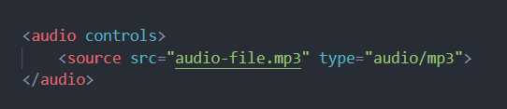

Embedding Video:

Similarly, you can embed video using the <video> element.

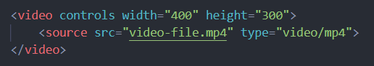

• Semantic element in HTML5?

<header>: Represents introductory content typically at the beginning of a section or document. It often contains headings, logos, and navigation menus.

<footer>: Represents the footer of a section or document, typically containing metadata, copyright information, contact details, etc.

<nav>: Represents a section of a page that contains navigation links.

<article>: Represents a self-contained piece of content that could be distributed and reused independently, such as blog posts, news articles, or forum posts.

<section>: Represents a thematic grouping of content within a document, typically with a heading.

<aside>: Represents content that is tangentially related to the content around it, such as sidebars, pull quotes, or advertisements.

<main>: Represents the main content of a document or application.

<details>: Represents a disclosure widget from which the user can obtain additional information or controls.

<summary>: Represents a summary, caption, or legend for a <details> element's disclosure box.

• Canvas and SVG tags

The <canvas> and <svg> tags are both commonly used in web development for creating graphics and visual elements, but they operate in different ways.

Canvas:

<canvas> is an HTML element that provides a drawing surface through JavaScript.

It allows for dynamic, scriptable rendering of 2D shapes and bitmap images.

It's essentially a bitmap canvas where you can draw graphics using JavaScript commands.

Canvas is good for applications where you need to manipulate pixels directly or where performance is crucial, like complex animations or games.

SVG (Scalable Vector Graphics):

<svg> is an XML-based vector graphics format that allows for the creation of vector shapes, paths, and text.

It defines graphics in terms of vectors, which allows them to be scaled to any size without losing quality.

SVG elements are part of the DOM (Document Object Model) and can be styled and manipulated using CSS and JavaScript.

SVG is great for creating scalable graphics like logos, icons, or illustrations that need to adapt to different screen sizes.