Web Designing Assignment

Module (HTML) -1

1.Are the HTML tags and elements the same thing?

A tag is a syntax in HTML that is used to define various types of content within a web page. Tags are enclosed in angle brackets < >. They typically come in pairs: an opening tag and a closing tag. For example, <p> is an opening tag for a paragraph, and </p> is a closing tag for the same paragraph. Tags define the structure and appearance of the content within a web page.

An element, on the other hand, is made up of one or more tags, along with the content they contain. An element consists of the opening tag, the content, and the closing tag. For example, in the HTML <p>Hello world</p>. they form the <p> element, which represents a paragraph in the web page.

So, while tags are the individual syntax used to define elements in HTML, elements are the combination of tags and content that make up the structure and content of a web page.

2.What are tags and attributes in HTML?

In HTML, tags and attributes are fundamental components used to structure and define elements within a web page.

Tags:

Tags are the building blocks of HTML markup.

They are enclosed in angle brackets < > and typically come in pairs: an opening tag and a closing tag.

Opening tags indicate the beginning of an element, and closing tags indicate the end of an element.

Tags define the structure and semantics of content within a web page. For example, <p> defines a paragraph, <h1> defines a level-one heading, <div> defines a division or section, etc.

Some tags are self-closing, meaning they do not require a separate closing tag. For example, <img> for inserting images, <br> for line breaks, etc.

Attributes:

Attributes provide additional information about HTML elements.

They are placed within the opening tag of an element and are comprised of a name-value pair.

Attributes modify the behaviour or appearance of an element.

Common attributes include class, id, src, href, alt, style, etc.

Attributes can be used to add styling, provide metadata, specify links, control element behaviour, and more.

For example, <a href="https://www.abc.com">Link</a> uses the href attribute to specify the URL that the anchor element links to.

Here is an example of an HTML element with a tag and an attribute:

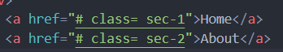

3.What are void elements in HTML?

Void elements in HTML are elements that do not have a closing tag and do not contain any content. Void elements are used for various purposes such as inserting images, line breaks, embedding media, and more. They are essential for structuring HTML documents and are particularly useful when you need to include standalone elements without any content or nested elements.

Here are some common examples of void elements in HTML:

<img>: Used to embed images.

<br>: Represents a line break or a line break opportunity.

<input>: Represents an input control in a form.

<hr>: Represents a thematic break or horizontal rule.

For example:

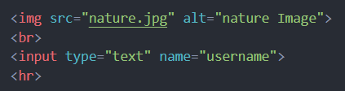

It is important to note that void elements cannot have any content or nested elements. They are self-contained within a single tag.

4.What are HTML Entities?

HTML entities are special sequences of characters used to represent reserved characters, characters with special meaning in HTML, or characters that cannot be easily typed or displayed using standard keyboard input. They are primarily used to ensure that these characters are displayed correctly in web browsers and are not interpreted as part of HTML syntax.

HTML entities start with an ampersand (&) and end with a semicolon (;). They can be represented either by their name or their numerical code.

For example:

&lt; represents the less-than sign <.

&gt; represents the greater-than sign >.

&amp; represents the ampersand &.

&quot; represents the double quotation mark ".

Additionally, HTML entities are used to represent special characters like non-breaking space (&nbsp;), copyright symbol (&copy;), trademark symbol (&trade;), and many others.

5.What are different types of lists in HTML?

Unordered list:

An unordered list starts with the <u1> tag. Each list item starts with the <li> tag.

The list items will be marked with bullets by default:

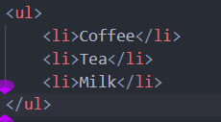

Ordered list:

An ordered list starts with the <ol> tag. Each list item starts with the <li> tag.

The list items will be marked with numbers by default:

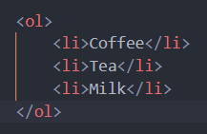

Definition list:

HTML also supports description lists.

A description list is a list of terms, with a description of each term.

The <dl> tag defines the description list, the <dt> tag defines the term and the <dd> tag describes each term:

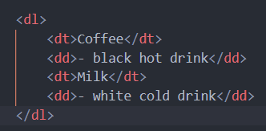

6.What is the ‘class’ attribute in HTML?

The class attribute specifies one or more class names for an element.

The class attribute is mostly used to point to a class in a style sheet. However, it can also be used by a JavaScript to make changes to HTML elements with a specified class.

The class attribute is part of the global attributes and can be used on any HTML element.

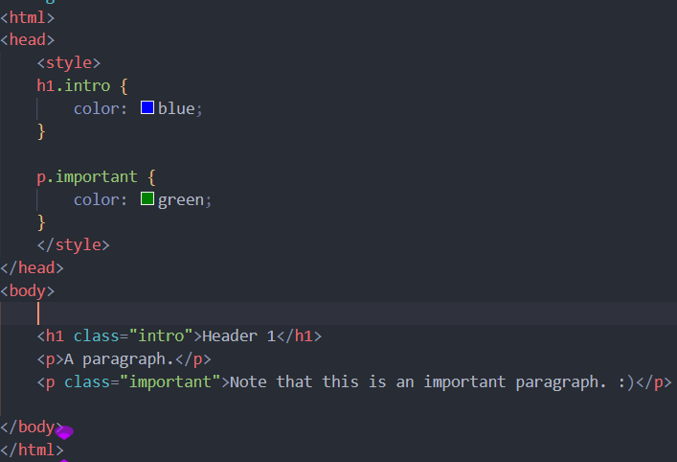

7.What is the difference between the ‘id’ attribute and the ‘class’ attribute of HTML elements?

**HTML id Attribute:**

The id attribute is a unique identifier that is used to specify the document. It is used by CSS and JavaScript to perform a certain task for a unique element. In CSS, the id attribute is written using the # symbol followed by id.

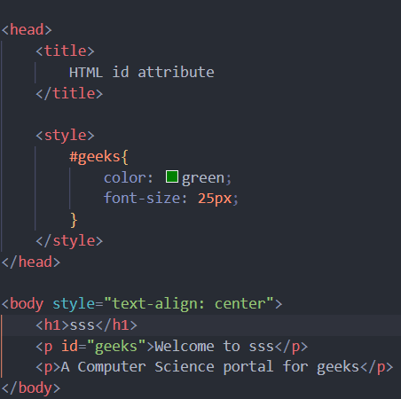

**HTML class Attribute:**

 The class attribute is used to specify one or more class names for an HTML element. The class attribute can be used on any HTML element. The class name can be used by CSS and JavaScript to perform certain tasks for elements with the specified class name. The class name in CSS stylesheet using “.” symbol.

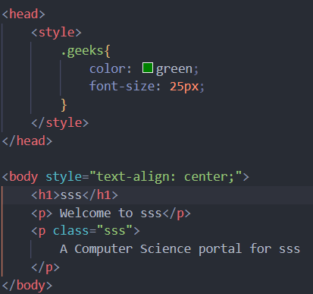

8.what are the various formatting tags in HTML?

<b> and <strong>: Both of these tags are used to make text bold. However, <strong> is considered to have stronger semantic meaning, indicating that the enclosed text is of greater importance or relevance for search engines and accessibility tools.

<i> and <em>: These tags are used to italicize text. Similar to <strong>, <em> has stronger semantic meaning, indicating emphasis on the enclosed text.

<u>: This tag is used to underline text.

<s>: This tag is used to strike through text, indicating that it is no longer relevant or accurate.

<sub> and <sup>: These tags are used to create subscript and superscript text, respectively. Subscript text appears below the baseline, while superscript text appears above it.

<small>: This tag is used to render text in a smaller font size, typically used for disclaimers, footnotes, or legal information.

<pre>: This tag is used to preserve the spacing and line breaks within the enclosed text, rendering it as preformatted text.

<code>: This tag is used to indicate that the enclosed text represents computer code or programming code. It typically renders the text in a monospace font.

9.How is Cell Padding different from Cell Spacing?

In HTML, cell padding and cell spacing are attributes used in table elements to control the spacing and alignment of content within table cells and the spacing between cells.

**Cell Padding**:

Cell padding is used to specify the space between the content of a table cell and the cell's borders.

It adds space inside the cell, pushing the content away from the cell borders.

Cell padding is specified in pixels or as a percentage of the cell's width.

For example:

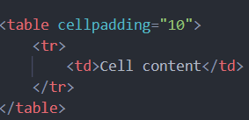

**Cell spacing:**

Cell spacing is used to specify the space between adjacent cells in a table.

It adds space between the borders of adjacent cells.

Cell spacing is specified in pixels or as a percentage of the table's width.

For example:

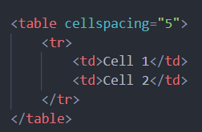

10. How can we club two or more rows or columns into a single row or column in an HTML table?

In HTML tables, you can use the rowspan and colspan attributes to merge two or more adjacent cells into a single cell, either horizontally or vertically.

Merging row with rowspan:

To merge multiple rows into a single row, you use the rowspan attribute on the cell you want to span across multiple rows.

The rowspan attribute specifies the number of rows the cell should span.

Example:

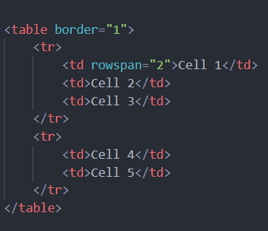

Merging columns with colspan:

To merge multiple columns into a single column, you use the colspan attribute on the cell you want to span across multiple columns.

The colspan attribute specifies the number of columns the cell should span.

Example:

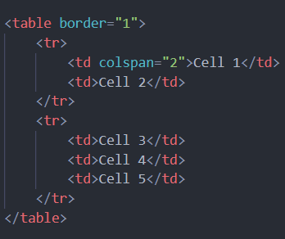

11.What is the difference between a block-level element and an inline element?

Block-level element:

Block-level elements typically start on a new line and occupy the full width available to them, pushing subsequent content to a new line.

They create "blocks" of content within the document flow.

Examples of block-level elements include <div>, <p>, <h1>-<h6>, <ul>, <ol>, <li>, <table>, <form>, etc.

Block-level elements can contain other block-level elements and inline elements.

Inline Elements:

Inline elements do not start on a new line and only occupy as much width as necessary, allowing other elements to sit beside them on the same line.

They are typically used for small chunks of content or parts of larger content.

Examples of inline elements include <span>, <a>, <strong>, <em>, <img>, <input>, <button>, <code>, etc.

Inline elements cannot contain block-level elements but can contain other inline elements.

Layout and flow: Block-level elements start on a new line and take up the full width available to them, while inline elements do not start on a new line and only take up as much width as necessary.

Nested content: Block-level elements can contain other block-level elements and inline elements, while inline elements cannot contain block-level elements but can contain other inline elements.

Default Display: By default, block-level elements have a display property of block, while inline elements have a display property of inline.

12. How to create a Hyperlink in HTML?

The html <a> tag defines a hyperlink.

<a href=”url”>link text</a>

The most important attribute of the<a> element is the href attribute, which indicates the link's destination.

The link text is the part that will be visible to the reader.

Example:

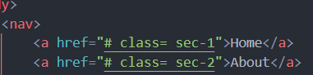

By default, links will appear as follows in all browsers:

An unvisited link is underlined and blue.

A visited link is underlined and purple.

An active link is underlined and red.

13. What is the use of an iframe tag?

The <iframe> (inline frame) tag in HTML is used to embed another HTML document within the current HTML document. It allows you to display content from another web page or external source within a frame or window on your web page. <iframe> elements are commonly used to embed maps, videos, social media feeds, advertisements, or other external content.



14. What is the use of a span tag? Explain with example?

The <span> tag in HTML is a generic inline container used to apply styles or manipulate specific parts of the text within a larger block of content. Unlike block-level elements like <div>, <span> does not create a line break and only affects the content it wraps around.

The main purpose of the <span> tag is to apply CSS styles, such as formatting, color, or font changes, to specific sections of text within a paragraph or other inline content.

example:

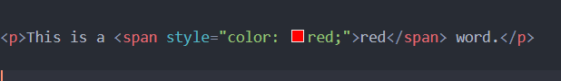

The text "red" is wrapped inside a <span> element.

The style attribute is used to apply a red colour to the text within the <span> element.

15. How to insert a picture into a background image of a web page?

To insert a picture into the background image of a web page, you can use CSS to set the background image of the entire page or a specific element such as the <body> element. Here is how you can achieve this:

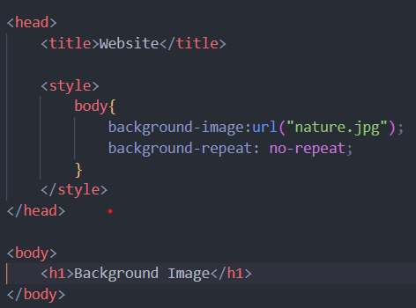

16. How are active links different from normal links?

Normal links:

Normal links are the default state of hyperlinks on a webpage.

They are displayed to users as regular text or images, and they typically have a default appearance defined by the browser or the website's CSS.

Normal links become active when the user hovers over them or clicks on them, transitioning to the active state.

Active links:

Active links represent hyperlinks that are currently being interacted with by the user.

In most cases, the active state of a link occurs when the user clicks on the link but has not yet released the mouse button.

Active links may have a different appearance compared to normal links to provide visual feedback to the user that they have successfully clicked on the link.

For example, active links may change colour, background colour, or have an underline to indicate that they are being clicked.

the main difference between active links and normal links lies in their appearance and behaviour during user interaction. Normal links are the default state of hyperlinks, while active links represent hyperlinks that are currently being clicked or interacted with by the user.

17. What are the different tags to separate sections of text?

<p> (paragraph):

The <p> tag is used to define paragraphs of text.

It creates a block-level element that starts on a new line and is separated from surrounding content.

Example:



<div> (division):

The <div> tag is a generic container used to group and separate sections of content.

It is a block-level element that does not have any inherent semantic meaning but is widely used for layout purposes and CSS styling.

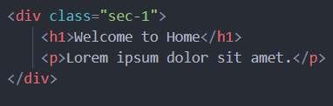

<section>:

The <section> tag is used to define a thematic grouping of content within a document.

It is often used to divide a page into distinct sections or chapters.

<section> elements are semantically meaningful and can be used to improve accessibility and search engine optimization.

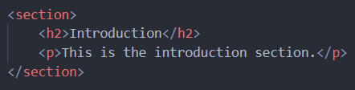

18. What is SVG?

SVG stands for Scalable Vector Graphics. It is a markup language for describing two-dimensional vector graphics in XML format. SVG is an open standard developed by the World Wide Web Consortium and is widely supported by modern web browsers.

SVG graphics are resolution-independent, meaning they can be scaled to any size without losing quality.

characteristics of SVG:

vector graphics: SVG graphics are composed of shapes such as lines, curves, rectangles, circles, and text. These shapes are defined by mathematical equations, allowing them to be scaled, rotated, and manipulated without losing quality.

Text support: SVG supports text elements, allowing you to include styled text within your graphics.

Interactive elements: SVG supports interactivity using event attributes.

19. What is difference between HTML and XHTML?

HTML (Hypertext Markup Language) and XHTML (Extensible Hypertext Markup Language) are both markup languages used for creating web pages, but they have some differences in syntax and rules.

HTML:

The full form of HTML is Hypertext Markup language.

Hypertext is a text that links one page to another page through hyperlinks and get activated when it is clicked. A markup language is one that uses tags to design the web page and make it look more attractive. Hypertext markup language is used to develop web pages from the basic level connecting multiple pages.

Advantages:

It is simple and can be easily understood by a beginner

HTML is supported by all browsers

It is free of cost and it is available by default in windows

Disadvantages:

It can’t produce dynamic output

Even a simple webpage requires number of lines of code

XHTML:

XHTML stands for Extensible hypertext markup language. It was developed by World Wide Web Consortium. It has the characteristics of both HTML and XML.

Doctype: used to declare the type of document

Head: used to declare the title and other attributes

Body: part that consist of the actual content that a web page contains

Advantages:

It follows strict rules hence reducing errors

It makes the code readable

It provides more security and source code can’t be accessed easily

As it follows all the rules of XML, it is easy to convert to other formats

Disadvantages:

Beginners find it difficult to learn

Only few browsers support XHTML.

20. What are logical and physical tags in HTML?

Logical tags:

Logical tags are also known as semantic tags.

Logical tags describe the meaning or purpose of the content rather than its presentation.

example of logical tags introduced in HTML5 include <header>, <nav>, <article>, <section>, <aside>, <footer>, etc.

These tags are designed to improve the organization, accessibility, and search engine optimization of web pages by clearly defining the purpose of different sections of content.

Physical tags:

Physical tags are also known as presentational tags.

Physical tags directly specify how content should be presented or styled on the web page.

Examples of physical tags include <font>, <b>, <i>, <u>, <center>, etc.

These tags were commonly used in early versions of HTML to apply styles such as font size, weight, style, and text alignment directly within the HTML document.