Link :- <https://public.tableau.com/authoring/SalesChartTask/Sheet2#2>

Sheet :– 1 Sales by category (Bar Chart)

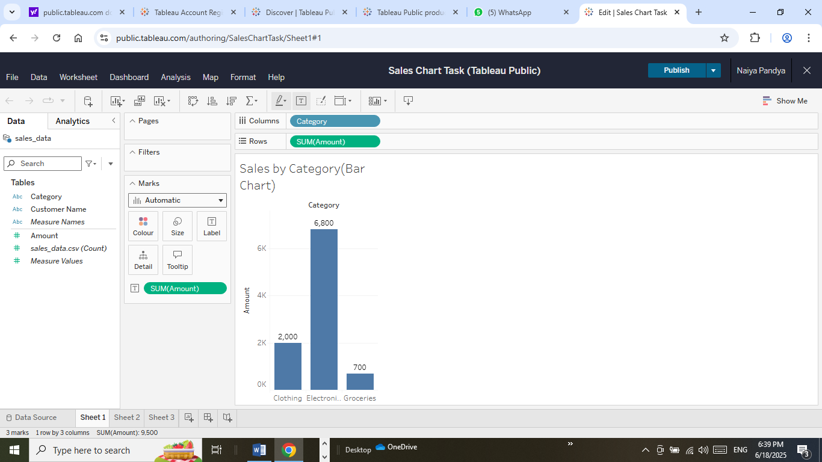

Sheet :-2 Customer-wise Sales(Pie chart)

