

Introduction
Agriculture is one of the most important sectors of the Indian economy. A large proportion of the population depends directly or indirectly on agricultural activities for employment and livelihood. Agricultural productivity, however, varies considerably across regions due to differences in climatic conditions, water availability, soil characteristics, crop selection and farming practices.
Among the environmental factors affecting agricultural productivity, rainfall and groundwater availability are particularly important. Rainfall provides a major source of water for agricultural activities, while groundwater supports irrigation, especially in regions where rainfall is insufficient or irregular.
The relationship between these factors and agricultural yield is complex. Excessive rainfall, insufficient rainfall and variations in groundwater availability may influence crop performance differently depending on the crop type, season and geographical region.
Traditional agricultural analysis often involves examining historical production and yield statistics. However, machine learning techniques provide additional opportunities to analyse relationships between multiple variables and estimate agricultural outcomes using historical observations.
Predictive analytics combines statistical methods, data analysis and machine learning algorithms to identify patterns in historical data and generate predictions. In this project, predictive analytics techniques are applied to agricultural datasets from Indian districts to estimate crop yield using environmental and agricultural indicators.
Problem Statement
Agriculture is highly dependent on environmental conditions such as rainfall and groundwater availability. Variations in these factors can influence crop productivity across different geographical regions. Understanding the relationship between environmental indicators and agricultural yield can help in analysing regional agricultural performance.
The objective of this project is to analyse agricultural productivity across Indian districts and develop machine learning regression models to estimate crop yield using rainfall, groundwater and other relevant agricultural indicators.
The project integrates district-level rainfall, groundwater and agricultural production datasets to create a unified dataset. Five regression algorithms are implemented and evaluated to compare their predictive performance.
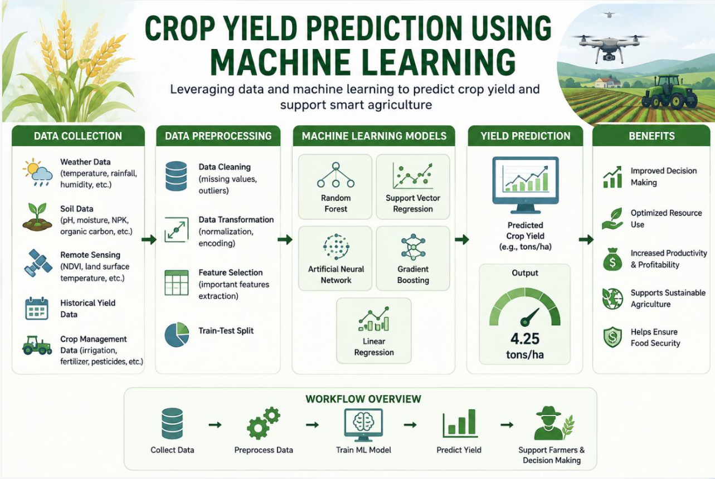
Objectives
The main objectives of this project are:
- To collect district-level rainfall, groundwater and agricultural production datasets.
- To inspect and understand the structure, quality and characteristics of the collected datasets.
- To clean the datasets by handling missing values, invalid records and inconsistencies.
- To aggregate daily rainfall and groundwater measurements at the agricultural-year level.
- To integrate the datasets using geographical and temporal identifiers.
- To perform Exploratory Data Analysis to identify patterns and relationships in agricultural productivity.
- To select relevant numerical and categorical features for machine learning.
- To implement five regression algorithms for crop yield estimation.
- To evaluate and compare the models using appropriate regression metrics.
- To identify the model that demonstrates the best performance on the selected test dataset.
Dataset Description and Data Collection
-Official government portals, like data.gov.in, India WRIS (indiawris.gov.in), only give piecewise downloads which is more difficult to retrieve and work on .
Files were downloaded via the India Data Portal (ISB), which republishes these official datasets. The original extraction pages are India WRIS and DES.
The data originally comes from CGWB, IMD and the Ministry of Agriculture, ISB’s portal only republishes it.

Downloaded Dataset:
- CGWB - Changes in Depth to Water Level
Saved as: groundwater.csv
Link: https://ckandev.indiadataportal.com/dataset/groundwater/resource/580a8f6e-3d86-4ca7-ac7d-cd5df12b443c
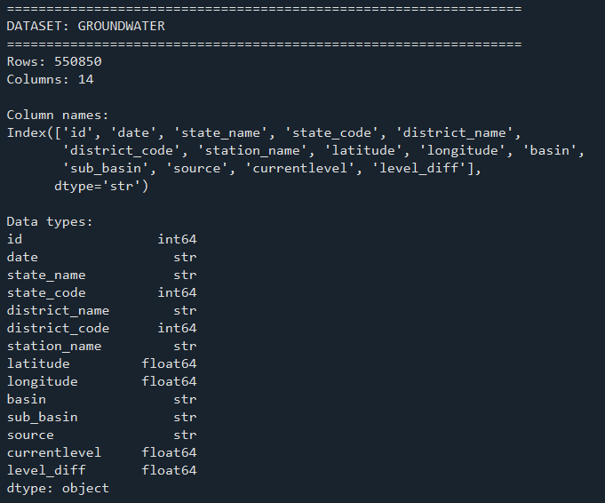
- Daily Rainfall Data - District Level
Saved as: rainfall_daily.csv
Link: https://ckandev.indiadataportal.com/dataset/climate-data/resource/d97707e6-9309-46a5-ac31-e8482ce8f9eb
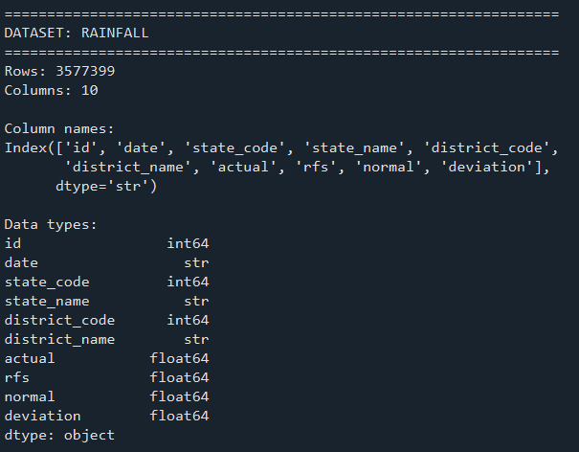
- Crop Wise Area Production Yield
Saved as: apy.csv
Link: https://ckandev.indiadataportal.com/dataset/area-production-yield-apy/resource/f980409d-49a2-42ae-9eb0-182365005c04
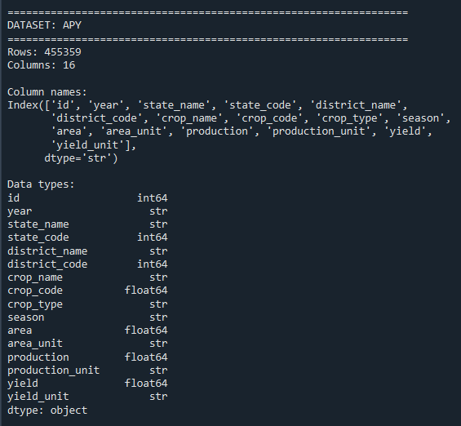
dataset attributes
Dataset | Important attributes
Groundwater | State code, district code, date, current level, level difference, station
Rainfall | State code, district code, date, actual rainfall, normal rainfall
APY | State, district, crop, season, area, production, yield, year

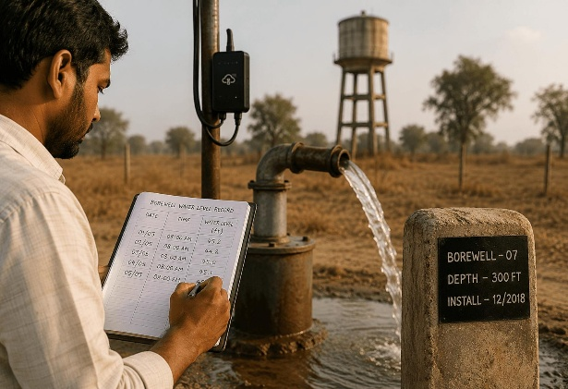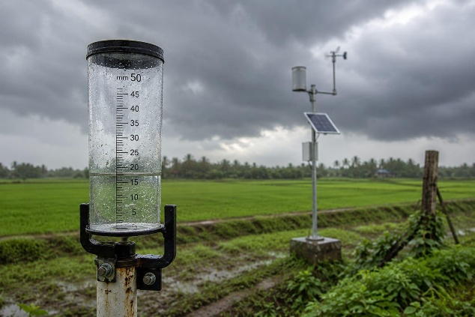

Preprocessing
1 | Finish geographic compatibility checks
2 | Audit missing values in all columns
3 | Check duplicates and invalid values
4 | Validate date ranges, units and numerical ranges
5 | Inspect outliers and unusual patterns
6 | Verify source documentation
7 | Decide whether the datasets are suitable for integration
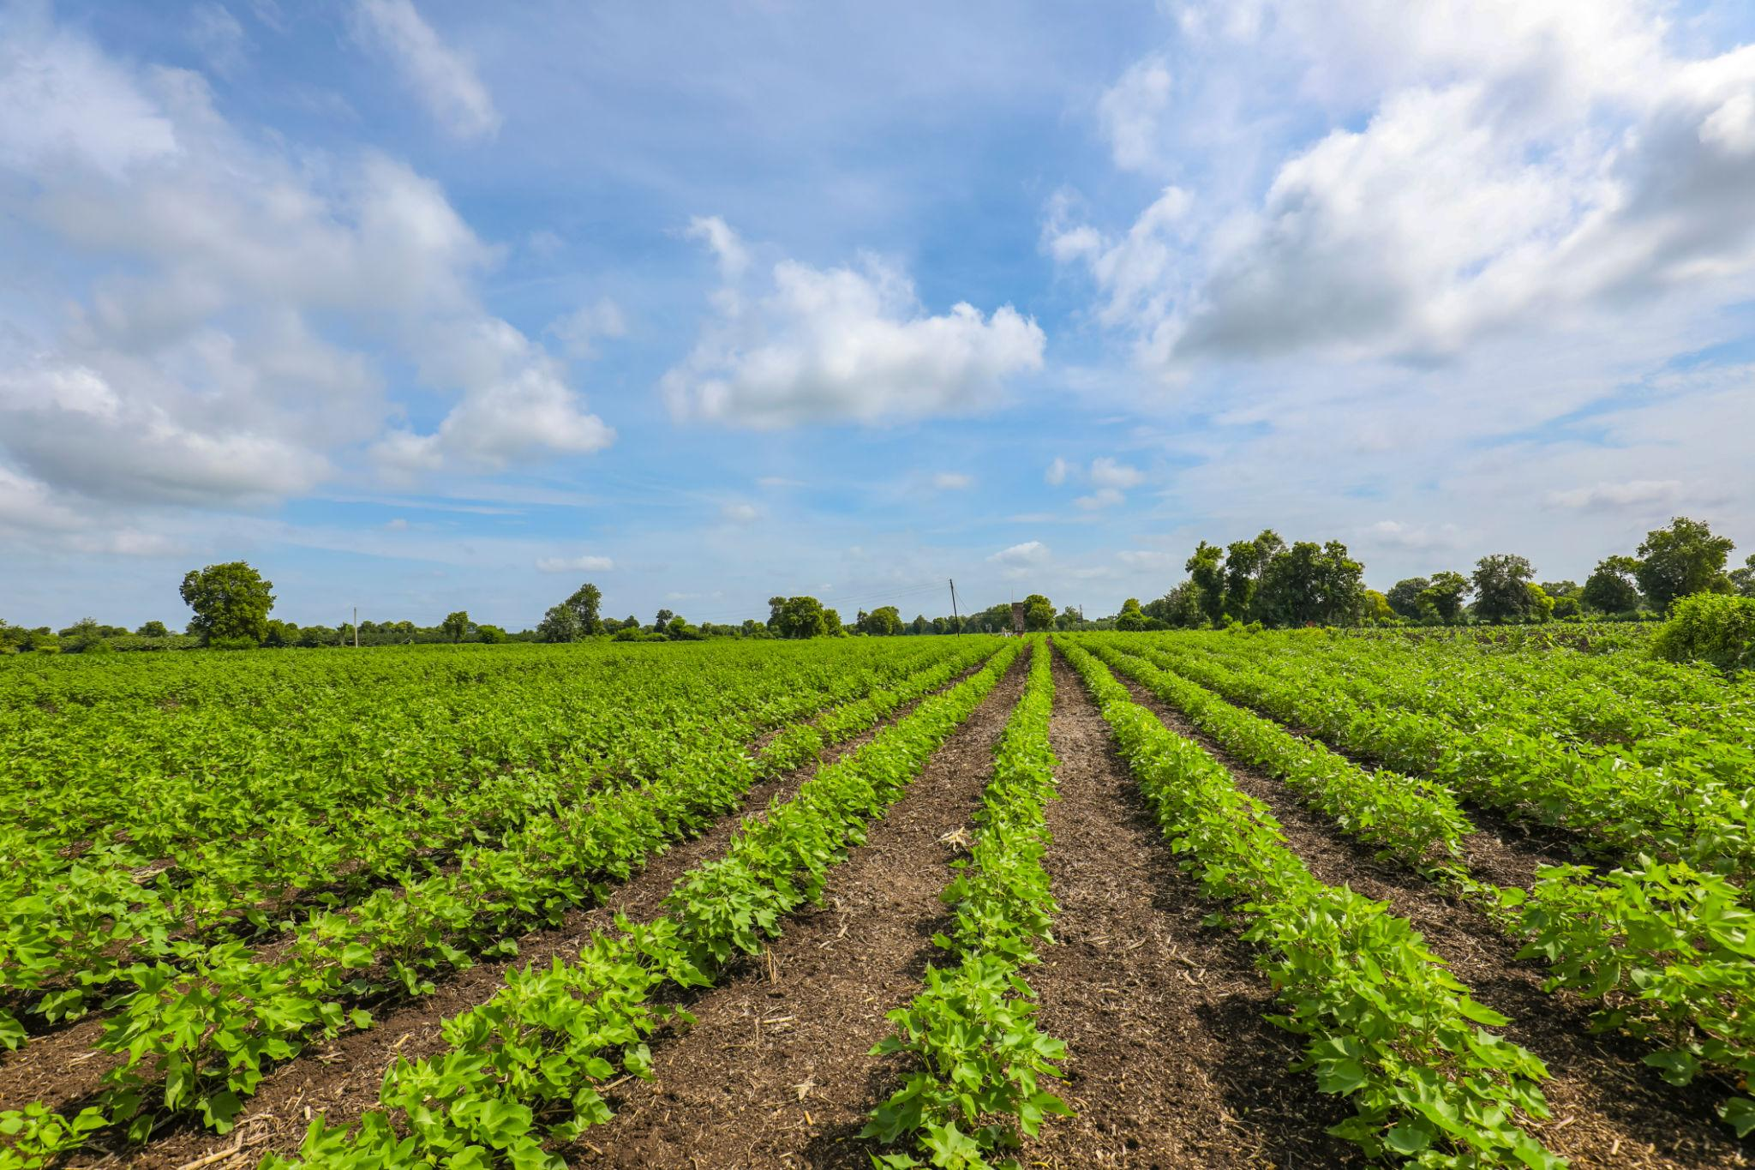
Dataset Description and Initial Data Validation.
Dataset Description
I selected three datasets for this project: groundwater-level data, daily district-level rainfall data and crop-wise area, production and yield data. These datasets provide information about water resources, rainfall patterns and agricultural productivity across Indian districts.
Initial Dataset Inspection and Study Period Selection

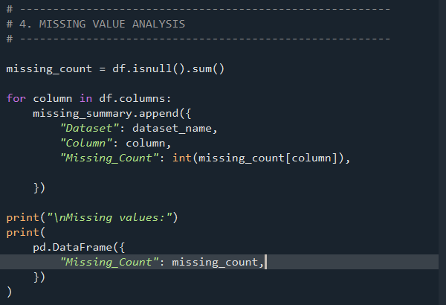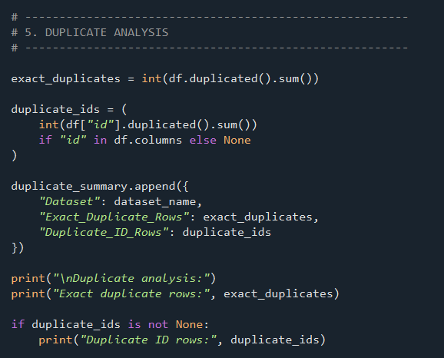

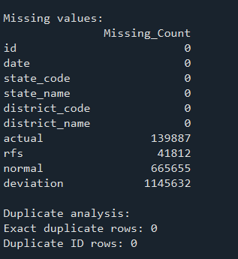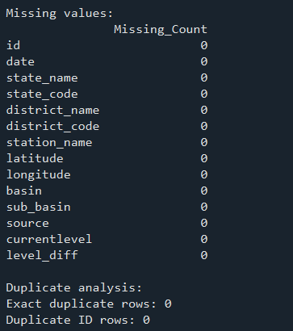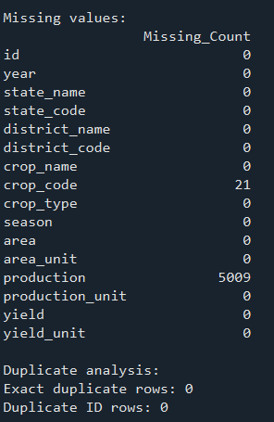
I started by inspecting the three datasets to understand their structure, data quality and available time periods. The groundwater dataset contained 550,850 records, the rainfall dataset contained 3,577,399 records and the APY dataset contained 455,359 records.
The initial checks showed that the groundwater dataset had no missing values or exact duplicate records. The rainfall dataset had missing values, mainly in the normal rainfall and deviation columns, while the APY dataset had missing values in crop code and production. No exact duplicate rows or repeated IDs were identified in the three datasets.
After comparing the available time periods, I selected 2017–2021 for the project because it provided five consecutive years of overlapping data. During this period, the groundwater dataset contained 265,710 records, rainfall contained 1,147,853 records and APY contained 106,444 records.
Groundwater coverage decreased over these years, with the number of monitoring stations falling from 18,427 in 2017 to 13,960 in 2021. The number of covered districts also decreased from 560 to 544. Rainfall coverage remained at 628 districts throughout the period.
I also checked the geographical overlap between the datasets. The number of districts common to all three datasets ranged from 543 in 2017 to 529 in 2021. Although coverage was not identical across all years, there was sufficient overlap to proceed with district-level integration.
APY Dataset Analysis and Cleaning
Before cleaning the APY dataset, I examined its crop and seasonal distribution. It contained 61 unique crops belonging to nine crop categories, with seven season categories. All yield values were recorded in tonnes per hectare.
One important observation was the presence of the Total season category. I found 13,896 groups containing Total-season records, many of which represented the combined area and production of individual seasons. Keeping these records alongside the individual seasons could result in double-counting. Therefore, I excluded the Total category from the modelling dataset.
I also checked the Whole Year category separately. It contained 13,234 records, and these occurred independently without corresponding individual-season records for the same crop, district and agricultural year. I therefore retained Whole Year as a separate season category.
The APY dataset contained 739 records with missing production values. I also examined 1,094 zero-yield observations to determine whether they were valid. Of these, 739 had missing production, 354 had zero production and one had positive production.
The remaining positive-production observation belonged to Cotton (Lint) in Ramanathapuram, Tamil Nadu. Its production was one tonne over an area of 2,152 hectares, giving a very small calculated yield of approximately 0.000465 tonnes per hectare. This explains why the recorded yield appeared as zero after rounding.
Based on these checks, I removed records with missing production and invalid agricultural values while retaining valid zero-yield observations. After excluding the Total season and cleaning the records, the APY dataset contained 91,809 records.
Environmental Data Processing and Dataset Integration
The rainfall and groundwater datasets contained observations at different frequencies from the annual agricultural records. I therefore aggregated both datasets using state code, district code and agricultural year.
For rainfall, I selected observations from July 2017 to June 2022 and calculated total rainfall, mean rainfall and the number of days with available rainfall observations. This produced 3,140 district-year records covering 628 districts across five agricultural years.
For groundwater, I calculated the median and mean groundwater levels, average level change, number of monitoring stations and number of available measurements for each district and agricultural year. This produced 2,233 district-year records.
After processing the environmental datasets, I merged them with the cleaned APY dataset using state code, district code and agricultural year. I used left joins so that agricultural records were not lost when corresponding environmental measurements were unavailable.
The integration preserved all 91,809 APY records and produced a final dataset containing 91,809 rows and 22 columns. There were no duplicate combinations of the selected join keys in the aggregated rainfall and groundwater datasets, so the merging process did not introduce unintended duplicate records.
Some district-year combinations still had missing environmental measurements. I retained these values for handling during model preprocessing rather than replacing them with zero.
The final integrated dataset was saved as integrated_agriculture_dataset.csv and used for Exploratory Data Analysis and model development.
Initial Analysis of the Integrated Dataset
The integrated dataset contained 61 crop categories across six remaining season categories. The yield variable had a median of 1.248 tonnes per hectare and a mean of approximately 75.060 tonnes per hectare. This large difference indicated a highly right-skewed distribution, with a small number of unusually high yield values.
Because of this distribution, I decided to apply a logarithmic transformation to the target variable during model training.
The dataset also contained missing values in several rainfall and groundwater features. These would be handled using imputation fitted on the training data. I excluded area and production from the predictor variables because these values are directly involved in calculating crop yield.
The resulting integrated dataset was used for the subsequent exploratory analysis and development of the five regression models.
Exploratory Data Analysis
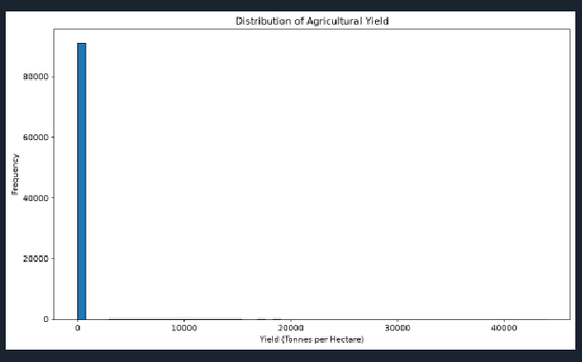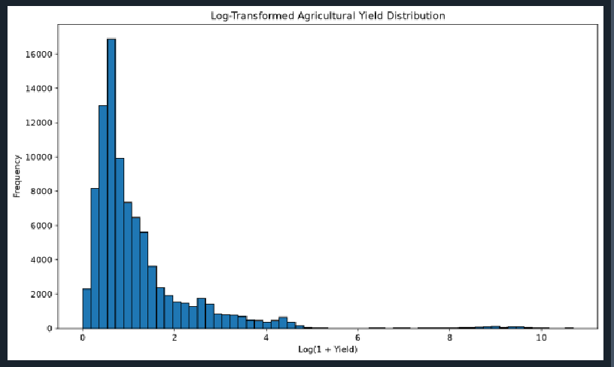
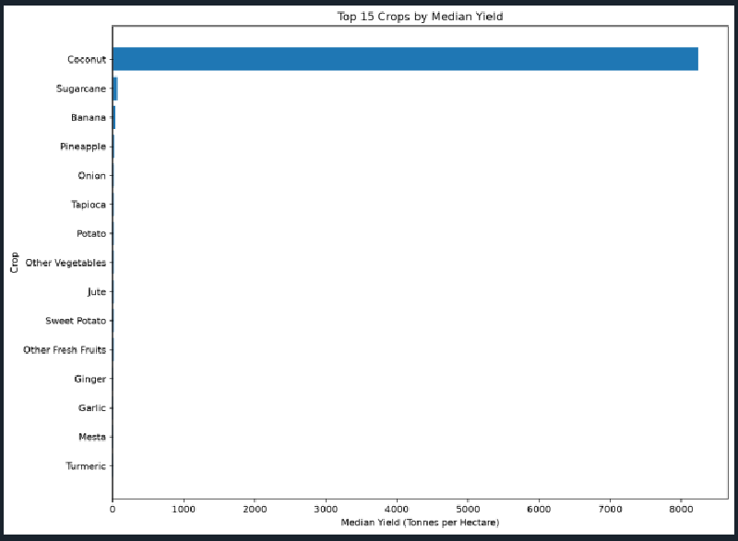

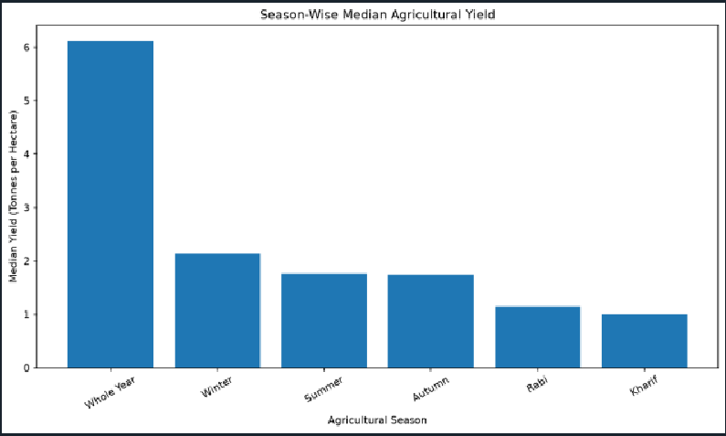
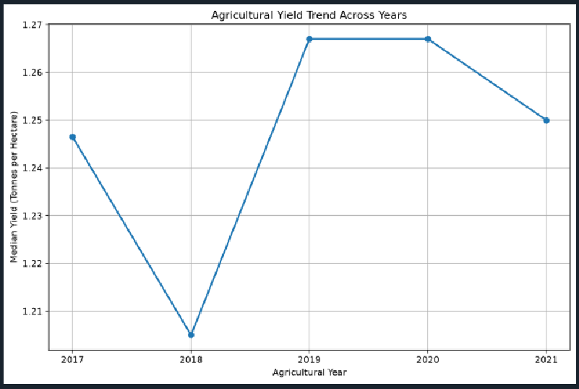
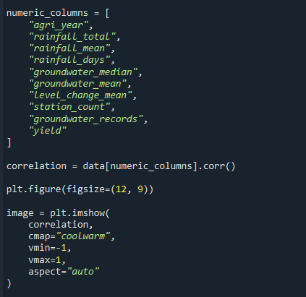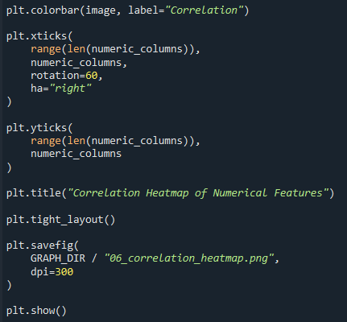

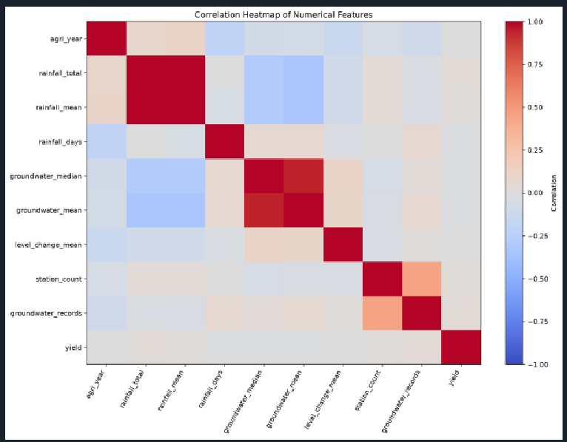
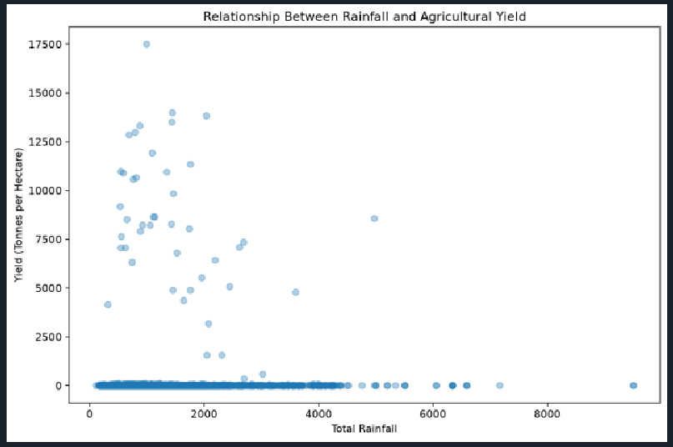
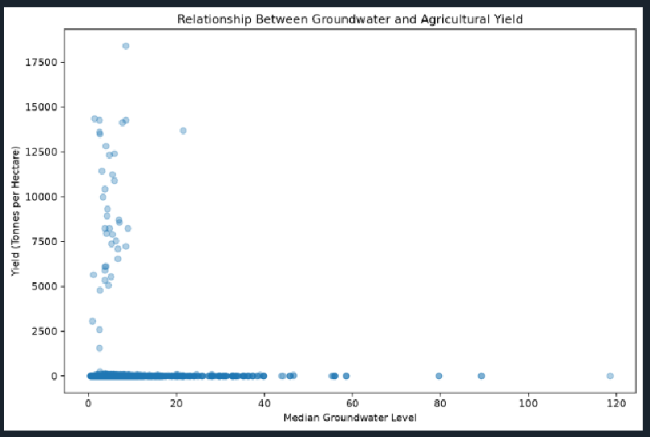
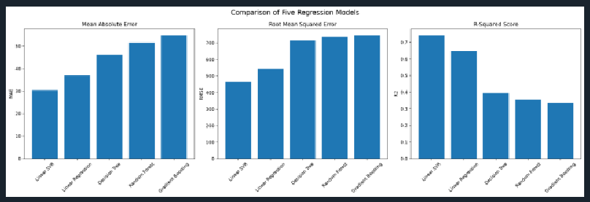

Methodology and Model Development
Linear Regression
Linear Regression is a supervised machine learning algorithm used to predict continuous numerical values.
It models the relationship between independent variables and a dependent variable using a linear equation.
The general equation is:
[Y=\beta_0+\beta_1X_1+\beta_2X_2+\cdots+\beta_nX_n]
Where:
- Y represents the predicted crop yield.
- X represents the input features.
- β₀ represents the intercept.
- β₁, β₂, ..., βₙ represent model coefficients.
The algorithm estimates coefficients that minimise the sum of squared differences between actual and predicted values.
Linear Regression was selected as a baseline model because it provides a simple approach for examining relationships between multiple input features and agricultural yield.
Decision Tree Regression
Decision Tree Regression is a supervised learning algorithm that predicts continuous values by dividing the dataset into smaller groups using feature-based decision rules.
The model begins with the complete dataset and repeatedly selects conditions that divide observations into smaller subsets.
Each internal node represents a decision based on a feature, while the terminal leaf nodes provide predicted values.
Decision Trees can capture nonlinear relationships and interactions between features.
They were selected because agricultural yield may vary depending on combinations of crop type, season, location and environmental conditions.
DecisionTreeRegressor(
max_depth=15,
min_samples_split=10,
min_samples_leaf=5,
random_state=42
)
The maximum depth and minimum sample parameters were specified to control tree complexity and reduce the possibility of excessive fitting to training observations.
Random Forest Regression
Random Forest Regression is an ensemble learning algorithm that combines multiple decision trees to generate predictions.
Each tree is trained using a randomly selected sample of the training data and a subset of features.
For regression tasks, the predictions from individual trees are combined by averaging their outputs.
This approach generally reduces the instability associated with using a single decision tree.
Random Forest was selected because it can model nonlinear relationships and interactions among multiple agricultural and environmental features.
RandomForestRegressor(
n_estimators=100,
max_depth=15,
min_samples_split=10,
min_samples_leaf=3,
n_jobs=-1,
random_state=42
)
The model uses 100 decision trees. The maximum depth and minimum sample settings help control model complexity, while parallel processing is enabled using n_jobs=-1.
Gradient Boosting Regression
Gradient Boosting Regression is an ensemble learning method that builds multiple weak prediction models sequentially.
Each new model attempts to reduce the errors produced by the previous models.
The algorithm combines the predictions of the successive learners to produce a final prediction.
Unlike Random Forest, which builds trees independently, Gradient Boosting builds learners sequentially so that later learners focus on the remaining prediction errors.
The algorithm was selected because it can capture complex relationships between input features and agricultural yield.
GradientBoostingRegressor(
n_estimators=100,
learning_rate=0.05,
max_depth=3,
random_state=42
)
The number of estimators controls the number of boosting stages, while the learning rate determines the contribution of each successive learner.
Linear Support Vector Regression
Support Vector Regression (SVR) is a supervised learning technique based on the principles of Support Vector Machines.
Unlike ordinary regression methods that minimise errors for every observation, SVR uses an epsilon-insensitive loss function. Errors within the specified epsilon margin are not penalised.
Linear Support Vector Regression uses a linear decision function to estimate continuous output values.
It was selected as an additional regression approach to compare its performance with linear regression and tree-based ensemble methods.
The linear implementation was used because the dataset contains more than 90,000 records, making computational efficiency an important consideration.
LinearSVR(
C=1,
epsilon=0,
max_iter=30000,
tol=1e-3,
random_state=42
)
The maximum number of iterations and convergence tolerance control the optimisation process.

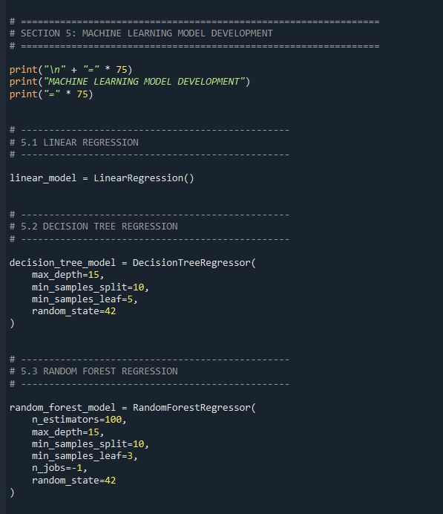
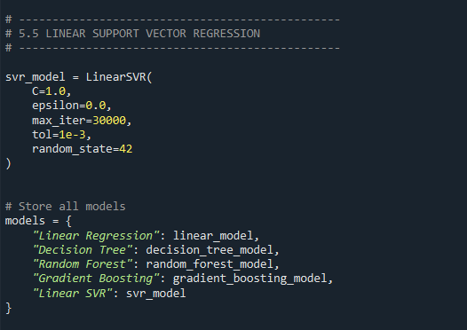
Model Training
Each regression model was combined with the preprocessing pipeline.
The models were fitted using the training dataset and the logarithmically transformed target variable.
After training, predictions were generated using the testing dataset.
The predictions were converted back to the original yield scale before evaluation.
Code Snippet 5.8: Model Training and Prediction
pipeline.fit(
X_train,
y_train_log
)

predicted_log = pipeline.predict(
X_test
)

predicted = np.expm1(
predicted_log
)

predicted = np.clip(
predicted,
0,
None
)
This approach ensures that the same preprocessing transformations are applied during both training and prediction.
MODEL EVALUATION AND RESULTS
Introduction
After training the five regression algorithms, their performance was evaluated using the reserved testing dataset.
The evaluation process compares the predicted crop yield values with the actual recorded yield values.
Four standard regression metrics were used: Mean Absolute Error, Mean Squared Error, Root Mean Squared Error and R-squared.
These metrics provide different perspectives on prediction performance.

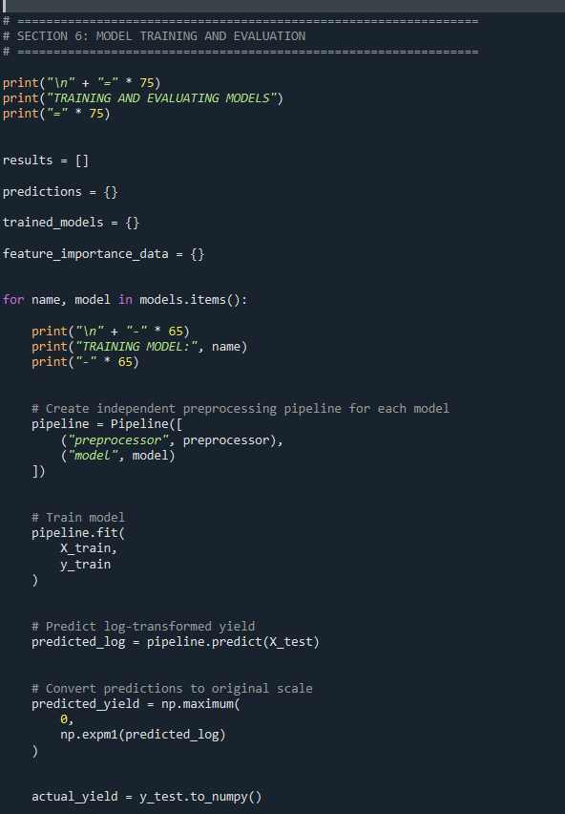
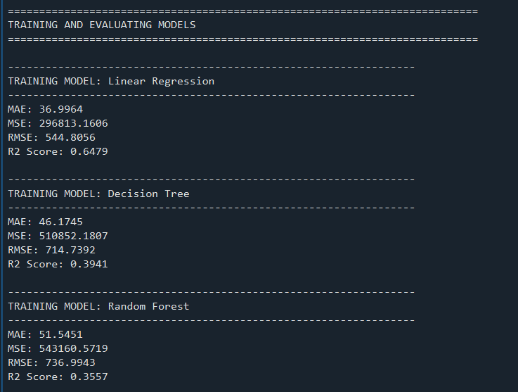
Evaluation Metrics
Mean Absolute Error (MAE)
Mean Absolute Error measures the average absolute difference between actual and predicted values.
[MAE=\frac{1}{n}\sum_{i=1}^{n}|y_i-\hat y_i|]
A lower MAE indicates that the model produces predictions that are closer to the actual values on average.
Mean Squared Error (MSE)
Mean Squared Error calculates the average of the squared differences between actual and predicted values.
[MSE=\frac{1}{n}\sum_{i=1}^{n}(y_i-\hat y_i)^2]
Squaring the errors gives greater importance to large prediction differences.
A lower MSE indicates better predictive performance.
Root Mean Squared Error (RMSE)
Root Mean Squared Error is the square root of Mean Squared Error.
[RMSE=\sqrt{MSE}]
RMSE expresses the prediction error in the same unit as the target variable.
A lower RMSE indicates smaller prediction errors, while large errors have a stronger effect on this metric.
R-squared (R²)
R-squared measures the proportion of variation in the actual target values explained by the regression model.
[R^2=1-\frac{\sum(y_i-\hat y_i)^2}
{\sum(y_i-\bar y)^2}]
An R² value closer to 1 indicates that the model explains a larger proportion of the variation in the target variable.
A negative R² value indicates performance worse than a baseline that predicts the mean of the observed target values.

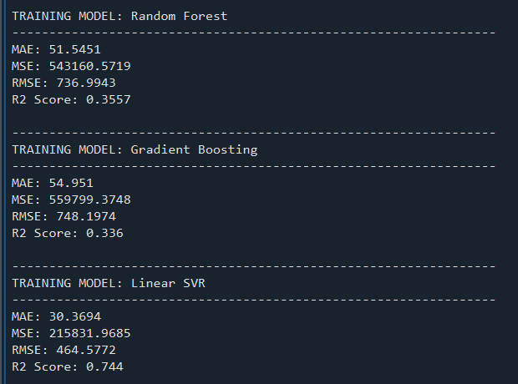
Model Performance Comparison
The five models were evaluated using the same testing dataset to ensure a consistent comparison.
The evaluation metrics were calculated after converting predictions back to the original yield scale.
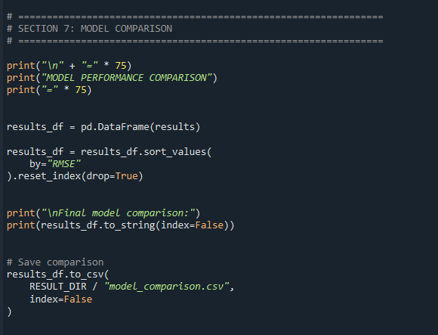
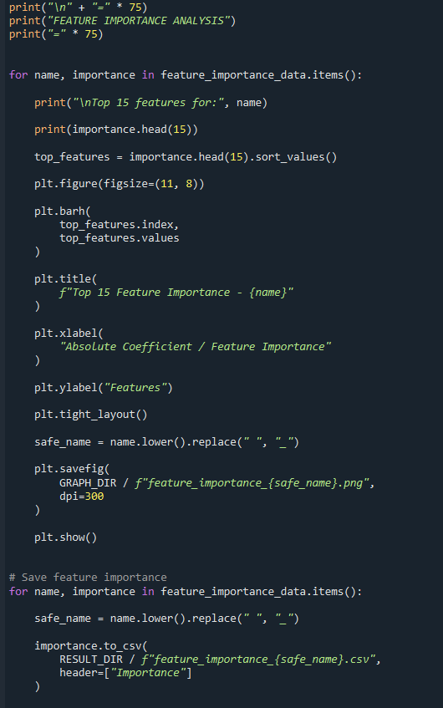
Actual vs Predicted Analysis
Actual versus predicted plots were generated to examine how closely the model predictions match the recorded crop yield values.
In these plots, actual yield values are represented on the horizontal axis and predicted yield values on the vertical axis.
A reference diagonal line represents the ideal situation in which predicted values are equal to actual values.
Points located closer to the diagonal line indicate more accurate predictions. Points farther from the line represent larger prediction errors.
The plots provide a visual comparison of the performance of the five regression models.
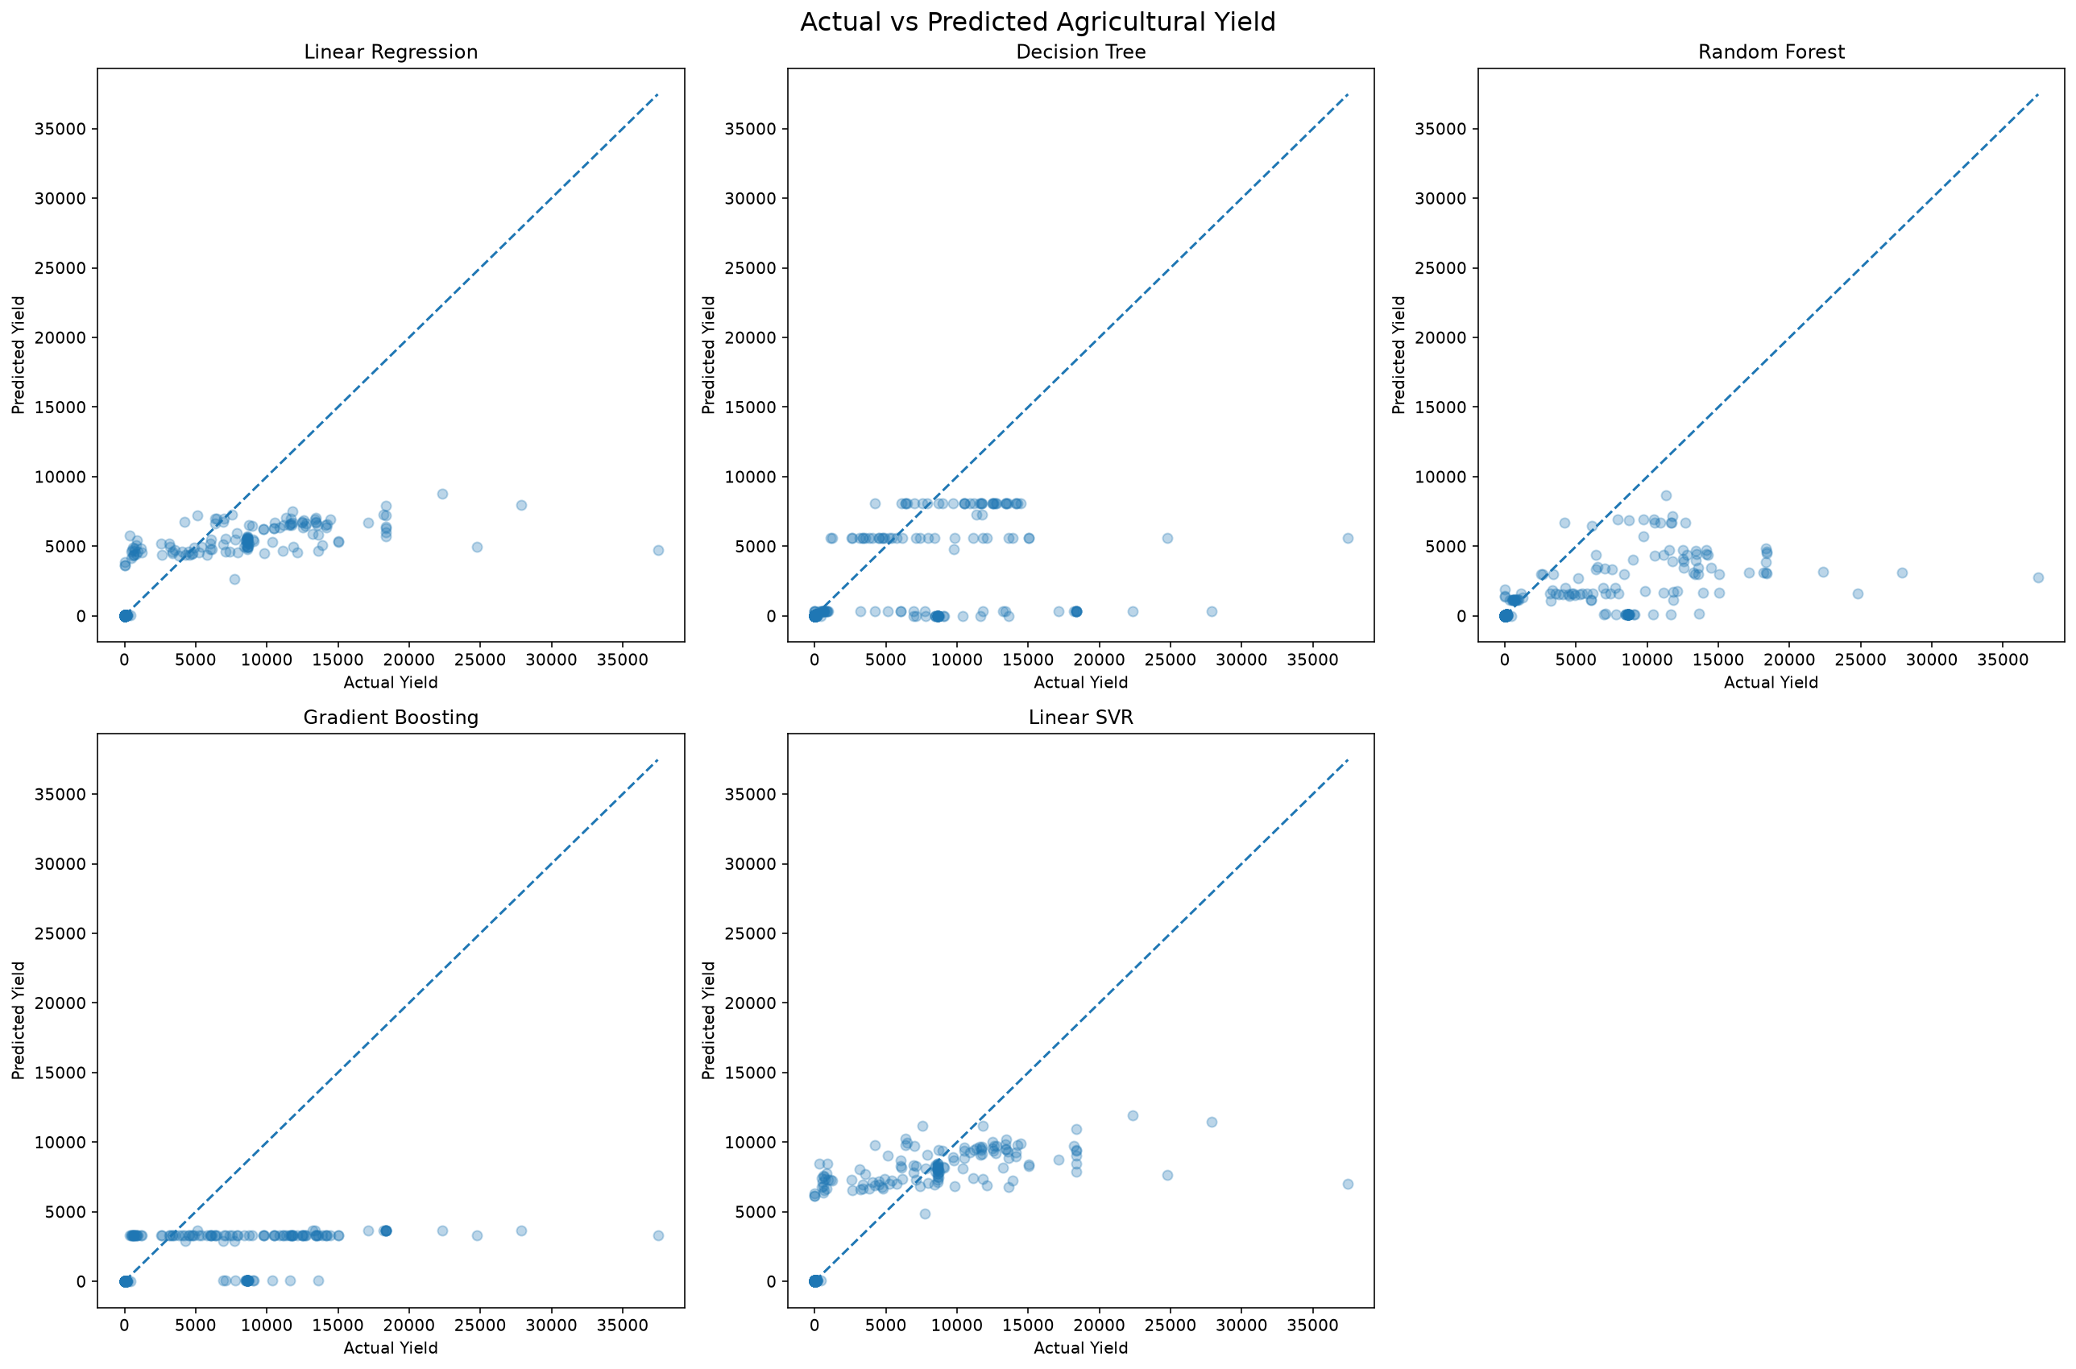
Residual Analysis
Residual analysis was performed to examine the errors generated by the selected best-performing model.
A residual represents the difference between the actual value and the predicted value.
[Residual=y-\hat y]
A residual equal to zero indicates an exact prediction.
Positive residuals indicate that the model underestimated the actual yield, while negative residuals indicate that the model overestimated the actual yield.
A residual scatter plot and residual histogram were generated to examine the distribution and behaviour of prediction errors.
Residual analysis helps identify systematic prediction errors and observations for which the model performs poorly.
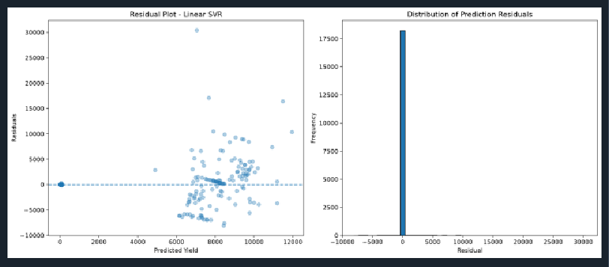
Feature Importance Analysis
Feature importance analysis was performed to understand which input variables contribute to the predictions generated by the regression models.
For tree-based algorithms, feature importance scores are derived from the model's internal feature-splitting behaviour.
For linear regression and Linear SVR, the absolute values of model coefficients can be examined to understand the relative magnitude of their fitted coefficients.
These measures are not directly interchangeable. Tree-based importance and absolute linear coefficients represent different model-specific quantities.
The analysis provides insight into the role of geographical, temporal, crop-related and environmental features in the prediction process.

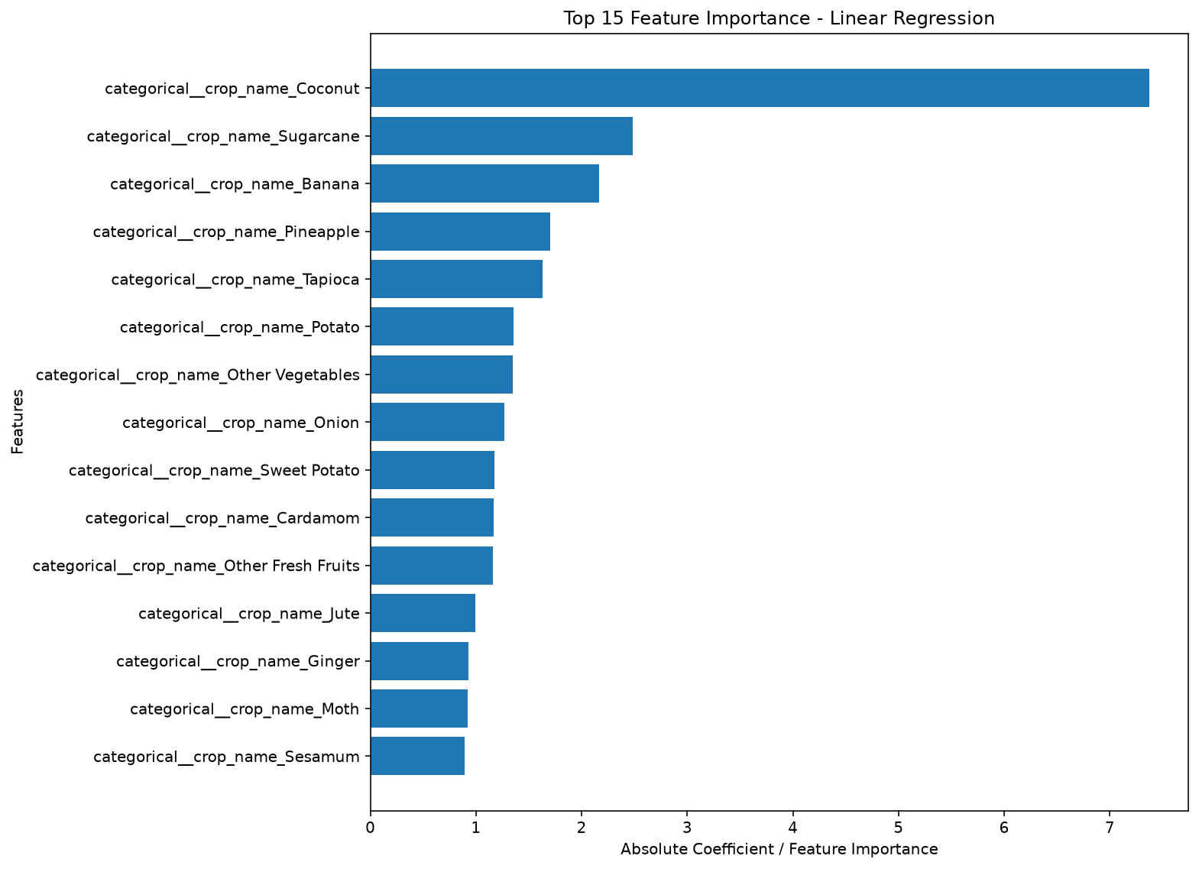
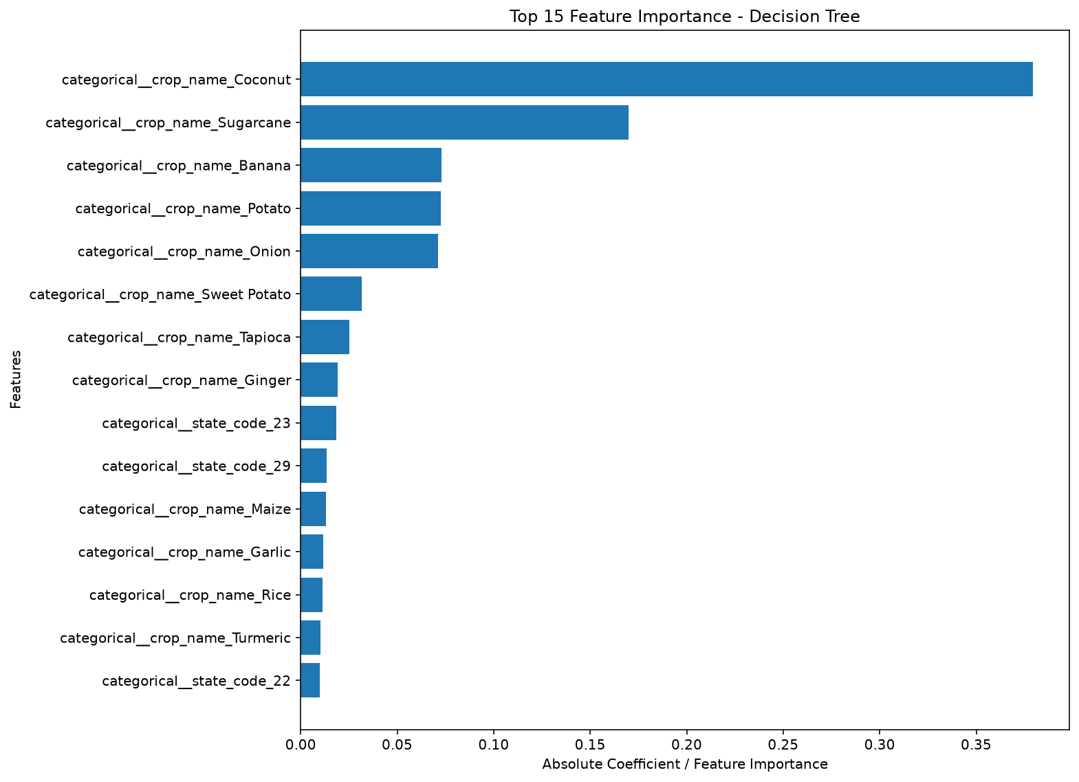
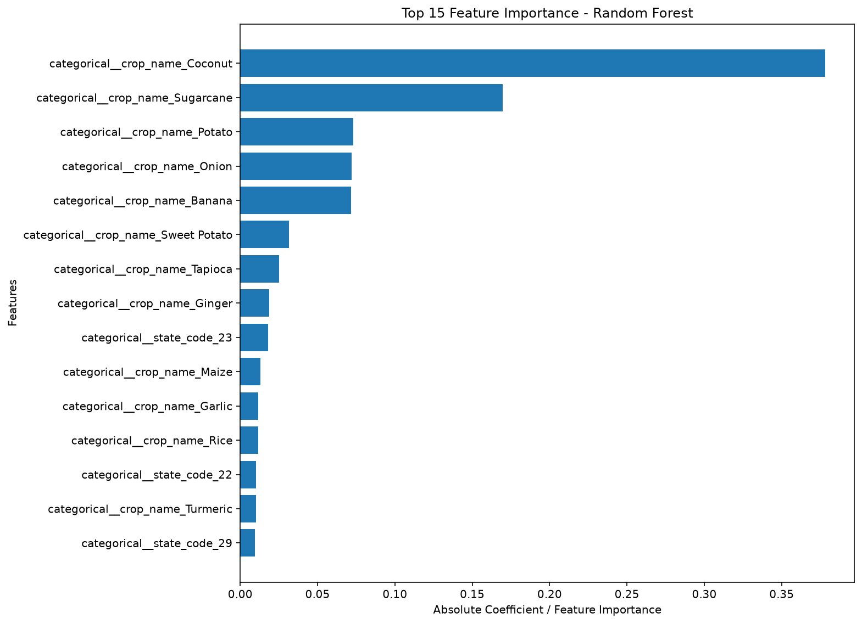
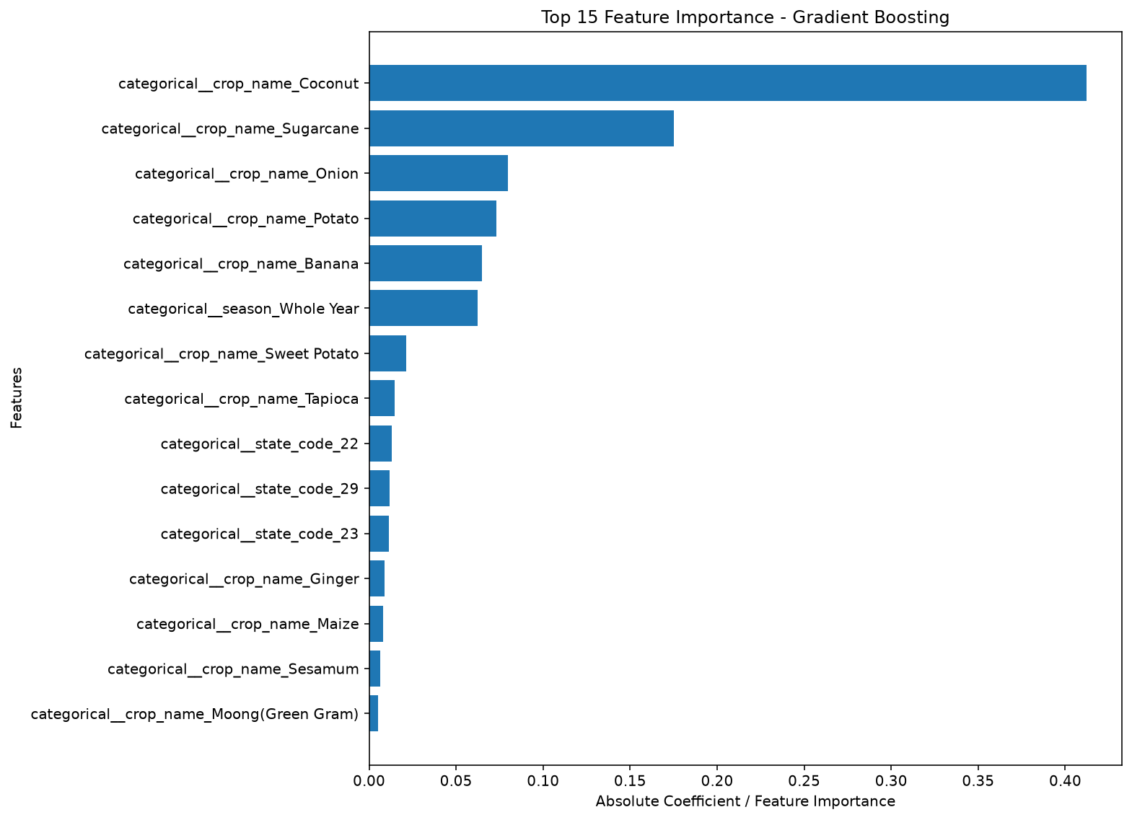

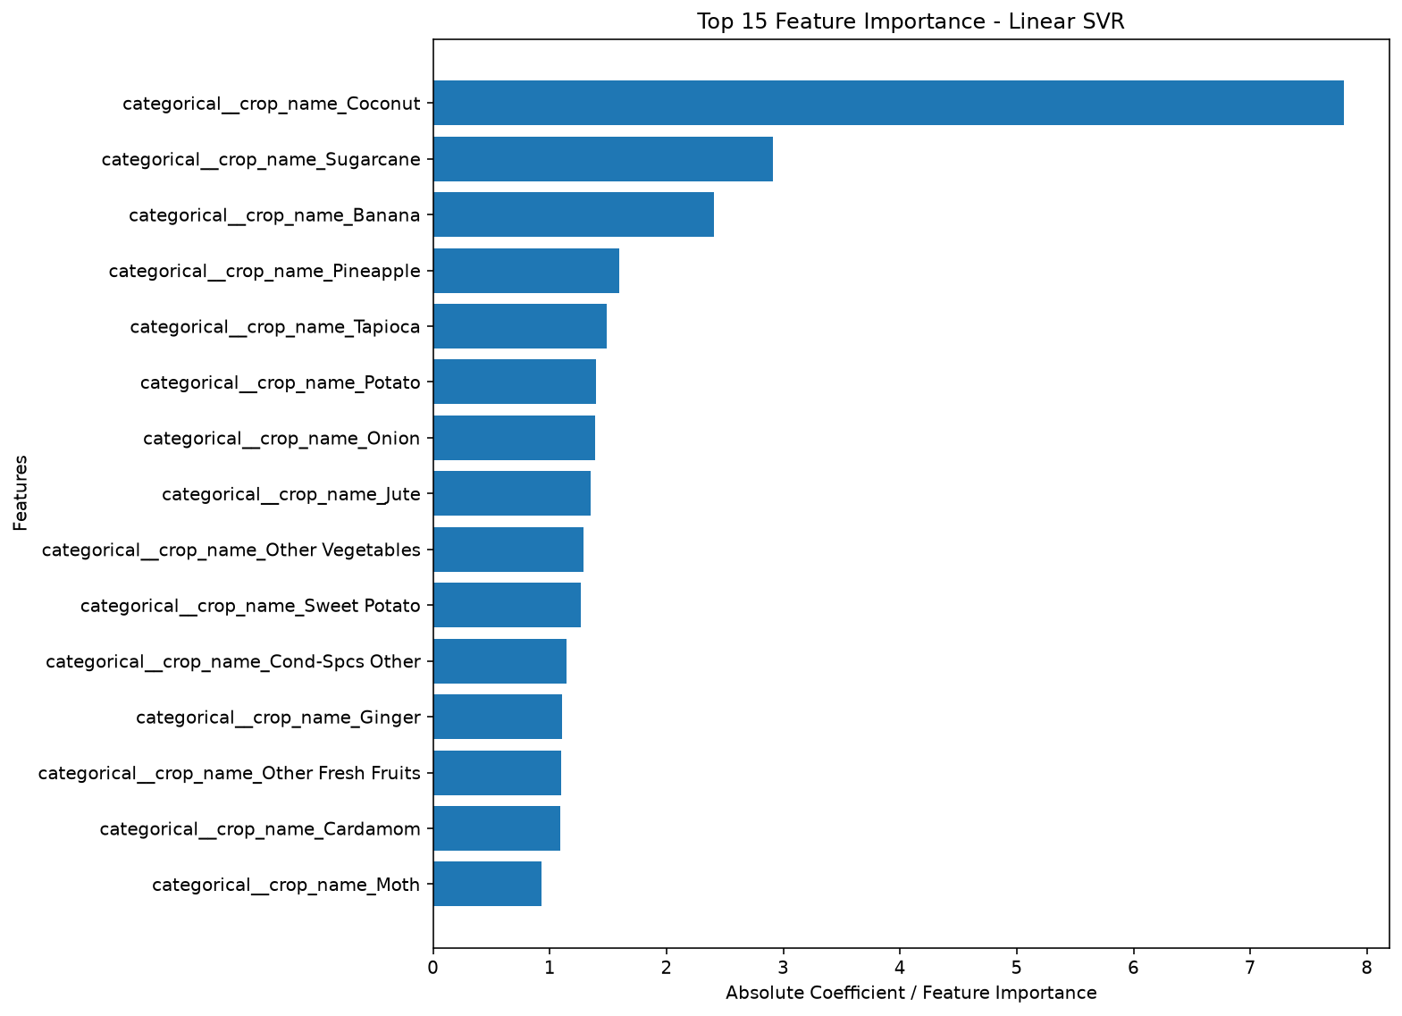

CONCLUSION AND FUTURE SCOPE
Conclusion
This project presented an end-to-end predictive analytics approach for analysing agricultural productivity across Indian districts using rainfall, groundwater and agricultural production data.
Three publicly available datasets were collected and processed to create a unified dataset containing environmental and agricultural information.
The preprocessing stage involved data inspection, missing-value analysis, invalid-record handling, agricultural-year extraction and environmental aggregation. Daily rainfall measurements were converted into district-level agricultural-year features, while groundwater measurements were summarised using mean, median, level change and monitoring coverage indicators.
The processed environmental datasets were integrated with the cleaned APY dataset using state code, district code and agricultural year. The final integrated dataset contained 91,809 records and 22 columns.
Exploratory Data Analysis was performed to examine crop yield distributions, crop-wise and season-wise variations, yearly trends and relationships between yield and environmental indicators.
Five regression algorithms were implemented: Linear Regression, Decision Tree Regression, Random Forest Regression, Gradient Boosting Regression and Linear Support Vector Regression.
A chronological training and testing strategy was used, with agricultural years 2017–2020 for training and 2021 for testing. The models were evaluated using MAE, MSE, RMSE and R².
The project provided practical experience in handling large real-world datasets, performing feature engineering, developing machine learning pipelines and comparing regression models for an agricultural application.
The results demonstrate how predictive analytics can be applied to historical agricultural data to study regional yield patterns and estimate crop productivity using multiple environmental and agricultural indicators.

