ASAP IDEA FEST

Monthly Ideathon Series- DECEMBER 2025

____________________________________________________________________________

1. Team Information
- Team Name:
- College/University/Organization:
- Department/Stream:
2. Theme of the Month: Using Data Analytics to Improve E-Commerce Sales and User Experience
3. Problem statement :.This dataset is an e-commerce website log created to help data analysts practice Exploratory Data Analysis (EDA) and data visualization.
The dataset contains information such as:
- When the website was accessed
- IP address of the visitor
- Country from which the website was accessed
- Language used on the website
- Amount of sales made by that IP address
Your task is to analyze this log data and generate meaningful insights about website traffic, user behavior, and sales patterns using EDA and data visualization techniques

4. Solution
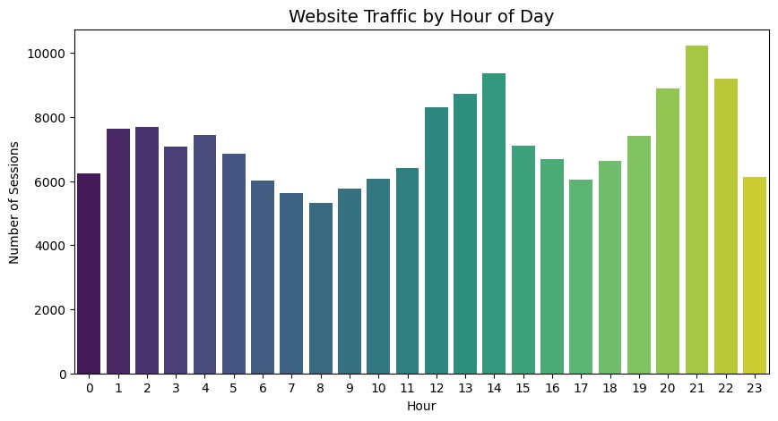 | - Peak user activity occurs between 9 PM and 11 PM, with the highest traffic at 10 PM.  - Midday engagement rises around 1–2 PM, indicating lunchtime browsing behavior.  - Lowest activity appears between 5 AM and 8 AM, when users are generally inactive.  - Overall traffic gradually increases from morning to evening before reaching its peak at night.
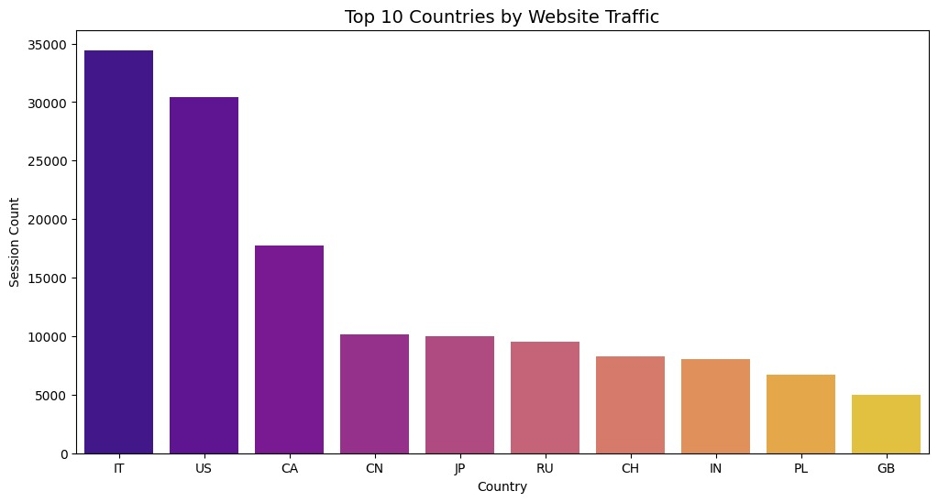 |  | - Italy (IT) is the top traffic source, contributing the highest number of sessions (~34,000).  - The US and Canada follow, indicating strong engagement from North America.  - Countries like China (CN), Japan (JP), and Russia (RU) show moderate traffic levels.  - India (IN), Poland (PL), and the UK (GB) appear in the lower end of the top 10 list.  - Traffic distribution is highly uneven, with the top 3 countries contributing the majority of sessions.

Submission Instructions:
- Download this word file
- Propose solutions in the above mentioned section
- Save this document as a PDF file.
- The filename should follow the format: [TeamName.pdf].
- The responses with team details shall be limited to 2 pages
- Submit the abstract after completing the team registration using the following link
REGISTER
- DEADLINE : Submit your abstract and register on or before 9th December 2025, 6 pm

