AgentV Architecture Whitepaper
Deep Dive into the Engine & State-Parity Mechanics

Version: 1.6.0 (April 2026 Industrial Baseline)
Date: May 6, 2026

Table of Contents
1. Executive Summary
2. Core Philosophy: Verification vs. Evaluation
3. The AgentV Engine Architecture
3.1 Orchestration Layer: Workflow DAGs
3.2 Communication Layer: Multi-Protocol Adapters
3.3 Execution Layer: The Tool Sandbox & PBAC
4. State-Parity Mechanics
4.1 Implicit Verification Loop
4.2 High-Fidelity World Shims
4.3 Differential State Encoding
5. The DNA Framework
5.1 Environmental DNA (Immutable Context)
5.2 Behavioral DNA (Decision Telemetry)
5.3 Forensic DNA (Cryptographic Anchoring)
6. Trust, Governance & Security
6.1 Ed25519 Trace Vaulting
6.2 Verification Certificate (VC) v3.0.0
6.3 Industrial Guardrails & PII Redaction
7. Conclusion

1. Executive Summary
88% of enterprise AI agents fail to reach production, primarily due to a lack of provable reliability. AgentV addresses this gap by providing the 'Verification OS' for autonomous software. Unlike traditional evaluation frameworks that focus on text-based accuracy, AgentV verifies state parity—ensuring the agent actually performed the correct actions in the physical environment. This whitepaper details the architectural innovations that enable deterministic verification at industrial scale.

2. Core Philosophy: Verification vs. Evaluation
AgentV distinguishes itself from LLM benchmarks through two core principles:
- - Verification vs. Evaluation: Evaluation asks 'Did the agent say the right thing?'. Verification asks 'Did the agent do the right thing and change the right state?'.
- - Deterministic State Parity: Ensuring that the agent's internal reasoning is cryptographically aligned with the resulting environmental delta.

3. The AgentV Engine Architecture
The AgentV engine is a decoupled, event-driven system designed for non-linear task execution and rigorous auditability.
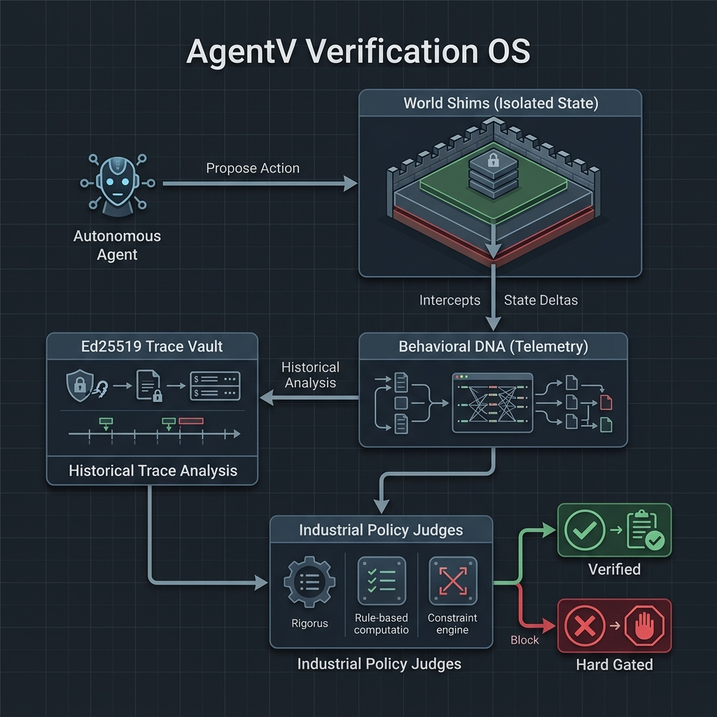
Figure 1: AgentV Verification OS Overview

3.1 Orchestration Layer: Workflow DAGs
The Agent Evaluation Specification (AES) v1.4 defines tasks as a Directed Acyclic Graph (DAG). The engine uses a Topological Sorter to determine execution order, allowing for complex, multi-step workflows. Nodes define specific task descriptions, required tools, and success criteria, while edges define conditional transitions.

3.2 Communication Layer: Multi-Protocol Adapters
This decoupling ensures that verification is independent of the agent's implementation stack.

3.3 Execution Layer: The Tool Sandbox & PBAC
The Tool Sandbox provides a governance-controlled environment for agent actions. It implements Permissions-Based Access Control (PBAC), where agents are granted granular 'reads' and 'writes' to specific resource namespaces (e.g., `ledger_db:audit_log`). This prevents unauthorized state mutations and ensures resource isolation.

4. State-Parity Mechanics
State parity is the cornerstone of AgentV. It ensures that the agent's actions produced the expected physical effect.
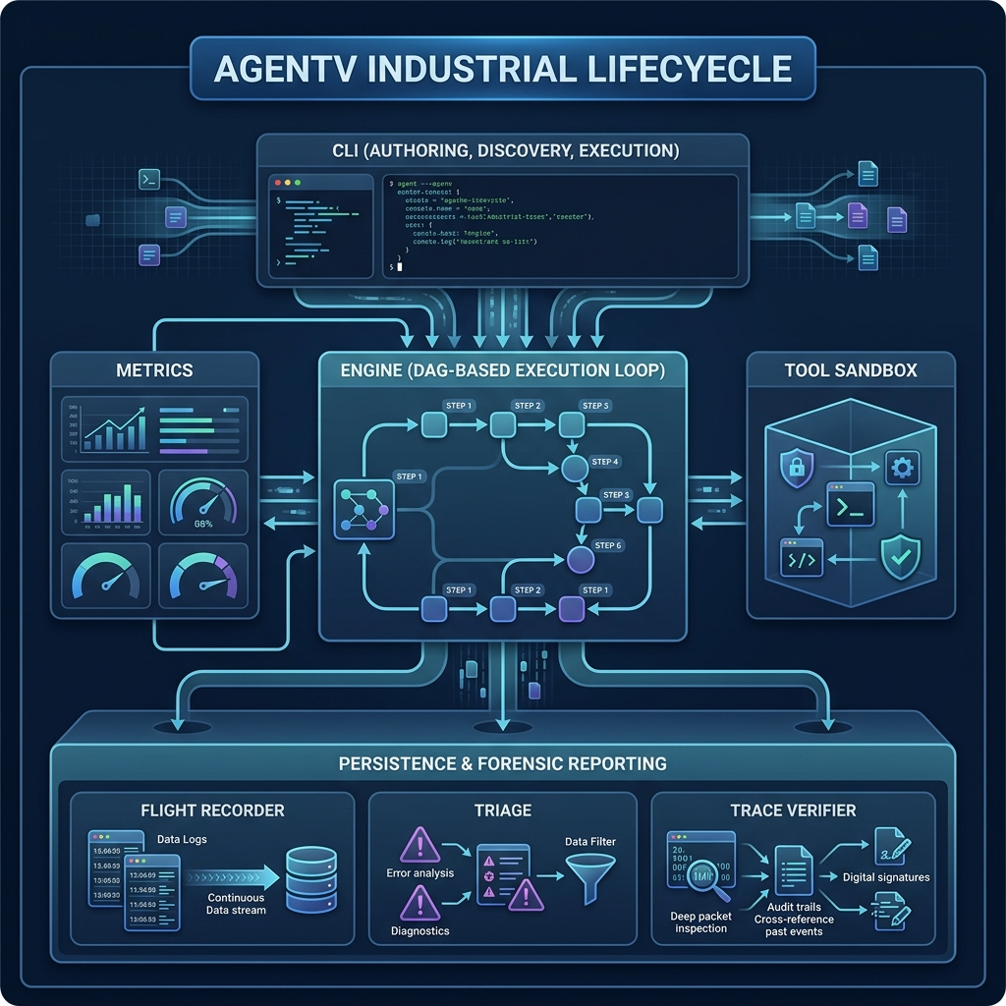
Figure 2: AgentV Industrial Lifecycle & Data Flow

4.1 Implicit Verification Loop
At the conclusion of each workflow node, the engine enters the Implicit Verification Phase. It polls active simulators (World Shims) to capture point-in-time snapshots and validates them against the 'expected_outcome' assertions. This loop includes industrial retry logic to account for asynchronous state propagation in distributed systems.

4.2 High-Fidelity World Shims
World Shims are isolated simulators that provide a deterministic execution context. From Banking ledgers to Healthcare EHR systems, these shims provide the 'Ground Truth' against which the agent's performance is measured. They are managed by a Schema-Driven Core Registry.

4.3 Differential State Encoding
To maintain O(1) performance and minimize forensic storage overhead, AgentV employs differential state encoding. The engine captures a full 'Environmental DNA' snapshot at T=0 and then records only the deltas (diffs) for subsequent turns. This ensures a perfect audit trail without the bloat of redundant data.

5. The DNA Framework
AgentV conceptualizes reliability through three layers of telemetry DNA.

5.1 Environmental DNA (Immutable Context)
Environmental DNA captures the state-centric simulation context. It includes tool versions, registry manifests, and resource availability snapshots. This ensures that the evaluation is deterministic and reproducible.

5.2 Behavioral DNA (Decision Telemetry)
Behavioral DNA is a high-granularity event bus that records the agent's decision-making process. It tracks the progression from Phase to Subtask to Action to Step, providing a precise 'genetic map' of the agent's intelligence.

5.3 Forensic DNA (Cryptographic Anchoring)
Forensic DNA provides the cryptographic ledger of the entire execution. Every trace, artifact, and state delta is hashed (SHA-256) and signed (Ed25519), creating a non-repudiable WORM (Write-Once-Read-Many) audit trail.

6. Trust, Governance & Security

6.1 Ed25519 Trace Vaulting
AgentV employs a 'Strict Industrial Vault' methodology. Each execution is isolated in its own directory, containing the forensic ledger, telemetry, and signed traces. This isolation prevents cross-run contamination and ensures that evidence is tamper-evident.

6.2 Verification Certificate (VC) v3.0.0
The Verification Certificate (VC) is the final artifact of an AgentV run. It is a signed JSON manifest containing the Merkle-style registry of all artifacts. It serves as the authoritative proof that an agent is cleared for production use in regulated industries.

6.3 Industrial Guardrails & PII Redaction
For enterprise deployments, AgentV includes automatic PII/Secret redaction, resource throttling, and hard-gating logic for CI/CD pipelines. It complies with NIST AI-100-1 and provides compliance packs for HIPAA, FINRA, and GDPR.

7. Conclusion
AgentV represents a shift from 'hoping agents work' to 'proving agents work'. By combining deep state parity verification with cryptographic forensic anchoring, AgentV provides the infrastructure necessary for autonomous agents to earn the right to act in the most critical enterprise environments.

