

rapport dU brief PROJET

***SCEnario 2***



29 novembre 2019

youcode

REALISE PAR :jaafar m’hamaed , khadija najem,meriem elmediouny, imad elberdaoui , GUERMOUD MARIA

First Step : Tagging



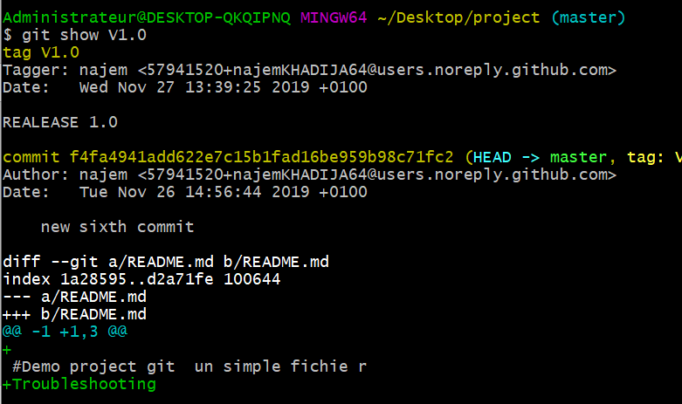

Git has the ability to tag specific points in a repository’s history as being important. Typically, people use this functionality to mark release points (v1.0, v2.0 and so on). In this section, you’ll learn how to list existing tags, how to create and delete tags, and what the different types of tags are.

Git show v1.0 : That shows the tagger information, the date the commit was tagged, and the annotation message before showing the commit information.

Second Step : Stashing and Saving work in Progress

git stash : Use git stash when you want to record the current state of the working directory and the index, but want to go back to a clean working directory be listed .

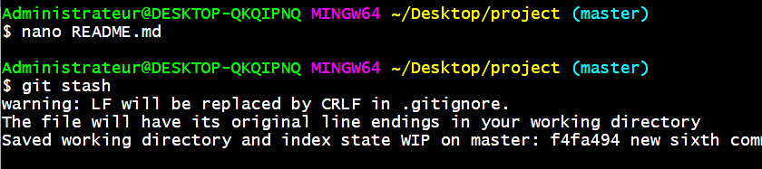

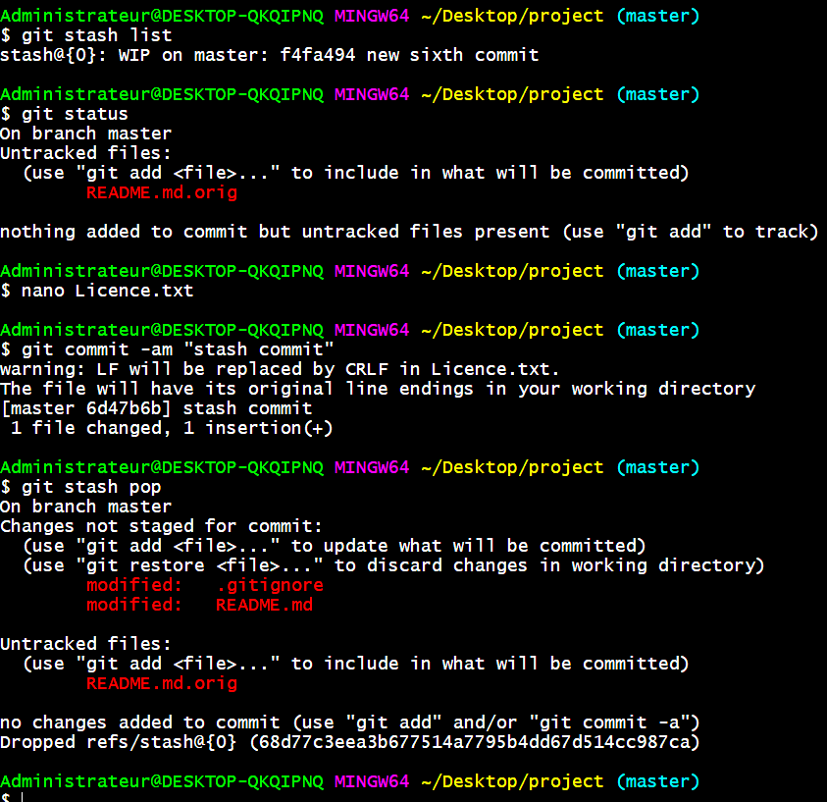

Third step: Voyage sur Github, Local Repo to Github Repo

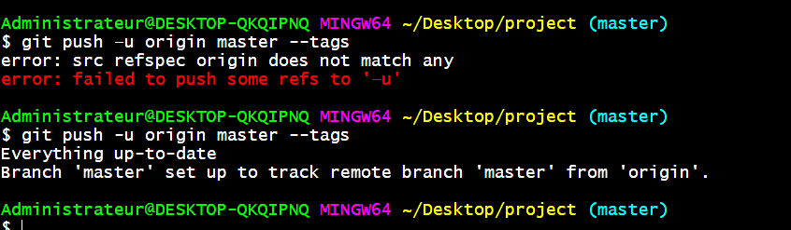

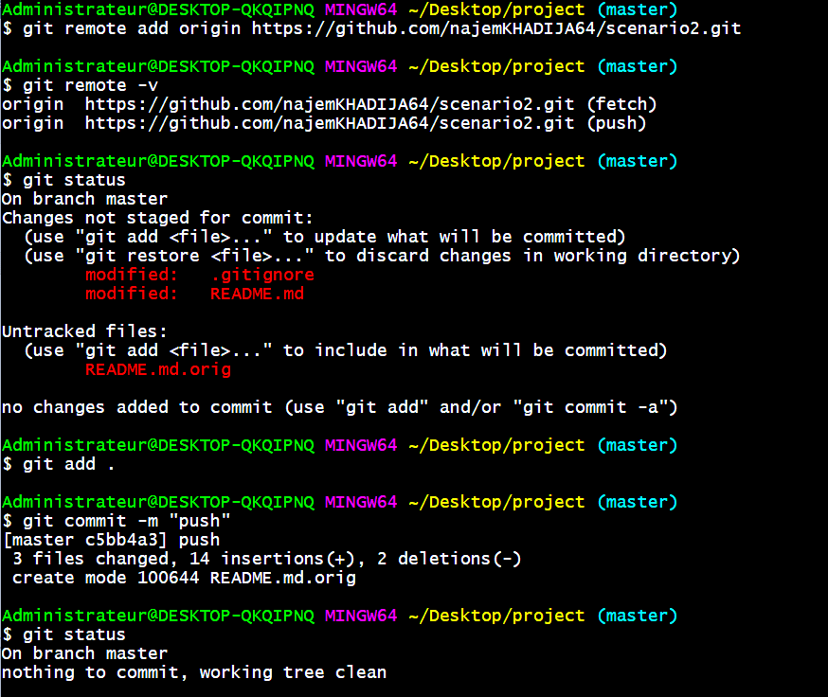

What is git remote add origin ?

It is communicate with the outside world, git uses what are called remotes. These are repositories other than the one on your local disk which you can push your changes into (so that other people can see them) or pull from (so that you can get others changes).

Fifth Step: Création d’une local copy

Sur Github création un autre repo nommé ( Monsiteweb).

Sixth step: Sending the website

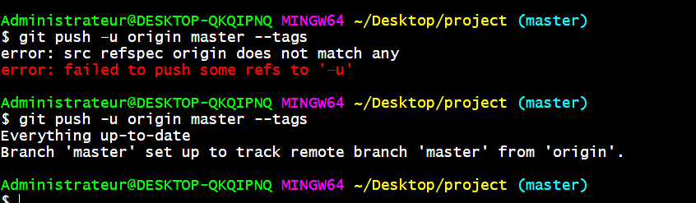

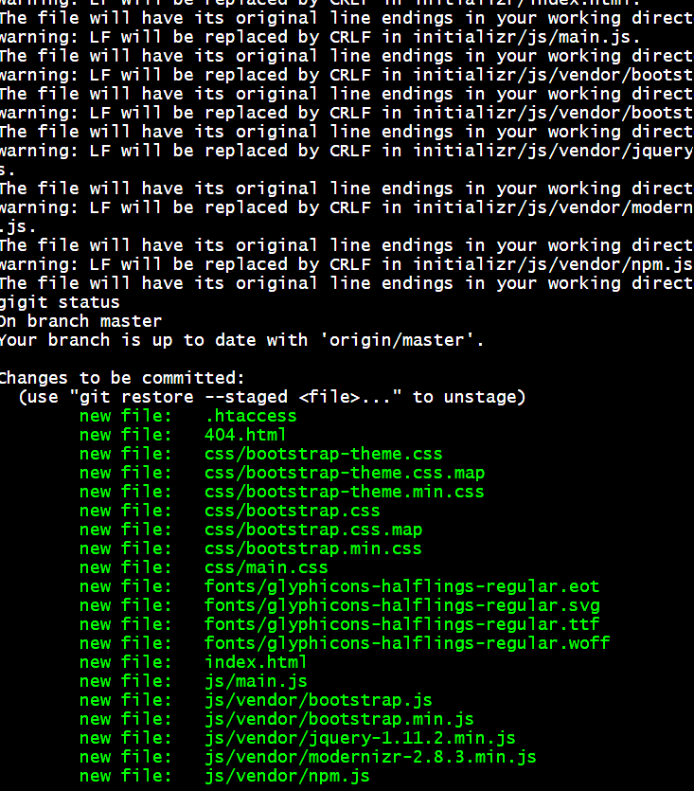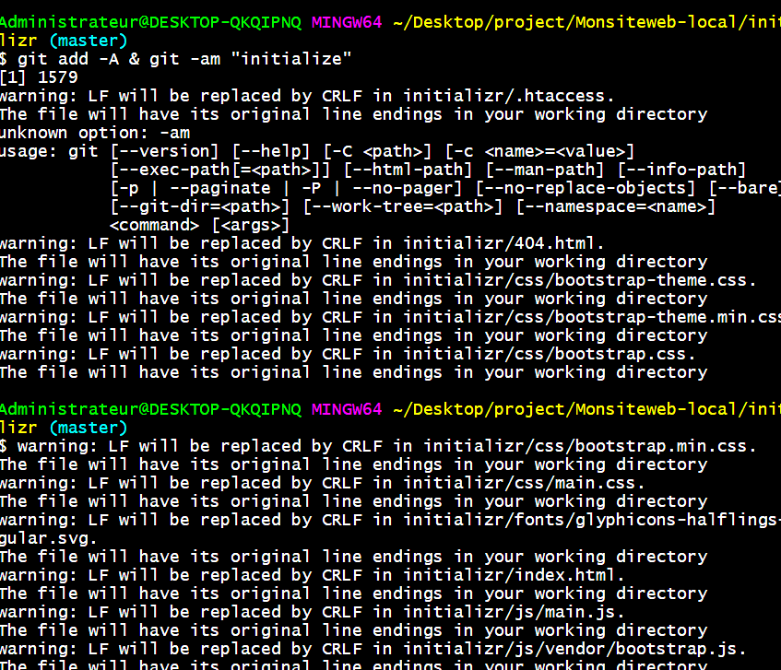

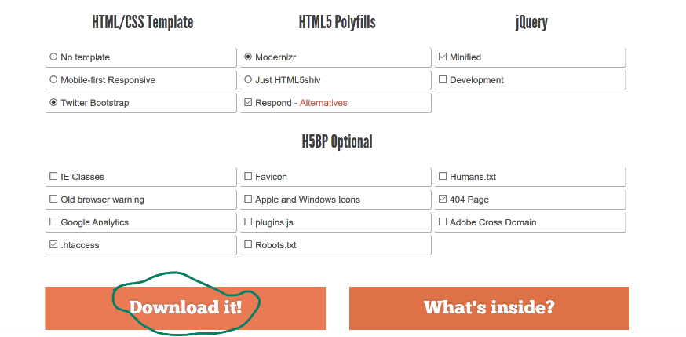

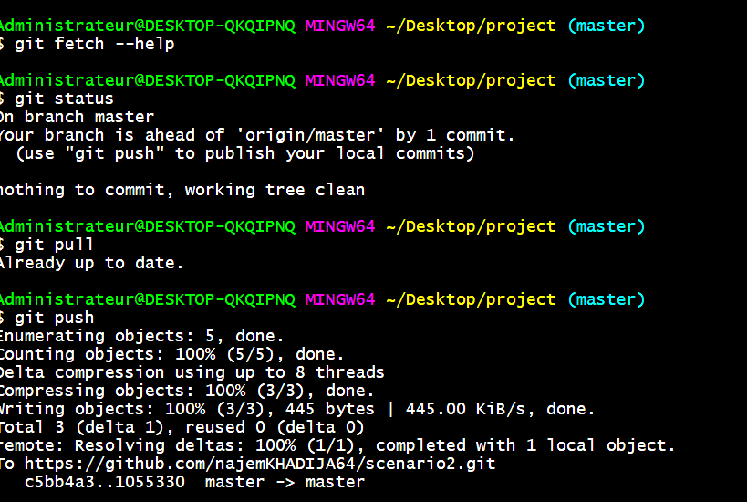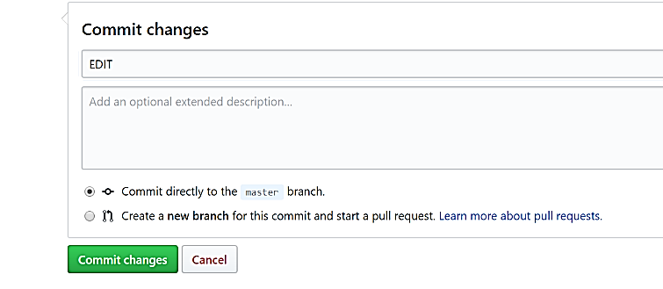Seventh step : Fetch and pull

The git fetch command downloads commits, files, and refs from a remote repository into your local repo. Fetching is what you do when you want to see what everybody else has been working on. It’s similar to svn update in that it lets you see how the central history has progressed, but it doesn’t force you to actually merge the changes into your repository.

On constate que les modifications et le commit qu'on a fait sur Github sont affichés aussi sur Git .