REMOTE ACCESS SYSTEM
System Design Specification

Zero-Trust Network Access · Secure Tunneling · Cloud-Native Scalability

Version 1.0 · March 27, 2026

Table of Contents
1. The Problem — Mission: Impossible … to Access
2. Technical Aspects of the Problem
3. High-Level Architecture
4. Authentication & Authorization
5. Cryptography Stack
6. Scalability & High Availability
7. Zero-Trust Security Model
8. Deployment Topology
9. Network Protocol Design
10. Monitoring, Observability & SIEM
11. Compliance & Regulatory Framework
12. Real-World Vendor Comparisons
13. References

1. The Problem — Mission: Impossible … to Access
Picture this: a sleek spy film where Agent X, sipping espresso at a Zurich café, needs to access the company's ultra-secret mainframe — guarded by firewalls thicker than a Swiss bank vault. Without the right gadget, the mission is over before it starts. That gadget? A modern Remote Access System.
In the real world, millions of employees, contractors, IoT devices, and cloud workloads need to reach private resources every second of every day — across coffee shops, airports, home offices, and data centers spread across five continents. The challenge is not simply "can they connect?" but:
- Can we PROVE they are who they claim to be? → Strong authentication, MFA, device posture
- Should they be ALLOWED to see this resource? → Fine-grained authorisation, RBAC/ABAC
- Is the data PROTECTED in transit? → End-to-end encryption with modern cipher suites
- Can the system handle 10x traffic spikes? → Horizontal auto-scaling, global PoPs
- How do we DETECT a breach in real time? → Continuous monitoring, anomaly detection, SIEM
Legacy VPN was the first answer — a heroic hack from the 1990s. It worked when everyone sat inside a nice, cozy perimeter. Today, that perimeter has dissolved. Enter Zero-Trust Network Access (ZTNA): trust nothing, verify everything, encrypt always.

2. Technical Aspects of the Problem

2.1 Identity & Trust Boundary
The classical network perimeter no longer exists. Identity becomes the new perimeter. Every principal — human, service account, device, or workload — must carry a cryptographically verifiable credential. The system must interoperate with enterprise IdPs (Active Directory, Okta, Google Workspace), support federated identity via SAML 2.0 / OIDC, and enforce continuous session re-evaluation.

2.2 Encryption at Every Layer
Data must be encrypted in transit (TLS 1.3, IPSec, WireGuard) and at rest. Key management must be centralised but highly available. The system must plan for post-quantum cryptography as NIST has finalised PQC standards (CRYSTALS-Kyber, CRYSTALS-Dilithium).

2.3 Global Latency Constraints
Users experience VPN as slow because traffic hairpins through a central gateway. Modern systems use Anycast routing, 50+ global PoPs, and intelligent traffic steering to keep round-trip latency under 50 ms for >95th percentile of users worldwide.

2.4 Protocol Diversity
The system must support TCP, UDP, ICMP (tunnelled), WebSocket, HTTP/2, and QUIC. Tunnel encapsulation can be IPSec/IKEv2, WireGuard, DTLS, or TLS-over-TCP. A split-tunnel mode reduces unnecessary backhauling of SaaS traffic.

2.5 Device Posture & Endpoint Security
A credential alone is insufficient. The device must be assessed: Is the OS patched? Is EDR running? Is disk encryption enabled? Posture signals feed the policy engine to grant conditional access.

2.6 Scalability & Elasticity
Peak loads can be 100× normal (e.g., pandemic remote-work surge). Kubernetes-native gateways with KEDA-driven autoscaling, stateless data-plane pods, and distributed session stores (Redis) enable horizontal scale to millions of concurrent sessions.

2.7 Observability & Threat Detection
Every connection attempt, policy decision, and data transfer must be logged with microsecond-resolution timestamps. Real-time pipelines feed SIEM (Splunk/ELK) and UEBA engines. Anomalous patterns (impossible travel, exfiltration volumes) must trigger automated responses.

3. High-Level Architecture
The system is divided into three major zones: Client Zone (who is connecting), Secure Access Zone (how we authenticate, authorise, and encrypt), and Resource Zone (what they are accessing). All traffic passes through the Secure Access Zone regardless of source or destination — enforcing consistent policy everywhere.
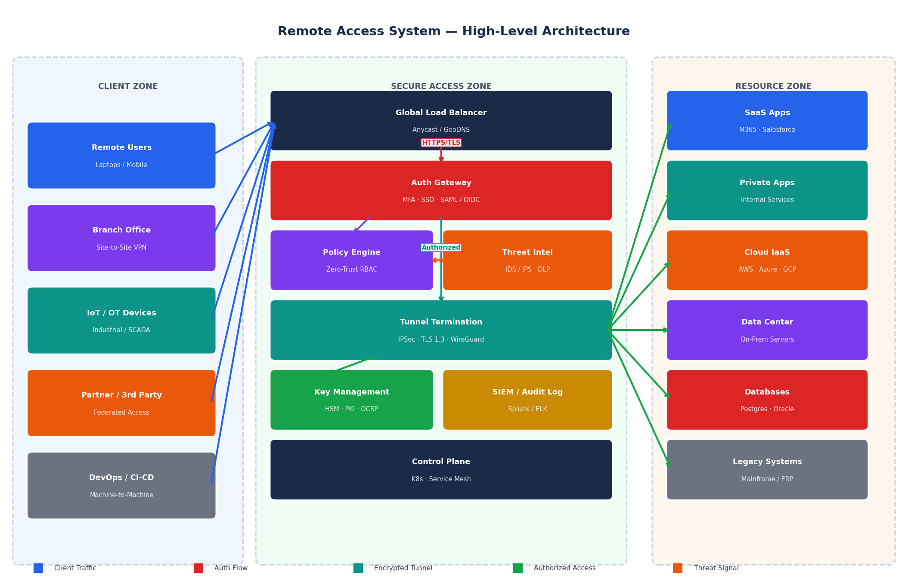
Figure 1 — Remote Access System High-Level Architecture

3.1 Component Summary
Component | Responsibility | Technology Examples
Global Load Balancer | Anycast routing, DDoS mitigation, geo-steering | Cloudflare, AWS Global Accelerator, F5 GTM
Auth Gateway | SSO, MFA, SAML/OIDC token validation | Okta, Azure AD, Ping Identity, Keycloak
Policy Engine | RBAC/ABAC evaluation, context-aware decisions | Open Policy Agent (OPA), Cedar, Styra
Threat Intelligence | IDS/IPS, DLP, behavioural analytics | CrowdStrike, Palo Alto Cortex, Darktrace
Tunnel Termination | IPSec/IKEv2, WireGuard, TLS 1.3 termination | StrongSwan, Wireguard-go, Envoy, NGINX
Key Management | HSM-backed key generation, rotation, OCSP | HashiCorp Vault, AWS KMS, Thales nShield
Control Plane | Config distribution, health checks, autoscaling | Kubernetes, Istio, Consul, etcd
SIEM / Audit | Log aggregation, alerting, forensic timeline | Splunk, Elastic SIEM, Microsoft Sentinel

4. Authentication & Authorization
"Who are you, and what are you allowed to do?" — the two oldest questions in security. Our system answers them with layered, cryptographically-enforced controls that make even the most determined attacker reach for decaf.
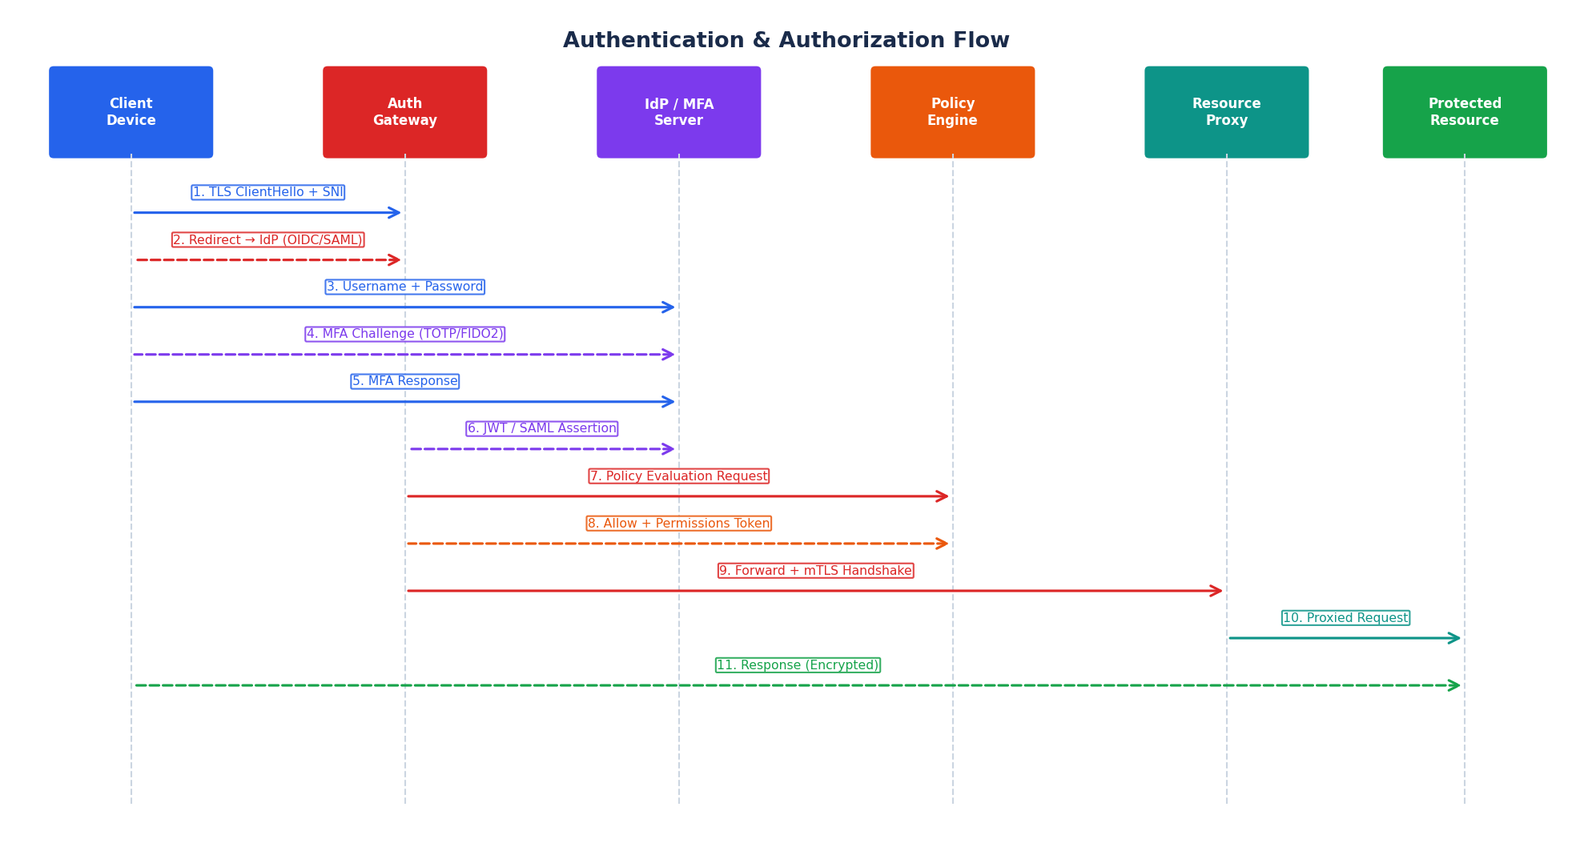
Figure 2 — Authentication & Authorization Sequence Flow

4.1 Authentication Methods Supported
Method | Protocol / Standard | Strength | Use Case
Password + MFA | LDAP / RADIUS + TOTP | High | Corporate users
FIDO2 / WebAuthn | W3C WebAuthn + CTAP2 | Very High | Phishing-resistant MFA
Smart Card / PIV | X.509 + PKCS#11 | Very High | Government / military
SAML 2.0 SSO | SAML 2.0 (XML) | High | Enterprise IdP federation
OIDC / OAuth 2.0 | RFC 6749 + OpenID Connect | High | SaaS, cloud-native apps
mTLS (machine) | TLS 1.3 + client certs | Very High | Service-to-service
Certificate-based | X.509 PKI | Very High | Managed endpoints
API Keys + JWT | RFC 7519 (JWT) | Medium | CI/CD pipelines, APIs
Kerberos | RFC 4120 | High | Windows AD environments
Biometric (device) | Platform authenticator | High | Consumer mobile devices

4.2 Authorization Model — RBAC + ABAC Hybrid
Role-Based Access Control (RBAC) provides the backbone: roles are assigned to users via the IdP group membership. Attribute-Based Access Control (ABAC) enriches decisions with runtime context: device posture score, geolocation, time of day, data sensitivity label, and threat intelligence feed. The Open Policy Agent (OPA) evaluates Rego policies in under 1 ms, allowing thousands of policy decisions per second without adding measurable latency to the connection flow.

4.3 Session Management
Parameter | Value | Notes
Session Token Type | JWT (RS256 / ES256) | Signed by Auth Gateway
Access Token TTL | 15 minutes | Short-lived, reduces blast radius
Refresh Token TTL | 8 hours (idle) / 24 h max | Rotated on each use
Re-auth Trigger | IP change, risk score spike | Step-up MFA required
Session Storage | Redis Cluster (encrypted) | In-memory, TTL-enforced
Revocation | Token introspection endpoint | Sub-second revocation propagation
Concurrent Sessions | Max 5 per user (default) | Configurable per policy group

5. Cryptography Stack
Cryptography is the bedrock. Get it wrong and the entire castle built on top crumbles. Our system layers encryption from the hardware root of trust all the way up to application-level token signing — and we are already preparing for the quantum apocalypse.
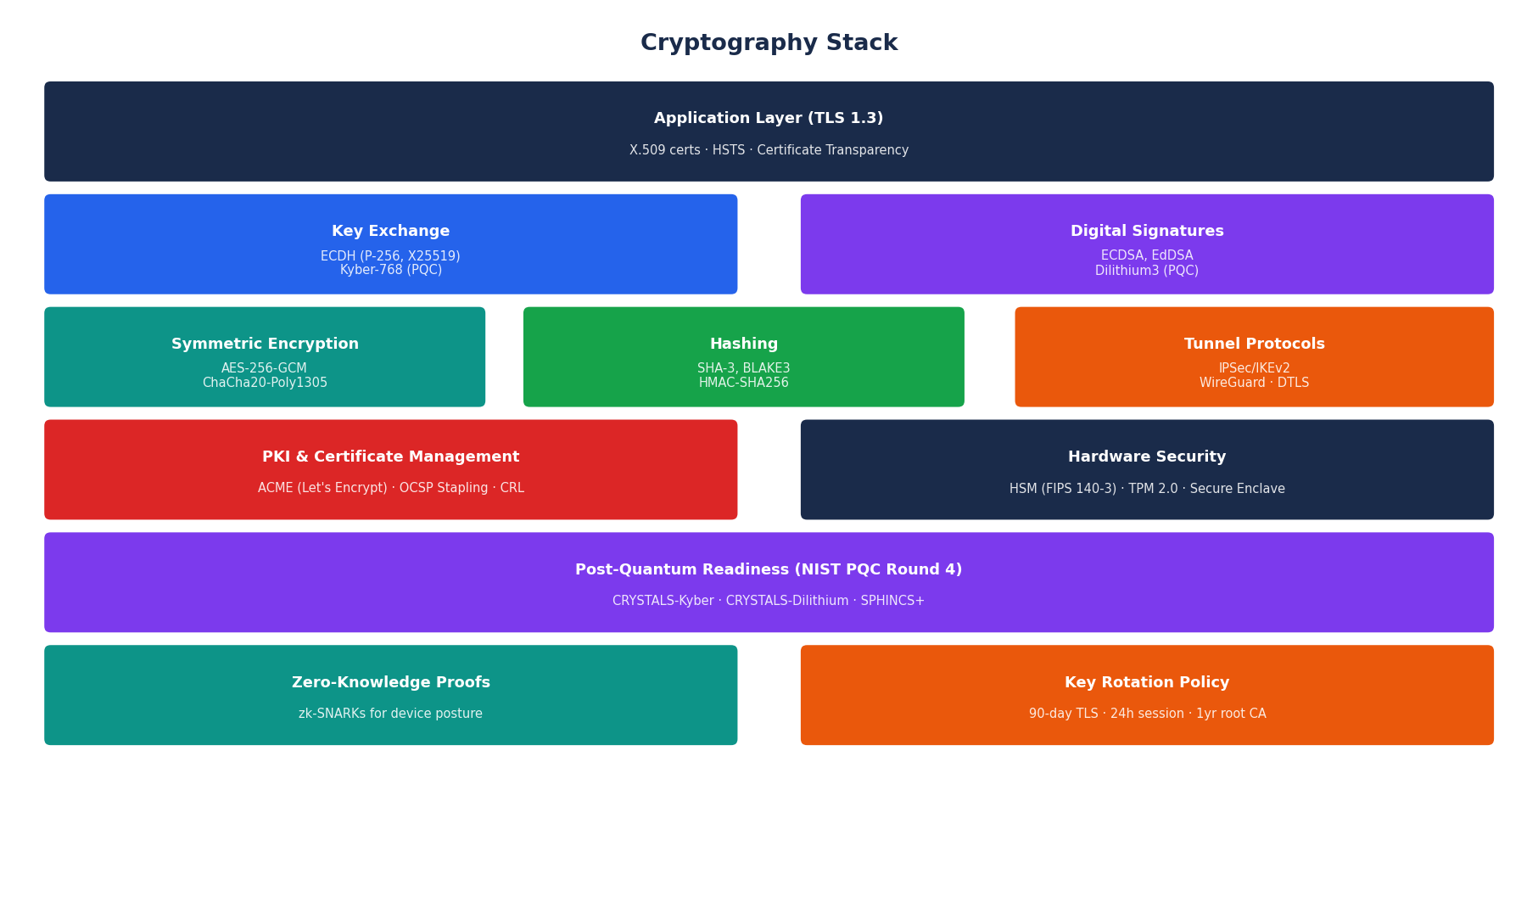
Figure 3 — Cryptography Stack Layers

5.1 Supported Cipher Suites (TLS 1.3)
Cipher Suite | Key Exchange | AEAD Cipher | HMAC
TLS_AES_256_GCM_SHA384 | X25519 / ECDH P-384 | AES-256-GCM | SHA-384
TLS_CHACHA20_POLY1305_SHA256 | X25519 | ChaCha20-Poly1305 | SHA-256
TLS_AES_128_GCM_SHA256 | X25519 / ECDH P-256 | AES-128-GCM | SHA-256
TLS_KYBER768_AES256_GCM_SHA384 | CRYSTALS-Kyber-768 | AES-256-GCM | SHA-384 (PQC)

5.2 Key Management Lifecycle
Key Type | Algorithm | Storage | Lifetime | Notes
Root CA Key | RSA-4096 / ECDSA P-384 | HSM (FIPS 140-3 L3) | 5 years | Air-gapped ceremony
Intermediate CA Key | ECDSA P-384 | HSM online | 1 year | OCSP Stapling
TLS Leaf Certificate | ECDSA P-256 | Vault PKI engine | 90 days | ACME auto-renewal
Session Key | AES-256 (ephemeral) | In-memory | 15 min | PFS via ECDH/X25519
Token Signing Key | EdDSA Ed25519 | Vault Transit | 30 days | Key rotation via API
Data-at-Rest Key | AES-256-GCM | AWS KMS / Cloud HSM | 1 year | Envelope encryption

5.3 Post-Quantum Cryptography Roadmap
NIST finalised its first post-quantum standards in 2024 (FIPS 203, 204, 205). Our system adopts a hybrid key exchange strategy during the migration period:
- Phase 1 (Now): Classical algorithms as primary, PQC as parallel KEM in TLS 1.3 extensions
- Phase 2 (2025-2026): Hybrid X25519+Kyber768 for all new connections
- Phase 3 (2027+): Full PQC primary; classical as fallback only
- Signature migration: EdDSA → CRYSTALS-Dilithium3 for certificate chains

6. Scalability & High Availability
When a global pandemic turns every kitchen table into a remote office, your VPN either scales or it becomes headline news for the wrong reasons. Our architecture is built to handle 0 to 10 million concurrent sessions without a single page to the on-call engineer at 3 AM.
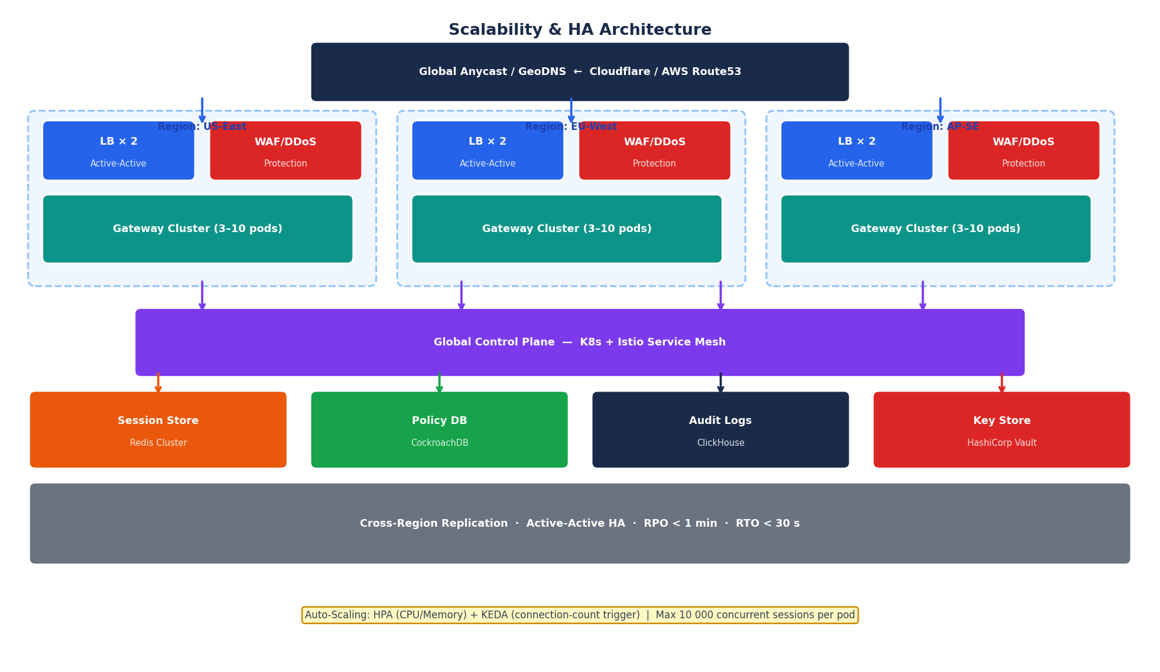
Figure 4 — Scalability & High Availability Architecture

6.1 Capacity Design Targets
Metric | Target | Typical Range | Design Decision
Concurrent Sessions | 10,000,000 | 1-5M | Horizontal pod scaling
Auth Transactions / sec | 100,000 | 10-50K | Stateless JWT validation
Tunnel Throughput (per PoP) | 100 Gbps | 10-40 Gbps | DPDK / eBPF data path
Policy Eval Latency (p99) | < 1 ms | 2-5 ms | OPA + in-memory cache
Session Establish Time | < 500 ms | < 1 sec | QUIC 0-RTT resumption
Availability SLA | 99.999% (5.26 min/yr) | 99.99% | Multi-region active-active
RTO (failover) | < 30 seconds | < 60 s | K8s liveness + readiness
RPO (data loss) | < 1 minute | < 5 min | Redis replication lag
Scale-out Time | < 60 seconds | < 3 min | HPA + pre-warmed pods

6.2 Autoscaling Strategy
The data-plane gateway pods are completely stateless — all session state lives in Redis. This means Kubernetes HPA can add or remove pods in under 60 seconds with zero connection disruption (existing sessions drain gracefully).
Mechanism | Configuration
HPA Trigger | CPU > 70% or Memory > 80% → add pods (up to max 200/region)
KEDA Trigger | Active connections > 8,000 per pod → scale out
Scale-in Guard | 10-minute cooldown + graceful drain (SIGTERM → wait → SIGKILL)
Pre-warming | Scheduled pre-scale for known peak events (Mon 8 AM, earnings call)
Global Failover | Route53 health checks → re-weight traffic to healthy regions in < 30s

7. Zero-Trust Security Model
"Never trust, always verify" sounds like advice from a paranoid spy thriller — but in cybersecurity, it is the only rational posture when the attacker might already be inside your network. ZTNA replaces implicit trust (because you're on the VPN, you're safe) with continuous, context-aware verification of every request.
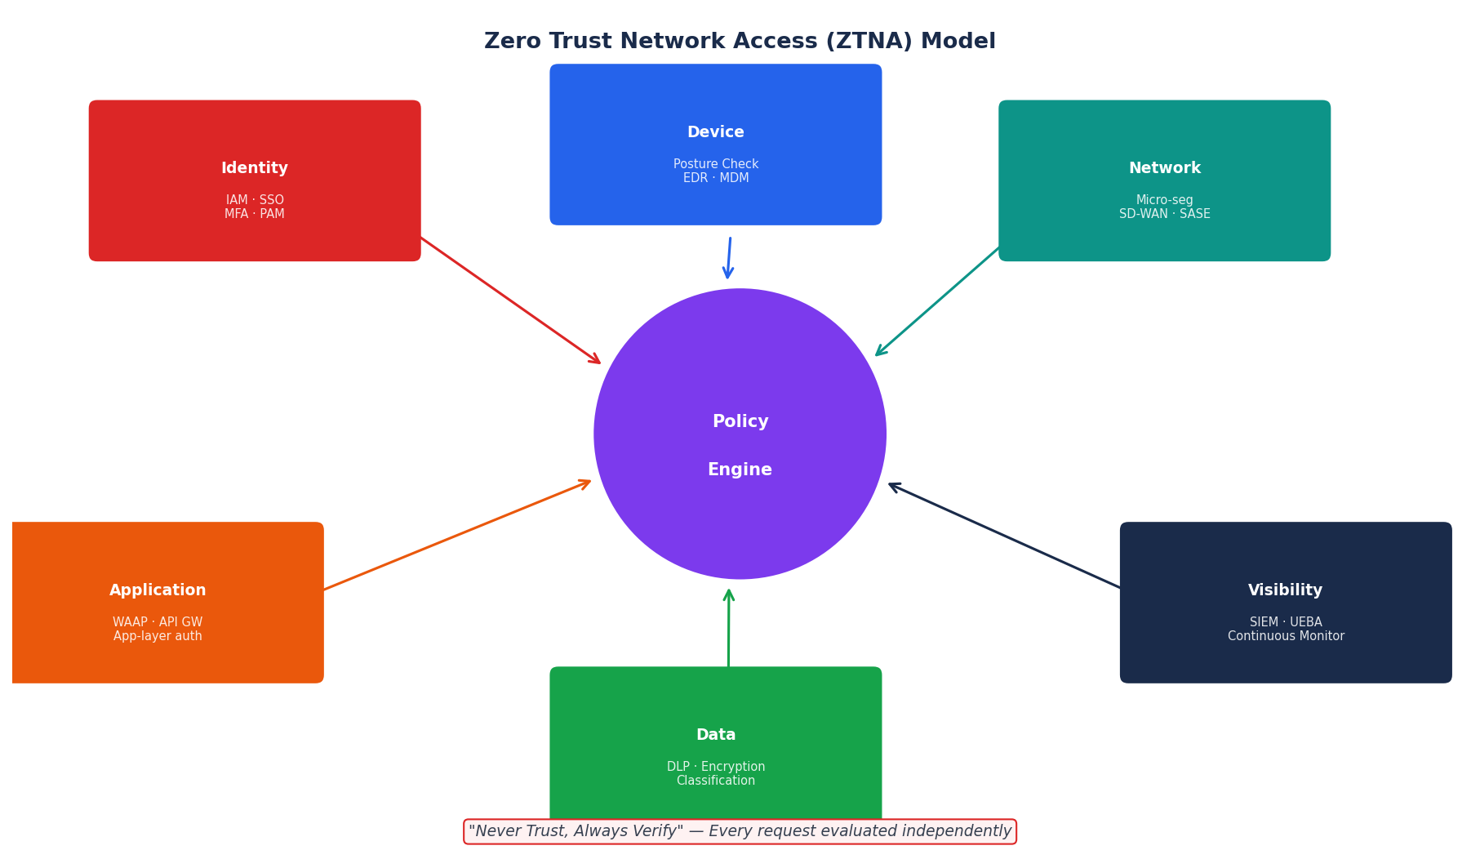
Figure 5 — Zero-Trust Architecture (Six Pillars)

7.1 The Six Pillars
- Identity: Every user and service account holds a cryptographic credential. IdP integration (Okta, Azure AD), continuous MFA, and privileged access management (PAM) ensure identity cannot be spoofed.
- Device: Endpoint posture is checked at connection and continuously monitored. Device health score (OS patch level, EDR status, disk encryption, screen lock) gates access level. A compromised laptop gets restricted access even with valid credentials.
- Network: Micro-segmentation replaces flat networks. SD-WAN and SASE enforce east-west traffic policies. Lateral movement is blocked even if an attacker gains a foothold.
- Application: Applications are invisible to unauthenticated users (dark cloud). The WAAP (Web Application and API Protection) layer inspects every request against OWASP Top-10 and API abuse patterns.
- Data: Data is classified, labelled, and tracked. DLP policies prevent exfiltration. Encryption-at-rest with tenant-specific keys ensures that even privileged operators cannot access raw data.
- Visibility: Comprehensive logging of all access decisions, enriched with threat intelligence, feeds UEBA models that detect compromised accounts via behavioural anomalies.

8. Deployment Topology
A single-datacenter gateway is a single point of failure and a latency nightmare for globally distributed users. Our topology follows the same playbook as CDN giants: push processing to the edge, keep the control plane centralised, replicate state globally.
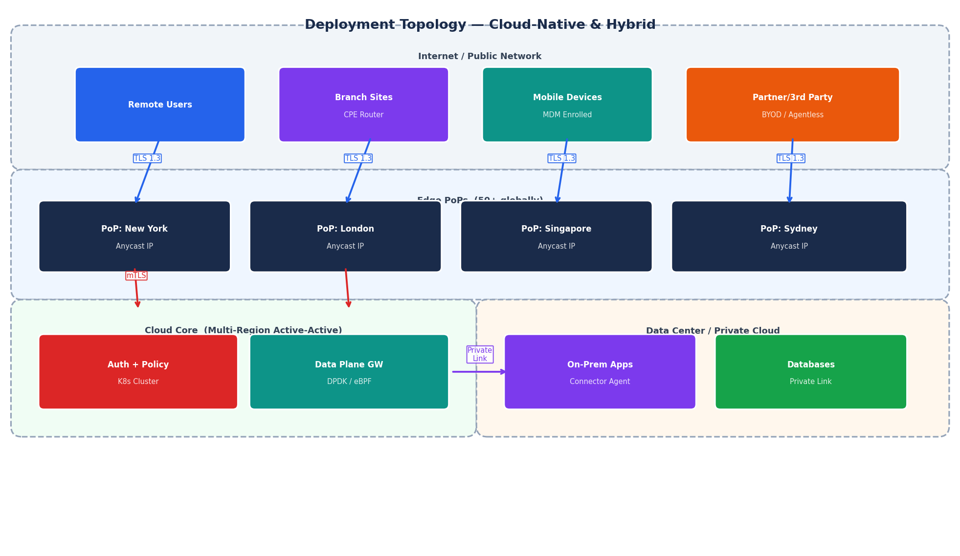
Figure 6 — Global Deployment Topology

8.1 PoP (Point of Presence) Specification
Attribute | Specification
Network | Dual 100 GbE uplinks, Anycast BGP, multi-ISP peering
Compute | 8× bare metal nodes, 32 cores / 256 GB RAM each
Gateway Pods | 40–100 K8s pods per PoP, autoscaled by KEDA
Tunnels | WireGuard (UDP 51820), IPSec (UDP 500/4500), TLS 443
DDoS Protection | Volumetric (800 Gbps scrubbing), L7 rate limiting
Latency SLA | < 50 ms RTT for > 95% of users within region
Redundancy | N+2 bare metal; N+10 pod headroom; dual power feeds

8.2 Connector Agent (for Private Apps)
For private applications sitting in a data center or private cloud, a lightweight Connector Agent is deployed inside the perimeter. It establishes an outbound-only, encrypted tunnel to the nearest PoP, making the application reachable without opening inbound firewall rules. This is the architectural pattern used by Zscaler Private Access (ZPA) and Cloudflare Tunnel.

9. Network Protocol Design

9.1 Tunnel Protocol Comparison
Protocol | Port(s) | Data Path | Security | Overhead | Best For
IPSec / IKEv2 | UDP 500 / 4500 | Kernel (xfrm) | Very High | High | Branch office, router-based VPN
WireGuard | UDP 51820 | Kernel module | Very High | Low | Modern endpoints, mobile
TLS 1.3 (DTLS) | TCP/UDP 443 | Userspace | High | Medium | Agentless / browser access
OpenVPN | UDP 1194/TCP 443 | Userspace (TUN) | Medium | High | Legacy compatibility
SSH Tunnel | TCP 22 | Userspace | High | Medium | Developer / bastion access
QUIC | UDP 443 | Kernel bypass | High | Low | Mobile, lossy networks

9.2 Split Tunnel vs Full Tunnel
Split tunnel routes only corporate-destined traffic through the gateway; internet traffic goes direct. Full tunnel routes everything. Our system defaults to intelligent split-tunnel with DNS-based steering:
- Corporate domains → encrypted tunnel via gateway
- SaaS (Microsoft 365, Google Workspace) → direct breakout (avoids hairpin latency)
- Threat categories (malware, phishing C2) → blocked at DNS layer regardless
- Unknown domains → inspected through gateway proxy for DLP

9.3 DNS Security
DNS is the phone book of the internet — and the most abused protocol in existence. Our system deploys:
- DNS-over-HTTPS (DoH) / DNS-over-TLS (DoT) for all client queries
- DNSSEC validation at the resolver
- DNS sinkholing for known malicious domains (threat intelligence feeds)
- Split-horizon DNS: internal hostnames resolve privately; external names resolve via public DNS
- DNS query logging for forensic investigation

10. Monitoring, Observability & SIEM
You cannot protect what you cannot see. Our observability stack provides real-time visibility from the chip to the application layer, with automated threat response that acts faster than any human SOC analyst.

10.1 Metrics, Logs & Traces (The Three Pillars)
Signal | Technology | Granularity | Key Data Points
Metrics | Prometheus + Grafana | 15-second scrape | Connection counts, auth rates, latency p50/p95/p99, CPU/mem, error rates
Logs | Fluentd → Elasticsearch | Real-time stream | Auth decisions, policy evaluation, tunnel events, admin actions (structured JSON)
Traces | OpenTelemetry + Jaeger | Per-request | Distributed trace from client TLS handshake through auth, policy, to backend response
Events | SIEM (Splunk/Sentinel) | Real-time correlation | Security events, anomaly alerts, compliance audit trail

10.2 Key Security Alerts
Alert Type | Trigger Condition | Automated Response
Impossible Travel | Login from two geographically impossible locations within short time | Block session + notify user + require re-auth
Credential Stuffing | > 50 failed auth attempts in 5 min from a single IP | IP block + CAPTCHA challenge + alert SOC
Data Exfiltration | Upload > 1 GB to external destination in a single session | DLP block + session quarantine + ticket raised
Privilege Escalation | Lateral movement to resources outside assigned role | Session terminate + access review initiated
Expired Certificate Conn | Client presents expired / revoked certificate | Hard reject + log for compliance audit
Anomalous Hours Access | Access at 3 AM from user who normally works 9–5 | Step-up MFA required + flag for UEBA review
TLS Downgrade Attempt | Client negotiates TLS 1.0/1.1 | Hard reject + alert (should never happen with modern clients)

11. Compliance & Regulatory Framework
Compliance is not just a checkbox exercise — it is the formal proof that your security posture meets externally validated standards. Organisations in different verticals face different regulatory requirements.

11.1 Compliance Matrix
Standard | Issuing Body | Scope | Key Requirements
SOC 2 Type II | AICPA | Security, Availability, Confidentiality, Integrity, Privacy | Annual audit, penetration test, access reviews
ISO 27001 | ISO/IEC | Information Security Management System (ISMS) | Certified ISMS, risk register, asset inventory
FedRAMP High | US Federal | Cloud services for US government data | ATO, FIPS 140-3 crypto, continuous monitoring
NIST SP 800-207 | NIST | Zero Trust Architecture standard | ZTNA implementation guide alignment
PCI DSS v4 | PCI SSC | Payment card data protection | Network segmentation, MFA, encryption at rest
HIPAA | US HHS | Healthcare data protection (PHI) | Audit logging, access controls, BAA required
GDPR | EU | Personal data protection for EU residents | Data residency, right to erasure, DPA required
CCPA | California | Consumer privacy rights | Data inventory, opt-out mechanisms
FIPS 140-3 | NIST | Cryptographic module validation | Level 3 HSMs for key storage

12. Real-World Vendor Comparisons
Learning from the giants. These vendors have collectively connected hundreds of millions of users — here is what they got right (and what our design incorporates from each).

Zscaler (ZPA / ZIA)
Cloud-native ZTNA pioneer. App Connectors create outbound tunnels; no inbound firewall rules needed. 150+ PoPs worldwide. Inline SSL inspection on all traffic. ~$13B market cap.
What we adopted: App Connector model (adopted), inline DLP, split-tunnel DNS
Limitations addressed: Proprietary platform; data residency concerns

Palo Alto Networks — (Prisma Access / GlobalProtect)
SASE leader combining SD-WAN, CASB, FWaaS, and ZTNA in a single platform. Prisma Access uses Panorama management. ML-powered NGFW inspection.
What we adopted: SASE convergence model, ML-based threat prevention, identity-based segmentation
Limitations addressed: Complexity; vendor lock-in; cost

F5 BIG-IP / APM
Enterprise workhorse. BIG-IP Access Policy Manager (APM) handles SSL-VPN, SAML federation, OAuth, and client certificate auth. Deployed in >90% of Fortune 500 companies.
What we adopted: Rich protocol support, iRules flexibility, proven HA/clustering
Limitations addressed: On-premises model; slower cloud-native journey

Cloudflare Access — (WARP + Tunnel)
Edge-first model. Cloudflare Tunnel replaces VPN entirely. Every request passes through Cloudflare's network for inspection. 300+ PoPs. Free tier.
What we adopted: Anycast edge model (adopted), Cloudflare Tunnel connector pattern, Magic WAN
Limitations addressed: Less suitable for heavy data-plane (e.g., voice/video bulk transfer)

Cisco AnyConnect — / SAFE
Largest installed base. AnyConnect client is ubiquitous. Umbrella (formerly OpenDNS) provides DNS-layer security. SAFE is Cisco's ZTNA framework.
What we adopted: DNS-layer security (adopted), device posture via ISE, mature client support
Limitations addressed: Legacy architecture; heavy client; migration complexity

12.1 Feature Comparison Matrix
Feature | Our System | Zscaler | Palo Alto | F5 | Cloudflare
ZTNA | ✓ | ✓ | ✓ | ✓ | ✓
SSL Inspection | ✓ | ✓ | ✓ | ✓ | ✓
MFA / SSO | ✓ | ✓ | ✓ | ✓ | ✓
WireGuard | ✓ | ✗ | ✗ | ✗ | ✓
Post-Quantum Crypto | ✓ (planned) | ✗ | ✗ | ✗ | ✓ (beta)
Open Source Core | ✓ | ✗ | ✗ | ✗ | Partial
On-Prem Connector | ✓ | ✓ | ✓ | ✓ | ✓
FIPS 140-3 | ✓ | ✓ | ✓ | ✓ | N/A
SIEM Integration | ✓ | ✓ | ✓ | ✓ | Partial
Kubernetes-native | ✓ | Partial | Partial | ✗ | ✓

13. References

13.1 Standards & RFCs
- NIST SP 800-207 — Zero Trust Architecture (2020)
- NIST FIPS 140-3 — Security Requirements for Cryptographic Modules
- NIST FIPS 203, 204, 205 — Post-Quantum Cryptography Standards (2024)
- RFC 8446 — The Transport Layer Security (TLS) Protocol Version 1.3
- RFC 7296 — Internet Key Exchange Protocol Version 2 (IKEv2)
- RFC 8032 — EdDSA: Edwards-Curve Digital Signature Algorithm
- RFC 6749 — The OAuth 2.0 Authorization Framework
- RFC 7519 — JSON Web Token (JWT)
- WireGuard Protocol Whitepaper — Jason A. Donenfeld (2017)

13.2 Vendor Architecture Documentation
- Zscaler Technical Architecture Guide — Zero Trust Exchange
- Palo Alto Networks Prisma Access Architecture Overview
- Cloudflare WARP + Tunnel Architecture (developers.cloudflare.com)
- F5 BIG-IP Access Policy Manager Administration Guide
- Cisco SAFE Architecture Guide — Zero Trust in Practice

13.3 Recommended Blog Posts
- The Cloudflare Blog — "How Cloudflare Tunnel Works" (blog.cloudflare.com)
- Netflix Tech Blog — "Zero Trust for Netflix" (netflixtechblog.com)
- Google BeyondCorp — "A New Approach to Enterprise Security" (cloud.google.com/beyondcorp)
- HashiCorp Blog — "Vault PKI Secrets Engine for TLS Certificate Management"
- SANS Institute — "Implementing Zero Trust Architecture" (sans.org)
- Hacking the Cloud — "VPN vs ZTNA: What Security Teams Need to Know"

13.4 Recommended YouTube Videos / Courses
- YouTube: "WireGuard: Next Generation VPN Protocol" — Jason Donenfeld (CCC 2017)
- YouTube: "Zero Trust Architecture Explained" — AWS re:Invent
- YouTube: "TLS 1.3 Deep Dive" — Cloudflare Blog Talk
- YouTube: "CRYSTALS-Kyber & Post-Quantum Cryptography" — IBM Research
- Coursera: "Cybersecurity Specialization" — University of Maryland
- Pluralsight: "Implementing Zero Trust with Azure Active Directory"
- A Cloud Guru: "AWS Security Specialty" (covers VPC, Direct Connect, PrivateLink)

13.5 Open Source Projects
- WireGuard-go — github.com/WireGuard/wireguard-go
- StrongSwan — github.com/strongswan/strongswan (IPSec)
- Open Policy Agent (OPA) — github.com/open-policy-agent/opa
- HashiCorp Vault — github.com/hashicorp/vault
- Envoy Proxy — github.com/envoyproxy/envoy
- Keycloak — github.com/keycloak/keycloak (OIDC/SAML IdP)
- Teleport — github.com/gravitational/teleport (Zero-Trust Access Platform)
- Nebula — github.com/slackhq/nebula (Slack's overlay mesh VPN)

Remote Access System Design · Version 1.0 · March 27, 2026 · CONFIDENTIAL

