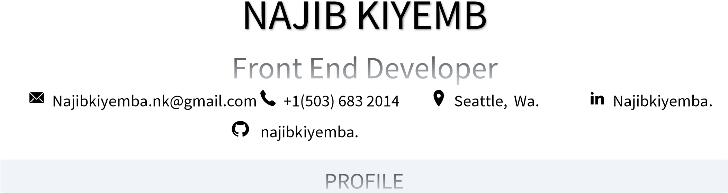Najib Kiyemba

Front End Developer with hands-on experience in developing web-based user interactions along with designing and implementing highly responsive user interface components by deploying React concepts. Proficient in translating designs and wireframes into high-quality code and writing application interface code via JavaScript and React JS workflows. Adept at monitoring and maintaining frontend performance

and troubleshooting and debugging applications for high quality performance.

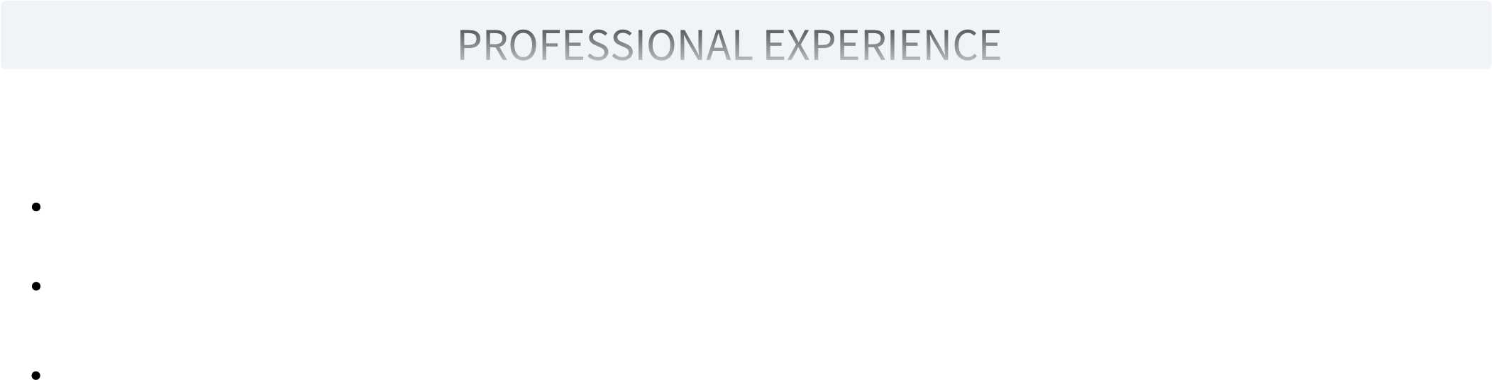***Movie Finder App*** 09/2022 – current https://github.com/najibkiyemba Seattle, Wa.

Movie finder is a website that uses API to communicate to other applications, share data, and help users like or dislike a movie.

|  |  |
| --- | --- |
| Improved user experience through deployment and debugging. |  |
| ***MyReactPortfolio Website*** https://github.com/najibkiyemba  Developed a personal portfolio using create-react-app to create a website using different react components and inbuild hooks functions.  • The website has a form that help users send messages. This component is fully functioning, it uses emaijs react component which is connected to gmail.com. | 04/2022 – 06/2022  Seattle, Wa |
| ***Ravenous App*** | 02/2022 – 04/2022 |

Application uses API key and is created using high quality React components that use hooks.

https:// github.com/najibkiyemba Seattle, Wa

Ravenous is a website which uses application interface to help users find restaurant close to their current location. The website communicates to yelp.com which is a web application already exist.

***Ravature*** 08/2020 – 05/2021

*https:// github.com/najibkiyemba. Seattle, Wa*

Created a Java project that was approved by Ravature recruiters.



Written high quality java code using classes, methods and objects

Mastered loops for example. For and while loops and how to avoid errors while accessing variables in global and functional scoop.



**Ivy Tech Community College** 04/2021-present

Associate of Science in Software Development South Bend, IN

Wrote a paper about internet of things (IOT).

Completed web development class and learnt how the web functions.

**The Excel Center** 02/2020 – 07/2021

High School South Bend, IN

Completed 40 credits of core-40 high school diploma.

