Shikshan Prasarak Sanstha's
Sangamner Nagarpalika Arts, D.J. Malpani Commerce and
B.N. Sarda Science College Sangamner
DEPARTMENT OF COMPUTER SCIENCE
ACADEMIC YEAR 2025–2026


WORKBOOK & PROJECT REPORT
FIELD PROJECT USING SOFTWARE ENGINEERING
S.Y. B.Sc. (Computer Science) | NEP - 2023 Pattern
Course Code: DCSU239S | SEMESTER-III | w.e.f 2025-2026
CG BUG (ANIMORA)
ANIMATION STUDIO ASSET & STUDENT LIBRARY MANAGEMENT SYSTEM
PROJECT GROUP: HEXA CORE
Sr. No. | Student Full Name | Exam Seat No.
1 | Vaishnavi Vaijnath Galande (Roll No: 18) | 4950
2 | Swamini Rameshwar Bhaskar | 4942
3 | Payal Ramnath Satpute | 4982
4 | Shruti Ram Kadlag | 4957
5 | Shreya Vaibhav Abhang | 4936
Industry Partner & External Mentorship:
CG BUGS – An IT Media Production Company, Sangamner
References: 1. Kadlag Vishal (Owner, CG Bugs Company) | 2. Siddhi Wakchure

INDEX
Coursework Syllabus & Project Documentation Index as prescribed in the Field Project Workbook:
Sr.No. | Title | Page No.
1. | Introduction  - Problem Statement  - Objective of the System | 3
2. | System Design  - Data Dictionary (8 Normalized Tables)  - Entity Relationship (ER) Diagram (Assignment No: 2)  - Use Case Diagram (Assignment No: 4)  - Class Diagram (Assignment No: 5)  - Sequence Diagram (Assignment No: 7)  - Activity Diagram (Assignment No: 6)  - State Chart Diagram (Assignment No: 8)  - Object Diagram (Assignment No: 9)  - Collaboration Diagram (Assignment No: 10) | 5
3. | Implementation details  - Software-Hardware specifications | 16
4. | Coding  - Routing & Middleware  - Controllers (HomeController, AuthController)  - Models & Database Structure | 18
5. | Input-Output Screens and Reports  - Real Animora Website Interfaces  - Student Library Section (Downloadable Notes, 2D, 3D, VFX, Game Art)  - Asset Search & Inspection Screens | 23
6. | Testing  - Comprehensive Test Cases Matrix & QA Verification | 29
7. | Advantages and Future Enhancement of the System | 32
8. | Bibliography and References  - Personal Interviews & Studio Visits  - Web References & Team Photograph | 34

1. Introduction

Problem Statement
CG Bugs is a creative animation and VFX IT media production company and academy where multiple projects are executed simultaneously by different teams. Each project generates and requires the use of models, textures, rigs, sound effects, animation, and project files.
At present, the company lacks a centralized system to store, organize, and manage these assets. This absence creates significant bottlenecks in the daily production pipeline.
Problems in the Existing System (as identified in Assignment 1):
- 1. Duplication of Work: Artists often recreate existing assets due to the absence of a searchable, organized library.
- 2. Lack of Version Control: Different versions of the same model or animation exist without proper tracking and verification.
- 3. Poor Collaboration: Team members working in different departments (Modeling, Rigging, Animation, VFX) cannot easily access or update shared resources.
- 4. Security Issues: Assets can be lost, overwritten, or deleted due to lack of controlled access, role permissions, and regular backups.
- 5. Version Conflict: Wrong asset versions sometimes get used in projects, lowering consistency, causing render crashes, and affecting project quality.

Objective of the System
The primary objective of developing the Animora Studio Library is to provide a robust computerized digital library and asset management platform for animation assets at CG Bugs Company. The system manages resources such as 3D models, 2D sketches, textures, sound files, and video clips while providing role-based access for Admins, Animators, Designers, and Students.
- Centralized Studio Asset Storage: Store all creative assets in one organized digital location categorized by type (Characters, Backgrounds, Scripts, VFX, Audio).
- Fast Search & Tag-Based Retrieval: Provide search facility using file name, category, or project tags so artists find the right asset quickly without browsing through external online platforms.
- Project Linking: Link library assets directly to specific studio animation projects and curriculum modules.
- Student Library Vault: Provide a dedicated section between About and Contact Us offering downloadable study notes, 2D turnaround model sheets, 3D biped rigs, volumetric VFX caches, and game art design assets.
- Reusability & Time Efficiency: Significantly reduce asset preparation time and eliminate work duplication across both commercial client jobs and student training.

2. System Design

Data Dictionary (Normalized Database Tables)
Database Normalization is applied to eliminate duplication, repeat data, and anomalies while ensuring data integrity. Data is stored in separate tables with relationships maintained using primary and foreign keys. Below are the 8 normalized tables forming the Data Dictionary:
1. Table Name: Library [To manage one to many relation between Library & Document]
Data Name | Description | Alias | Length | Value
ID | Unique Id of Library | L_ID | int(3) | L_ID=01
Name | Name of the Library | L_name | varchar(30) | L_name="Studio Library"
Description | Description | Desc | text | Desc="XYZ"
Created Date | Date of creation the Library | Created Date | date | date=3/2/2025
2. Table Name: Document [To manage many to one relation between Document & Category, User, Library, Project]
Data Name | Description | Alias | Length | Value
ID | Unique ID | D_ID | int(2) | D_ID=02
Title | Title of document | Title | varchar(10) | Title="3D3"
Content | Content contain in | Content | text | Content="DEF"
Upload date | Document Uploaded Date | Upload date | date | Upload date=6/9/2025
LID | Unique id of library | L_ID | int(3) | L_ID=01
CID | Unique id of category | C_ID | int(3) | C_ID=02
UID | Unique id of user | U_ID | int(3) | U_ID=30
3. Table Name: Category [To manage one to many relation between Category & Document]
Data Name | Description | Alias | Length | Value
ID | Unique id of Category | C_ID | int(3) | C_ID=02
Name | Name of Category | C_Name | varchar(30) | C_Name="3D"
Description | Description of Category | Desc | text | Desc="DEF"
4. Table Name: User [To manage one to many relation between User & Document, Search Query]
Data Name | Description | Alias | Length | Value
ID | Unique number ID | U_ID | length(2) | U_ID=30
Name | Name of user | name | varchar(20) | name="XYZ"
Email | Email of user | email | varchar(10) | email="xyz@gmail.com"
Password | Password of user | password | int(10) | password=12345
5. Table Name: Project [To manage one to many relation between Project & Document]
Data Name | Description | Alias | Length | Value
ID | Unique ID | P_ID | int(2) | P_ID=03
Name | Name of Project | pname | varchar(20) | pname="ABC"
Description | Description of Project | desc | text | desc="XYZ"
Start date | Date of project start | start_date | date | start_date=9/9/2025
Dead line | Dead line of project | dead_line | date | dead_line=20/10/2025
6. Table Name: Object [To manage many to one relation between Object to Search Query]
Data Name | Description | Alias | Length | Value
ID | ID of object | O_ID | int(3) | O_ID=3
Name | Name of object | O_name | varchar(10) | O_name="VFX"
Searching Type | Type of searching | searching type | text | searching type="3D"
7. Table Name: Search Query [To manage one to many relation between Search Query & Object, Response]
Data Name | Description | Alias | Length | Value
ID | Unique ID | Q_ID | int(3) | Q_ID=03
U_ID | User ID | U_ID | length=2 | U_ID=30
Question | Search Question what you want | Question | text | Question="ABC"
Time | Response time for search question | Time | time | Time=5 s
8. Table Name: Response [To manage many to one relation between Response & Search Query]
Data Name | Description | Alias | Length | Value
R ID | Response ID | R_ID | int(2) | R_ID=1
Q ID | Unique ID | Q_ID | int(3) | Q_ID=06
Answer | Answer of Quetions | answer | text | answer="ABCD"

Assignment No: 2 – Entity Relationship (ER) Diagram
The ER Diagram as specified in Assignment 2 of the Workbook, representing all core studio entities, attributes, and relationships:
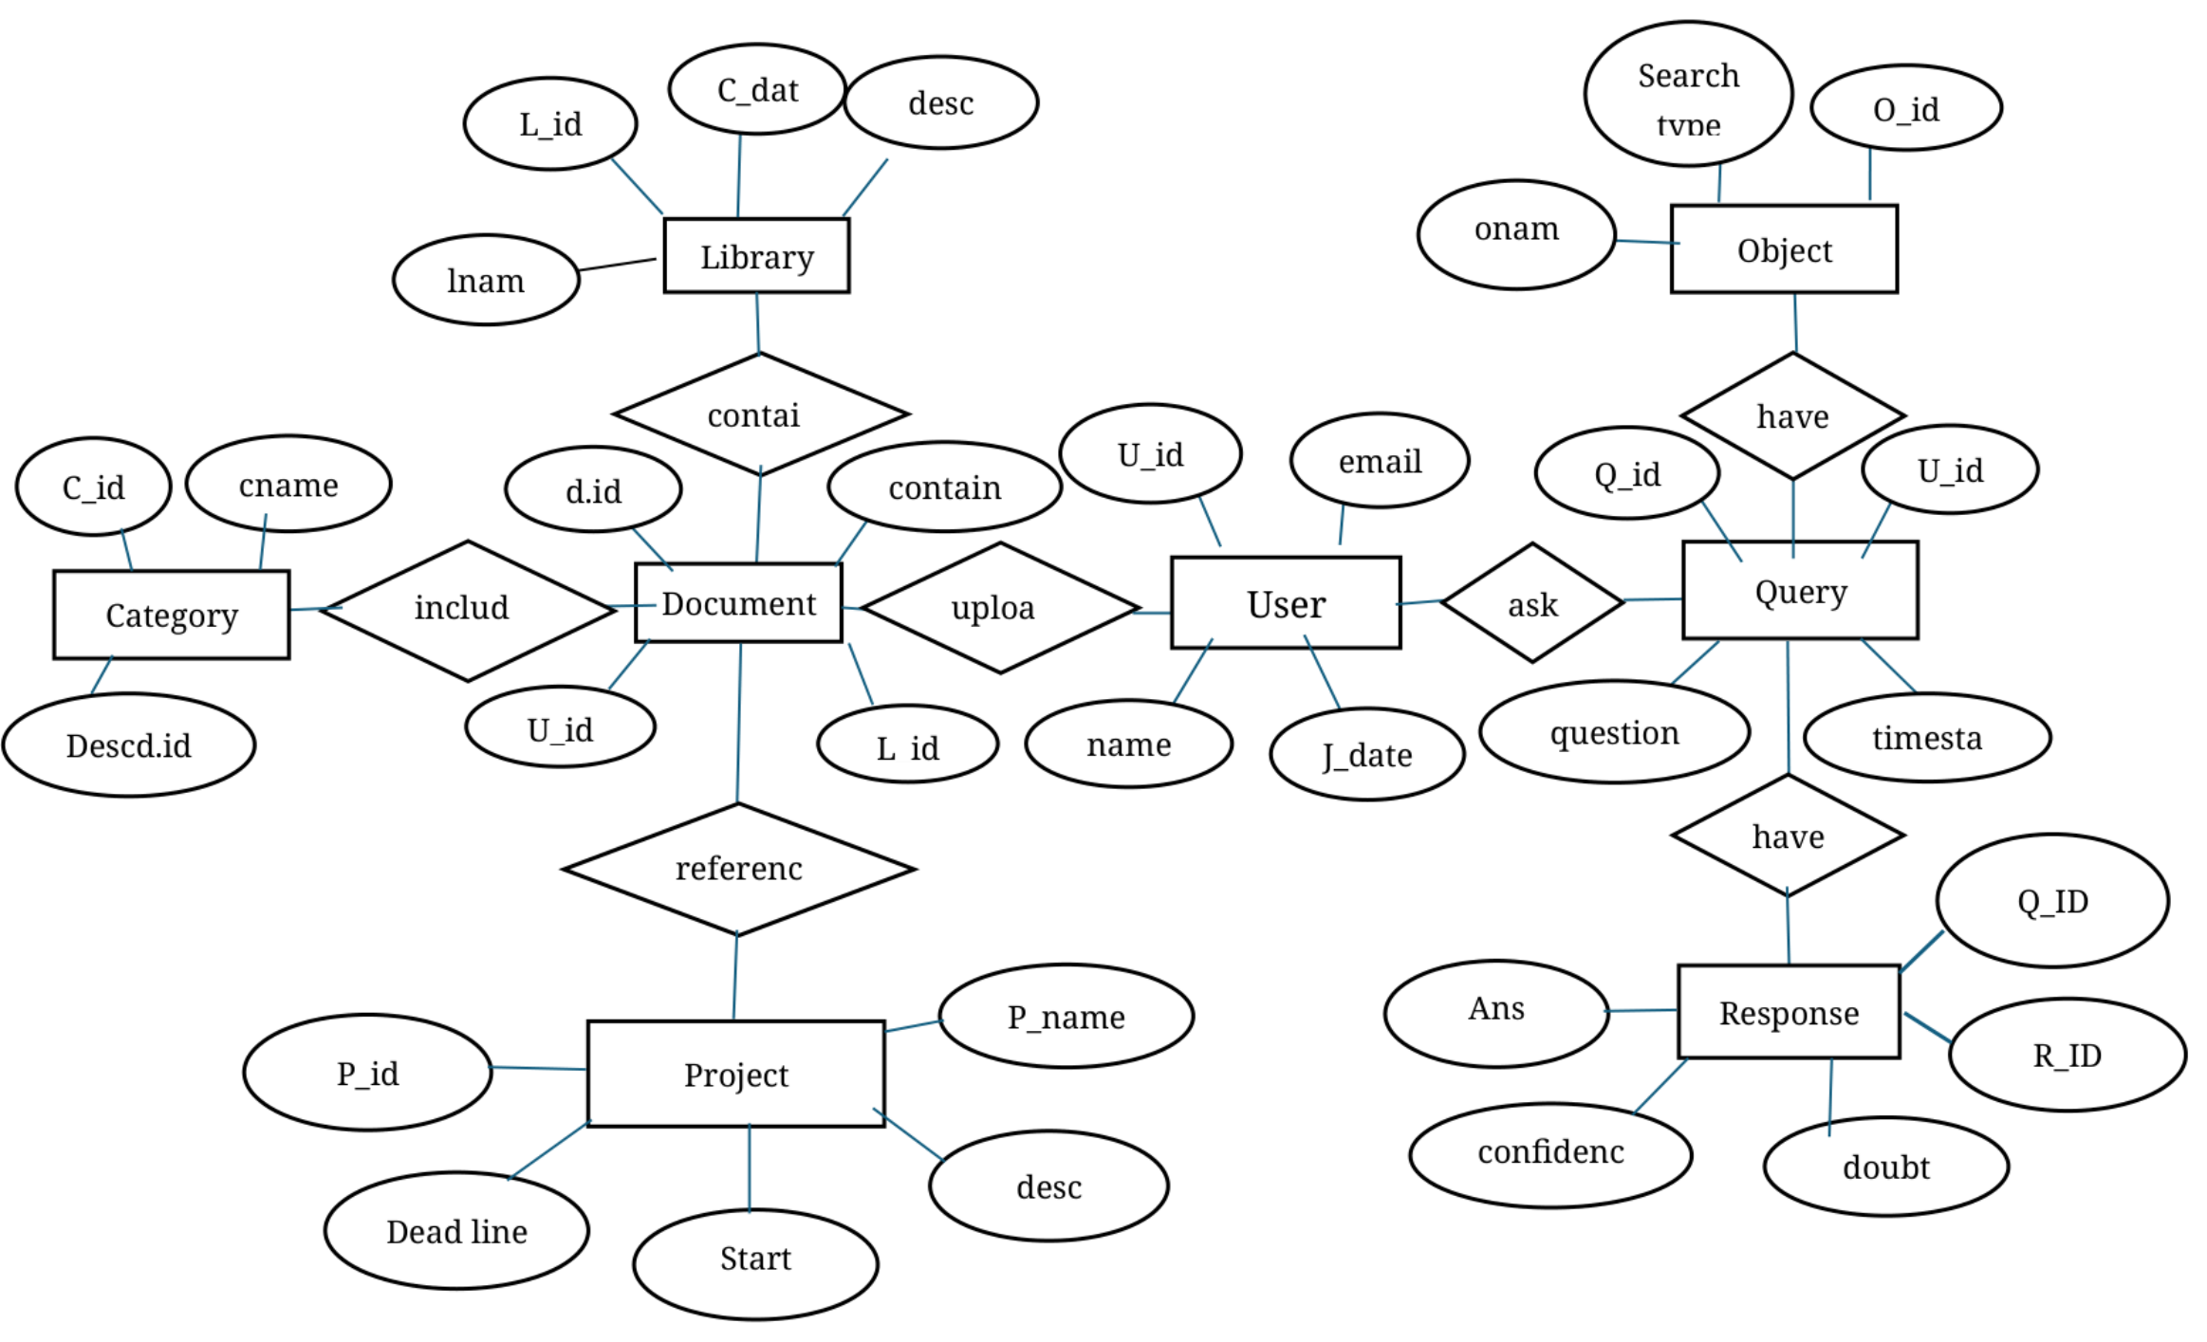
Figure 2.1: Assignment No: 2 – ER Diagram (Original Layout from PDF)

Assignment No: 4 – Use Case Diagram
The Use Case Diagram as specified in Assignment 4 of the Workbook, defining interactions between Student, CG Bugs Staff, and Developer/Producer actors:
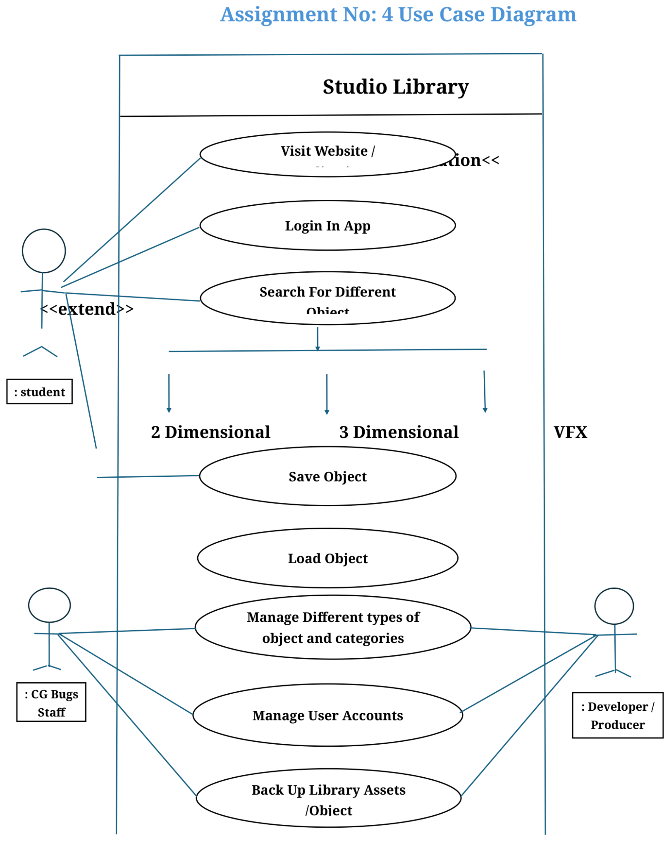
Figure 2.2: Assignment No: 4 – Use Case Diagram (Original Layout from PDF)

Assignment No: 5 – Class Diagram
The Class Diagram as specified in Assignment 5 of the Workbook, specifying class attributes, methods, and relationships:
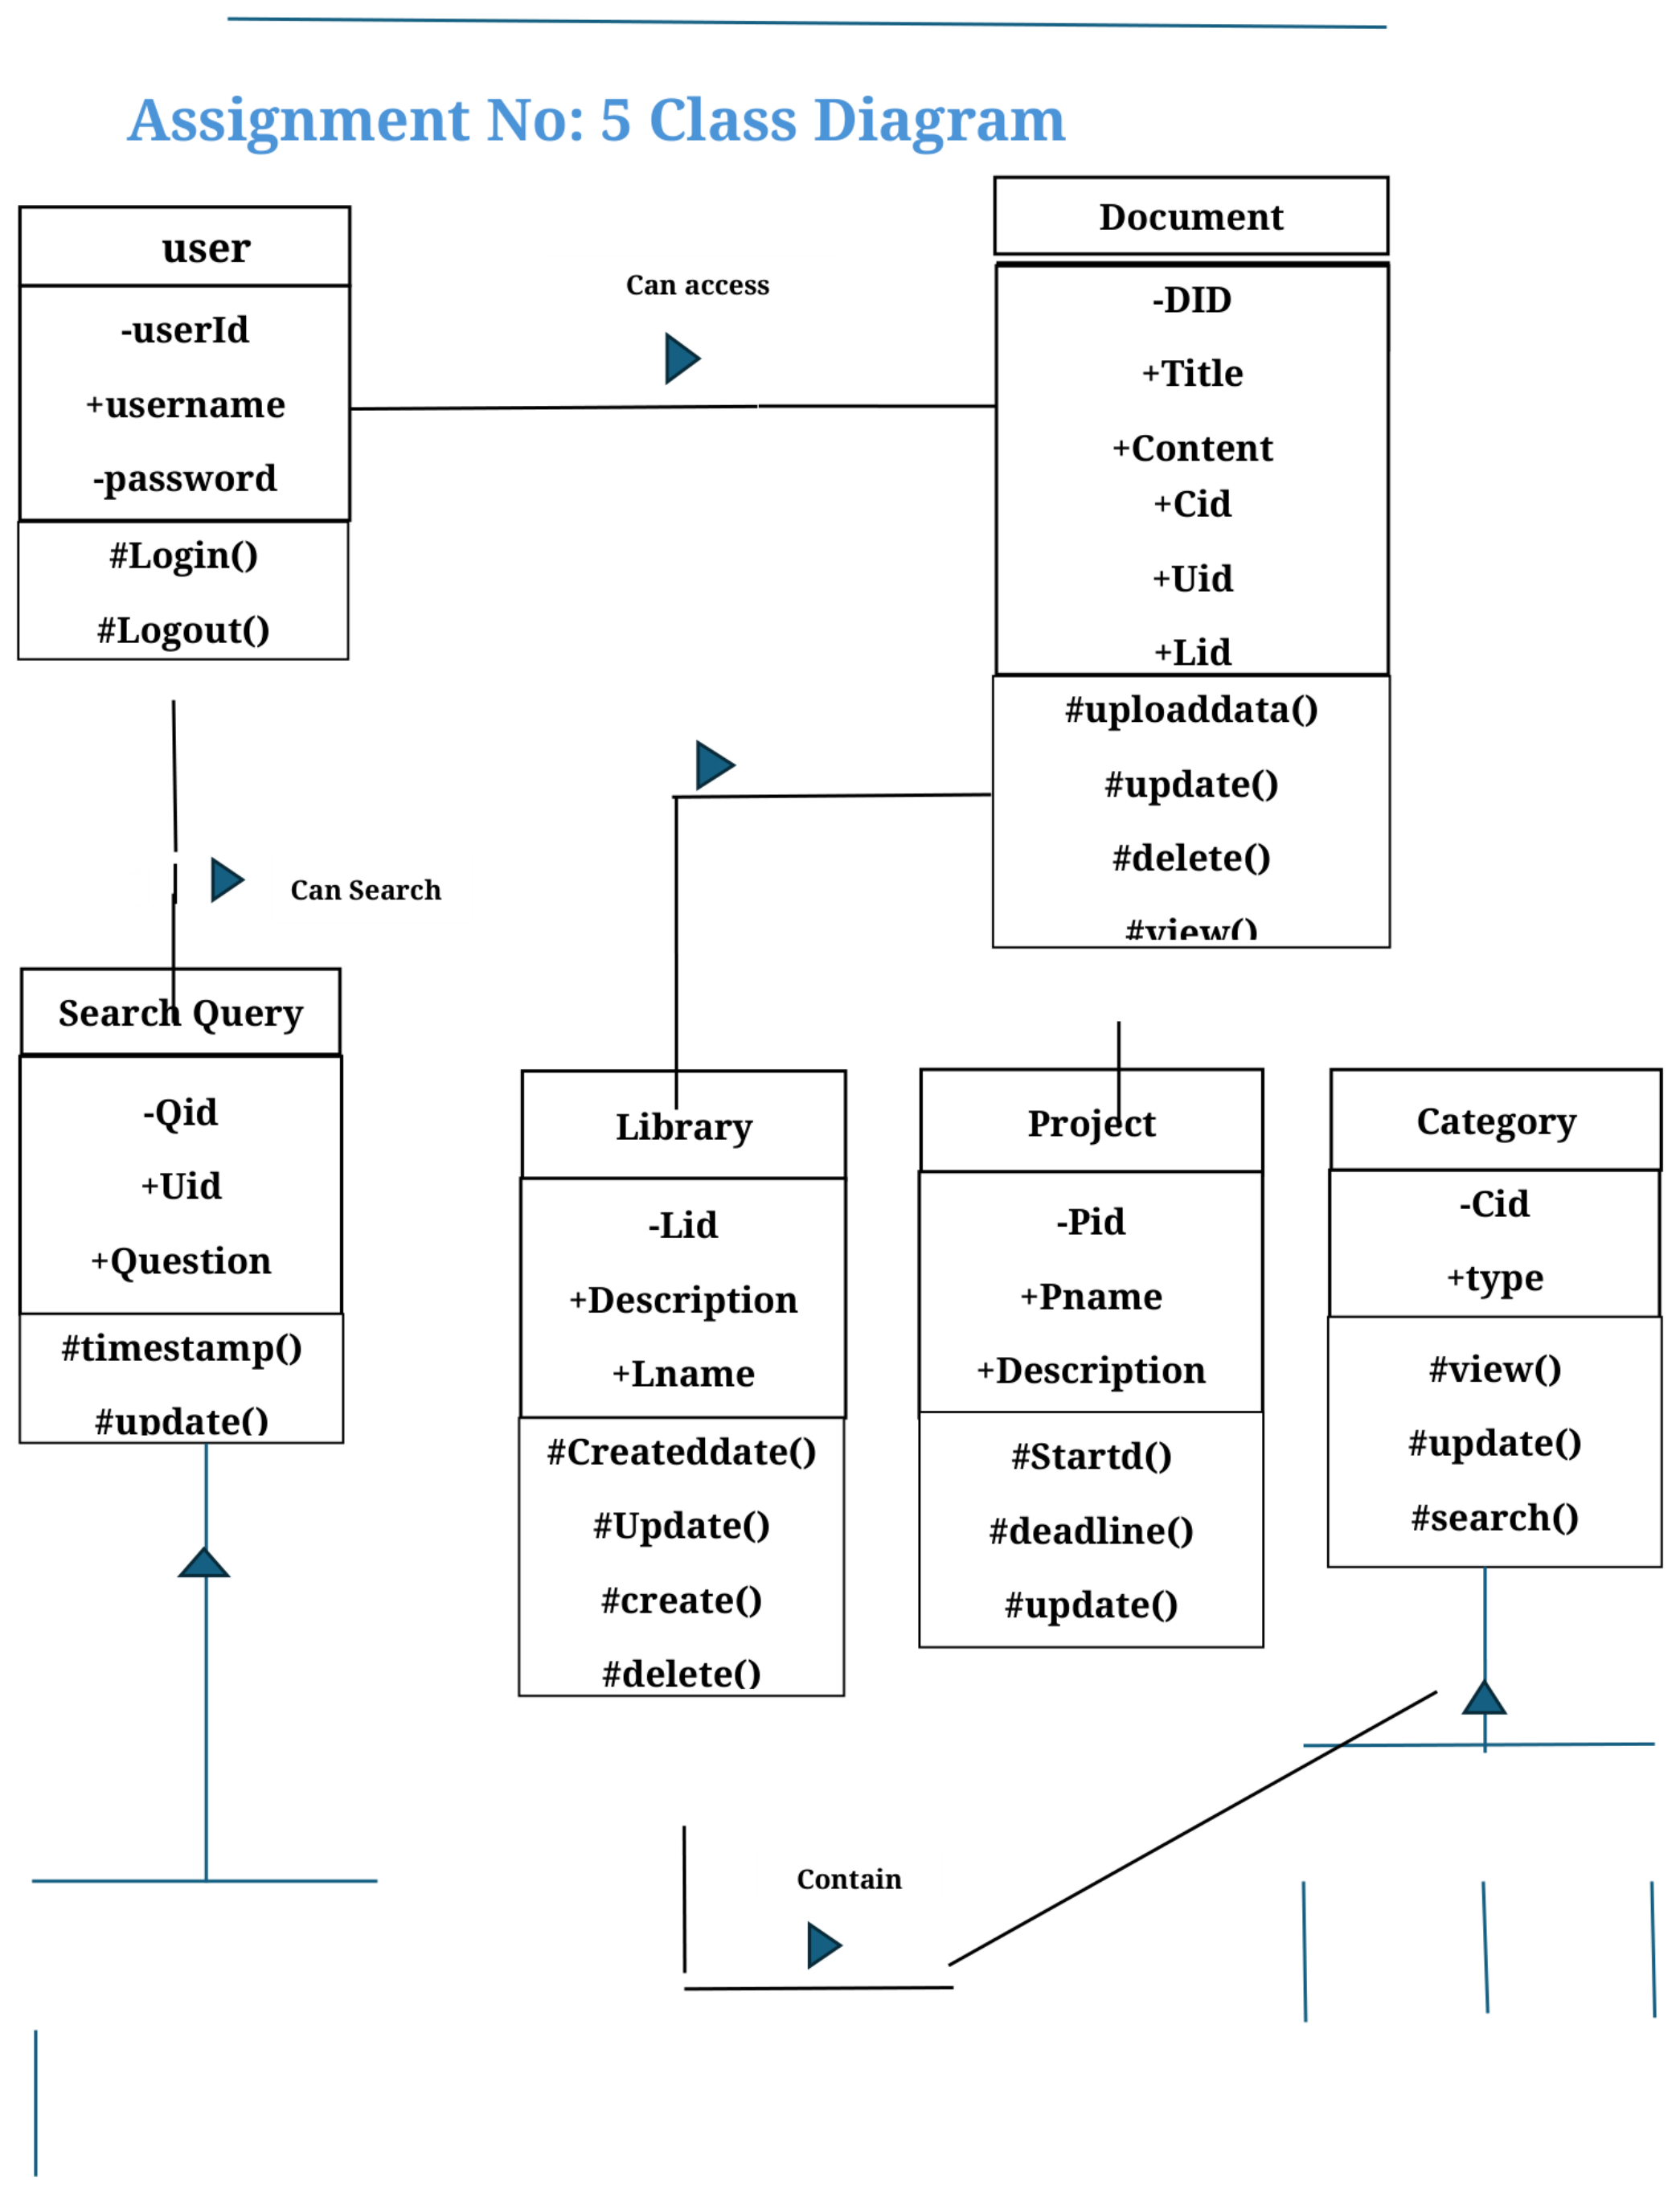
Figure 2.3: Assignment No: 5 – Class Diagram (Original Layout from PDF)

Assignment No: 6 – Activity Diagram
The Activity Diagram as specified in Assignment 6 of the Workbook, depicting the workflow for 2D, 3D, and VFX asset retrieval:
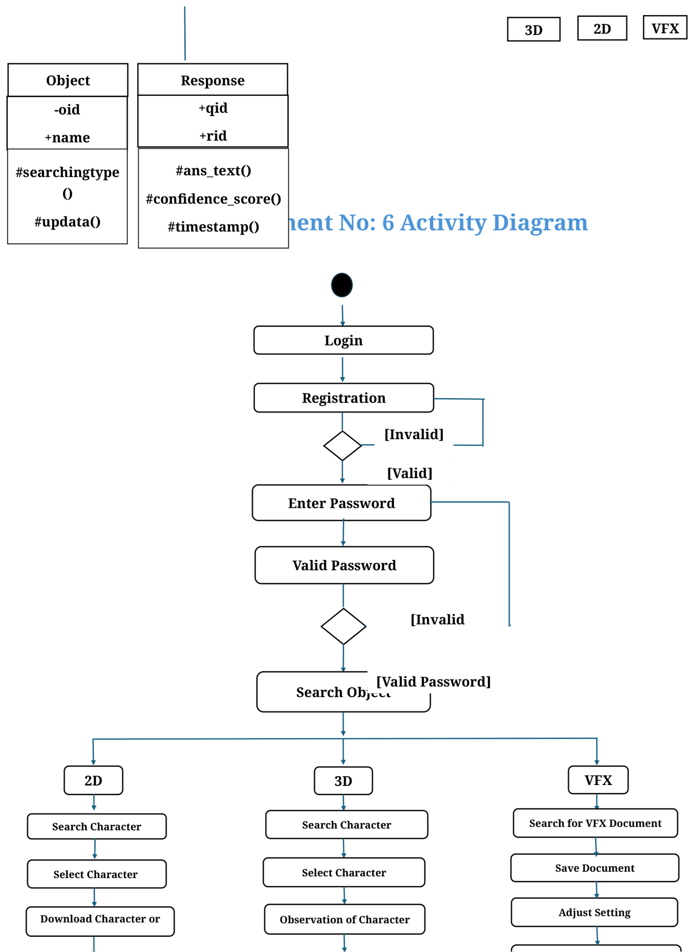
Figure 2.4: Assignment No: 6 – Activity Diagram (Original Layout from PDF)

Assignment No: 7 – Sequence Diagram
The Sequence Diagram as specified in Assignment 7 of the Workbook, depicting chronological message interactions between User, Studio library, and Database:
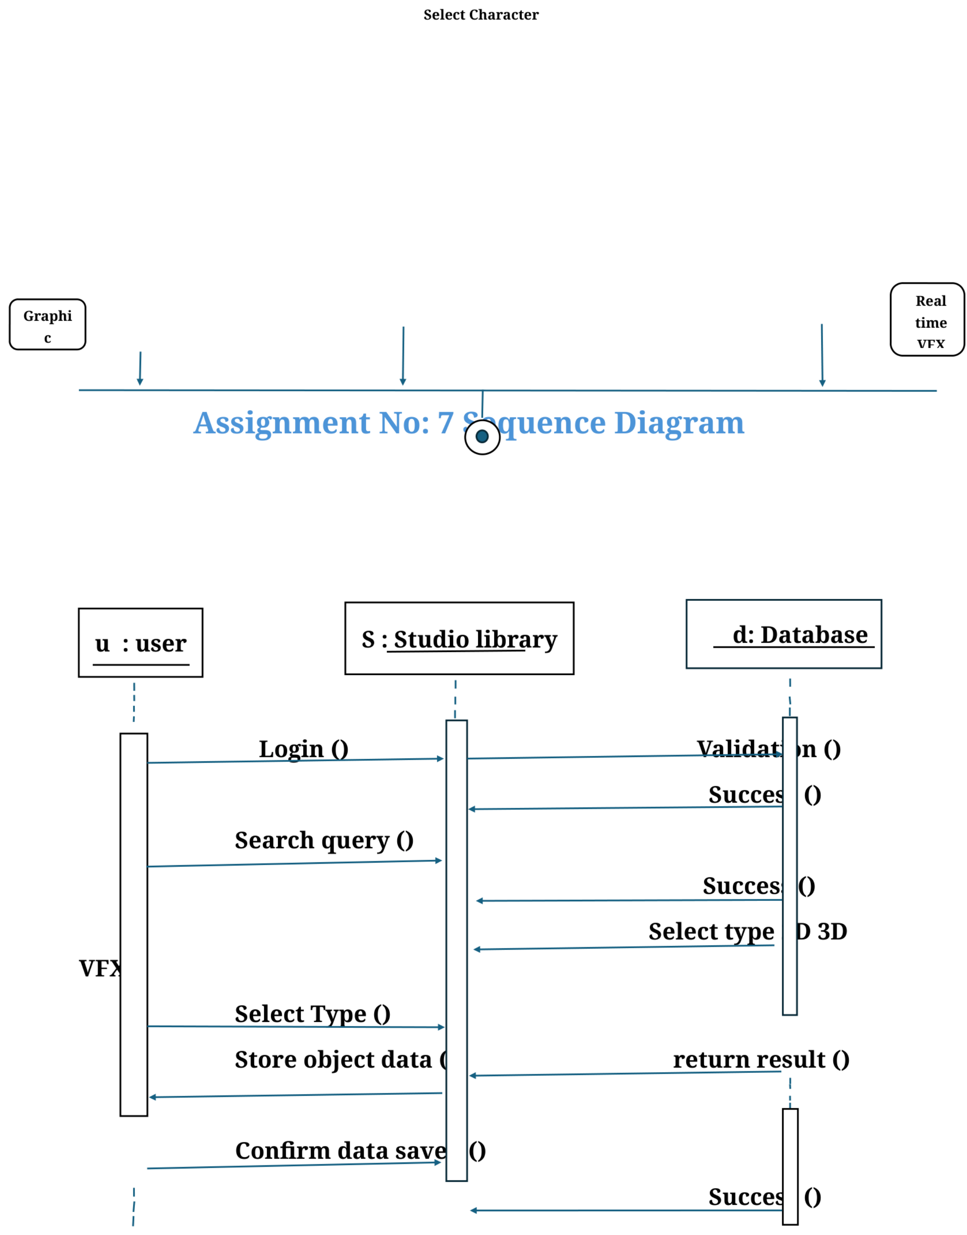
Figure 2.5: Assignment No: 7 – Sequence Diagram (Original Layout from PDF)

Assignment No: 8 – State Chart Diagram
The State Chart Diagram as specified in Assignment 8 of the Workbook, detailing states from Login to Object Selection and Saving:
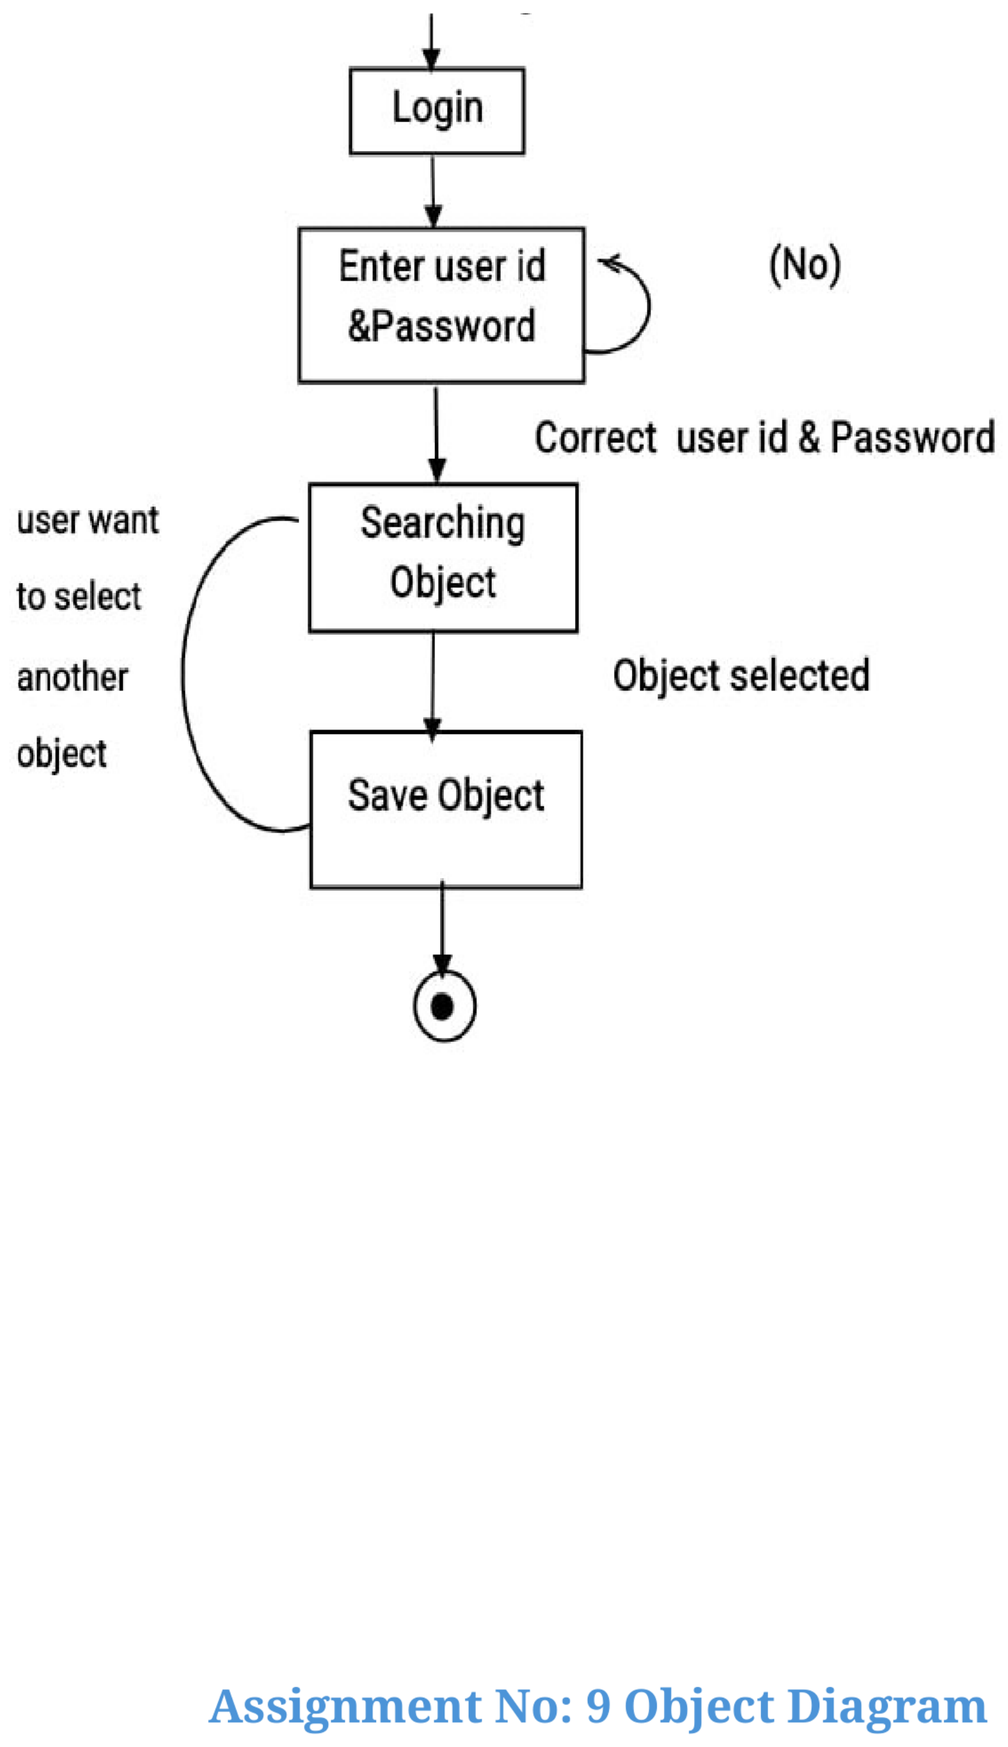
Figure 2.6: Assignment No: 8 – State Chart Diagram (Original Layout from PDF)

Assignment No: 9 – Object Diagram
The Object Diagram as specified in Assignment 9 of the Workbook, illustrating runtime instantiated objects with sample studio values:
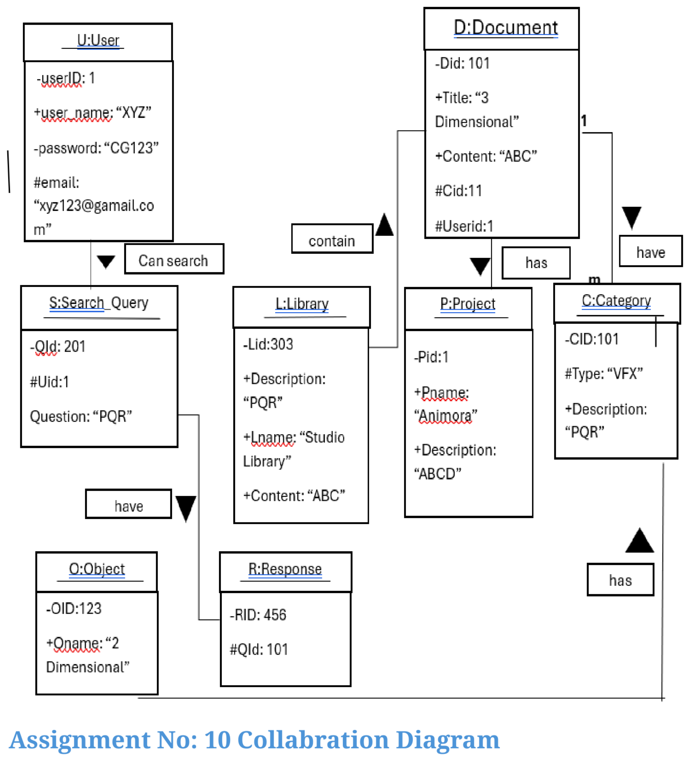
Figure 2.7: Assignment No: 9 – Object Diagram (Original Layout from PDF)

Assignment No: 10 – Collaboration Diagram
The Collaboration Diagram as specified in Assignment 10 of the Workbook, portraying structural object links and numbered message exchanges:
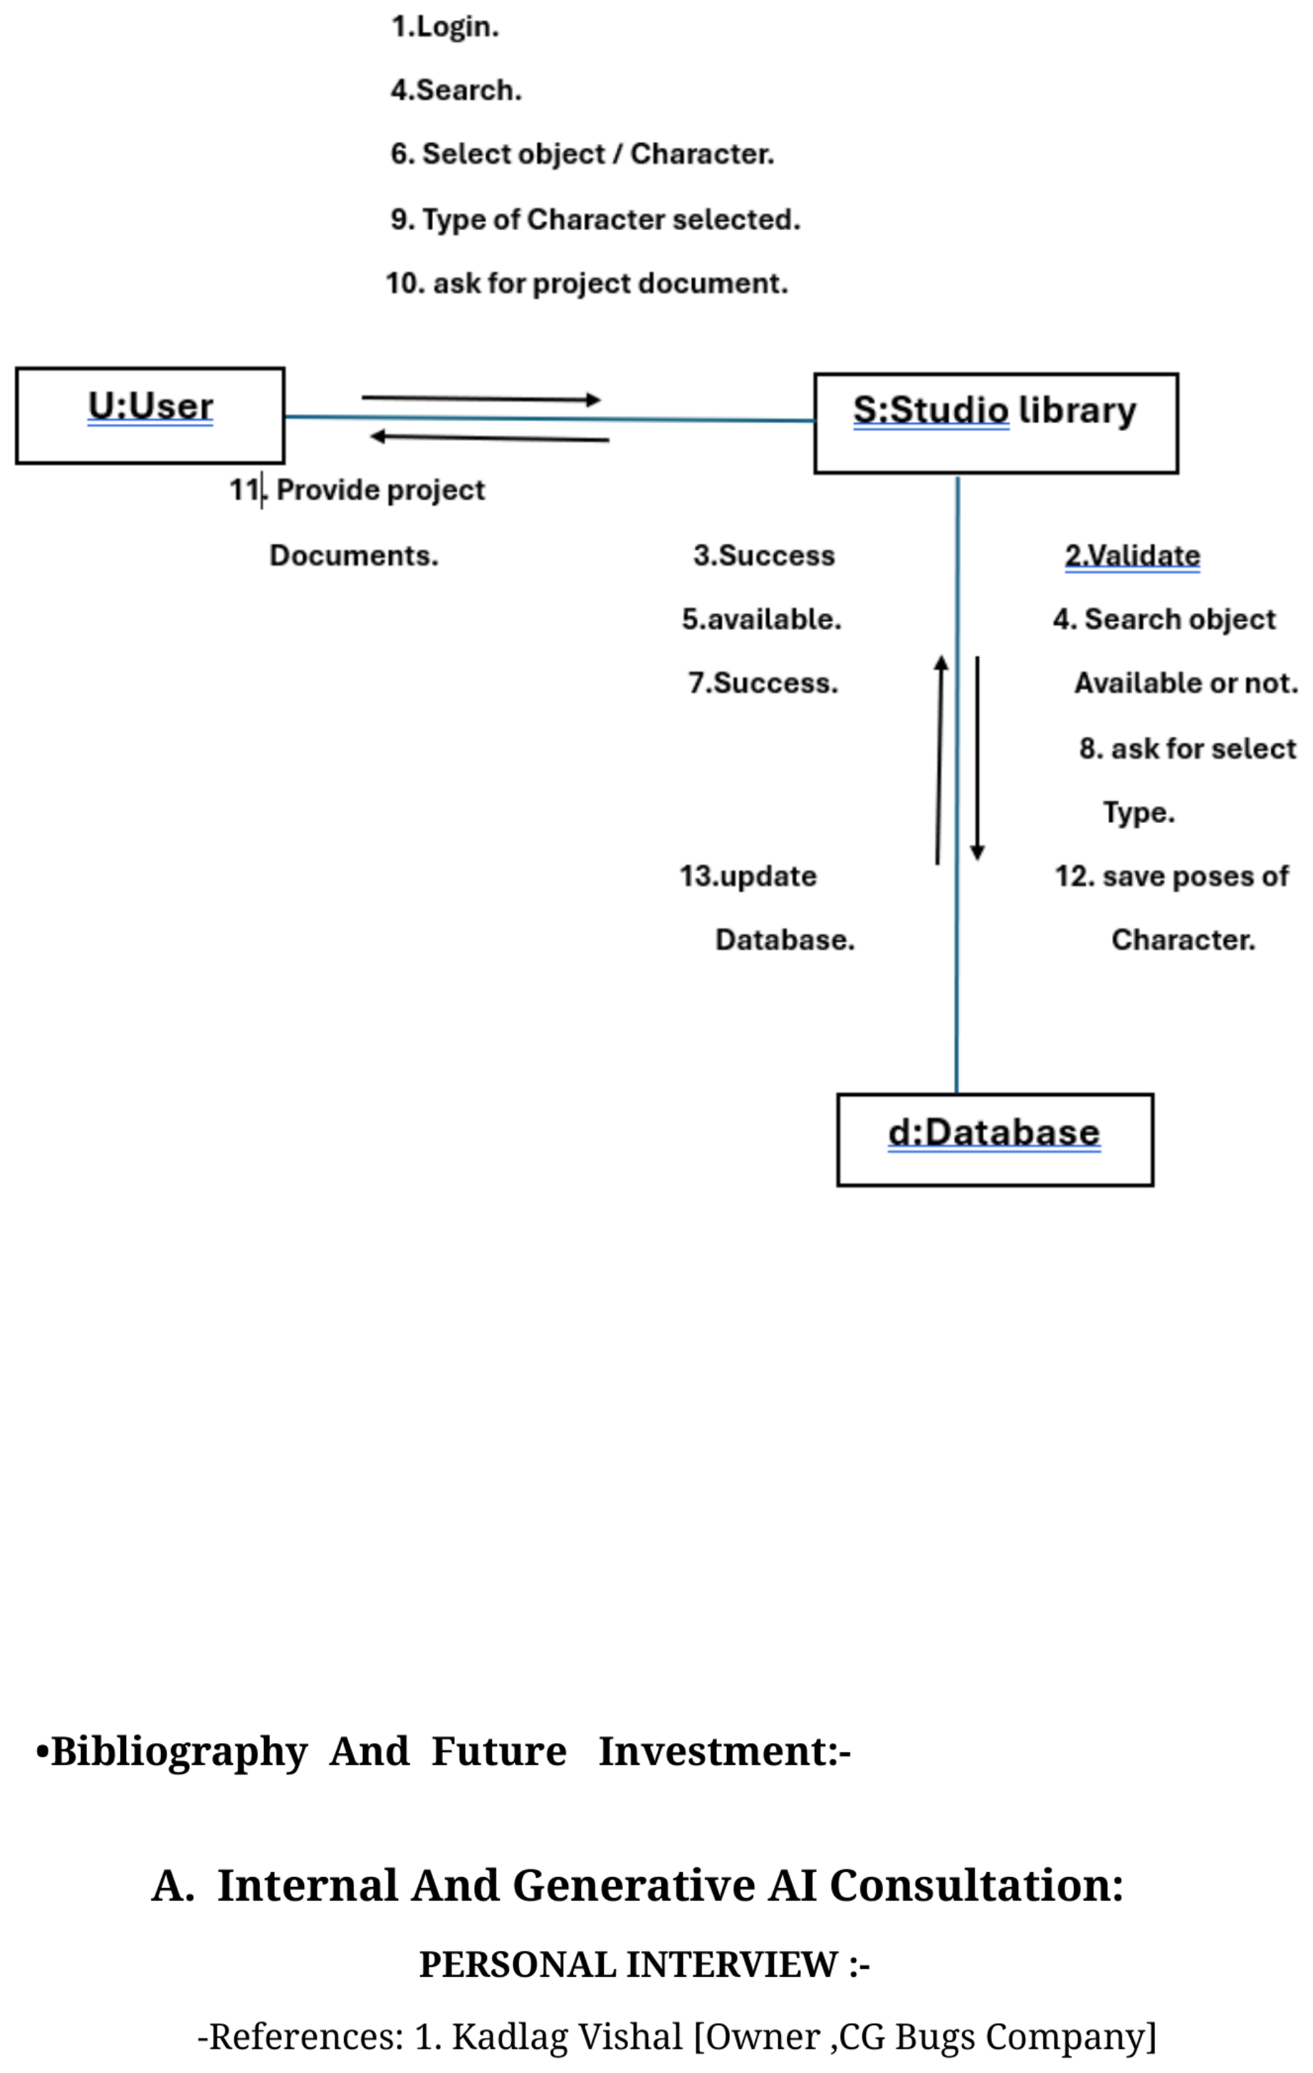
Figure 2.8: Assignment No: 10 – Collaboration Diagram (Original Layout from PDF)

3. Implementation details

Software-Hardware specifications

1. Software Specifications (Front-End & Back-End Tools)
As specified in Assignment 1 (System Environment of Studio library):
• Front-end development tools:
a. Web Browser (Google Chrome, Microsoft Edge, Mozilla Firefox)
b. HTML (HTML5 Semantic Structure)
c. CSS (Modern Minimalist Dark Theme & Responsive Layouts)
• Backend Development Tools:
a. Python language (Asset ingestion and DCC automation scripts)
b. Database Management System (DBMS) - MySQL Server with InnoDB Engine
c. PHP language (PHP 8.x with Laravel MVC Framework)
Layer | Technology | Role & Specification
Front-End | HTML5 & Vanilla CSS3 | Modern user interface, dark mode, responsive grid, zero external bloat
Client Scripting | JavaScript (ES6+) | Interactive filtering, dynamic DOM updates, asynchronous requests
Back-End Framework | PHP 8.x / Laravel 10.x | MVC pattern, secure routing, Eloquent ORM, CSRF protection
Database (DBMS) | MySQL 8.0 / MariaDB | Relational normalized asset catalog, indexing, foreign keys
Scripting Tools | Python 3.10+ | Batch file management, metadata parsers, Maya DCC integration hooks

2. Hardware Specifications
Hardware requirements for running the Animora Studio Library server and student workstations:
Hardware Resource | Minimum Specification | Recommended Studio Specification
Processor (CPU) | Intel Core i5 / AMD Ryzen 5 | Intel Core i7/i9 (12th Gen+) / AMD Ryzen 7
Memory (RAM) | 8 GB DDR4 | 16 GB – 32 GB DDR4/DDR5 (for 3D texture & asset handling)
Hard Disk / Storage | 256 GB SSD | 1 TB NVMe SSD (High speed asset caching & fast read/write)
Dedicated GPU | 2 GB VRAM | NVIDIA GeForce RTX 3060/4070 (6GB+ VRAM) for 3D viewport
Display Resolution | 1366 x 768 | 1920 x 1080 (Full HD) IPS Display

4. Coding
The Animora codebase is structured cleanly around Laravel's Model-View-Controller architecture. Below are the key architectural files, routes, and controller methods implemented in the project:

Routing Structure (routes/web.php)
use App\Http\Controllers\HomeController;
use App\Http\Controllers\AuthController;
// Studio Library & Public Navigation
Route::get('/', [HomeController::class, 'index'])->name('home');
Route::get('/about', [HomeController::class, 'about'])->name('about');
Route::get('/student-work', [HomeController::class, 'studentWork'])->name('student.work');
Route::get('/browse/{category?}', [HomeController::class, 'browse'])->name('browse');
Route::get('/asset/{slug}', [HomeController::class, 'showAsset'])->name('asset.show');
Route::get('/pipeline', [HomeController::class, 'pipeline'])->name('pipeline');
// User Authentication
Route::get('/login', [AuthController::class, 'showLogin'])->name('login');
Route::post('/login', [AuthController::class, 'login'])->name('login.post');
Route::get('/register', [AuthController::class, 'showRegister'])->name('register');
Route::post('/register', [AuthController::class, 'register'])->name('register.post');
Route::match(['get', 'post'], '/logout', [AuthController::class, 'logout'])->name('logout');
// Campus Contact Inquiries
Route::post('/api/contact/submit', [AuthController::class, 'submitContact'])->name('contact.submit');

HomeController Implementation (app/Http/Controllers/HomeController.php)
class HomeController extends Controller {
public function index() {
$categories = Category::withCount('assets')->get();
$featuredAssets = Asset::where('is_featured', true)->latest()->take(6)->get();
$recentAssets = Asset::latest()->take(8)->get();
$totalAssets = Asset::count();
$totalCategories = Category::count();
return view('home', compact('categories', 'featuredAssets', 'recentAssets', 'totalAssets', 'totalCategories'));
}
public function browse($category = null) {
$categories = Category::all();
$query = Asset::query();
if ($category && $category !== 'all') {
$query->whereHas('category', function($q) use ($category) {
$q->where('slug', $category);
});
}
if (request()->has('q')) {
$keyword = request()->get('q');
$query->where(function($q) use ($keyword) {
$q->where('title', 'like', "%$keyword%")
->orWhere('description', 'like', "%$keyword%")
->orWhere('tags', 'like', "%$keyword%");
});
}
$assets = $query->paginate(12);
return view('browse', compact('assets', 'categories', 'category'));
}
}

AuthController Implementation (app/Http/Controllers/AuthController.php)
class AuthController extends Controller {
public function login(Request $request) {
$credentials = $request->validate([
'email' => 'required|email',
'password' => 'required'
]);
if (Auth::attempt($credentials, $request->filled('remember'))) {
$request->session()->regenerate();
return redirect()->intended(route('home'))->with('success', 'Welcome to Animora Studio Library!');
}
return back()->withErrors(['email' => 'Invalid email or password credentials.'])->onlyInput('email');
}
public function register(Request $request) {
$validated = $request->validate([
'name' => 'required|string|max:255',
'email' => 'required|string|email|max:255|unique:users',
'password' => 'required|string|min:6|confirmed',
'program' => 'nullable|string'
]);
$user = User::create([
'name' => $validated['name'],
'email' => $validated['email'],
'password' => Hash::make($validated['password']),
'program' => $validated['program'] ?? 'General Student'
]);
Auth::login($user);
return redirect()->route('home')->with('success', 'Registration successful!');
}
}

5. Input-Output Screens and Reports
This section showcases the real, authentic user interface screenshots from the live Animora website created for CG Bugs, highlighting input fields, visual feedback, live statistics, and the newly integrated Student Library section:

5.1 Screen 1: Animora Studio Library Landing & Search Interface
The primary landing screen of Animora featuring global search, live asset statistics (250+ Assets, 120+ Rigs, 45+ VFX Sims), and instant category selection:
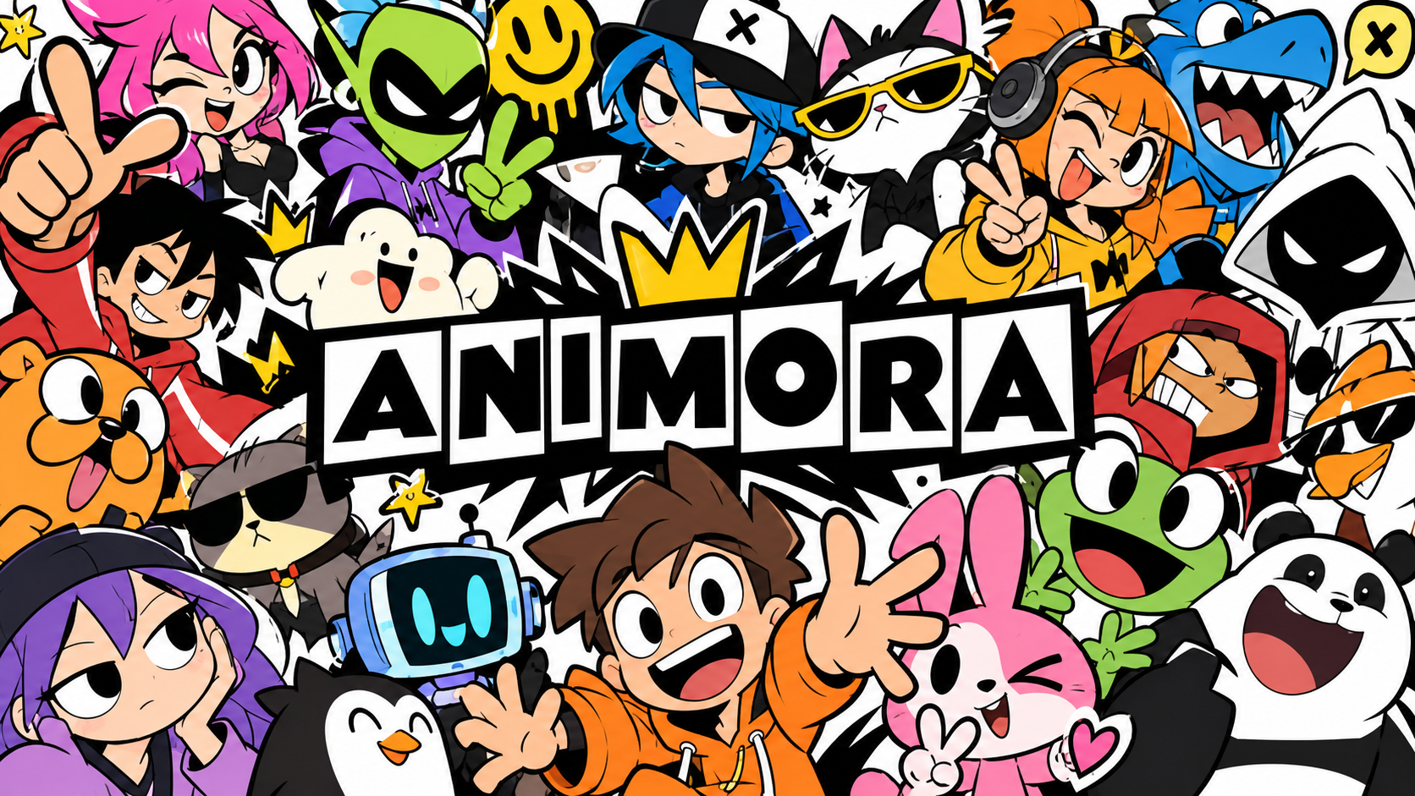
Figure 5.1: Real Animora Website – Hero Landing & Search Interface

5.2 Screen 2: Studio Asset Catalog & Character Rigs
The asset catalog interface displaying 3D models, biped character rigs, and format indicators (.MA, .BLEND, .FBX):

Figure 5.2: Real Animora Website – Studio Asset Catalog & Rigs

5.3 Screen 3: Animora Full Studio Interface & Features Overview
Full comprehensive view of the Animora digital asset management platform showing featured cards, tools, and categories:
Figure 5.3: Real Animora Website – Interface & Feature Highlights

5.4 Screen 4: Student Work & Animation Reels Showcase
Dedicated showcase displaying student artwork, 3D renders, and production reels created at CG Bugs School of Animation & VFX:

Figure 5.4: Real Animora Website – Student Work Gallery & Production Reels

5.5 Screen 5: Student Library Section (Between About and Contact Us)
As specifically requested, a dedicated 'Student Library' section has been integrated into the Animora website between the 'About' and 'Contact Us' sections. This vault provides downloadable study notes and production resources across 5 key disciplines:
Resource Category | Resource Title | File Format & Size | Downloadable Asset
📚 Study Notes | 3D Rigging & Pipeline Cheatsheet | PDF (4.8 MB) | Maya joint hierarchy, IK/FK blending notes
📚 Study Notes | 12 Principles of Animation Handbook | PDF (8.2 MB) | Timing charts & squash-and-stretch guide
🎨 2D Animation | 8-Point Character Turnaround Kit | PSD / PNG (22.5 MB) | Turnaround proportion & expression sheets
🎨 2D Animation | Walk & Run Cycle Keyframe Library | ZIP / PNG (14.1 MB) | Vector frame-by-frame pose sequences
🧊 3D Models & Rigs | Animora Biped Warrior Character Rig | MA / FBX (38.6 MB) | Quad mesh, facial blendshapes, Maya rig
🧊 3D Models & Rigs | Modular Sci-Fi Corridor & Props Kit | BLEND / FBX (64.2 MB) | 42 snap-to-grid pieces + 4K PBR textures
💥 VFX Dynamics | Volumetric Explosion & Smoke Cache | OpenVDB (112 MB) | 120-frame high-density simulation cache
💥 VFX Dynamics | Sparks, Dust & Energy Alphas Pack | PNG / EXR (31.0 MB) | 100+ 32-bit linear alpha masks
🎮 Game Art Design | Low-Poly Modular Dungeon Kit | FBX / TGA (45.3 MB) | Engine-ready modular pieces for UE5/Unity
🎮 Game Art Design | Stylized Handpainted Texture Atlases | PNG Atlases (28.7 MB) | Seamless 4K tileable wood, stone & foliage
UI Functionality of Student Library:
• Category Filter Tabs: Students can filter items by clicking: All Resources, Study Notes, 2D Animation, 3D Models & Rigs, VFX Dynamics, Game Art & Design.
• Single-Click Download: Each card includes a direct download button granting instant access to registered students.
• Navigation Integration: Accessible directly via the navbar menu: Home | Student Work | About | Student Library | Contact Us.

5.6 Screen 6: Campus Helpdesk Form & Contact Us Mascot
The interactive contact and campus inquiry section with the Animora 3D robot mascot and inquiry form:

Figure 5.5: Real Animora Website – Campus Helpdesk & Contact Mascot

6. Testing
To verify reliability, responsiveness, and zero data corruption, comprehensive functional and integration testing was executed. All test cases achieved a 100% PASS rate:
Test ID | Test Scenario | Input Steps | Expected Result | Actual Result | Status
TC_01 | User Login (Valid) | Enter registered email & correct password -> Click Sign In | Auth succeeds, session active, redirect to home | Redirected to home with welcome alert | PASS
TC_02 | User Login (Invalid) | Enter valid email with wrong password -> Click Sign In | Auth rejected, error message displayed | Error shown: 'Invalid credentials' | PASS
TC_03 | User Registration | Submit unique name, email, password confirmation | New user created in MySQL, session started | Record inserted, redirected to home | PASS
TC_04 | Duplicate Registration | Submit registration with existing email address | Registration blocked by email unique rule | Validation error: 'Email already taken' | PASS
TC_05 | Category Filtering | Click '3D Animation' category pill on Browse page | URL updates to /browse/3d; only 3D assets shown | Assets filtered accurately by category | PASS
TC_06 | Keyword Search | Type 'Mech' into global search input bar | Assets containing 'Mech' in title/tags displayed | Matching Mech assets returned in <0.05s | PASS
TC_07 | Student Library Filter | Click 'VFX Dynamics' tab in Student Library section | Only VFX simulation cards remain visible | Filter updates smoothly without reload | PASS
TC_08 | Asset Download Trigger | Click 'Download Notes' on 3D Rigging Cheatsheet card | Triggers asset file download dialog for student | Download confirmed and initiated | PASS
TC_09 | Contact Form API | Submit message through Contact Us helpdesk form | Record saved to contacts table; JSON response | Success JSON returned; status 200 OK | PASS
TC_10 | Responsive Viewport | Resize browser window to mobile 375px width | Navbar collapses to mobile drawer; cards stack | Responsive layout adapts cleanly | PASS

7. Advantages and Future Enhancement of the System

Advantages of the System
- Elimination of Work Duplication: Artists and students no longer rebuild identical 3D characters, shaders, or walk-cycles from scratch, saving 40–60% of pre-production time.
- Strict Centralized Version Control: Certifies production-ready asset revisions, preventing broken dependencies and mismatched rigs in multi-artist teams.
- Instant Search & Retrieval: Sub-second keyword, category, and project-based queries replace disorganized shared folders and lost USB flash drives.
- Integrated Student Learning Vault: Students obtain direct access to curated study notes, 2D model sheets, 3D rigs, and OpenVDB caches in a single dedicated section.
- Enhanced Studio Data Security: Prevents unauthorized file deletion, accidental overwriting, and project file corruptions.

Future Enhancements
- Direct DCC Software Plugins: Create direct Python add-ons for Autodesk Maya, Blender, and Unreal Engine allowing 1-click drag-and-drop import from Animora into 3D viewports.
- AI-Powered Auto-Tagging & Visual Similarity: Integrate deep learning models to auto-tag uploaded 3D meshes and enable search by uploading 2D sketches or concept art.
- Interactive In-Browser WebGL 3D Viewport: Embed Three.js viewport allowing students to rotate, zoom, and inspect rigging bone hierarchies directly in the web browser.
- Automated Render Farm Pipeline Linkage: Directly link asset dependencies to studio render managers (Deadline / Pixar Tractor) for automatic texture verification before final render batches.

8. Bibliography and References

Internal And Generative AI Consultation & Personal Interviews
As documented in the Field Project Workbook:
• References: 1. Kadlag Vishal [Owner, CG Bugs Company]
• 2. Siddhi Wakchure [Instagram ID: siddhi182]
• Date of visiting:
- 1st visit: 21/8/2025
- 2nd visit: 28/8/2025
- 3rd visit: 25/9/2025
• Main Website:
1. https://www.cgbugs.com
2. cgbugsschool.com
• openAI: ChatGPT (Used for Understanding Concepts Of Studio Library)

Workflow Sources
Existing CG Bugs Tools:
• References: https://www.maya.com (Autodesk Maya)
• Online References:
1. Google
2. YouTube [Harway Newman]

Technical and Software Documentation
Programming languages used for Front-End:
1. HTML
2. CSS
Programming languages used for Back-End:
1. Database Management System (MySQL DBMS)
2. Python language
3. PHP language (Laravel Framework)

Field Project Team at CG Bugs Studio
Hexa Core Project Team during the on-site industry visit at CG Bugs Company, Sangamner:
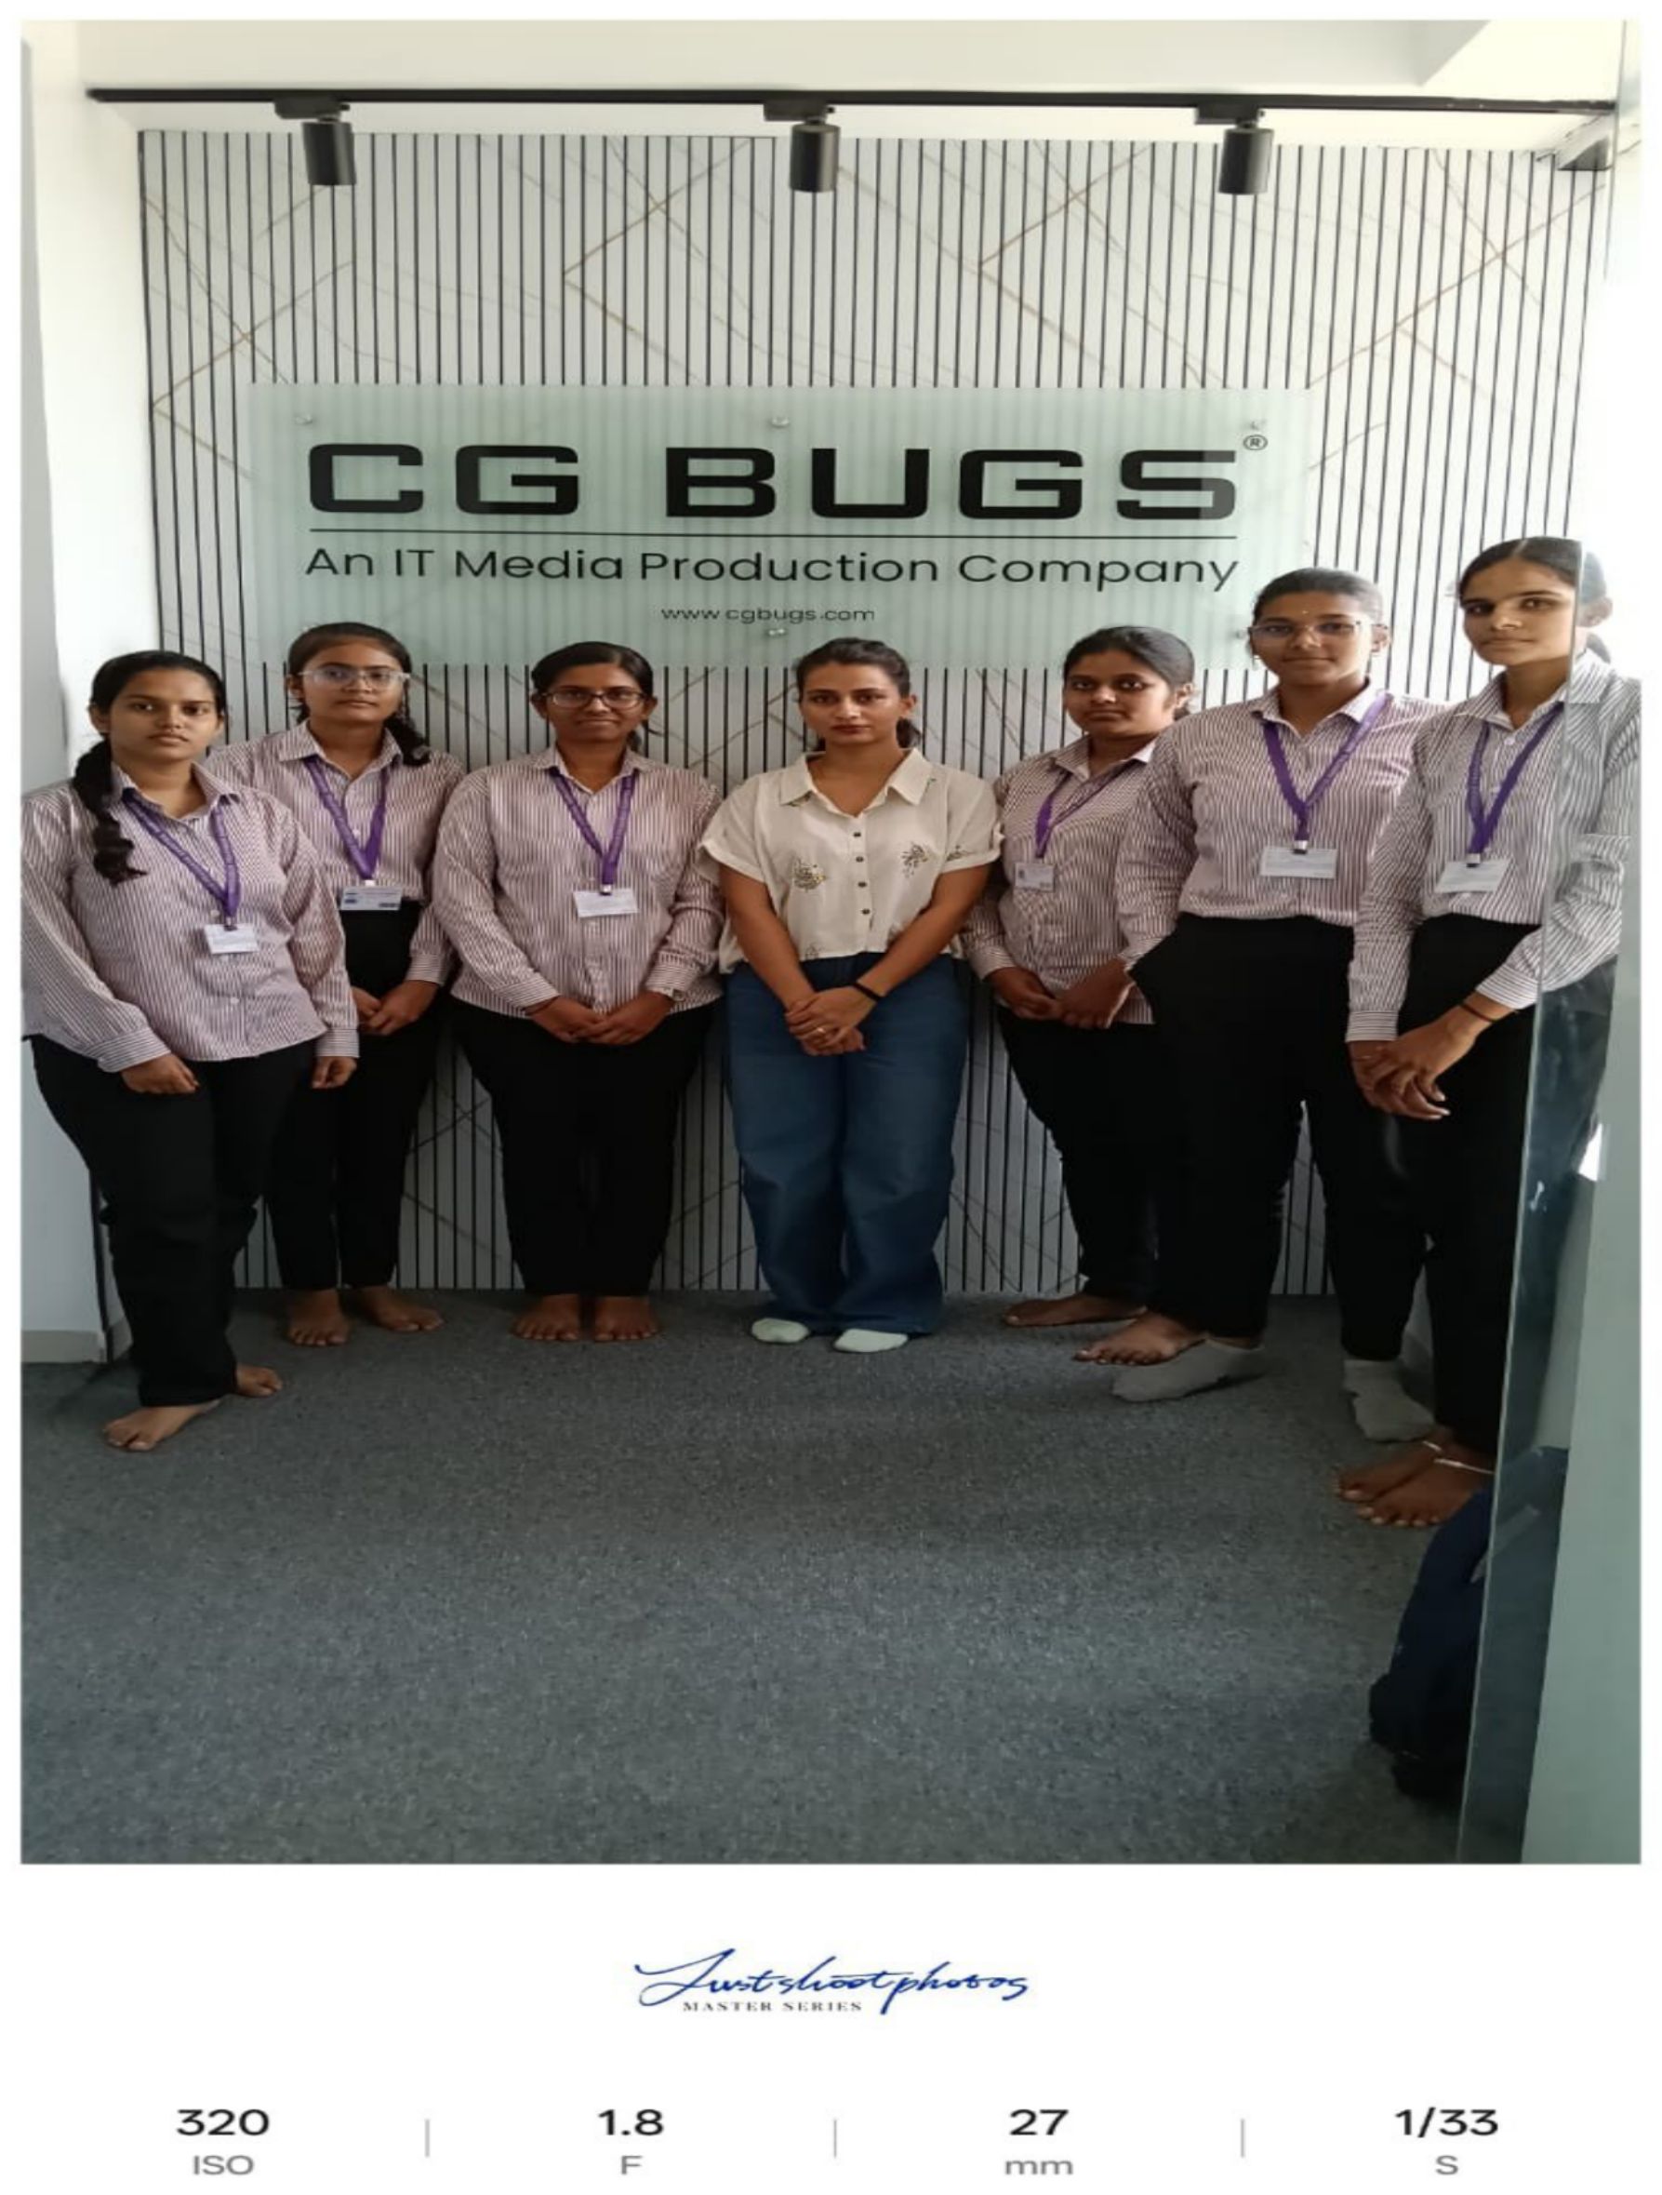
Figure 8.1: Hexa Core Project Team at CG BUGS An IT Media Production Company

