SECURE EVENT MANAGEMENT SYSTEM FOR EDUCATIONAL INSTITUTIONS
Muhammad Afif Najmi bin Mustafa¹, Ts. To Muhd Faizal bin Ahmad²
^{1, 2}Faculty of Computing & Multimedia, Universiti Poly-Tech Malaysia
ABSTRACT
Club and society committees at Universiti Poly-Tech Malaysia (UPTM) still submit event proposals, budgets and post-event reports to the Student Affairs (HEPA) department in hardcopy. The process offers no way to track a submission, no structured approval stages and no record of who reviewed or approved a document, which leaves room for lost files, delays and unauthorised changes. This project developed the Secure Event Management System (SEMS), a web-based platform that manages the full event lifecycle, from proposal submission and HEPA review to the event calendar and post-event reporting. SEMS was built with React.js, Vite and Tailwind CSS on the frontend, Node.js and Express.js on the backend and a MySQL database, following the Agile methodology. Requirements were gathered through a questionnaire with 52 respondents and an interview with a HEPA officer. Security sits at the core of the design: role-based access control (RBAC) for three user roles with club-scoped access, bcrypt password hashing, email one-time passwords, account lockout, JWT session control, rate limiting, secure HTTP headers, multi-layer file upload validation and a detailed audit log. A three-signature sign-off keeps the official BHEP form and its wet-ink requirement intact. All 43 developer test cases passed, the HEPA client accepted the system, and in user acceptance testing with 53 respondents every user reported being satisfied, with 98.1% recommending SEMS to replace the paper-based process. The results show that a centralised, security-focused platform can make campus event governance more efficient, transparent and accountable.
Keywords: Event Management System, Role-Based Access Control, Audit Logging, Secure File Upload, Web Application Security

1.0 INTRODUCTION
Digital technology has changed the way universities run their administration, yet many campus processes in Malaysia are still handled on paper. At Universiti Poly-Tech Malaysia (UPTM), a private university in Kuala Lumpur offering programmes in computing, business and engineering, every registered club and society falls under the Student Affairs department, known as Hal Ehwal Pelajar (HEPA). Whenever a club plans an activity, its committee prints the event proposal, the budget breakdown and, later, the post-event report, and hands them to HEPA staff in person. As administration becomes more complex and the demand for accountability grows, digital systems in higher education have become a necessity rather than an option (Alenezi et al., 2023).
This manual process creates three main problems. First, submission is fragmented. HEPA officers cannot easily tell whether a document has been submitted, committees receive no acknowledgement, and there is no organised view of pending and completed submissions, so documents get lost or delayed. Second, there is no structured approval workflow or access control. Proposals do not move through defined stages, committees have no standard way to resubmit revised documents, and nothing separates what each type of user is allowed to do, even though role-based access control (RBAC) is widely regarded as the key approach to limiting access in educational systems (Khamulyak & Tsehelyk, 2025; Al-Saeed et al., 2026). Third, there is no audit trail or secure document handling. Nobody can tell who submitted, reviewed, queried or approved a document, or when. Missing audit logs and weak access monitoring are among the key factors behind data breaches in universities (Li et al., 2023), and once documents move online, uploads that are not validated can let malicious files in disguised as legitimate paperwork (Eshetu et al., 2024).
This paper presents the Secure Event Management System (SEMS), a web-based platform developed to replace this process. The project had three objectives: (i) to create a centralised web-based platform covering the entire event lifecycle; (ii) to implement RBAC together with a structured approval workflow; and (iii) to implement secure handling of every uploaded file. SEMS serves three roles, namely Club Committee, HEPA Officer and Administrator. Its scope is limited to event-related documents at UPTM, so university-wide document management, financial accounting beyond event budgets and integration with other university systems were left outside the project.

2.0 LITERATURE REVIEW
This section reviews the literature behind the four main ideas in SEMS, namely centralised document management, RBAC, audit logging and secure file handling. It then compares three existing systems to identify the gap that this project fills.

2.1 Centralised Document Management in Institutions
Centralised document management brings submission, review, approval and storage together on one digital platform. Without it, workflows become disjointed, record-keeping varies from one office to another and administrative decisions cannot be traced. Alenezi et al. (2023) found that higher education institutions that replace manual methods with centralised digital systems gain clear improvements in operational efficiency, staff accountability and the speed of decision-making. Lakhani et al. (2026) report a similar result for event management in particular, showing that an integrated digital college event platform reduces administrative workload and shortens approval turnaround. These findings support the main design goal of SEMS, which is to keep every proposal, budget and post-event report in one auditable place.

2.2 Role-Based Access Control
RBAC limits what a user can see and do according to the role they hold in an organisation, which enforces the principle of least privilege. Khamulyak and Tsehelyk (2025) identify RBAC as the most suitable access governance model for educational institutions and warn that unclear permission boundaries create visibility gaps that expose sensitive data. Al-Saeed et al. (2026) add that a formal, well-structured role hierarchy improves both security and long-term maintainability, while a poorly planned one becomes harder to manage as users and features grow. Since the current process at UPTM has no access control at all, SEMS applies RBAC with clearly defined permissions for each role.

2.3 Audit Logging for Accountability
An audit log is an organised record of the important actions in a system: who did what, to which record, and when. It supports accountability, digital forensics and incident investigation. Li et al. (2023) show that missing audit logs and weak access monitoring are major contributors to data breaches in universities, and that institutions without them are far more likely to suffer unauthorised access and data manipulation without noticing. Industry breach reports point in the same direction, with many incidents involving actions that proper logging and access oversight would have exposed (Jartelius, 2020). Li et al. (2023) also caution that logging should capture meaningful events without slowing the system down during busy periods. For these reasons, SEMS records every submission, review decision, query, resubmission and login together with the user, timestamp, IP address and result.

2.4 Secure File Handling
Any system that accepts uploaded files carries the risk of harmful content reaching the server. In their study of university website vulnerabilities, Eshetu et al. (2024) found insecure file handling to be a common target of attacks on higher education web applications, often because institutions underestimate the risk. They recommend several layers of validation: checking the MIME type, whitelisting file extensions, randomising stored file names and keeping files away from direct public access. SEMS applies these layers to every document attached to a proposal.

2.5 Related Systems
Three existing systems were studied. Presence.io is a student engagement platform that helps universities manage student organisations, event discovery, QR code check-ins and participation analytics. However, it focuses on engagement rather than document submission and approval, and its permissions are too basic for institutional document control (Presence-io, 2026). Anthology Engage, formerly Campus Labs Engage, manages clubs, events and co-curricular activities on an enterprise scale, but it separates data at the institution level instead of offering fine-grained roles for a HEPA-style approval process, and its licensing and configuration make it impractical for UPTM (Anthology Inc., 2026). Open Journal Systems (OJS), developed by the Public Knowledge Project (2026), offers a well-defined multi-stage editorial workflow, time-stamped logs of editorial decisions and role-based access for editors, reviewers and authors. It is, however, built for journal manuscripts and has no event calendar, budget review or club-based roles. Table 1 summarises the comparison.
Table 1: Comparison of existing systems with SEMS
CRITERIA | PRESENCE.IO | ANTHOLOGY ENGAGE | OJS | SEMS
Main focus | Student engagement and event participation | Enterprise student engagement management | Journal manuscript publishing | Campus event proposal governance
Event proposal and budget submission | No | No | No | Yes
Structured multi-stage approval | No | No | Yes | Yes
Role-based access for the approval process | Basic permissions | Institution-level isolation | Yes | Yes, with club scope
Time-stamped audit trail | No | Not specified | Yes | Yes
Secure file upload validation | No | No | Not a focus | Yes
Campus event calendar | Yes | Yes | No | Yes

None of the three systems covers the whole UPTM process on its own. SEMS therefore combines the auditable multi-stage workflow demonstrated by OJS with the campus event focus of Presence.io and Anthology Engage, and builds RBAC, secure file validation and audit logging into its foundation.

3.0 METHODOLOGY
SEMS was developed using the Agile methodology. This section describes the development approach, how the requirements were gathered, and how the system and its security framework were designed and implemented.

3.1 Agile Development Approach
SEMS is not a single component but a set of modules that depend on one another: login and role checks, the proposal form, HEPA review and decision-making, file uploads, the event calendar and the audit log running in the background. Building all of them in one pass, as the Waterfall model would require, was risky, especially because the requirements came from a real client and continued to change. Agile breaks the work into short sprints, and each sprint goes through planning, design, development, testing and review, as shown in Figure 1. A fault in the RBAC module, for example, could be caught within its own sprint instead of months later, and feedback from HEPA could be taken in throughout the project. Each sprint began by setting its goal and what "done" meant. The design step then worked out the affected database tables, wireframes and API endpoints, including how security controls such as file validation would be structured. Development stayed limited to the features of that sprint, and every feature was tested for function and, where relevant, for security before the sprint closed.
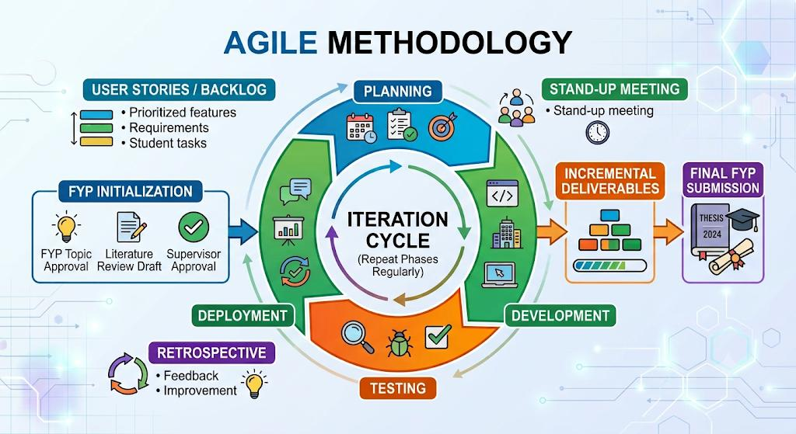
Figure 1: Agile methodology applied in the development of SEMS

3.2 Requirement Gathering
Requirements were gathered in two ways: an online questionnaire for UPTM students, club committee members and staff, and an interview with a HEPA officer. The questionnaire was distributed through Google Forms and received 52 responses, mostly from general students (55.8%) and club and society committee members (40.4%). The results confirmed the problem. When asked about delays, lost documents or confusion over approvals, 75.0% said this happened sometimes and 23.1% said it happened often, leaving only 1.9% who had never experienced it. Concern about data being manipulated in manual forms was high, with 69.2% rating it at level 4, and 73.1% were unsure whether the current process could show who approved an event and when. Respondents also had clear priorities for the new system. RBAC was chosen as the most critical security feature (92.3%), followed by secure file upload restrictions (90.4%), audit logs (63.5%) and secure authentication (55.8%). Readiness for change was strong, as 75.0% strongly agreed that they would use the new system and the remaining 25.0% said it would depend on how easy it was to use.
The interview with Encik Mohd Harith bin Yahya from the HEPA office corrected an important assumption. Approval is not a simple approve-or-reject decision: HEPA may accept a proposal or return it with queries, after which the committee revises and resubmits it. The interview also confirmed that all paperwork is currently submitted in hardcopy, that it is hard to know which officer is holding a particular file, and that HEPA's main security concern is unauthorised changes to approved budget figures. These findings shaped the workflow of SEMS and led to the decision to lock approved budgets behind RBAC, validate every file on the server and keep an audit log that cannot be edited.

3.3 System Requirements
Based on these findings, the functional requirements in Table 2 were defined. The non-functional requirements were that pages should load within five seconds, the interface should be simple enough for non-technical committee members, no data should be lost during submission, and every action that changes a record should be traceable to a user and a timestamp. The Student role was removed from the requirements midway through development, so the final system serves three roles. Because all role checks were centralised in one middleware, this change was made safely without disturbing the rest of the system.
Table 2: Functional requirements of SEMS
REQUIREMENT | DESCRIPTION
User authentication | Registration verified by email OTP; login with bcrypt-hashed passwords and JWT sessions.
Role-based access control | Separate permissions for Club Committee, HEPA Officer and Administrator, with club-scoped access.
Event proposal submission | A five-step wizard for event details, organiser, budget, supporting documents and a final review.
Approval workflow | HEPA officers approve, query or reject proposals with remarks after confirming a three-signature sign-off.
Resubmission | Queried proposals can be revised and resubmitted, keeping the version number and HEPA remarks.
BHEP form generation | The official BHEP.ML.01.04A-00 form is filled automatically from the proposal for printing.
Event calendar | Approved events are displayed on a monthly calendar.
Post-event reporting | Committees submit a report after the event for HEPA to review.
User and club management | Administrators create and approve accounts, assign roles and manage clubs.
Audit logging | Every key action is recorded with the user, IP address, browser and result.

3.4 System Design and Implementation
The frontend is a single-page application built with React.js, Vite and Tailwind CSS, with support for dark mode, and it communicates with a REST API built on Node.js and Express.js. The backend handles the business logic, input validation and access control. Data is stored in a MySQL (MariaDB) database running on XAMPP, made up of ten tables linked by foreign keys: users, clubs, proposals, proposal_documents, proposal_budget_items, proposal_remarks, post_event_reports, otp_codes, audit_logs and system_settings, as shown in Figure 2. A club can have many users and many proposals, each proposal can have many documents, budget items, remarks and post-event reports, and every audit entry links back to the user who performed the action. The proposals table also stores a version number that increases with each resubmission, along with the HEPA officer who confirmed the sign-off and the time it was confirmed. The security libraries used are bcrypt, JSON Web Token, Multer, Helmet and express-rate-limit, while Nodemailer sends the OTP and notification emails. The system was developed in Visual Studio Code and tested in Google Chrome.
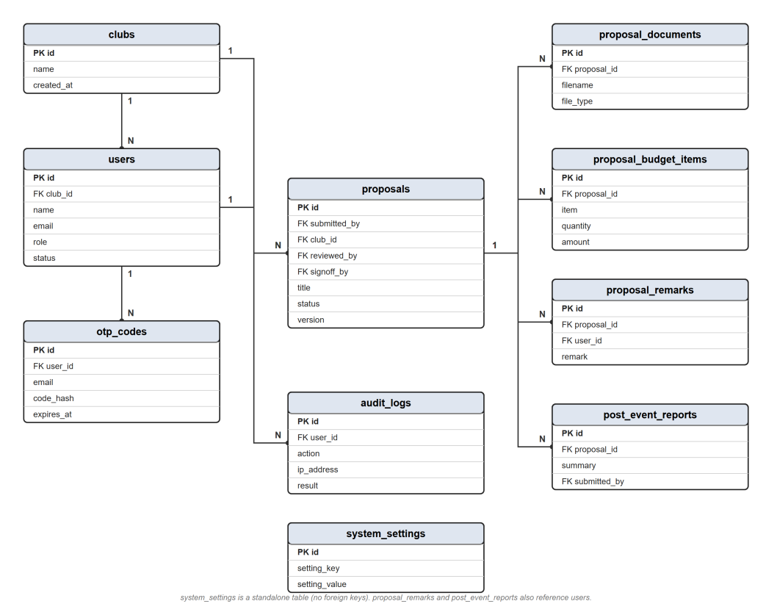
Figure 2: Entity Relationship Diagram (ERD) of SEMS

The interface gives each role only the pages it needs. Club committees see their proposals grouped by status and create new ones through the five-step wizard. HEPA officers work from a review queue sorted by priority, and before a proposal can be approved, they must confirm the three required signatures, namely Advisor/BHEP, Setiausaha ATAP Kolej and Pengarah. The Approve button stays disabled until all three are ticked, and the confirmation is written to the audit log (Figure 3). SEMS then generates the official BHEP.ML.01.04A-00 form from the proposal so that it can be printed for wet-ink signatures, which keeps the existing official procedure intact. Administrators manage users, clubs and system settings, and they can filter the audit log and export it as a CSV file.
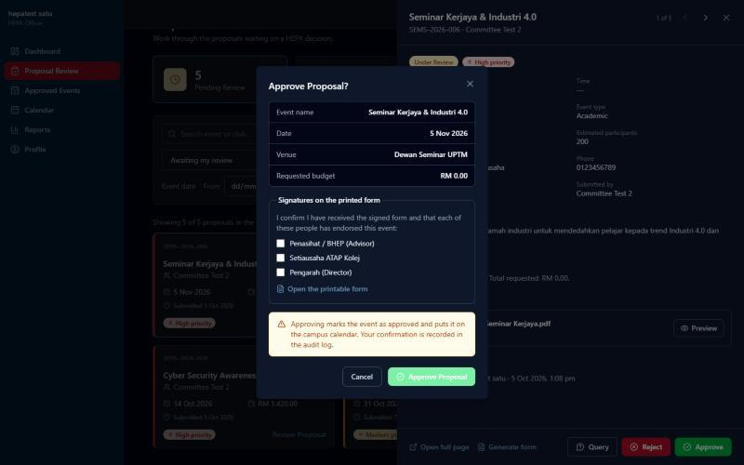
Figure 3: Proposal approval with three-signature sign-off confirmation

3.5 Security System Framework
Security is the focus of this project, in line with the Cyber Security specialisation (CT206). SEMS is protected in layers, as illustrated in Figure 4. A request from the browser passes through the network and transport layer (HTTPS, Helmet with a Content-Security-Policy, and rate limiting), the authentication layer (email OTP, bcrypt password hashing, account lockout and JWT sessions), the authorisation layer (RBAC and club-scoped access) and the application layer (input validation, secure file upload and business logic). It finally reaches the data layer, where passwords are stored only as hashes and every key action is written to the audit log. Table 3 maps each control to the security principle it supports.
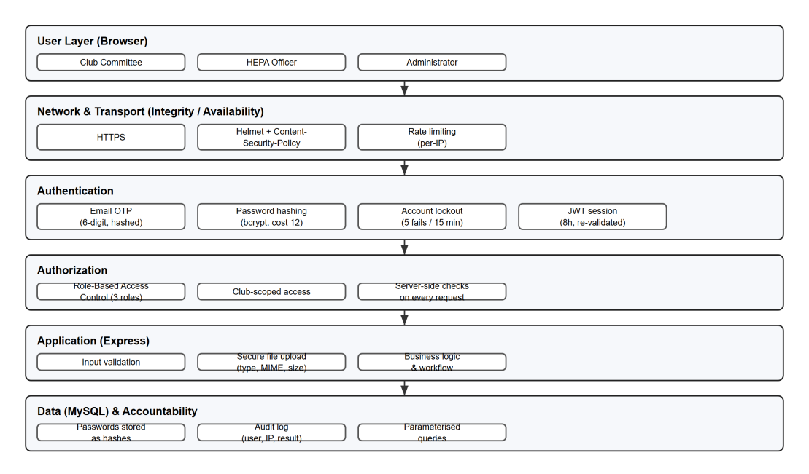
Figure 4: Security system framework of SEMS

Table 3: Security controls mapping
NO | SECURITY CONTROL | PRINCIPLE | IMPLEMENTATION IN SEMS
1 | Password hashing (bcrypt, cost 12) | Confidentiality | Passwords are stored only as bcrypt hashes, never in plain text
2 | Role-based access control | Authorisation | The server checks the user's role on every protected route
3 | Club-scoped access | Authorisation | A committee can open only its own club's proposals
4 | Account lockout | Authentication | Five failed logins lock the account for 15 minutes
5 | Rate limiting | Availability | Login and OTP limited to 10 requests per 15 minutes; 300 requests per 15 minutes per IP overall
6 | Email OTP verification | Authentication | Six-digit code, stored hashed, valid for 10 minutes with five attempts
7 | Session control (JWT, 8 hours) | Authentication | Tokens issued before a password change are refused; deactivation applies immediately
8 | Audit logging | Accountability | Every key action is logged with the user, IP address, browser and result
9 | Secure file upload | Integrity | Extension and MIME whitelist, size limit and a random file name on disk
10 | Secure HTTP headers (Helmet and CSP) | Integrity | Security headers and a Content-Security-Policy on every response

Two of these controls are worth a closer look. Every uploaded file is checked three times: the extension must be on the allowed list, the MIME type must match the extension, and the file must stay within the size limit. Accepted files are then saved under a random name so that the original cannot be requested directly, while a disallowed file such as an .exe is rejected. Session control also goes beyond token expiry. When a user changes their password, every token issued earlier is refused, which signs out all other devices, and when an administrator deactivates an account, access ends on the very next request.

4.0 FINDINGS AND DISCUSSION
SEMS was evaluated through non-functional testing (performance, security, usability and reliability), functional testing (unit, integration and system) and acceptance testing with the client and real users. All 43 developer test cases passed, as summarised in Table 4.
Table 4: Summary of developer testing results
TESTING TYPE | TEST CASES | PASSED
Performance | 4 | 4
Security | 6 | 6
Usability | 5 | 5
Reliability | 4 | 4
Unit | 10 | 10
Integration | 8 | 8
System | 6 | 6
Total | 43 | 43

4.1 Non-Functional Testing
Performance was well within the five-second target. The club dashboard loaded in 1.19 seconds, the HEPA review queue with 25 proposals in 1.17 seconds and the administrator dashboard with its charts in 1.01 seconds, while a proposal submitted with two PDF attachments was processed in 0.09 seconds. The security tests in Table 5 show that every control behaved as designed.
Table 5: Security testing results
ID | TEST | EXPECTED | ACTUAL RESULT | STATUS
NFT-S01 | Club committee accesses HEPA or admin data | 403 Forbidden | HEPA proposal list and user list both returned 403 | Passed
NFT-S02 | Approve without confirming the sign-off | Blocked | HTTP 400; status remained under review | Passed
NFT-S03 | Passwords stored as hashes | No plain text | 13 of 13 passwords stored as bcrypt (cost 12) | Passed
NFT-S04 | Five wrong passwords entered | Account locked | Locked; correct password then refused (429); ACCOUNT_LOCKED logged | Passed
NFT-S05 | Committee opens another club's proposal | 403 Forbidden | 403 "You do not have access to this proposal" | Passed
NFT-S06 | Upload a disallowed file type (.exe) | Rejected | HTTP 400: file extension ".exe" is not allowed | Passed

Usability testing covered desktop and mobile layouts, dark mode and form validation, and it uncovered two problems that had not been obvious during coding. Some grey text in dark mode did not meet the WCAG AA contrast standard, and the proposal form zoomed in on phones because its input text was smaller than 16 pixels. Once the colours were corrected and the input text was set to 16 pixels on small screens, all 818 text elements across five pages met WCAG AA, with the lowest contrast measured at 4.7:1, and the form stopped zooming. Reliability tests confirmed that drafts kept their data when reopened, that a resubmitted proposal became version 2 while keeping the HEPA remark, and that deactivating an account or changing a password ended other sessions immediately.

4.2 Functional Testing
Unit testing checked ten modules with valid and invalid inputs. These included registration validation, OTP verification, login lockout, wizard validation, budget calculation (50 × RM6.00 + 1 × RM120.00 correctly totalled RM420.00), file type validation, the remark required for a review decision, the sign-off checkboxes, BHEP form generation and the rule that administrators cannot change their own role. Integration testing confirmed that data moved correctly between modules: from registration through OTP to login, from submission to the HEPA queue, from a query back to resubmission, and from approval to the event calendar, with eight audit entries recorded for a single proposal. System testing followed a proposal through its whole lifecycle, from submitted to under review, queried, resubmitted and finally approved. It also covered the forgot-password flow, administrator tasks, CSV export of the audit log and analytics counts, all of which matched the database.

4.3 Acceptance Testing
Client acceptance testing took place on 7 October 2026 with Encik Mohd Harith bin Yahya, Assistant Manager of the Co-Curriculum and Entrepreneurship Sector (Student Affairs and Alumni) at UPTM, whose sector approves club event proposals and budgets. He walked through proposal submission and review, the three-signature sign-off, the generated BHEP form, the audit log and the analytics, and he accepted every aspect, confirming that SEMS matches the current HEPA process and meets its requirements. His only concern was the cost of maintaining the system and who would be responsible for it.
User acceptance testing (UAT) was conducted through Google Forms and received 53 responses from people who had used the system, 94.3% of whom tested it as club committee members. Statements were rated on a four-point scale from 1 (strongly disagree) to 4 (strongly agree). Table 6 summarises the key results, and Figure 5 shows overall satisfaction.
Table 6: Key results of user acceptance testing (53 respondents)
STATEMENT | RESULT
Could complete the main task from start to finish | 98.1% agree (60.4% strongly)
Proposal flow matches UPTM's approval process | 100% agree
Generated BHEP form showed the correct details | 100% agree (81.1% strongly)
Could always see a proposal's status and who acted on it | 100% agree
Trust SEMS to keep information secure | 100% agree
Menus, buttons and labels were clear | 100% agree
Overall satisfaction | 100% satisfied (56.6% very satisfied)
Would recommend SEMS to replace the paper-based process | 98.1% yes

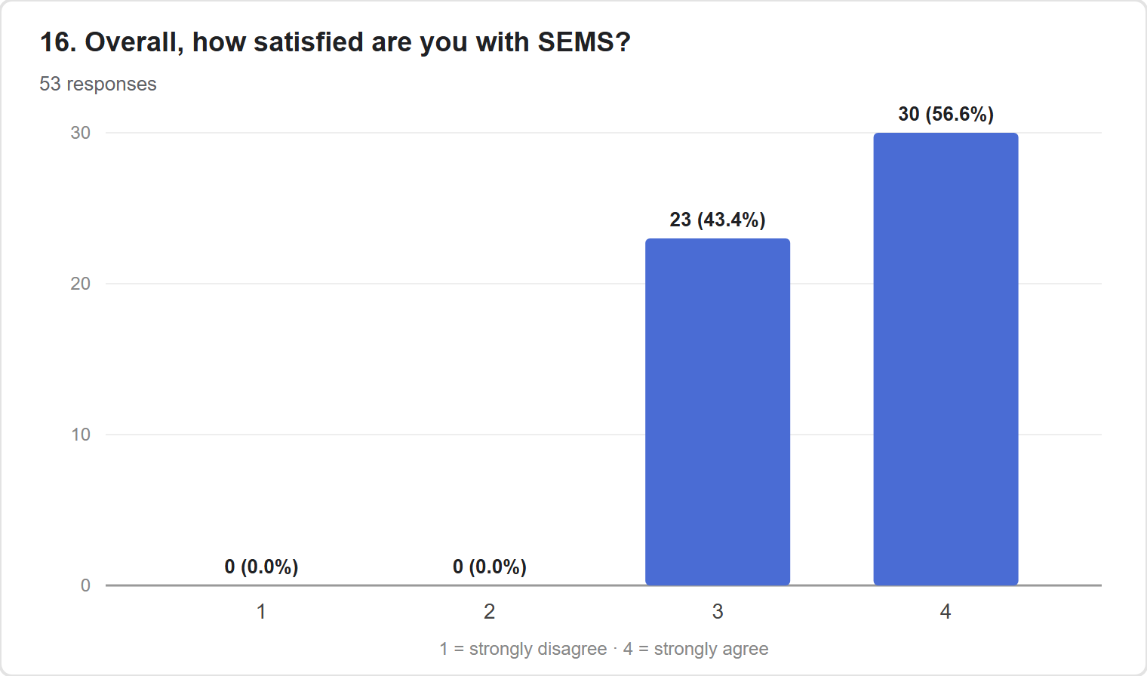
Figure 5: Overall user satisfaction with SEMS

When asked what they would change, 56.6% of respondents said nothing, 22.6% asked for a mobile app and 11.3% wanted more reports. About a quarter (24.5%) found a page slightly confusing, although none reported a serious problem.

4.4 Discussion
The results show that all three objectives were achieved. The first objective, a centralised platform, is demonstrated by the integration and system tests in which a proposal passed through every stage, from submission to the calendar and the post-event report, with all data kept in a single database. The second objective, RBAC with a structured approval workflow, is supported by the access control tests (NFT-S01 and NFT-S05), the sign-off test (UNIT-8) and the full lifecycle test (SYS-1). The third objective, secure file handling, is confirmed by tests UNIT-6 and NFT-S06, in which valid PDF files were accepted and an executable file was refused. These results respond directly to the questionnaire, where RBAC and file upload restrictions were the two most requested security features. The strong UAT scores also suggest that the added security did not make the system harder to use, a common pitfall of digital transformation in higher education (Alenezi et al., 2023).
SEMS still has some limitations. It was designed around the HEPA process and BHEP form at UPTM, so another institution would need to adapt it. During the project, it ran from a laptop through a public tunnel, which meant access depended on the laptop staying on. Finally, the system records who confirmed the sign-off and when, but the wet-ink signatures themselves remain on paper and are not captured digitally.

5.0 CONCLUSION
This project moved the club event proposal and approval process at UPTM from paper to a secure web-based system while keeping the official BHEP form and its wet-ink sign-off. SEMS combines a centralised event lifecycle, a structured approval workflow and layered security controls, including RBAC with club scoping, bcrypt hashing, email OTP, account lockout, JWT session control, rate limiting, secure headers, multi-layer file validation and a detailed audit log. All 43 test cases passed, the HEPA client accepted the system and every UAT respondent was satisfied with it. The project also showed that keeping security and access control centralised makes change easier to manage, as seen when the Student role was removed during development, and that testing with real users reveals problems that coding alone does not.
Future work should begin with hosting, by moving SEMS from a laptop and public tunnel to a UPTM server maintained by the IT unit or to a cloud server, which would also answer the client's concern about maintenance cost and ownership. A digital signature could then replace the wet-ink signatures so that the whole approval is tracked within the system. A mobile app with push notifications would help users receive updates more quickly, and configurable roles and forms would allow other institutions to adopt the system.
REFERENCES
Alenezi, M., Wardat, S., & Akour, M. (2023). The need of integrating digital education in higher education: Challenges and opportunities. Sustainability, 15(6), 4782. https://doi.org/10.3390/su15064782
Al-Saeed, M., Al-Mulla, A., & Al-Otaibi, S. (2026). A formalized zoned role-based framework for the analysis, design, implementation, maintenance and access control of integrated enterprise systems. Computers, 15(3), 187. https://doi.org/10.3390/computers15030187
Anthology Inc. (2026). Anthology Engage help center. https://help.anthology.com/engage/?lang=en
Eshetu, A., Salau, A. O., & Jain, S. (2024). Cybersecurity vulnerabilities and solutions in Ethiopian university websites. Journal of Big Data, 11(1), 1–22. https://doi.org/10.1186/s40537-024-00980-z
Jartelius, M. (2020). The 2020 Data Breach Investigations Report – a CSO's perspective. Network Security, 2020(7), 9–12. https://doi.org/10.1016/S1353-4858(20)30079-9
Khamulyak, V., & Tsehelyk, H. (2025). Role-based access in education systems: Designing visibility and compliance governance. Preprints.org. https://doi.org/10.20944/preprints202511.1587.v1
Lakhani, S., Sharma, P., Parmar, M., Patel, D., Shrivastava, S., & Parmar, J. (2026). Evently-AI-Powered College Event Management System. International Journal of Research and Innovation in Applied Science (IJRIAS), 11(2), 1699–1709. https://doi.org/10.51584/IJRIAS.2026.110200158
Li, J., Xiao, W., & Zhang, C. (2023). Data security crisis in universities: Identification of key factors affecting data breach incidents. Humanities and Social Sciences Communications, 10(1), 1–13. https://doi.org/10.1057/s41599-023-01757-0
Presence-io. (2026). Presence-io features and automation platform. https://presence-io.com/en/
Public Knowledge Project. (2026). Open Journal Systems (OJS). Simon Fraser University. https://pkp.sfu.ca/software/ojs/

