Coding Academy by Orange



MASTERPIECE PROJECT Title: Idea Media

Developed by: Najlaa Al-Smadi

Orange Coding Academy – Irbid

Fourth Cohort 2024

Acknowledgments

I would like to begin by expressing my profound gratitude to God Almighty for granting me the strength and capability to successfully complete this project. I am also deeply appreciative of the invaluable opportunity provided to me by the Programming Academy from Orange. My heartfelt thanks go out to all the dedicated trainers who have supported and guided us throughout this journey. In particular, I would like to acknowledge the exceptional leadership and mentorship of Mr. Muhammad Freihat, Director of Irbid Academy, along with our job coach Amer Abu Al Hayja, technical trainer Ayman Aljaradat, and coach Batool Al Dalki. Their unwavering support and expertise have been truly instrumental in making this project a success.

Abstract

The project focuses on developing an online platform dedicated to teaching and promoting various handcrafts. This platform aims to empower individuals by providing comprehensive learning paths in fields such as carpentry, knitting, resin art, and more, helping users develop their skills and launch their own projects. Additionally, the platform offers an integrated marketplace where users can buy and sell handcrafted items and necessary tools. By combining education with business opportunities, the platform not only fosters skill development but also creates a vibrant community for artisans. Key features include interactive courses, expert mentorship, support for users, and a seamless e-commerce experience. The goal is to create a unique space where education and entrepreneurship converge, enabling users to both learn and profit from their crafts.

**1.1 Problem Statement**

Individuals interested in learning handcrafts often face several challenges, including a lack of access to quality educational resources, insufficient guidance on starting and managing their own craft businesses, and difficulty in finding a platform that connects learning with a marketplace to sell their products. Additionally, many aspiring artisans struggle to find mentors who can provide ongoing support, and those who wish to sell their handmade items often face challenges in marketing and reaching a broad audience. Moreover, traditional training methods can be costly, time-consuming, or limited to specific geographic locations.

**1.2 Solution**

The proposed platform addresses these challenges by offering an integrated online solution that combines comprehensive handcraft courses with a marketplace for artisans. It allows users to enroll in interactive, video-based courses that cover various handcraft skills such as carpentry, knitting, and resin art. The platform also provides mentorship and continuous support from expert artisans, helping users develop their skills and start their own businesses. Additionally, the platform includes an online marketplace where users can showcase and sell their handmade products, providing them with a direct channel to potential customers. By combining education and entrepreneurship, this solution fosters a community of artisans and empowers users to transform their skills into profitable ventures.

Edimedia Project

Contents  
  
Chapter 1: Introduction ............................................................................................. 2  
 1.1 Objective ........................................................................................................ 2  
 1.2 Technologies Used for Edimedia ................................................................ 2  
  
Chapter 2: Requirements and Analysis ................................................................ 3  
 2.1 Functional Requirements .............................................................................. 3  
 2.2 Non-Functional Requirements ...................................................................... 4  
 2.3 Test Cases for Edimedia ................................................................................. 5  
  
Chapter 3: Design ................................................................................................... 6  
 3.1 Database Schema .......................................................................................... 6  
 - Relationships ................................................................................................. 6  
  
Chapter 4: Conclusion & Future Work ................................................................. 9  
 4.1 Conclusion .................................................................................................... 9  
 4.2 Future Work ................................................................................................... 9

# Chapter 1: Introduction

## 1.1 Objective

The Edimedia project aims to build an educational platform that offers comprehensive learning paths for various handicrafts by integrating digital media and interactive content. Users can develop skills in fields like woodworking, knitting, resin art, and more. The platform provides opportunities for professional growth and entrepreneurship, alongside a marketplace for selling handmade products and craft-related tools.

## 1.2 Technologies Used for Edimedia

HTML/CSS and JavaScript: For developing an interactive user interface and providing a smooth user experience.  
SQL Server: To manage and store data related to users, courses, workshops, and transactions.  
Visual Studio and GitHub: For software development and version control.  
REST API: To serve interactive media such as videos and articles.

# Chapter 2: Requirements and Analysis

## 2.1 Functional Requirements

Content Management: Teachers should be able to add, edit, and delete courses and workshops.  
Search Functionality: Users must be able to search for courses and workshops using different filters such as category, difficulty, or popularity.  
User Authentication: Users must be able to create accounts, log in, and update their personal information.  
Payment Gateway: The platform should support online payment for premium courses and workshops.  
Marketplace: The system should include a section where users can buy tools and materials related to the crafts they learn.

## 2.2 Non-Functional Requirements

Performance: The platform must handle a large number of concurrent users without lag.  
Security: User data, including payment details, should be encrypted and secure.  
Scalability: The platform should be scalable to accommodate increasing numbers of courses, users, and products.  
Responsive Design: The design should be adaptable to different screen sizes, such as mobile devices and tablets.

## 2.3 Test Cases for Edimedia

Account Creation and Login: Verify that users can create accounts and log in successfully with valid credentials.  
Search and Filter: Test the functionality of search filters to ensure users find relevant courses based on their input.  
Payment Process: Ensure that payments for courses and workshops are processed securely and correctly.  
Marketplace: Validate that users can browse products, add items to their cart, and complete purchases seamlessly.

# Chapter 3: Design

## 3.1 Database Schema

The database design for Edimedia includes several key tables to manage users, courses, products, and orders. Below are the main tables and their relationships:  
- Users Table: Stores user details like name, email, role (student, teacher).  
- Courses Table: Contains information about available courses, such as title, description, teacher ID, and price.  
- Products Table: Manages items in the marketplace, including product name, description, price, and stock.  
- Orders Table: Logs transactions and purchases made by users in the marketplace.  
- Reviews Table: Stores user reviews and ratings for courses and products.

### Relationships

Users and Courses: A user can enroll in many courses, and each course can have multiple users enrolled, forming a Many-to-Many relationship.  
Users and Reviews: Users can leave reviews for multiple courses and products, which creates a One-to-Many relationship between users and reviews.  
Courses and Reviews: Each course can have several reviews, forming a One-to-Many relationship.  
Users and Orders: Each user can make multiple orders, establishing a One-to-Many relationship between users and orders.

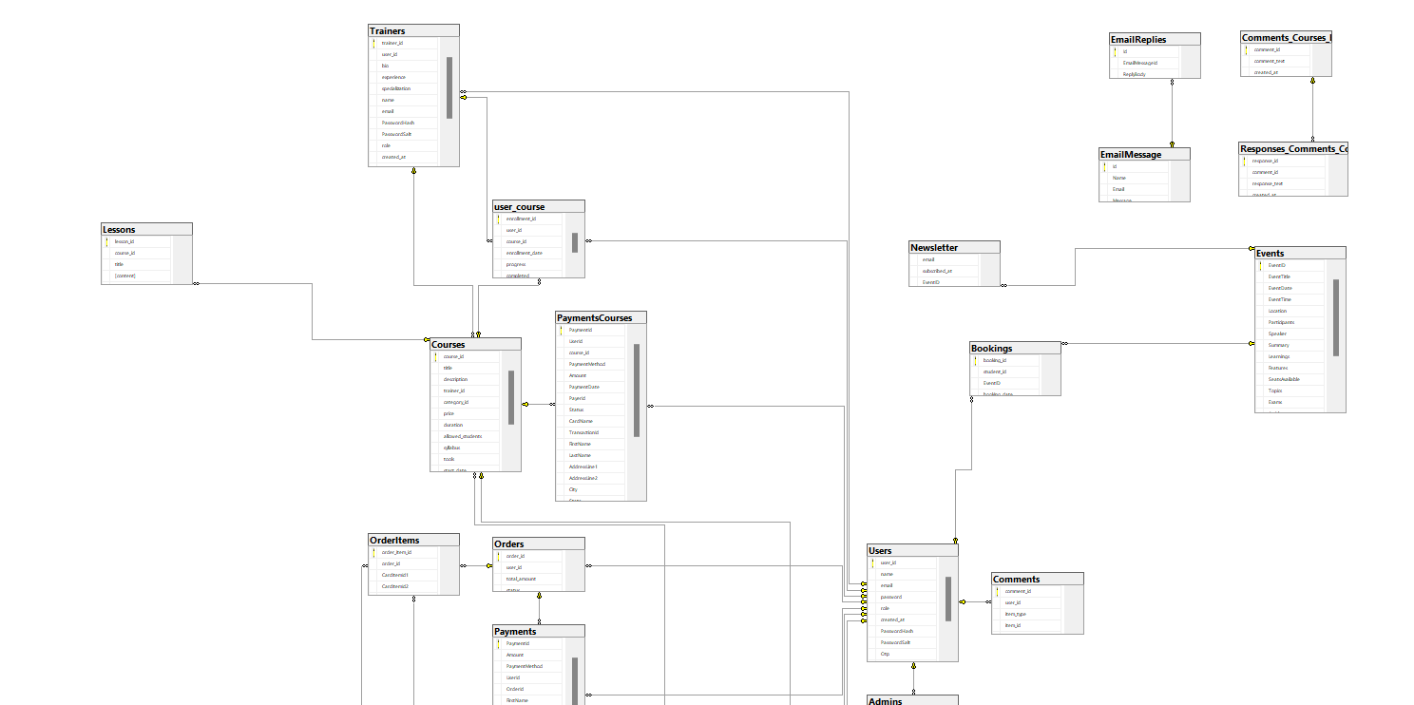

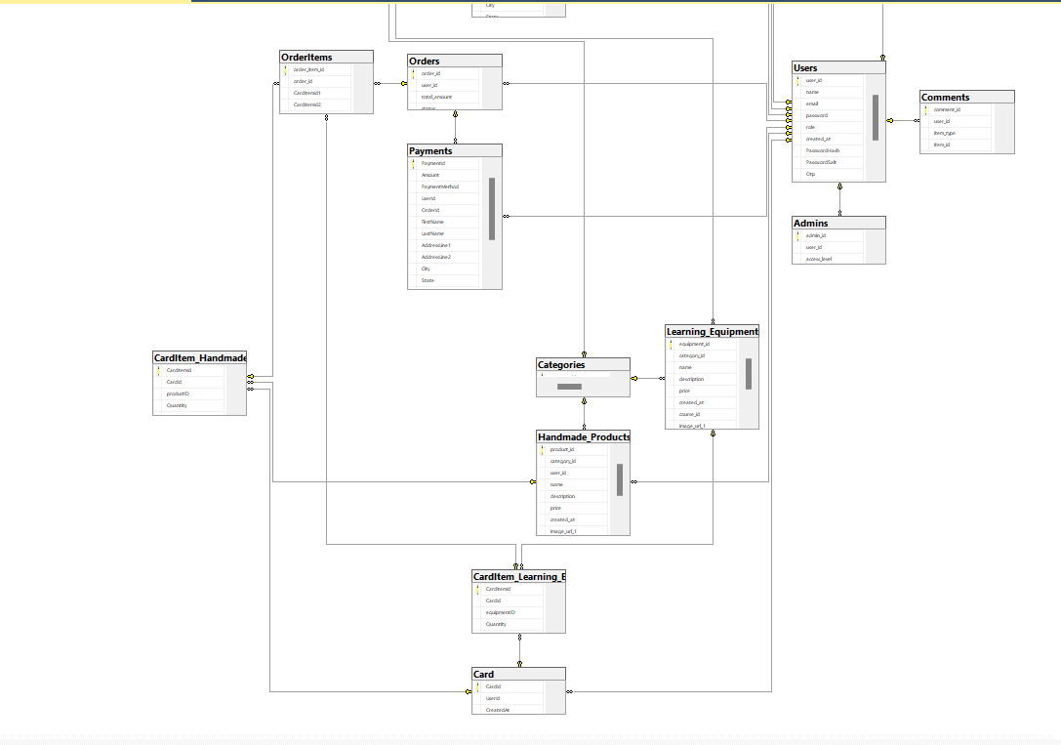

# Chapter 4: Conclusion & Future Work

## 4.1 Conclusion

The Edimedia project successfully integrates craft education with digital interactivity, offering a comprehensive platform for users to learn, create, and grow their skills. It combines professional craftsmanship with business opportunities, giving users access to high-quality, structured learning materials.

## 4.2 Future Work

Future improvements could include:  
- Adding More Craft Categories: Expanding the platform to include a wider variety of crafts such as digital art, calligraphy, or photography.  
- Multilingual Support: Implementing support for different languages to reach a global audience.  
- Augmented Reality (AR) Integration: Introducing AR features for real-time guidance during hands-on projects.  
- Social Media Integration: Allowing users to share their projects and achievements directly to social media platforms.