P R O C E S S S Y N C H R O N I Z A T I O N
A Comprehensive Comparison of Process Synchronization Mechanisms
Dekker • Peterson • Semaphore • Monitor • Readers–Writers

Details
Title | A Comprehensive Comparison of Process Synchronization Mechanisms
Course | Embedding System
Author | Najla Davarpanah
Instructor | Majid Shamshirgaran
University / Faculty | Eshragh University
Date | 10 November 2026

English edition

Abstract and Contents
When several processes access shared data concurrently, a correct synchronization mechanism is required to avoid inconsistency. This article compares five well-known approaches: Dekker's and Peterson's software algorithms for two processes, semaphores as an operating-system primitive, monitors as a language-level construct, and the classical readers–writers problem. Each is presented with pseudocode, C code, a flowchart, an execution trace, worked examples and exam-style questions. Comparison tables cover mutual exclusion, progress, bounded waiting, starvation, deadlock, busy waiting, scalability and more, and charts visualise the differences.
Keywords: synchronization, critical section, mutual exclusion, Dekker, Peterson, semaphore, monitor, readers–writers
Contents
1 | Introduction and the Critical-Section Problem
2 | Dekker's Algorithm
3 | Peterson's Algorithm
4 | Semaphores
5 | Monitors
6 | Readers–Writers Problem
7 | Comprehensive Comparison Tables
8 | Charts
9 | Examples and Exam Questions
10 | Conclusion
11 | References

1. Introduction and the Critical-Section Problem
In multiprocess and multithreaded systems, processes read and write shared data to exchange information or use common resources. If concurrent access is not controlled, the result depends on the exact interleaving of instructions, a phenomenon called a race condition.
A classic example: processes P1 and P2 execute counter++ and counter-- respectively on a shared variable counter = 5. At machine level each statement takes three steps: load into a register, modify the register, store back to memory. Depending on how the steps interleave, the final value may be 4, 5 or 6, although only 5 is correct.

Structure of a critical section
The part of the code that touches shared data is the critical section (CS). Each process has four parts: entry, critical section, exit and remainder. The algorithms in this article are different ways of building the entry and exit sections.
Pseudocode — general structure
do {
ENTRY SECTION // ask for permission
CRITICAL SECTION // touches shared data
EXIT SECTION // give permission to others
REMAINDER SECTION
} while (true);

The three correctness requirements
- Mutual exclusion: at most one process is inside the critical section at any time.
- Progress: if the critical section is free and some processes want to enter, only those processes take part in deciding who enters next, and the decision cannot be postponed indefinitely; a process in its remainder section must not block others.
- Bounded waiting: from the moment a process requests entry until it is granted, the number of times other processes enter first is bounded (no starvation).
Assumptions: nothing is assumed about the relative speed of processes, and reading or writing a simple variable is treated as an atomic action.

Classification of the methods
Table 1 — Classification of the methods
Method | Type | Implementation level | Requirements
Dekker | Software algorithm | User program | Shared memory only
Peterson | Software algorithm | User program | Shared memory only
Semaphore | Synchronization primitive | OS kernel / library | Atomic operations and a wait queue
Monitor | Structured construct | Language / library | Lock + condition variables
Readers–Writers | Classical problem | Design pattern | Solved with semaphores or monitors

Note
“Readers–writers” is a problem, not a primitive. In the comparison tables its column refers to the standard semaphore solution (reader priority); other solutions are noted separately.

In brief
A race condition arises when the result depends on the interleaving of operations on shared data. A correct solution must guarantee mutual exclusion, progress and bounded waiting without assuming anything about relative process speeds.

2. Dekker's Algorithm
Dekker's algorithm is the first correct software solution to the critical-section problem for two processes. It was devised by the Dutch mathematician T. J. Dekker and published by Dijkstra in 1965. It uses only shared memory and needs no special hardware instruction.

Idea
There are two shared variables: the array flag[2], which tells whether each process wants to enter, and turn, which decides priority in case of conflict. A process first announces its interest; if the rival is also interested and the turn is not its own, it backs off (lowers its flag), waits until it is its turn, and tries again. This back-off is what removes the deadlock of simpler schemes.
Pseudocode — process Pi (j = 1 - i)
shared: boolean flag[2] = {false, false};
int turn = 0;

Pi:
repeat
flag[i] = true;
while (flag[j] == true) {
if (turn != i) { // not my turn: back off
flag[i] = false;
while (turn != i) ; // wait for my turn
flag[i] = true;
}
}
// ---- CRITICAL SECTION ----
turn = j; // hand priority to the other
flag[i] = false;
// ---- REMAINDER SECTION ----
forever
C code (C11 atomics)
#include <stdatomic.h>
#include <stdbool.h>

atomic_bool flag[2] = { false, false };
atomic_int turn = 0;

void dekker_enter(int i) {
int j = 1 - i;
atomic_store(&flag[i], true);
while (atomic_load(&flag[j])) {
if (atomic_load(&turn) != i) {
atomic_store(&flag[i], false);
while (atomic_load(&turn) != i) { /* busy wait */ }
atomic_store(&flag[i], true);
}
}
}

void dekker_exit(int i) {
atomic_store(&turn, 1 - i);
atomic_store(&flag[i], false);
}
The code uses atomic variables with the default seq_cst ordering. On modern processors, replacing them with ordinary variables lets memory reordering break the algorithm.
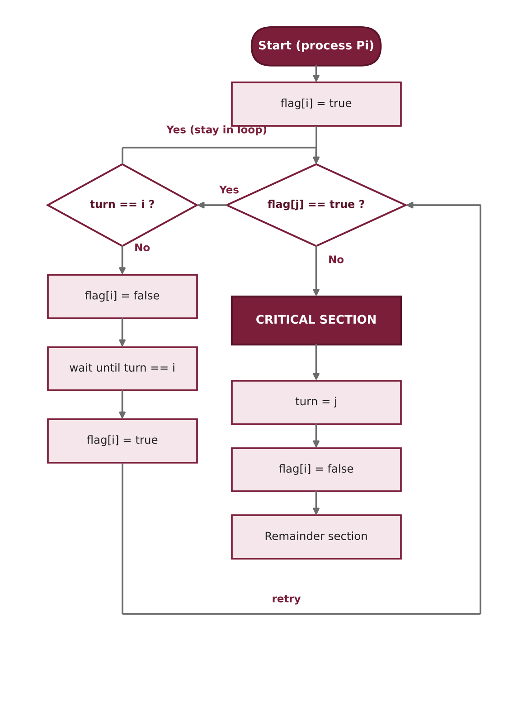
Figure 1 — Flowchart of Dekker's algorithm for process Pi

Execution trace
Assume turn = 0 and both processes want to enter at the same time:
Table 2 — Dekker trace (both processes request entry)
Step | P0 | P1 | f[0] | f[1] | turn
1 | flag[0]=true | flag[1]=true | T | T | 0
2 | flag[1] is true; turn==0 → stays in loop | flag[0] is true; turn≠1 → flag[1]=false | T | F | 0
3 | flag[1] is false → enters CS | waits for turn==1 | T | F | 0
4 | turn=1; flag[0]=false (exit) | turn==1 → flag[1]=true | F | T | 1
5 | remainder section | flag[0] is false → enters CS | F | T | 1

Properties
- Mutual exclusion: holds; entry is possible only when flag[j] is seen false.
- Progress: holds; if the rival is not interested, flag[j]=false and the process enters regardless of turn.
- Bounded waiting: holds; on exit turn is given to the rival, so each process waits for at most one entry of the rival.
- Drawbacks: only two processes; busy waiting; subtle logic; needs memory ordering on modern hardware.
In brief
Dekker's algorithm (1965) uses flag[2] to announce intent and turn to resolve conflicts; the process without priority backs off by lowering its flag. It guarantees mutual exclusion, progress and bounded waiting, but only for two processes and with busy waiting.

3. Peterson's Algorithm
In 1981 G. L. Peterson published a much simpler two-process solution. The variables are the same (flag[2] and turn), but the logic is one of politeness: a process that wants to enter announces its interest and then gives the turn to the rival. If both want to enter at once, the one that wrote turn last has yielded and waits.
Pseudocode — process Pi (j = 1 - i)
shared: boolean flag[2] = {false, false};
int turn;

Pi:
repeat
flag[i] = true; // I am interested
turn = j; // but you go first
while (flag[j] == true && turn == j) ; // wait
// ---- CRITICAL SECTION ----
flag[i] = false; // I am done
// ---- REMAINDER SECTION ----
forever
C code (C11 atomics)
#include <stdatomic.h>
#include <stdbool.h>

atomic_bool flag[2] = { false, false };
atomic_int turn;

void peterson_enter(int i) {
int j = 1 - i;
atomic_store(&flag[i], true);
atomic_store(&turn, j);
while (atomic_load(&flag[j]) && atomic_load(&turn) == j) {
/* busy wait */
}
}

void peterson_exit(int i) {
atomic_store(&flag[i], false);
}
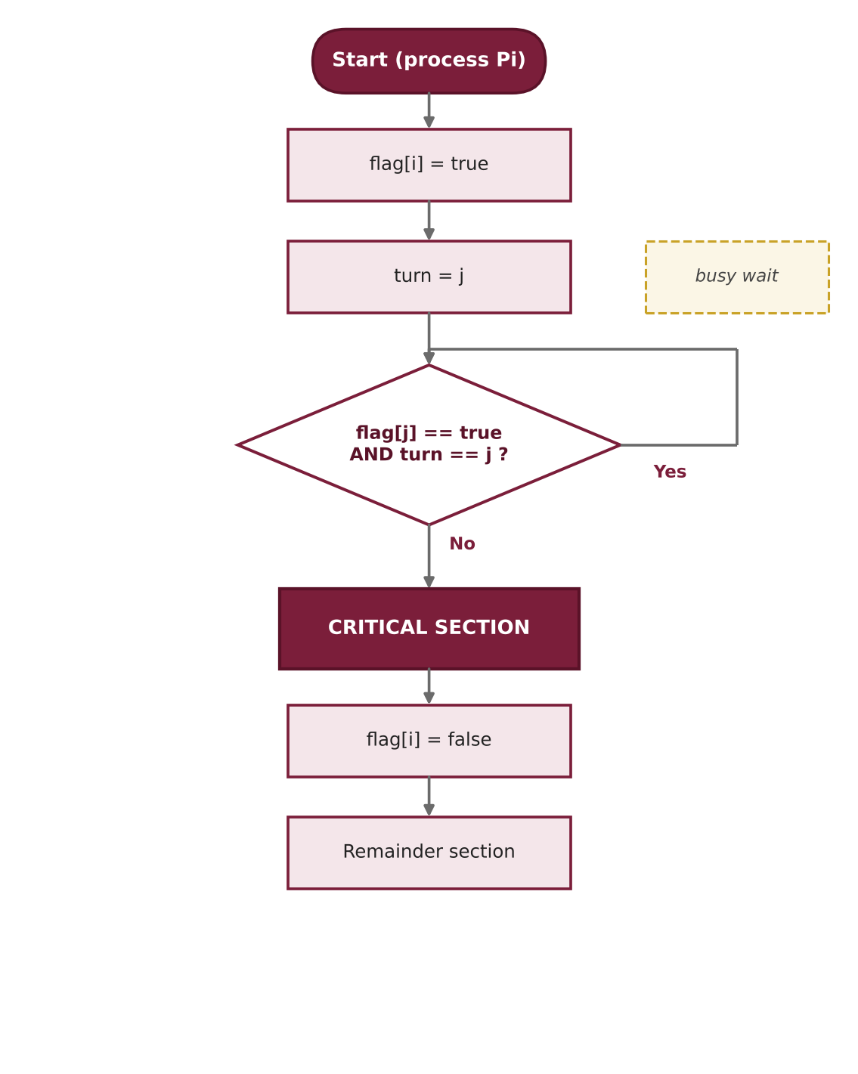
Figure 2 — Flowchart of Peterson's algorithm

Short proof of mutual exclusion
Suppose P0 and P1 are both in the critical section. Each saw the loop condition false before entering. P0 saw either flag[1] false or turn==0; but P1 had already written flag[1]=true and keeps it until exit, so P0 must have seen turn==0. Symmetrically P1 must have seen turn==1. Since turn is a single variable and the last writer decides, both cannot hold at once — a contradiction.

Execution trace
Table 3 — Peterson trace (both processes request entry)
Step | P0 | P1 | f[0] | f[1] | turn
1 | flag[0]=true | — | T | F | ?
2 | — | flag[1]=true | T | T | ?
3 | turn=1 | — | T | T | 1
4 | — | turn=0 (last writer) | T | T | 0
5 | flag[1]&&turn==1? false → enters | flag[0]&&turn==0? true → waits | T | T | 0
6 | flag[0]=false (exit) | condition false → enters | F | T | 0

Properties and notes
- Mutual exclusion, progress and bounded waiting all hold; the rival enters at most once before you.
- Drawbacks: only two processes, busy waiting, and it needs sequentially consistent memory; without seq_cst or a memory fence, the store buffer can reorder flag[i]=true and the read of flag[j], letting both processes enter.
- Generalisation to N processes is possible with the filter lock or the Bakery algorithm, at higher cost and complexity.
In brief
Peterson's algorithm (1981) simplifies Dekker's idea: a process sets its flag and then yields the turn to the other. The last writer of turn waits. It satisfies all three requirements for two processes in a few lines, but needs sequentially consistent memory and busy waiting.

4. Semaphores
Semaphores were introduced by Dijkstra in 1965. A semaphore is an integer S modified only through two atomic operations: wait (Dijkstra's P, *proberen*) and signal (V, *verhogen*). Unlike Dekker and Peterson, semaphores work for N processes, and in the blocking implementation a waiting process is put to sleep in a queue instead of spinning, which frees the processor.

Definition and blocking implementation
Pseudocode — semaphore operations
typedef struct { int value; queue list; } semaphore;

wait(S): // P, down (executed atomically)
S.value = S.value - 1;
if (S.value < 0) {
add this process to S.list;
block(); // sleep: no busy waiting
}

signal(S): // V, up (executed atomically)
S.value = S.value + 1;
if (S.value <= 0) {
remove a process P from S.list;
wakeup(P);
}
In this implementation a negative value of S equals the number of waiting processes. Two common kinds exist: the binary semaphore (mutex) with value 0 or 1 for mutual exclusion, and the counting semaphore for multi-instance resources.
Pseudocode — mutual exclusion
semaphore mutex = 1;

Pi:
repeat
wait(mutex);
// ---- CRITICAL SECTION ----
signal(mutex);
// ---- REMAINDER SECTION ----
forever
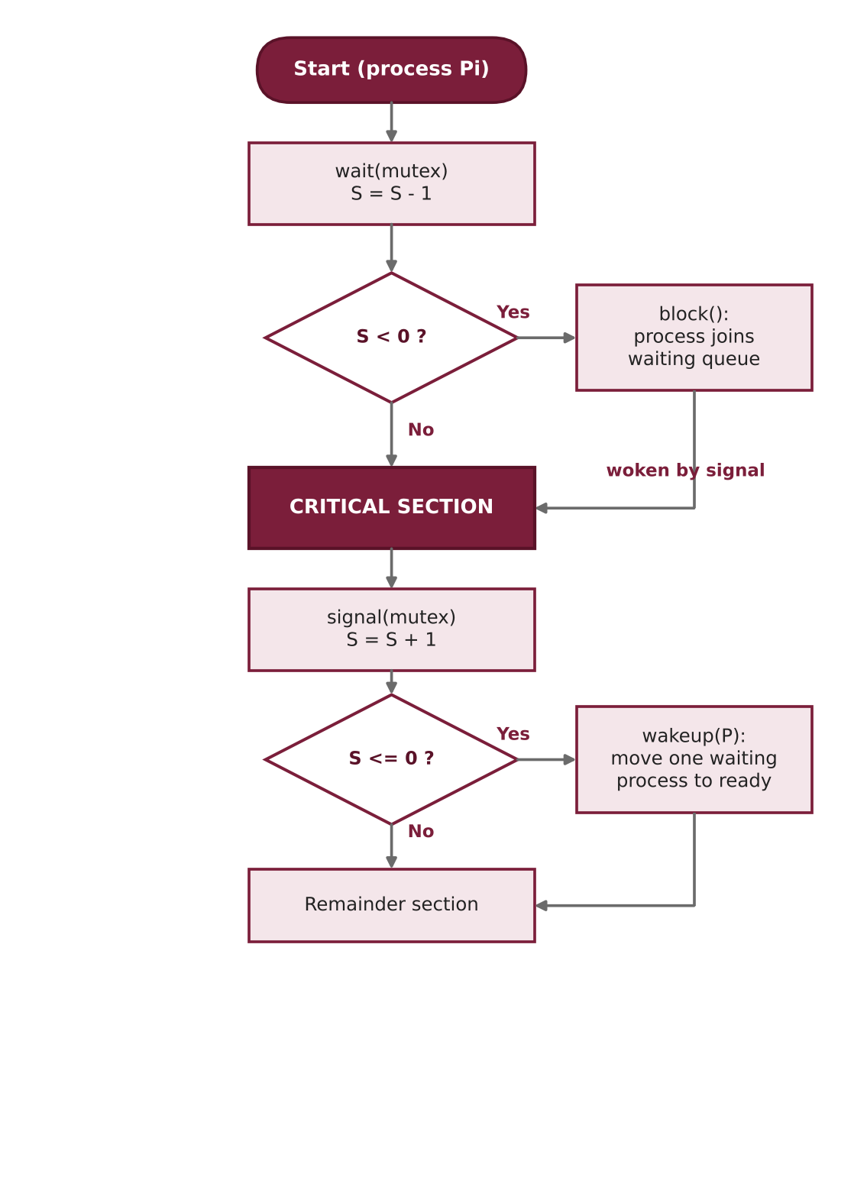
Figure 3 — Flowchart of semaphore usage (wait / signal)

Example: bounded-buffer producer–consumer
Three semaphores are needed: empty (free slots, initially N), full (filled slots, initially 0) and mutex (exclusive access to the buffer).
Pseudocode
semaphore mutex = 1, empty = N, full = 0;

Producer: Consumer:
repeat repeat
item = produce(); wait(full);
wait(empty); wait(mutex);
wait(mutex); item = remove();
insert(item); signal(mutex);
signal(mutex); signal(empty);
signal(full); consume(item);
forever forever
C code (POSIX threads + semaphores)
#include <pthread.h>
#include <semaphore.h>
#define N 8

int buf[N], in = 0, out = 0;
sem_t empty, full, mutex;

void *producer(void *arg) {
for (int i = 0; i < 100; i++) {
sem_wait(&empty);
sem_wait(&mutex);
buf[in] = i; in = (in + 1) % N;
sem_post(&mutex);
sem_post(&full);
}
return NULL;
}

void *consumer(void *arg) {
for (int i = 0; i < 100; i++) {
sem_wait(&full);
sem_wait(&mutex);
int x = buf[out]; out = (out + 1) % N;
sem_post(&mutex);
sem_post(&empty);
(void)x; /* use the item here */
}
return NULL;
}

int main(void) {
pthread_t p, c;
sem_init(&empty, 0, N);
sem_init(&full, 0, 0);
sem_init(&mutex, 0, 1);
pthread_create(&p, NULL, producer, NULL);
pthread_create(&c, NULL, consumer, NULL);
pthread_join(p, NULL);
pthread_join(c, NULL);
return 0;
}

Properties and pitfalls
- Mutual exclusion and progress hold with correct use. Bounded waiting depends on the queue policy: a strong semaphore (FIFO queue) guarantees it, a weak one (arbitrary wake-up) does not.
- Deadlock: a wrong order of operations, e.g. wait(mutex) before wait(empty) in the producer, can deadlock.
- Error-prone: forgetting a signal or swapping wait and signal breaks mutual exclusion or blocks processes forever; it is an unstructured, low-level tool.
- Priority inversion may occur and calls for protocols such as priority inheritance.
In brief
A semaphore is an integer manipulated only by atomic wait (P) and signal (V). Blocking semaphores avoid busy waiting and work for any number of processes, but are low-level and error-prone. Bounded waiting holds only with FIFO (strong) semaphores.

5. Monitors
Monitors were proposed by C. A. R. Hoare (1974) and Brinch Hansen to reduce the error-proneness of semaphores. A monitor is an abstract data type that holds shared data and the procedures that access it, and the language or compiler guarantees that at most one process is active inside its procedures at any time, so the programmer does not write wait/signal for mutual exclusion.
For conditional synchronization (e.g. “the buffer is not empty”) a monitor uses condition variables with two operations: x.wait() blocks the process and releases the monitor lock, and x.signal() wakes one waiting process. Unlike a semaphore signal, a condition signal with no waiter has no effect and is not remembered.

Two signal semantics
- Hoare (signal-and-wait): the signalling process hands the monitor to the woken one immediately; the condition is guaranteed to hold, so if suffices.
- Mesa (signal-and-continue): the signaller continues and the woken process re-acquires the lock later; the condition may have changed, so a `while` loop is required. Java, pthreads and most real systems follow Mesa.
Pseudocode — bounded-buffer monitor
monitor BoundedBuffer {
int buf[N]; int count = 0, in = 0, out = 0;
condition notFull, notEmpty;

procedure put(x) {
while (count == N) notFull.wait();
buf[in] = x; in = (in + 1) % N; count++;
notEmpty.signal();
}

procedure get() {
while (count == 0) notEmpty.wait();
x = buf[out]; out = (out + 1) % N; count--;
notFull.signal();
return x;
}
} // at most one process is active inside at any time
C code (pthread mutex + condition variables)
#include <pthread.h>
#define N 8

static int buf[N], in = 0, out = 0, count = 0;
static pthread_mutex_t m = PTHREAD_MUTEX_INITIALIZER; /* monitor lock */
static pthread_cond_t notFull = PTHREAD_COND_INITIALIZER;
static pthread_cond_t notEmpty = PTHREAD_COND_INITIALIZER;

void put(int x) {
pthread_mutex_lock(&m); /* enter monitor */
while (count == N) pthread_cond_wait(&notFull, &m);
buf[in] = x; in = (in + 1) % N; count++;
pthread_cond_signal(&notEmpty);
pthread_mutex_unlock(&m); /* exit monitor */
}

int get(void) {
pthread_mutex_lock(&m);
while (count == 0) pthread_cond_wait(&notEmpty, &m);
int x = buf[out]; out = (out + 1) % N; count--;
pthread_cond_signal(&notFull);
pthread_mutex_unlock(&m);
return x;
}
In Java the same pattern is written with synchronized and wait()/notifyAll(). C has no built-in monitor; here it is emulated with a lock and condition variables.
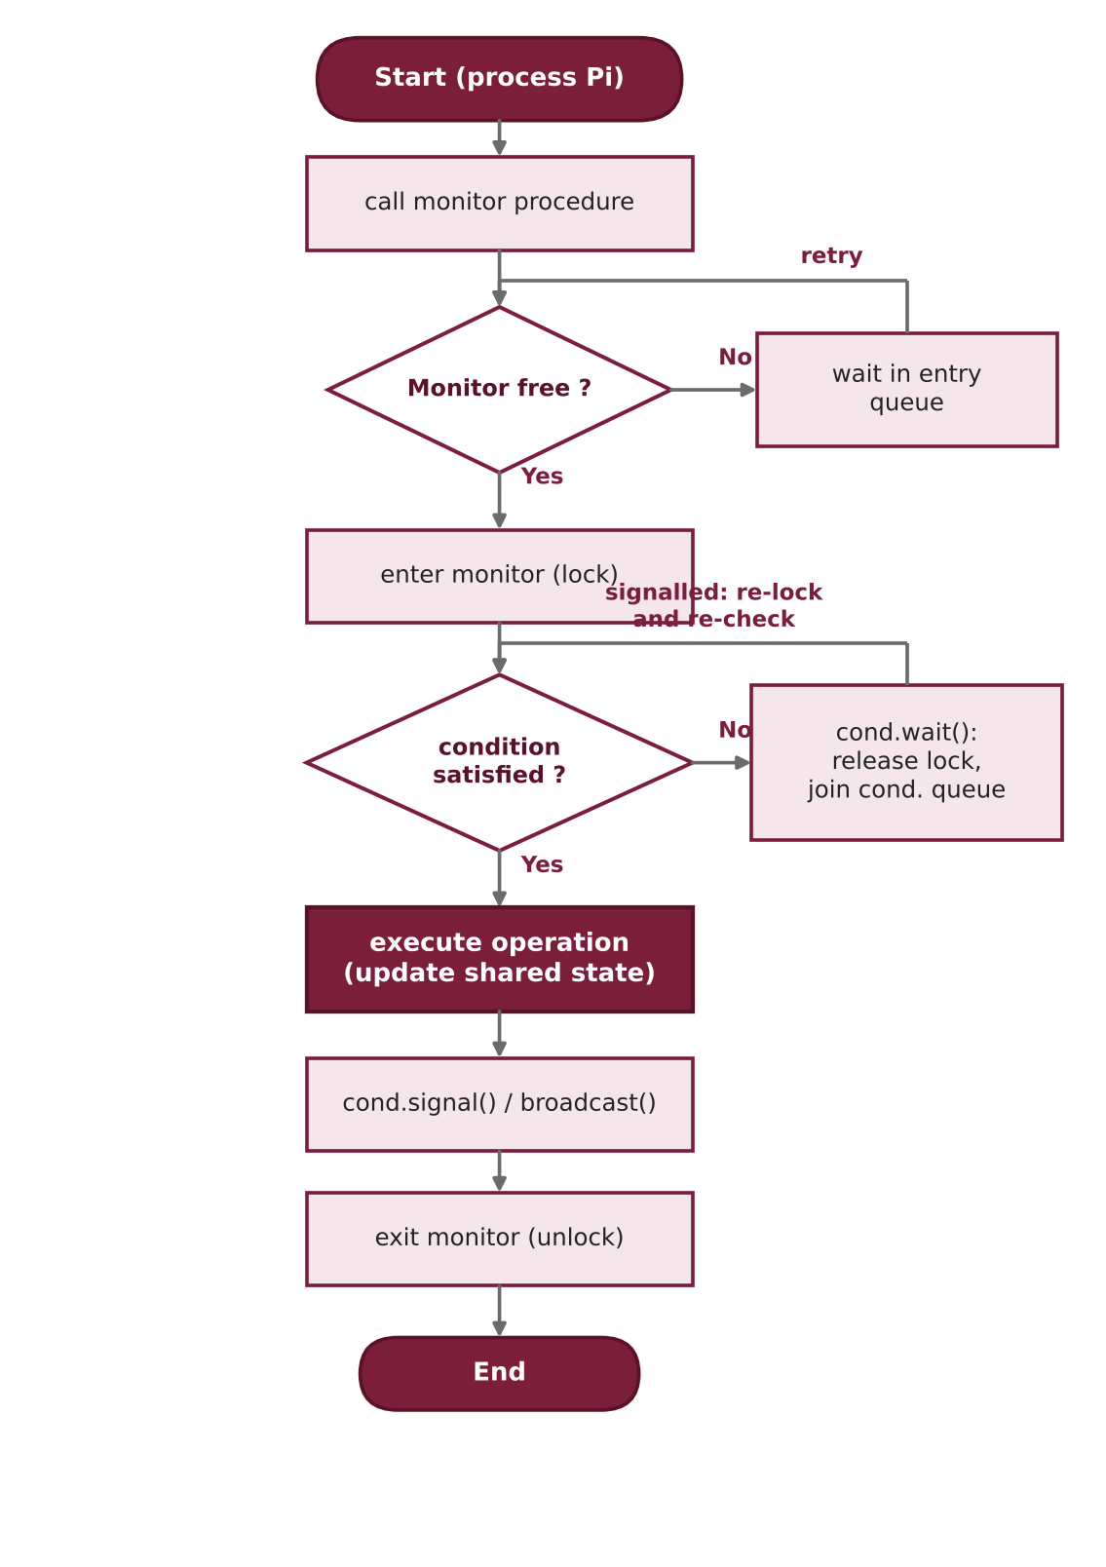
Figure 4 — Flowchart of monitor entry/exit with a condition variable

Properties and pitfalls
- Automatic, structured mutual exclusion; the safest and most readable tool in this article.
- Deadlock is still possible, e.g. through nested monitor calls that hold another lock.
- Starvation is possible under Mesa semantics if woken processes repeatedly find the condition false and the queue is not fair.
- Needs language or library support; has lock and context-switch costs.
In brief
A monitor bundles shared data and its procedures; the language guarantees that only one process is active inside at a time. Condition variables provide conditional synchronization; a signal with no waiter is lost. With Mesa semantics, always re-check the condition in a while loop.

6. Readers–Writers Problem
The readers–writers problem was posed by Courtois, Heymans and Parnas in 1971. A shared data object (e.g. a database) is used by readers, which only read and may run concurrently, and writers, which need fully exclusive access: no other writer and no reader may be active together with a writer. Unlike plain mutual exclusion, concurrency among readers is allowed and raises throughput.

Three variants
Table 4 — Variants of the readers–writers problem
Variant | Rule | Consequence
First — reader priority | While some reader is reading, a new reader may enter | Possible writer starvation
Second — writer priority | When a writer is waiting, no new reader may enter | Possible reader starvation
Third — fair | Entry in arrival order (FIFO) for all requests | No starvation; less concurrency

Semaphore solution (reader priority)
rw_mutex controls access to the data, read_count holds the number of active readers, and mutex protects read_count. The first reader locks writers out and the last reader lets them in again.
Pseudocode
semaphore rw_mutex = 1, mutex = 1;
int read_count = 0;

Writer: Reader:
wait(rw_mutex); wait(mutex);
// WRITE read_count++;
signal(rw_mutex); if (read_count == 1) wait(rw_mutex);
signal(mutex);
// READ
wait(mutex);
read_count--;
if (read_count == 0) signal(rw_mutex);
signal(mutex);
C code (POSIX semaphores)
#include <semaphore.h>

sem_t rw_mutex, mutex; /* both initialised to 1 */
int read_count = 0;

void writer(void) {
sem_wait(&rw_mutex);
/* ... write shared data ... */
sem_post(&rw_mutex);
}

void reader(void) {
sem_wait(&mutex);
if (++read_count == 1) sem_wait(&rw_mutex); /* first reader */
sem_post(&mutex);

/* ... read shared data ... */

sem_wait(&mutex);
if (--read_count == 0) sem_post(&rw_mutex); /* last reader */
sem_post(&mutex);
}
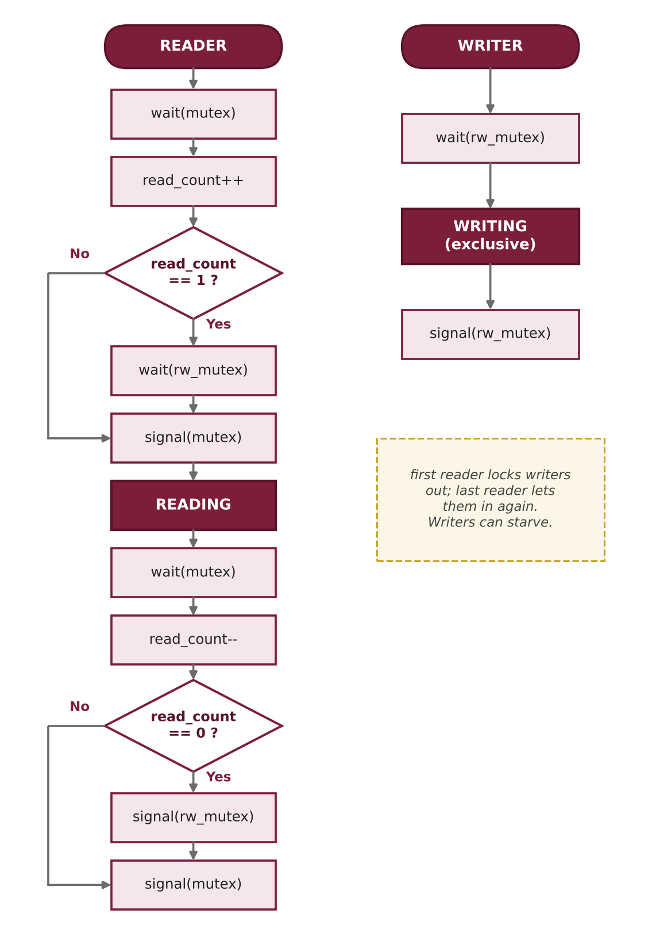
Figure 5 — Flowchart of reader and writer (semaphore solution)

Fair version with semaphores
Adding a queue semaphore service that every request passes through preserves arrival order:
Pseudocode — third problem
semaphore service = 1, rw_mutex = 1, mutex = 1; int read_count = 0;

Reader: Writer:
wait(service); wait(service);
wait(mutex); wait(rw_mutex);
if (++read_count == 1) signal(service);
wait(rw_mutex); // WRITE
signal(service); signal(rw_mutex);
signal(mutex);
// READ
wait(mutex);
if (--read_count == 0) signal(rw_mutex);
signal(mutex);

Monitor solution (writer priority)
Pseudocode
monitor ReadersWriters {
int readers = 0, waitingWriters = 0; boolean writing = false;
condition okToRead, okToWrite;

procedure startRead() {
while (writing || waitingWriters > 0) okToRead.wait();
readers++;
}
procedure endRead() {
readers--;
if (readers == 0) okToWrite.signal();
}
procedure startWrite() {
waitingWriters++;
while (writing || readers > 0) okToWrite.wait();
waitingWriters--; writing = true;
}
procedure endWrite() {
writing = false;
if (waitingWriters > 0) okToWrite.signal();
else okToRead.broadcast();
}
}
C code (pthread monitor)
#include <pthread.h>

static pthread_mutex_t m = PTHREAD_MUTEX_INITIALIZER;
static pthread_cond_t okToRead = PTHREAD_COND_INITIALIZER;
static pthread_cond_t okToWrite = PTHREAD_COND_INITIALIZER;
static int readers = 0, writing = 0, waitingWriters = 0;

void start_read(void) {
pthread_mutex_lock(&m);
while (writing || waitingWriters > 0) pthread_cond_wait(&okToRead, &m);
readers++;
pthread_mutex_unlock(&m);
}
void end_read(void) {
pthread_mutex_lock(&m);
if (--readers == 0) pthread_cond_signal(&okToWrite);
pthread_mutex_unlock(&m);
}
void start_write(void) {
pthread_mutex_lock(&m);
waitingWriters++;
while (writing || readers > 0) pthread_cond_wait(&okToWrite, &m);
waitingWriters--; writing = 1;
pthread_mutex_unlock(&m);
}
void end_write(void) {
pthread_mutex_lock(&m);
writing = 0;
if (waitingWriters > 0) pthread_cond_signal(&okToWrite);
else pthread_cond_broadcast(&okToRead);
pthread_mutex_unlock(&m);
}
POSIX also provides a ready-made reader–writer lock (pthread_rwlock_t), which is preferable to hand-written code in practice.
In brief
Readers may share the data; a writer needs exclusive access. The first solution (reader priority) can starve writers, the second (writer priority) can starve readers, and the third uses a service queue to be fair. Both semaphores and monitors can implement all three.

7. Comprehensive Comparison Tables
This section compares the five methods on correctness parameters (Table 5) and engineering parameters (Table 6). The “Readers–Writers” column refers to the standard semaphore solution (reader priority) unless stated otherwise.
Table 5 — Correctness and behaviour
Parameter | Dekker | Peterson | Semaphore | Monitor | Readers–Writers
Mutual exclusion | ✔ | ✔ | ✔ (if used correctly) | ✔ (automatic) | ✔ (writer vs. all)
Progress | ✔ | ✔ | ✔ | ✔ | ✔
Bounded waiting | ✔ (at most once) | ✔ (at most once) | Only with FIFO queue | Usually with FIFO queue | Variant 1 ✘, variant 3 ✔
Starvation | None | None | Possible (weak semaphore) | Possible (Mesa) | Writer (var. 1) / reader (var. 2)
Deadlock | None | None | Possible with wrong order | Possible (nested calls) | Possible with wrong order
Busy waiting | Yes | Yes | No (blocking type) | No | No
Fairness | Nearly fair (2 procs) | Fair (2 procs) | Depends on queue | Depends on cond. queue | Variant 3 is fair
Reader concurrency | — | — | — | — | Yes (goal of the problem)

Table 6 — Engineering and practical aspects
Parameter | Dekker | Peterson | Semaphore | Monitor | Readers–Writers
Year / inventor | 1965, Dekker / Dijkstra | 1981, Peterson | 1965, Dijkstra | 1974, Hoare / Brinch Hansen | 1971, Courtois et al.
Type | Software algorithm | Software algorithm | OS primitive | Language construct | Classical problem
Number of processes | 2 | 2 (generalised: Filter) | N | N | N readers + N writers
Hardware / OS need | Memory only (+ memory ordering) | Memory only (+ memory ordering) | Atomic ops + OS queue | Lock + condition variable | Semaphore or monitor
Shared variables | 3 | 3 | 1 (mutex) | 0 explicit (internal lock) | 3 (rw_mutex, mutex, read_count)
Abstraction level | Low | Low | Medium | High | Design pattern
Ease of use | Hard | Fairly simple | Medium | Easy | Medium
Error-proneness | High | Medium | High | Low | Medium
Run-time cost | High CPU use | High CPU use | Context switch when waiting | Lock + context switch | Same as base tool
Typical use | Teaching, theory | Teaching, theory, simple systems | Kernels, threads, counted resources | Java, C#, libraries | Databases, caches

Summary of the tables
Dekker and Peterson suit teaching and the theory of correctness; semaphores suit more than two processes without busy waiting; monitors give safer and more readable code; and the readers–writers pattern fits data with many readers and few writers, with the policy (reader, writer or fair) chosen to match the workload.

8. Charts
The charts below visualise several aspects of the comparison. The scores in Figures 6 and 7 are the author's qualitative assessment based on structural properties of each method (1 = weak, 5 = strong), not the result of empirical measurements.
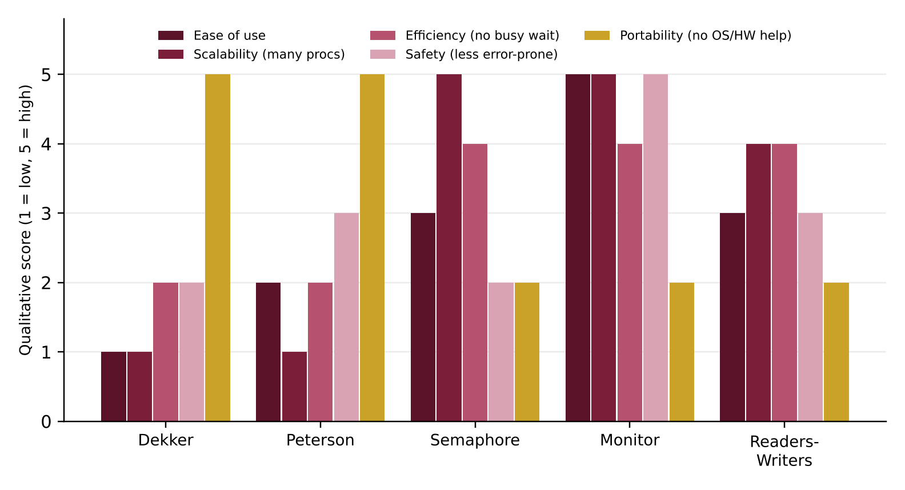
Figure 6 — Qualitative comparison on five criteria (bar chart)
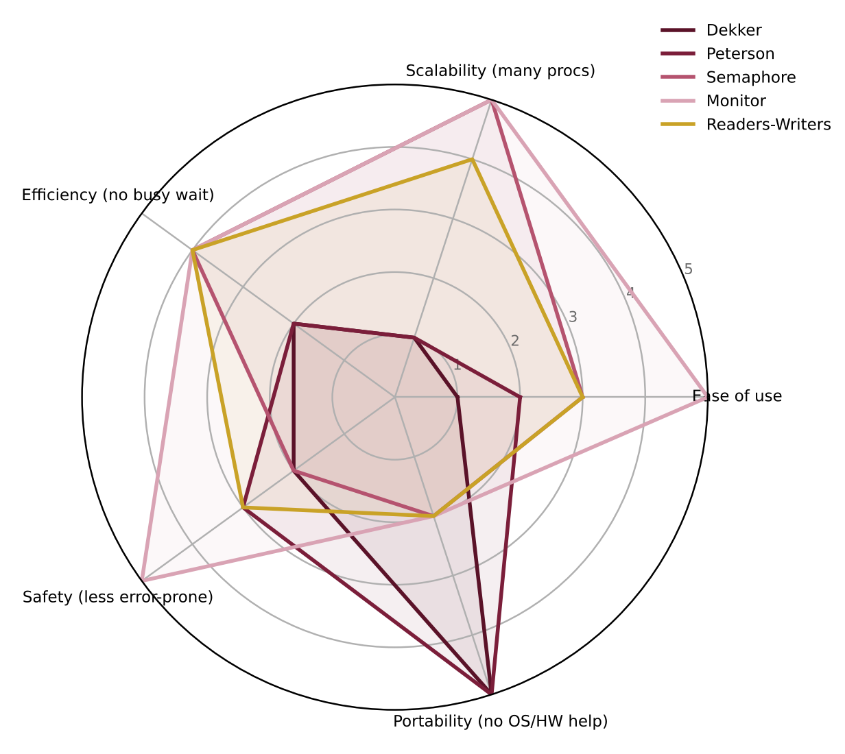
Figure 7 — Radar chart of the same criteria
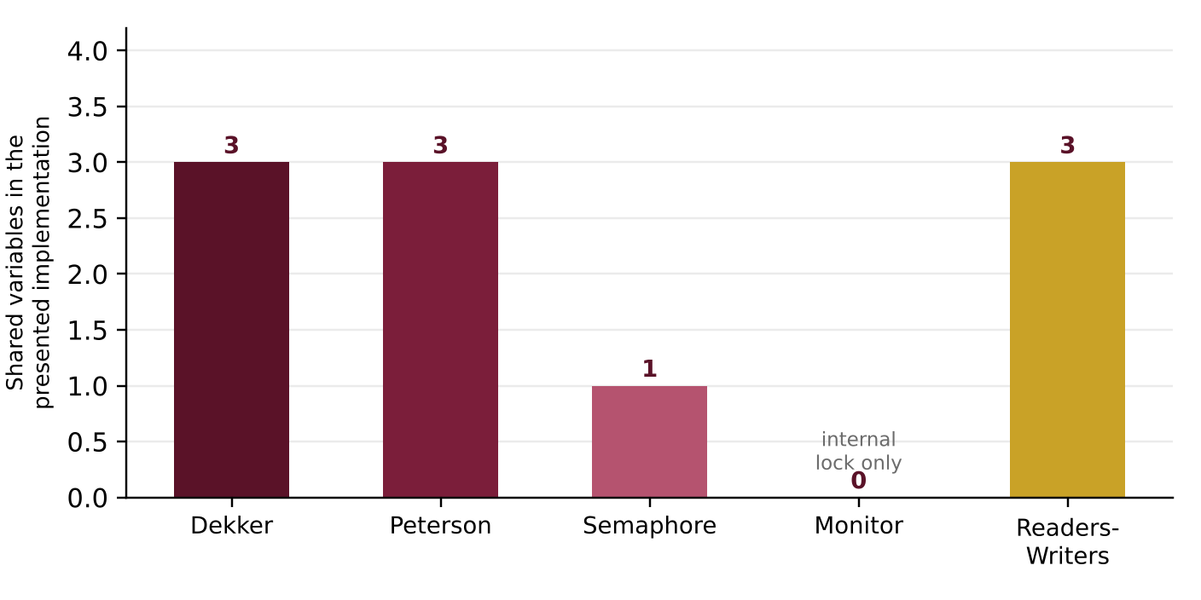
Figure 8 — Shared variables in the presented implementations
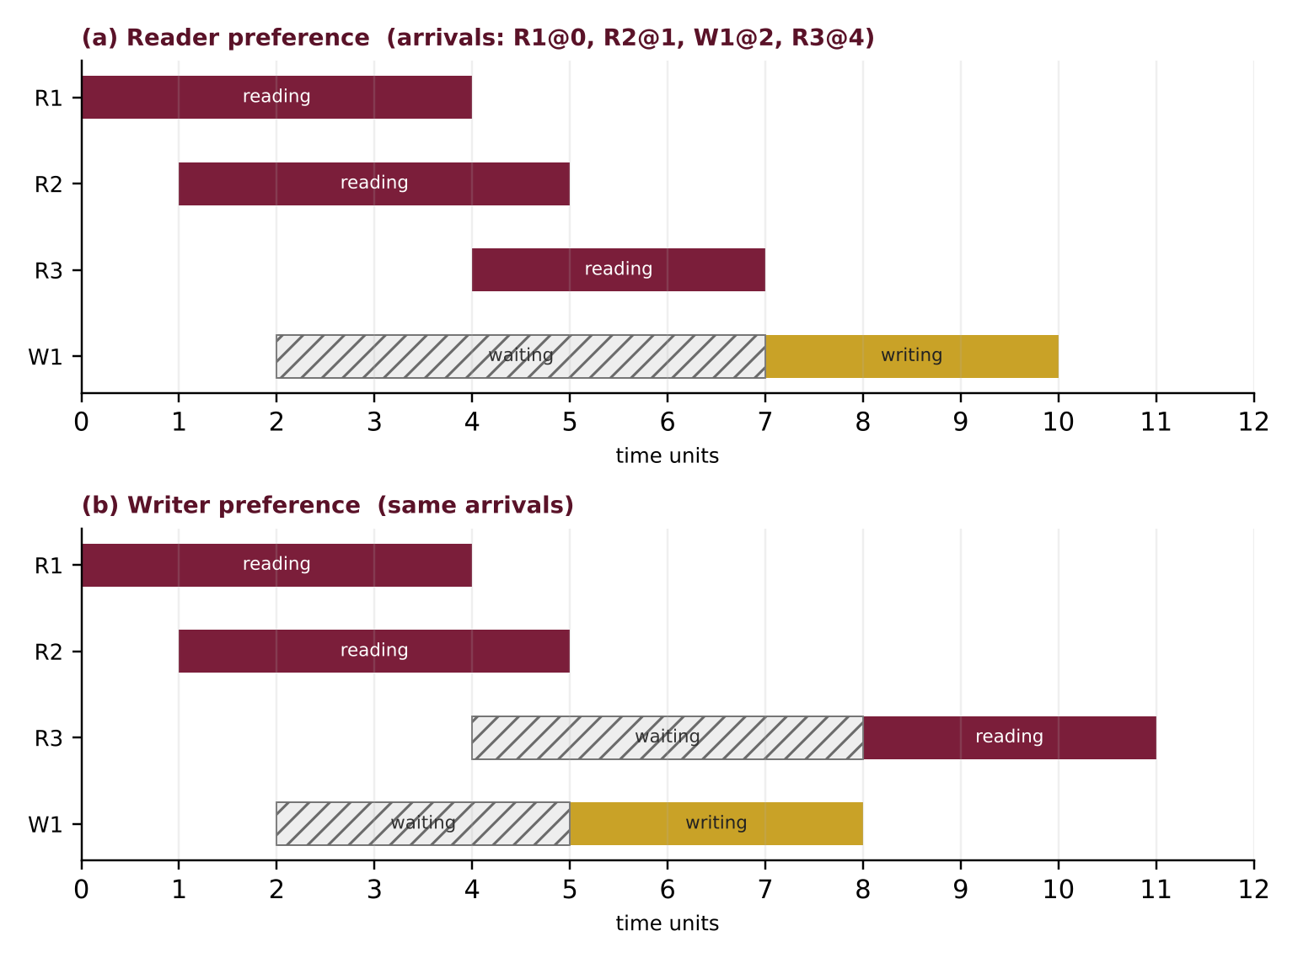
Figure 9 — Sample timeline: reader preference vs. writer preference
In Figure 9 (an illustrative scenario, not a measurement) R1 arrives at time 0, R2 at 1, W1 at 2 and R3 at 4. With reader priority R3 is admitted because readers are already reading, and W1 waits until time 7. With writer priority R3 is held behind W1, and W1 writes once R1 and R2 finish (time 5).

9. Examples and Exam Questions
For each of the five methods, one worked example and several questions with answers are given.

9.1 Dekker
Worked example
If turn = 1 and only P0 wants to enter, what happens? P0 writes flag[0]=true, sees flag[1] false and enters immediately, even though the turn belongs to P1. This is the progress property: turn matters only when there is a conflict.
Question 1: What happens if the statement flag[i] = false inside the loop is removed from Dekker's algorithm?
Answer: Deadlock. Suppose turn = 0 and both flags are true. P1, since turn ≠ 1, waits for turn == 1 but keeps its flag true; P0 sees flag[1] true and spins in the while loop. turn changes only after P0 exits, so neither makes progress.
Question 2: For how many processes does Dekker's algorithm work, and does it have bounded waiting?
Answer: Only 2 processes. Yes, it has bounded waiting: after exit, turn is given to the rival, so each process waits for at most one entry of the rival.

9.2 Peterson
Worked example
If P1 is in its remainder section, flag[1]=false. P0 writes its flag and turn=1, but the condition flag[1] && turn==1 is false, so it enters: a lone requester is never blocked.
Question 3: If the two entry statements are swapped (first turn = j, then flag[i] = true), is mutual exclusion violated? Build a scenario.
Answer: Yes. P0: turn=1; P1: turn=0; P1: flag[1]=true; P1 sees flag[0] false and enters. Then P0: flag[0]=true; the condition flag[1] && turn==1 is false because turn==0, so P0 enters too, and both are inside the critical section.
Question 4: Why can Peterson's algorithm fail on modern processors without a memory fence?
Answer: The processor or compiler may reorder the write of flag[i]=true and the read of flag[j] (especially with a store buffer). Both processes may then read the other's flag as false and enter. The fix is seq_cst atomics or a memory fence.

9.3 Semaphore
Worked example — counting semaphore with initial value 2
Four processes A..D execute wait(S) in order, then A and B execute signal(S):
A: S=1; B: S=0; C: S=-1 (blocked); D: S=-2 (blocked); A: signal → S=-1, C wakes; B: signal → S=0, D wakes. A negative value shows the number of waiters.
Question 5: Using a semaphore, guarantee that statement S1 of P1 always runs before S2 of P2.
Answer: Create semaphore sync with value 0. P1: S1; signal(sync); and P2: wait(sync); S2;. If P2 arrives first it blocks until P1 signals.
Question 6: Show how a wrong order of wait calls creates a deadlock.
Answer: With two semaphores A=1 and B=1: P1: wait(A); wait(B); and P2: wait(B); wait(A);. If P1 takes A and P2 takes B, each waits for the other forever. Fix: always acquire semaphores in a fixed global order.

9.4 Monitor
Worked example — buffer of capacity 2
put(x) and put(y) fill the buffer (count=2). put(z) blocks in notFull.wait() and releases the lock. get() removes an item, count=1, and notFull.signal() wakes the waiting producer; it re-checks count==N, finds it false and inserts z.
Question 7: Why must a Mesa-style monitor wait on a condition with while rather than if?
Answer: Between the signal and the re-acquisition of the lock, another process may enter and change the condition (or a spurious wake-up may occur). while re-checks the condition after waking.
Question 8: What is the difference between a semaphore signal and a condition-variable signal?
Answer: A semaphore signal increments the counter and is remembered; a condition signal with no waiter has no effect and is lost.

9.5 Readers–Writers
Worked example — reader priority
R1 enters (read_count=1, takes rw_mutex). W1 blocks on wait(rw_mutex). R2 arrives: read_count=2, not 1, so it does not need rw_mutex and enters. As long as readers keep arriving one after another, read_count never reaches 0 and W1 keeps waiting — writer starvation.
Question 9: What are the roles of mutex and rw_mutex in the semaphore solution?
Answer: mutex only protects the variable read_count from concurrent updates by readers. rw_mutex controls access to the data: a writer takes it fully, while readers take it as a group (the first reader acquires it, the last releases it).
Question 10: Which variants suffer from starvation, and how can it be fixed?
Answer: Variant 1 starves writers and variant 2 starves readers. Variant 3 uses a service queue (a service semaphore, or a FIFO queue in a monitor) to preserve arrival order and has no starvation.
Question 11: (Multiple choice) Which method works for more than two processes and has no busy waiting? a) Dekker b) Peterson c) blocking semaphore d) none
Answer: Option c; Dekker and Peterson support only two processes and use busy waiting.

10. Conclusion
Dekker's and Peterson's algorithms show that mutual exclusion can be built with shared memory alone and no special instruction, but they are limited to two processes, use busy waiting and depend on correct memory ordering. Semaphores are scalable and efficient but low-level and error-prone. Monitors add structure and automatic mutual exclusion, making concurrent programming safer, and are very common in modern languages. The readers–writers problem shows that choosing the policy (reader priority, writer priority or fairness) matters as much as choosing the primitive.
- To learn correctness concepts: Dekker and Peterson.
- To control resources and execution order among many processes: semaphores.
- For structured, low-error code: monitors (or lock + condition variable).
- For shared data that is mostly read: the readers–writers pattern or pthread_rwlock_t.
Summary
Pick the primitive by the number of processes and the level of safety needed, and then pick the policy that matches the workload.

11. References
- Dijkstra, E. W. (1965). Cooperating Sequential Processes (EWD123). Technological University Eindhoven.
- Peterson, G. L. (1981). Myths About the Mutual Exclusion Problem. Information Processing Letters, 12(3), 115–116.
- Hoare, C. A. R. (1974). Monitors: An Operating System Structuring Concept. Communications of the ACM, 17(10), 549–557.
- Brinch Hansen, P. (1973). Operating System Principles. Prentice Hall.
- Courtois, P. J., Heymans, F., & Parnas, D. L. (1971). Concurrent Control with “Readers” and “Writers”. Communications of the ACM, 14(10), 667–668.
- Silberschatz, A., Galvin, P. B., & Gagne, G. Operating System Concepts. Wiley.
- Tanenbaum, A. S., & Bos, H. Modern Operating Systems. Pearson.

