**Lab week 2**

**CS471**

Student name: Najla Alharbi - 421202013

**Part1**

**Task 1: Start Wireshark and capture packets.**

done

**Task 2: Filter HTTP packets and analyze them.**

Request Method: GET

Request URL: "/c/msdownload/update/others/2024/09/41889205_0cad149816c4c64b92e841b895186663beaa8e8c.cab"

Response code: 200 OK

**Part 2:**

**Task 1: Filter TCP packets**

done

**Task 2: Analyze TCP handshake and investigate Data Transfer and Termination**

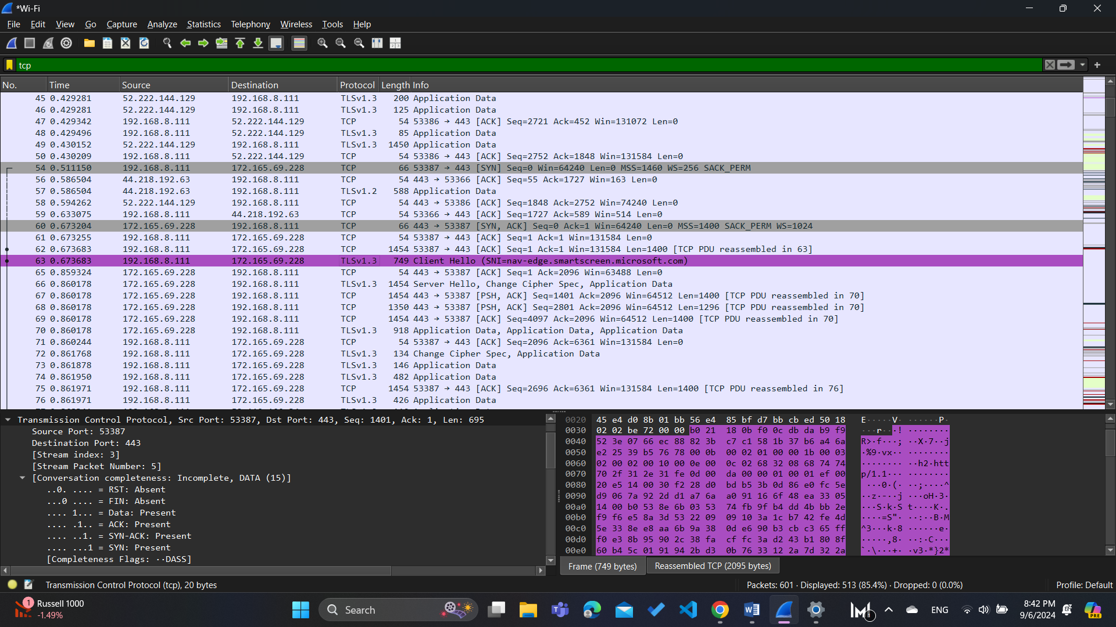Step 2: Note the sequence and acknowledgment numbers, take a screenshot

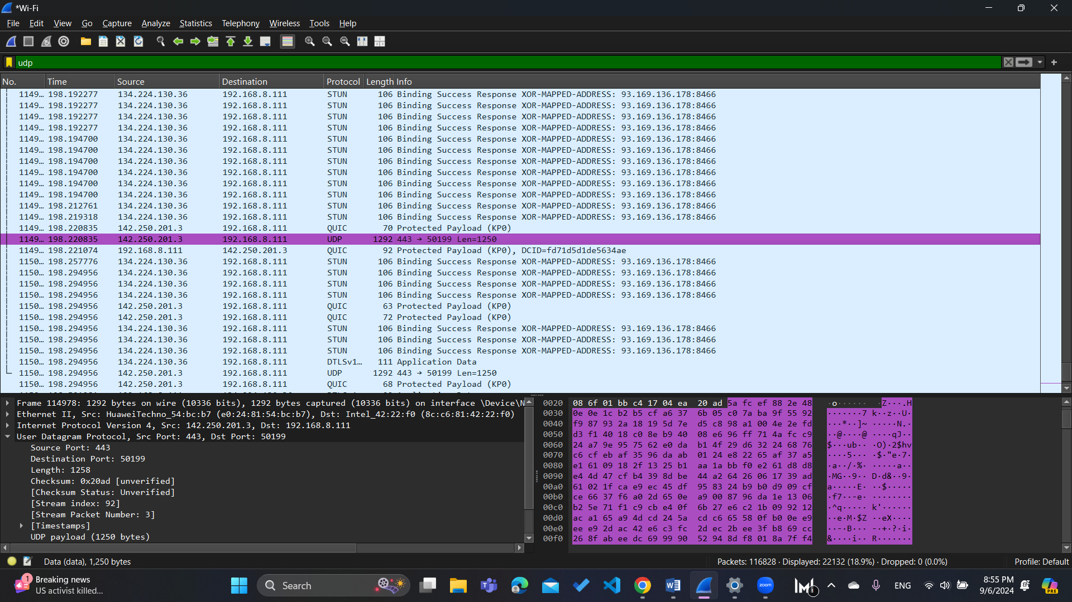Step 3: Observe the data packets exchanged between the client and server. Take a screenshot

**Part 3**

**Task 1: Generate UDP traffic and capture packets I captured the UDP packets.**

done

**Task 2: Filter and analysis UDP Packets**

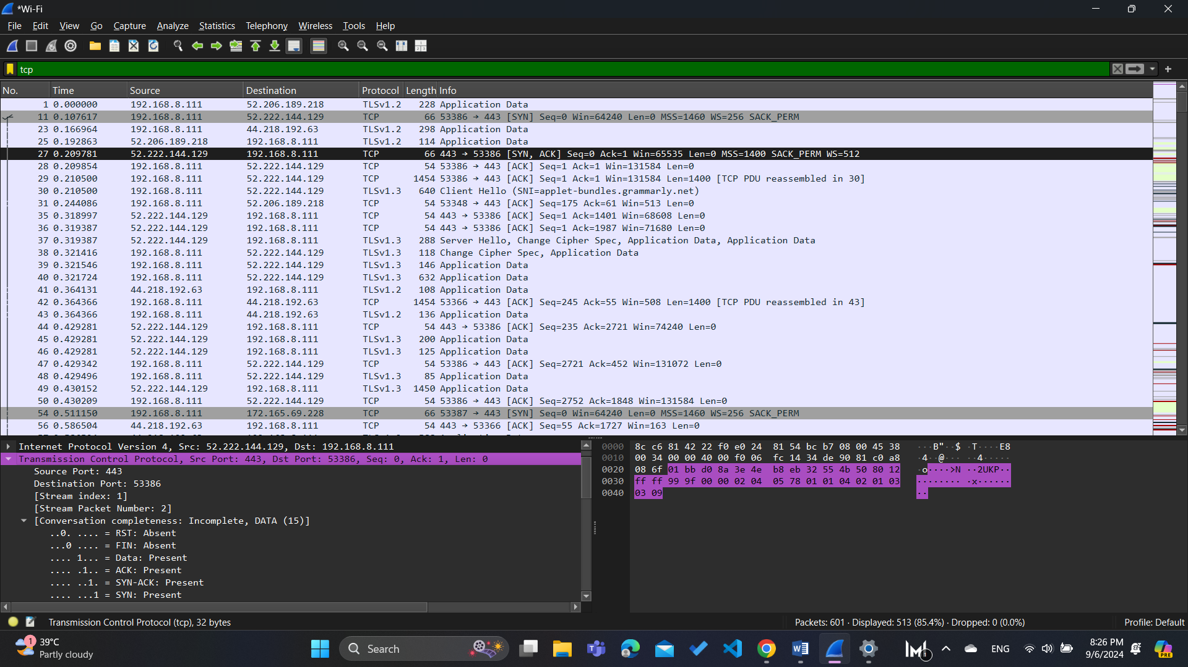here is the header of the UDP packet:

comparing the TCP header with the UDP header we can see that the UDP header is much simpler than TCP, UDP header Only contains Source Port, Destination Port, Length, and Checksum, but the TCP header Contains additional fields like sequence number, acknowledgment number, flags, and window size to ensure reliable data transmission.

**Part 4:**

**Task 1: Fill in the following table and provide reasons.**

|  |  |  |
| --- | --- | --- |
|  | **TCP or UDP** | **Reasons** |
| Reliability and Connection Establishment | **TCP** | The TCP protocol uses a three-way handshake (SYN, SYN-ACK, ACK) to establish a reliable connection before transmitting data |
| Data Integrity and Ordering | **TCP** | TCP uses checksums to verify that data has not been corrupted during transmission and it TCP assigns sequence numbers to packets, which helps in reordering them correctly |

**Task 2: Identify the use Cases and Performance of TCP and UDP.**

|  |  |  |
| --- | --- | --- |
|  | **TCP** | **UDP** |
| Use cases | Web browsing – Email – File transfers | Streaming Media – Online Gaming |
| Performance | High Reliability – higher latency | Low reliability – lower latency |