**CHAPTER ONE**

**INTRODUCTION**

**1.1 Objectives**

The principal objective of this project is to provide lectures contents that has been given by the teachers of a department of an educational institution . Students will get the lectures contents by joining specific group which is created by teachers . Particularly another important point is to submit the assignments of any subject through this application .

**1.2 Importance and applications**

This project makes very easy to store and access information over the internet where the present system is cumbersome with the manual system . In this software , teachers and students can discuss each of others by posting & commenting in the group within a short time . This project can be used to current demand prevailing of students for collaboration with the teachers very well .

**1.3 Conclusion**

As the computerized system is used in every developed countries all over the world , there are no options for the progressive country like Bangladesh to avoid computerized system . So , we should transform the manual system into computerized system as early as possible for the better achievement .

**CHAPTER TWO**

**BACKGROUND STUDY**

**2.1 Scripting Language used to develop this project**

1. HTML5
2. Bootstrap
3. JavaScript
4. PHP5
5. CSS3

**2.2 What is HTML?**

Hypertext Markup Language , commonly referred to as HTML , is the standard markup language used to create web pages . It is written in the form of HTML elements consisting of tags enclosed in angle brackets (like <html>) . HTML tags most commonly come in pairs (like <h1> and </h1>) . HTML describes the structure of a website semantically along with cues for presentation , marking it a markup language rather than programming language.

HTML elements form the building blocks of all websites. HTML allows images and objects to be embedded and can be used to create interactive forms.

**2.3 The reason of using HTML5**

* Accessibility
* Video and audio support
* A simplified doctype
* Cleaner code
* Smarter storage
* Better user interactions
* Game development possibilities
* Legacy/cross browser support
* Easy mobile support

**2.4 What is CSS?**

Cascading Style Sheets (CSS) is a style sheet language used for describing the look and formatting of a document written in a markup language. CSS is designed primarily to enable the separation of document content from document presentation , including elements such as layout , colors, fonts .

**2.5 What is Bootstrap**

Bootstrap is a free and open source collection of tools for creating websites and web applications. It is most popular HTML , CSS and JavaScript framework for developing response , mobile-first websites. It contains HTML and CSS based design templates for typography, forms, components as well as optional JavaScript extensions. It aims to ease the development of dynamic websites and web applications.

**2.6 Reason of using Bootstrap**

**1. Easy to get started:** CSS pre-processing is great and every front development should learn it. Bootstrap offer LESS files to use it , but it also provides the plain old CSS file for those don’t want to use CSS pre-processing.

**2. Great grid system:** Bootstrap is built on responsive 12 column grids,layouts and components. Another useful set of features are the responsive utilities classes which make a certain block of content appear or hide only on devices based on the size of the screen.

**3. Base styling for most HTML elements:** A website element such as headings , elements , lists , tables , buttons , forms , etc . All these fundamental HTML elements have been styled and extensible classes .

4. Extensive list of components: Whether needs drop down menus, pagination or alert boxes , bootstrap has got covered . Styling of every single elements follows a consistent theme and customizing takes just few minutes.

5. Bundled JavaScript: The components such as drop down menu are interactive with the numerous JavaScript plugins bundled in the bootstrap package.

**2.7 What is JavaScript?**

A scripting language developed by Netscape to enable web authors to design interactive sites. It can interact with HTML source code , enabling web authors to spice up sites with dynamic content.

**2.8 The reason of using JavaScript**

1. Prototyping language
2. Available tools
3. Easy to debug
4. Allows object oriented design
5. Easily extensible

**2.9 Server web Scripting with PHP4**

PHP is rapidly growing web technology which enables web designers to build dynamic interactive web applications , incorporating information from the host of database and includes features such as e-mail integration dynamically generated images . PHP adds features to make web applications development even easier.

**2.10 The reason of using PHP5**

In web programming , all languages do pretty much thing they all interact with the relational database , work with file system and interact with a web server. The question about which language is the best is rarely a matter of languages inability to perform certain actions. PHP is a cross platform , HTML embedded , server web scripting language.

* Cross platform

We can run most PHP4 code without alternation on computers running many different pertains systems. A PHP4 that run on a linux will generally run on windows as well.

* HTML embedded

PHP4 code is written in files containing a mixture of PHP instructions and HTML code.

* Server Side

The PHP4 programs we write are run on a server specially a web server.

* A web scripting language

We run PHP5 programs via a web browser. We access the web browser on which they reside and this runs the program , sending any resulting output back to the browser.

* Fast and easy
* Access everything
* Contently being improved
* Free

**2.11 PHP Database connectivity**

A database is simply a collection of data, which is organized in such a way that its contents can easily be accessed and manipulated.

A database management system (DBMS) or database engine provides the software used to store , retrieve and modify data in a database.

* **PHP MySQL Connectivity**

In order to work with a MySQL server in PHP , The following steps should be performed:

1. Open a connection to the server
2. Work with the databases in server
3. Close the server

**2.12 What is MySQL?**

MySQL is a freely available RDBMS (Relational Database Management System).It is a true multi-user .multi-threaded SQL database server. SQL(Standard Query Language) is the most popular and standardized database language of the world. MySQL is a client/server implementation that consists of server daemon MYSQL and many different client programs and libraries.

**2.13 The main features of MySQL**

The following list describes some of the important characteristics of MYSQL:

* Fully multithreaded using kernel threads.
* Compatible with C, C++, java, PHP, Perl etc.
* Very fast joins using an optimized one-sweep multi-join.
* Full operator and function support in the SELECT and WHERE parts of queries.
* Full support of SQL. GROUP BY and ORDER BY clauses.
* Tables can be mixed from different database in the same query.
* In memory hash tables which are used as temporary tables.
* Handle large database. We are using MySQL with some database that contains 50,000,000 records.
* All columns have default values.
* Written in C and C++. Tested with a board range of different compilers.
* A very fast thread-based memory allocation system.

**2.14 The Apache Server**

Apache is the most widely used HTTP server in the world today. It surpasses all free and commercial competitors on the market and provides a myriad of features. It is also the most widely used web server for a Linux system. A web server like apache in its simplest function , is software that displays and serves HTML pages hosted on a server to a client browser that understand the HTML code.

**CHAPTER THREE**

**DESIGN AND IMPLEMENTATION**

**3.1 Flow diagrams for Teacher-Student Collaboration System**

Flow diagram of Teacher:

Signup

Login

Profile/Create- Group/Join Group

Create Group

Add Member

Profile

By Email invitation

Change Password

Add Assignment

Write Post

Add Lecture

Add Photo

**Fig: Flow diagram of Teacher**

Flow diagram of Student:

Signup

Login

Student Group/Profile

Join Group

Create Group

Profile

Get Lectures content

Write a post

Submit assignment

Change Password

Add photo

**Fig: Flow diagram of Student**

Flow diagram of Admin:

Admin panel

View/ Add/Delete Admin

View/Remove member

Insert/Edit/Delete of group Information

**Fig: Flow diagram of admin**

**3.2 working principle for Teacher-Student Collaboration System**

All Activities are divided into three modules:

* Group Management Module
* Assignment Module
* Discussion Module

**Group Management Module:**

1. Create Group
2. Delete Group
3. Update Group
4. Lectures uploading
5. Writing a post
6. Getting Lectures contents
7. Add members

Initially teacher creates a group for the students by providing specific Course Title/Subject name ,group code , Session , Group description. After creating the group , teachers are able to write a post , lectures files uploading . They can also be performed editing , deleting the group contents. Teacher can add the students to the group by email invitation.

Students can join the created group by providing the secret group code which is given by the teacher in the class room of very fast class of that course. After joining that group , students are able to see all lectures file , all posts and they can download that files if they want. In the same time , student can write a post of that group .

**Assignment Module:**

1. Upload assignment
2. Submit Assignment
3. File adding Options
4. Last date to submit

Teacher can assign an assignment to the students by this application. On the created group , the teacher can add an assignment with Assignment title and required file for the students . In the student view , they can submit the assignment with corresponding assignment title where the last date of that assignment is added by the teacher. They can’t submit the assignment if the date is over .

In the teacher view , all submitted assignment list having the student name, roll , status and corresponding files are seen by the teacher . Then the teacher can download these submitted files.

**Discussion Module:**

1. Problem Analysis
2. Commenting of individual post

Each of the group post has been included the commenting facilities for both of the teacher and student. They can discuss any problem domain within the post of that group by comments.

**3.3 E-R Diagram for database design (incomplete)**

Manage

Groups

Users

Group-members

**3.4 Database design for the teacher-Student Collaboration System**

Database Name : **ts_collaboration**

**Table 1: users**

|  |  |  |  |  |
| --- | --- | --- | --- | --- |
| S.N | Field name | Data type | size | validation |
| 1 | id | INTEGER | 10 | Primary key |
| 2 | name | VARCHAR | 255 |  |
| 3 | email | VARCHAR | 255 |  |
| 4 | password | VARCHAR | 255 |  |
| 5 | user_type_id | INTEGER | 11 | Foreign key |
| 6 | photo | TEXT |  |  |
| 7 | gender | VARCHAR | 255 |  |
| 8 | remember_token | VARCHAR | 100 |  |
| 9 | created_at | TIMESTAMP |  |  |
| 10 | updated_at | TIMESTAMP |  |  |

**Table 2: groups**

|  |  |  |  |  |
| --- | --- | --- | --- | --- |
| S.N | Field name | Data type | size | validation |
| 1 | id | INTEGER | 10 | Primary key |
| 2 | group_name | VARCHAR | 255 |  |
| 3 | group_code | VARCHAR | 255 |  |
| 4 | course_code | VARCHAR | 255 |  |
| 5 | user_id | INTEGER | 11 | Foreign key |
| 6 | group_moderator | INTEGER | 11 |  |
| 7 | session | VARCHAR | 255 |  |
| 8 | short_description | VARCHAR | 100 |  |
| 9 | created_at | TIMESTAMP |  |  |
| 10 | updated_at | TIMESTAMP |  |  |

|  |  |  |  |  |
| --- | --- | --- | --- | --- |
| S.N | Field name | Data type | size | validation |
| 1 | id | INTEGER | 10 | Primary key |
| 2 | group_id | INTEGER | 11 |  |
| 3 | user_id | INTEGER | 11 |  |
| 4 | title | VARCHAR | 255 |  |
| 5 | type | VARCHAR | 255 |  |
| 6 | body | TEXT |  |  |
| 7 | created_at | TIMESTAMP |  |  |
| 8 | updated_at | TIMESTAMP |  |  |

**Table 3: posts**

|  |  |  |  |  |
| --- | --- | --- | --- | --- |
| S.N | Field name | Data type | size | validation |
| 1 | id | INTEGER | 10 | Primary key |
| 2 | post_id | INTEGER | 11 |  |
| 3 | last_submit_date | VARCHAR | 255 |  |
| 4 | created_at | TIMESTAMP |  |  |
| 5 | updated_at | TIMESTAMP |  |  |

**Table 4: assignments**

|  |  |  |  |  |
| --- | --- | --- | --- | --- |
| S.N | Field name | Data type | size | validation |
| 1 | id | INTEGER | 10 | Primary key |
| 2 | user_type | VARCHAR | 255 |  |

**Table 5: user_types**

**Table 5: group_members**

|  |  |  |  |  |
| --- | --- | --- | --- | --- |
| S.N | Field name | Data type | size | validation |
| 1 | id | INTEGER | 10 | Primary key |
| 2 | group_id | INTEGER | 11 |  |
| 3 | user_id | INTEGER | 11 |  |
| 4 | created_at | TIMESTAMP |  |  |
| 5 | updated_at | TIMESTAMP |  |  |

|  |  |  |  |  |
| --- | --- | --- | --- | --- |
| S.N | Field name | Data type | size | validation |
| 1 | id | INTEGER | 10 | Primary key |
| 2 | user_id | INTEGER | 11 |  |
| 3 | designation | INTEGER | 11 |  |
| 4 | created_at | TIMESTAMP |  |  |
| 5 | updated_at | TIMESTAMP |  |  |

**Table 6: teachers**

|  |  |  |  |  |
| --- | --- | --- | --- | --- |
| S.N | Field name | Data type | size | validation |
| 1 | id | INTEGER | 10 | Primary key |
| 2 | user_id | INTEGER | 11 |  |
| 3 | roll | INTEGER | 11 |  |
| 4 | year | VARCHAR | 255 |  |
| 5 | semester | VARCHAR | 255 |  |
| 6 | created_at | TIMESTAMP |  |  |
| 7 | updated_at | TIMESTAMP |  |  |

**Table 7: students**

**Table 8: comments**

|  |  |  |  |  |
| --- | --- | --- | --- | --- |
| S.N | Field name | Data type | size | validation |
| 1 | id | INTEGER | 10 | Primary key |
| 2 | group_id | INTEGER | 11 |  |
| 3 | user_id | INTEGER | 11 |  |
| 4 | post_id | INTEGER | 11 |  |
| 5 | comment | TEXT |  |  |
| 6 | created_at | TIMESTAMP |  |  |
| 7 | updated_at | TIMESTAMP |  |  |

|  |  |  |  |  |
| --- | --- | --- | --- | --- |
| S.N | Field name | Data type | size | validation |
| 1 | id | INTEGER | 10 | Primary key |
| 2 | post_id | INTEGER | 11 |  |
| 3 | content | TEXT |  |  |
| 4 | created_at | TIMESTAMP |  |  |
| 5 | updated_at | TIMESTAMP |  |  |

**Table 9: contents**

|  |  |  |  |  |
| --- | --- | --- | --- | --- |
| S.N | Field name | Data type | size | validation |
| 1 | Id | INTEGER | 10 | Primary key |
| 2 | group_id | INTEGER | 11 |  |
| 3 | user_id | INTEGER | 11 |  |
| 4 | post_id | INTEGER | 11 |  |
| 5 | Link | TEXT |  |  |
| 6 | created_at | TIMESTAMP |  |  |
| 7 | updated_at | TIMESTAMP |  |  |

**Table 10: uploads**

**CHAPTER FOUR**

**TOOLS**

**4.1 Technical Requirements**

* **Hardware**
* Parsonal computer/smartphone
* **Software**
* JavaScript and CSS supported browser

**4.2 Server-side Requirements**

* **Hardware**
* Server computer
* **Software**
* OS: Linux (Ubuntu 14.03 LTS)
* Programming language : PHP5, HTML5,JavaScript , CSS3 or above
* Database Server: Mysql Server
* Web Server: Apache2
* Development Tools: Ajax
* IDE : PhpStorm

**CHAPTER FIVE**

**RESULT AND DISCUSSION**

**5.1 Input output Screen**

This project consists of several major sections

* Landing page
* Login page
* Signup page
* User home page
* Admin panel

**5.2 Landing page**

The appearance of the page is shown in the following figure:

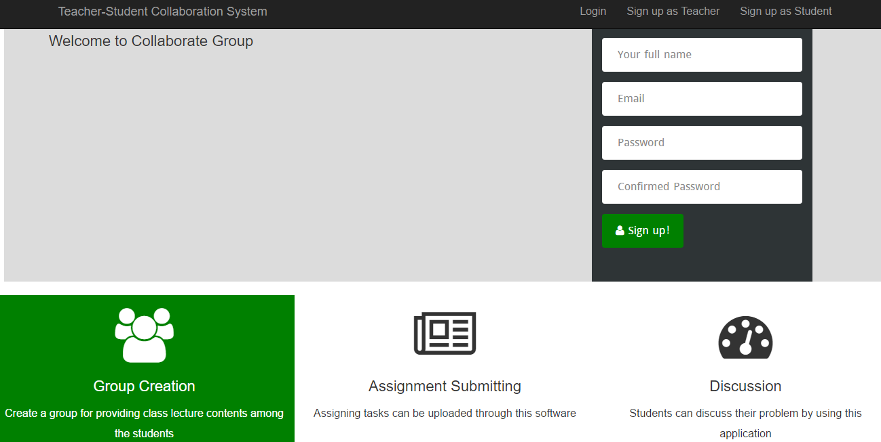

**Fig: landing page**

**5.3 Login page**

The appearance of the page is shown in the following figure:

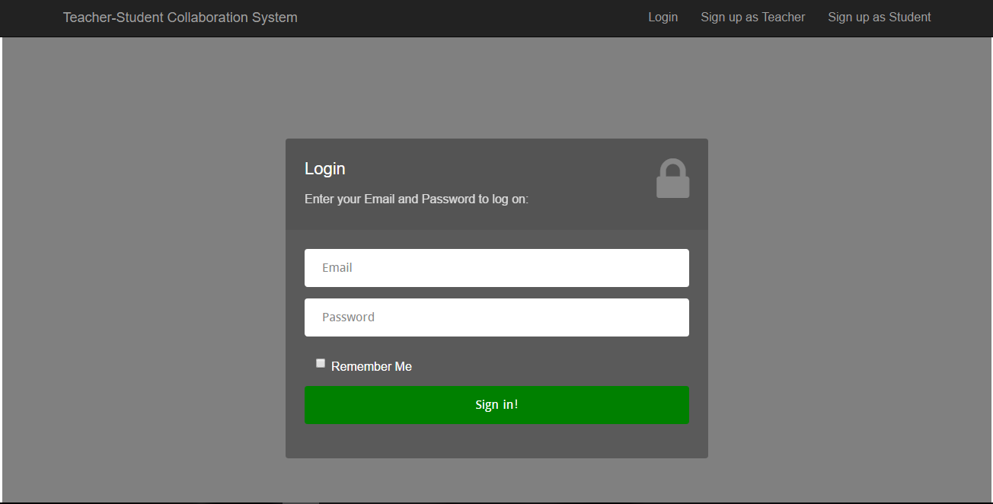

**Fig: login page**

**5.4 Signup page**

The appearance of the page is shown in the following figure:

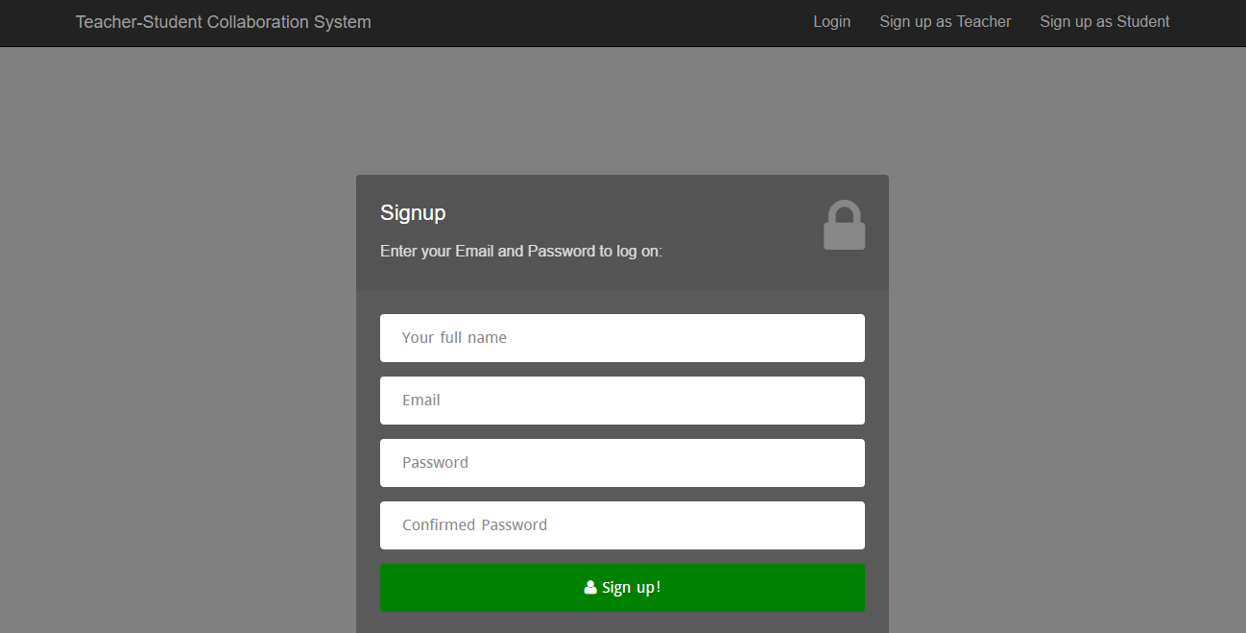

**Fig: signup page**

**5.5 User Home Page**

The appearance of the page is shown in the following figure:

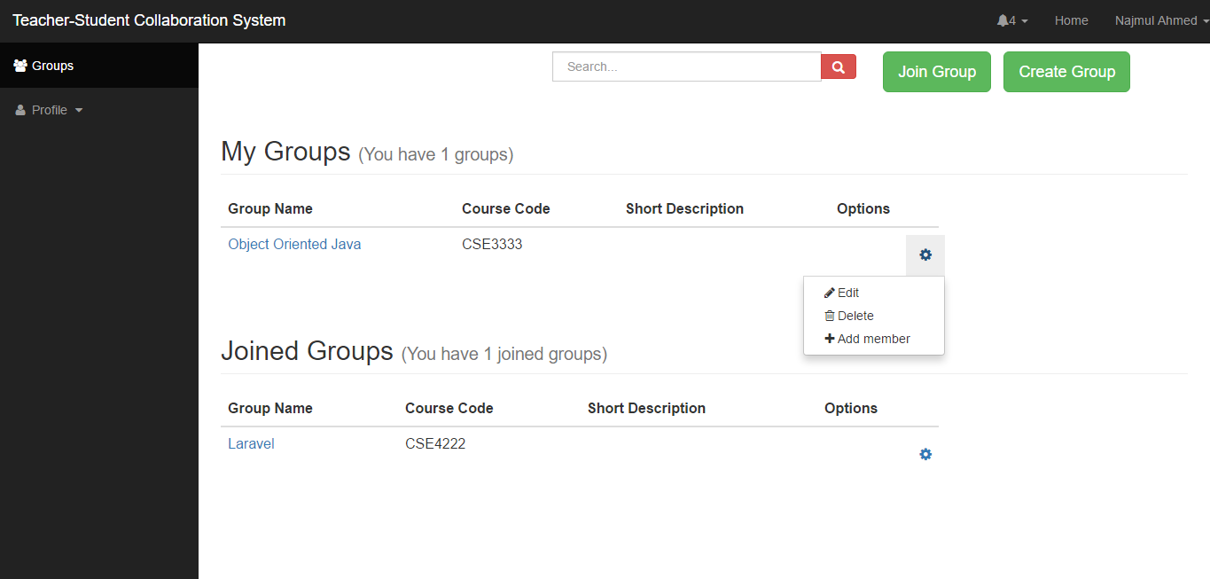 **Fig: User home page**

**5.6 Group home page**

The appearance of the page is shown in the following figure:

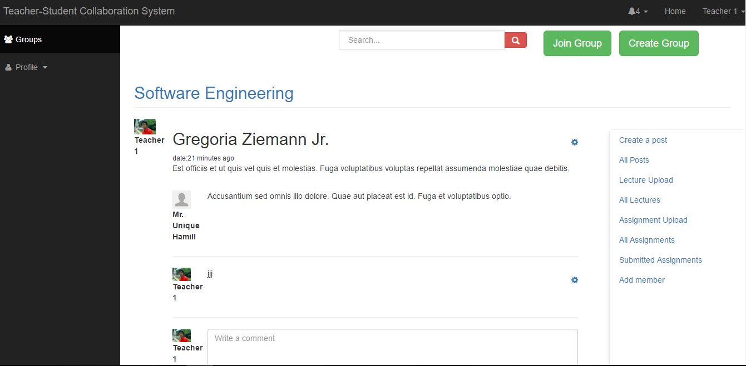

**Fig: group home page**

**5.7 Student view of joining group**

The appearance of the page is shown in the following figure:

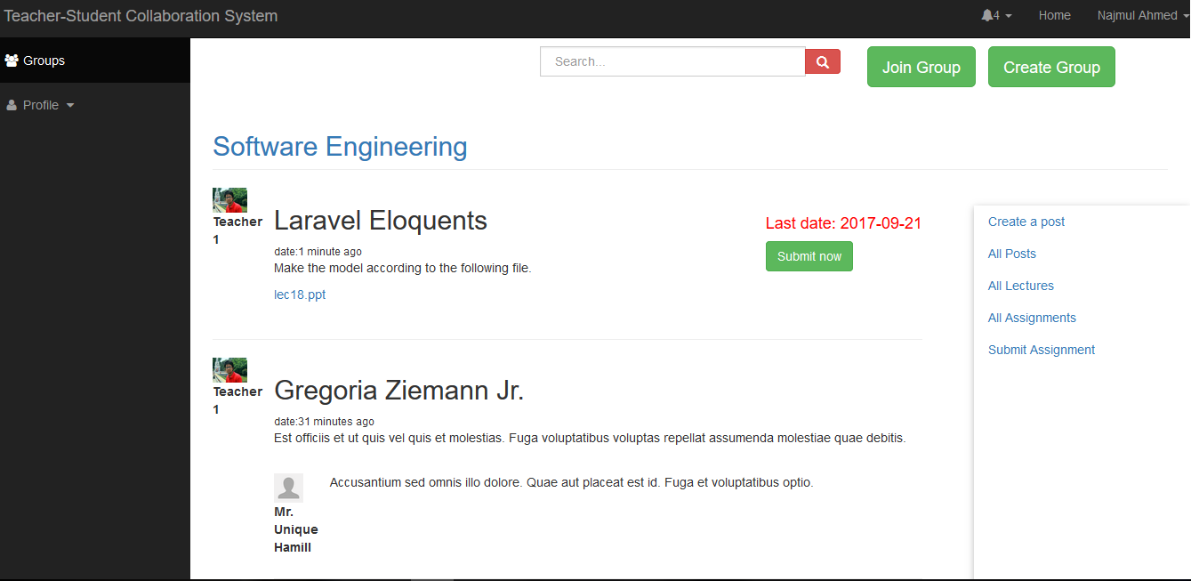

**Fig: student group view**

**5.8 Group member invitation page**

The appearance of the page is shown in the following figure:

