Project -03

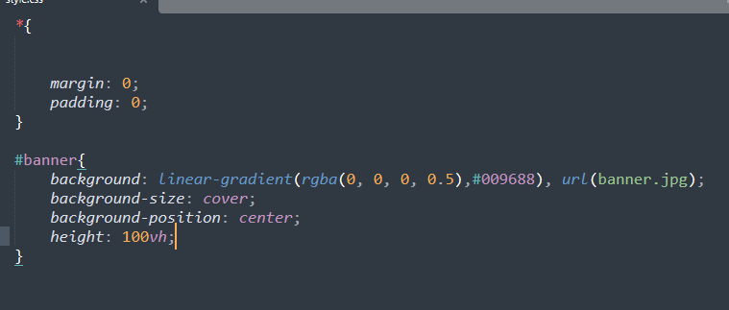



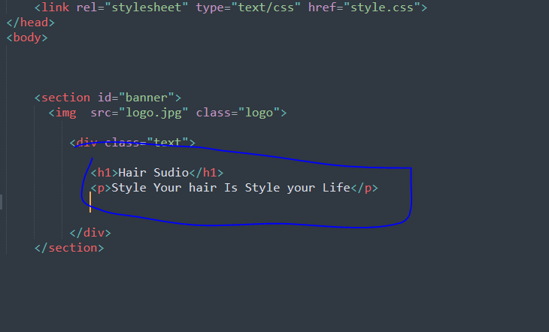

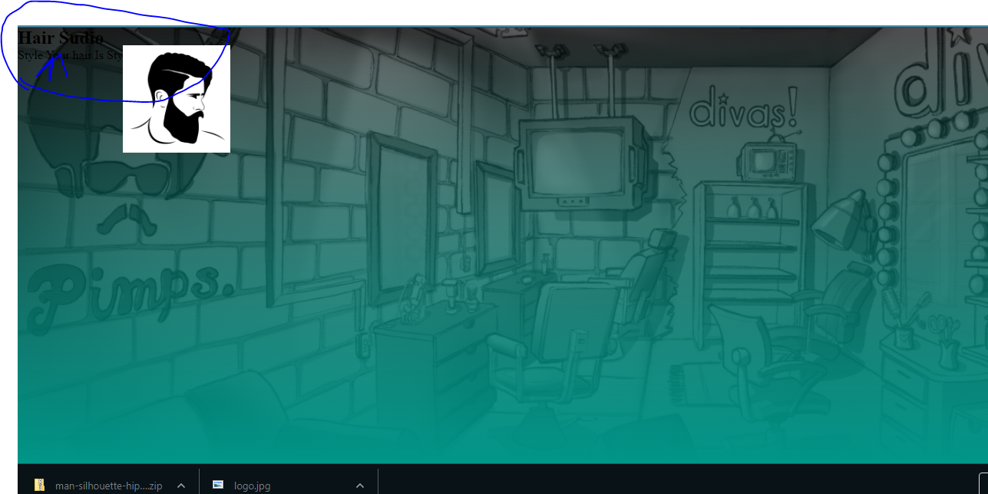

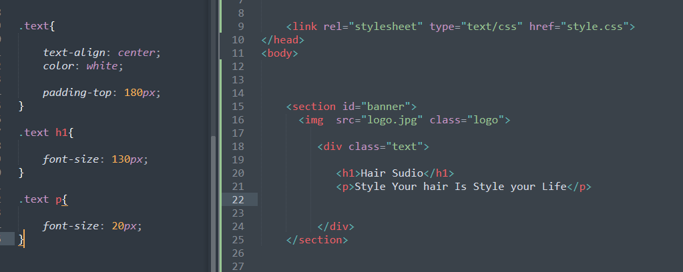



1.First search google font:

1. .Then search Kaushan coppy the link ..then select poppins ,and elect 2 links ….

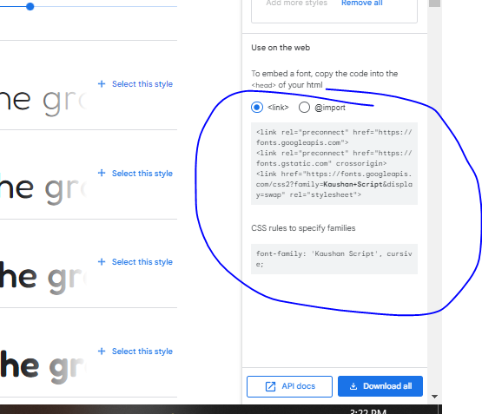

Then add link in the html file like __

<link rel="preconnect" href="https://fonts.googleapis.com">  
<link rel="preconnect" href="https://fonts.gstatic.com" crossorigin>  
<link href="https://fonts.googleapis.com/css2?family=**Kaushan+Script**&display=swap" rel="stylesheet">

And add css file

