FULL CONTENT FOR YOUR IMD318 WEBSITE
🏠 1. HOME PAGE (Content)
Welcome to My Personal Website
Hi and welcome!
This website is created as part of my IMD318 Individual Project. Here, I share a little bit about myself including my biodata, education journey, experiences, my family and some pictures in the gallery.
This site is fully designed and written using basic HTML and CSS as required for this course.
Prepared by:
Iqlima Binti Rojulaini
UiTM ID: 2023467144
Class: KCDIM1105B
Thank you for visiting my personal website!

👤 2. BIODATA PAGE (Content)
My Biodata
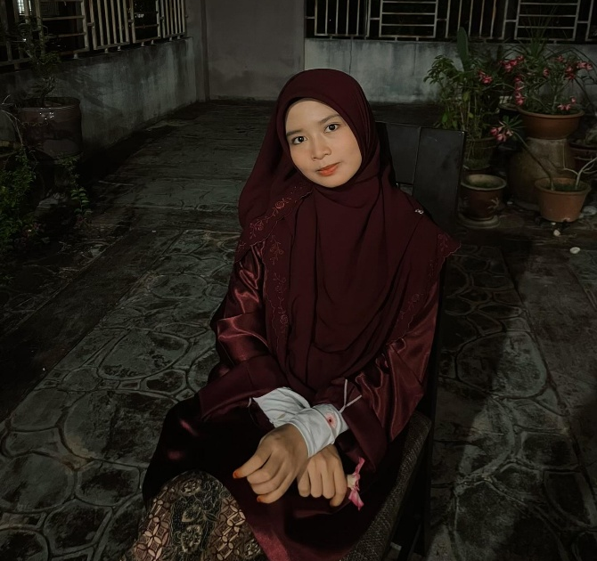
Here are some simple things about me:
- Full Name: Iqlima Binti Rojulaini
- Age: 20 years old
- Date of Birth: 16/08/2005
- Place of Birth: (Insert place)
- Address: No 15, Jalan Mawar 2, Lorong ½ A,Persiaran Amanjaya 4 ,Bandar Ambangan Height ,08000,Sungai Petani ,Kedah.
- Course: Diploma in Information Management
- Hobbies: Shopping, drawing, watching Korean dramas, playing badminton
- Personality: Friendly, quiet at first, creative, calm
- Interests: I love drawing especially when I’m stressed because it helps express my feelings.
- Fun Fact: I enjoy watching dramas at night if I have free time!
My Motto:
“Do your best and let everything fall into place.”

🧩 3. EXPERIENCE PAGE (Content)
My Experiences
Here are some of the experiences that shaped who I am today:
- Part-Time Job as Cashier (2022)
I learned customer service, handling cash and time management.
- School Program Committee Member
I joined several school events as part of the organizing team. This helped me learn teamwork and responsibility.
- Internship at Administrative Unit, UiTM (Under Puan Yuhaniza Bt. Yusof)
During my internship, I assisted with administrative tasks, document management, and student affairs.
This experience improved my communication skills and understanding of office operations.
- Volunteering & University Activities
I joined small volunteer programs and campus activities which gave me confidence and new friends.
What I Learned:
Teamwork, discipline, communication skills, and being confident in handling tasks.

🎓 4. EDUCATION PAGE (Content)
My Education Journey
Here is a simple overview of my educational background:
- Primary School: (SK Semeling)
Year: (Insert years)
- Secondary School: (SMK Agama Yan)
Year: (2018-2022)
Achievements: (SPM or school awards if any)
- Diploma in Information Management – UiTM Merbok
2023 – Present
Currently in Semester (5).
Courses I enjoy: Web content management, information literacy, record management.
Future Goal:
I aim to continue learning and improve my skills in information management and web content design.

👪 5. FAMILY PAGE (Content)
My Family
Family is my biggest support system. Here’s a little about them:
- Father: Rojulaini Bin Ahmad (Teacher)
- Mother: Umi Salmah Binti Yeop (Teacher)
- Siblings:
  - (Rojulul Ilmi Bin Rojulaini) – (18)
  - (Ilmina Binti Rojulaini) – (16)
  - (Rojulun Amin Bin Rojulaini) –(11)
We are a simple and close family. We like spending time together during holidays, sometimes going out for shopping or eating outside. They always encourage me to continue my studies and become a better person.
Why My Family Is Important:
They inspire me to work hard, stay humble, and appreciate everything I have.

📞 7. CONTACT PAGE (Optional but Recommended)
Contact Me
If you would like to reach me, here are my contact details:
- Email:iqlimarojulaini@gmail.com
- Instagram:qima.__
- GitHub : https://github.com/2023467144-source
Feel free to contact me anytime!

📝 8. FOOTER (Put this on every page)
Created by Iqlima Binti Rojulaini
IMD318 Individual Project
© 2025 – All Rights Reserved

