**Computer Peripheral & Interfacing Project (IOT)**

Presented by-

**Team "Digital Dynamos"**

**Najnin Sultana Shirin** (B190305031)

**Fahim Hasan**(B190305029)

**Project title**: Women Safety and Tracking using GPS and GSM.

**Problem statement**:

In this women safety project, we are developing a robust solution that incorporates a dual-button system. One button initiates the transmission of an emergency message, including the user’s location, while the other button triggers an immediate emergency call via GSM technology. This streamlined approach prioritizes rapid and effective responses in situations requiring urgent assistance.

**Objective**: The objective of the project is to create a system that:

* Develop a real-time location tracking system with GSM messaging and calls.
* Implement an emergency alert system with GPS location sharing.
* Provide two-way communication with authorities.

**Features**:

* Emergency button
* Real-time Location Tracking.
* Emergency alert message with location.
* Emergency call.

**Workflow diagram**:

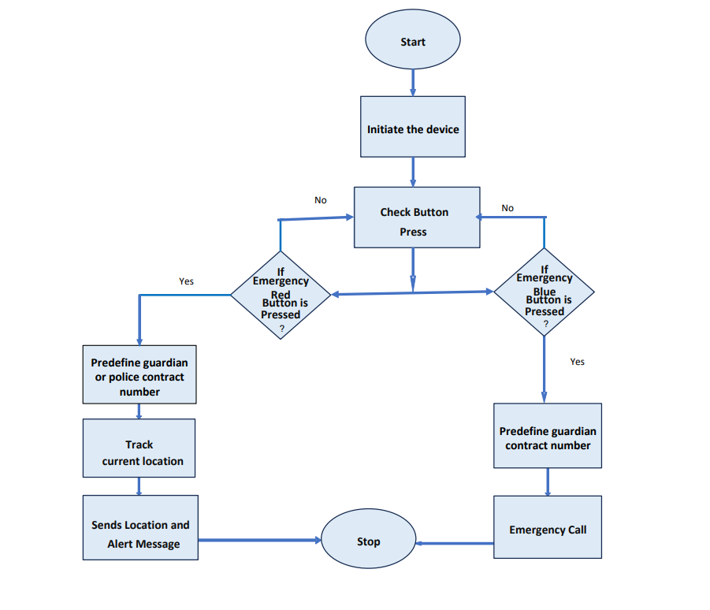

**Fig:2 Flow Chart of Our Women’s Safety & Tracking System**

**Dataflow diagram:**

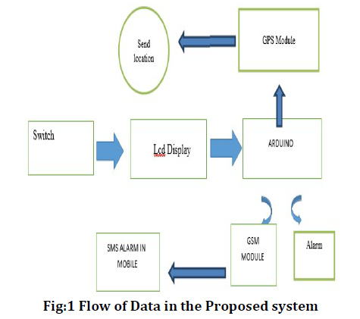

**Prototype:**

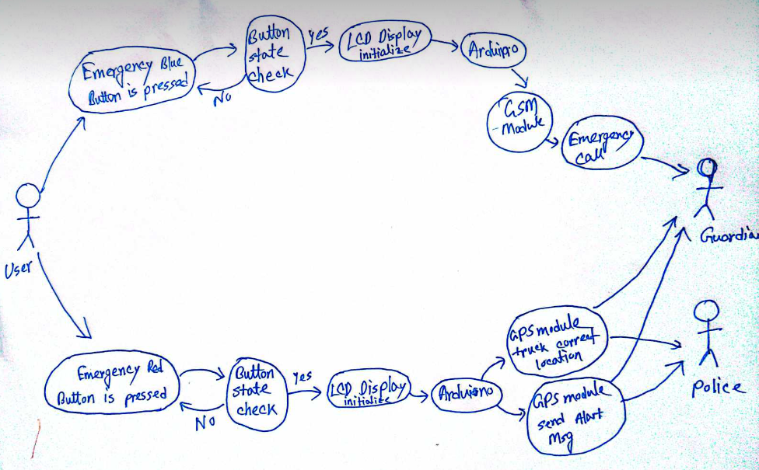

**Fig: Use Case Diagram**

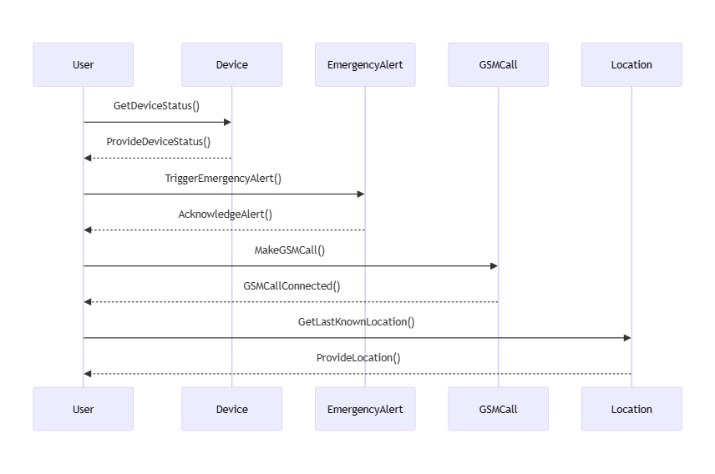

**Fig: Sequence Diagram**

**Tools and devices**:

* Arduino
* GPS Module
* GSM Module
* LCD Display
* Step-down converter
* Push Button
* Resister
* PCB
* Power Supply

**References**:

* [Microsoft Word - z47 Implementation of Women Safety System using Internet of Things (researchgate.net)](https://www.researchgate.net/profile/Anny-Leema/publication/344073130_Implementation_of_Women_Safety_System_using_Internet_of_Things/links/5f50fb1a299bf13a319ac1d8/Implementation-of-Women-Safety-System-using-Internet-of-Things.pdf)
* [Iot Based Smart Device for Women Safety.pdf (ijaem.net)](https://ijaem.net/issue_dcp/Iot%20Based%20Smart%20Device%20for%20Women%20Safety.pdf)
* [Arduino based Women Safety Device with GPS Tracking and Emergency Alerts (circuitdigest.com)](https://circuitdigest.com/microcontroller-projects/arduino-based-women-safety-device-for-emergency-alert-and-tracking)