Pharmaceutical Analysis Report

##### by: NAthan-Andrew Tompkins

The analysis performed on the two datasets (Mouse_metadata.csv, Study_results.csv) was completed using the Matplotlib Python library within the matplotlib_pharmaceuticals_analysis.ipynb file located in this repository.

# Study statistics

|  |  |
| --- | --- |
| Number of drugs considered in this analysis | 9 + Placebo |
| Drug names | Capomulin, Ketapril, Naftisol, Infubinol, Stelasyn, Ramicane, Zoniferol, Propriva, Ceftamin + Placebo |
| Total number of records before cleaning | 1893 |
| Total number of records after cleaning | 1880 |
| Initial mice recorded | 249 |
| Mice analyzed once data was cleaned | 248 |
| Most observed drugs | Capomulin (230 records), Ramicane (228 records) |
| Mouse gender distribution (full study) | Male: 51%, Female 49% |
| Avg. Weight/Tumor Volume Correlation Coefficient | 0.84 |

# Observations

1. An analysis of the final tumor volume outliers (Chart 4) reveals that mice in the Capomulin and Ramicane regimens recorded the lowest results across the study. No other drug regimen indicated a significant reduction or *reversal* of tumor volume than these two.
2. Chart 7, a regression analysis, proves that weight and tumor volume are *highly correlated*. While this regression analysis was illustrated for mouse ID: l509, the the average Correlation Coefficient for the two variables is calculated to be 0.81, for this mouse, where 1 is *perfectly correlated,* and 0.84 for the fully study
3. Despite the gender distribution for the full study being roughly equal (Chart 3) the individual regimens varied greatly in this (Chart 2.) Despite this finding, the top-performing drugs (Capomulin and Ramicane) do not seem to be effected by this variance, as the gender distributions were 23.3% higher in female, and 108.1% higher in male, respectively, while revealing the same effectiveness noted in observation 1.
4. It should be noted that the studies comprised of the most mice resulted in the most successful regimens studied, as these collectively contained 18.5% more mice than the next two regimen by count (Chart 1 and Chart 4.) (This is not to say the number of mice studied is an as-of-yet significant variable, just that the effectiveness of the Capomulin and Ramicane regimens against the other 8 could indicate further study.

## Appendix

### Chart 1: Mice (Per trial)

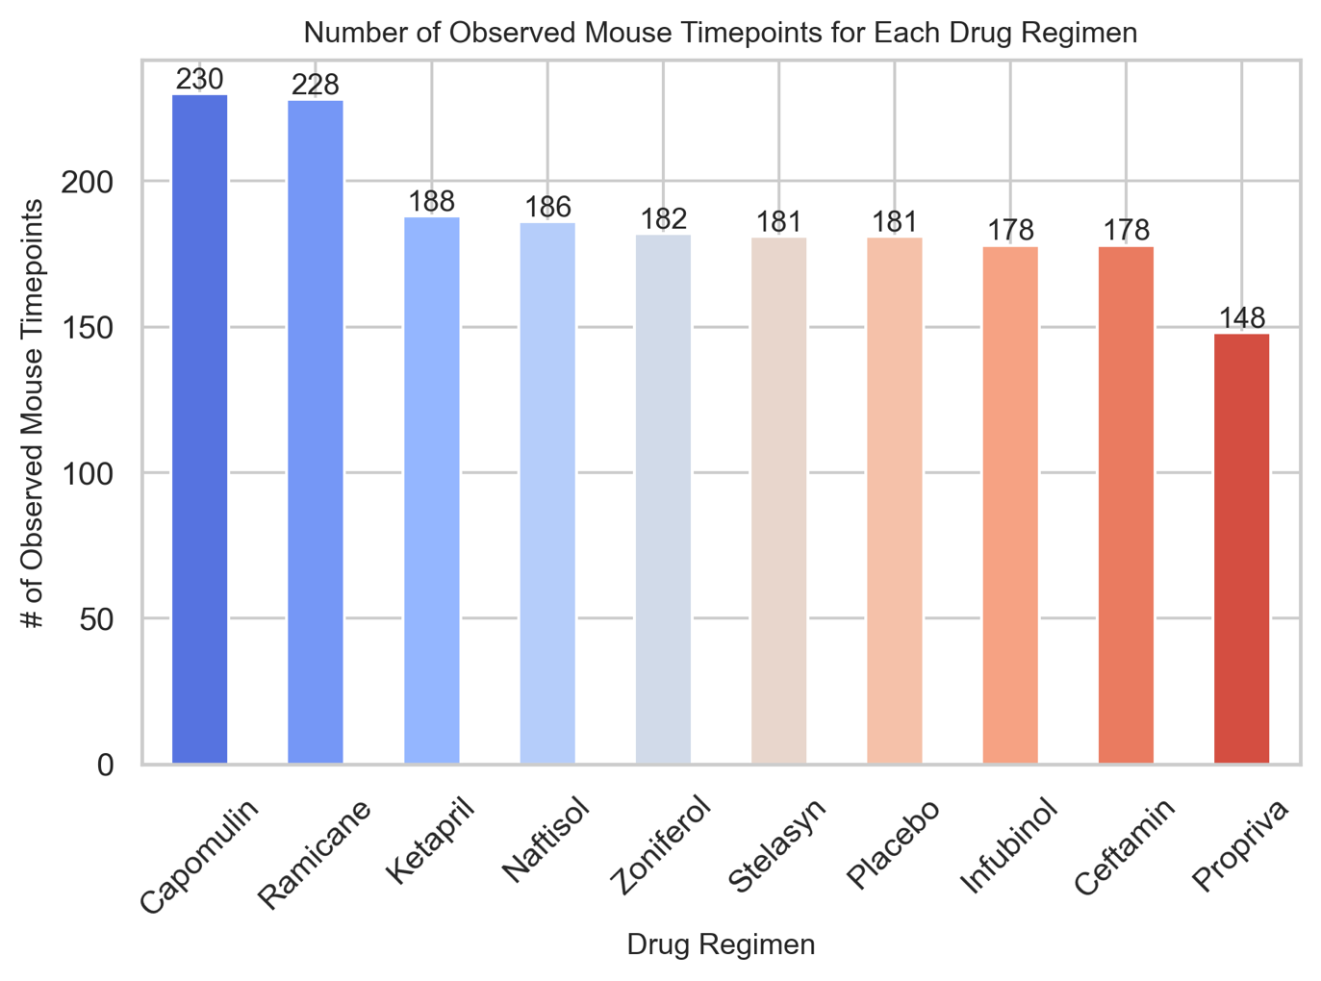

### Chart 2:

### Chart 3: gender distribution (full study)

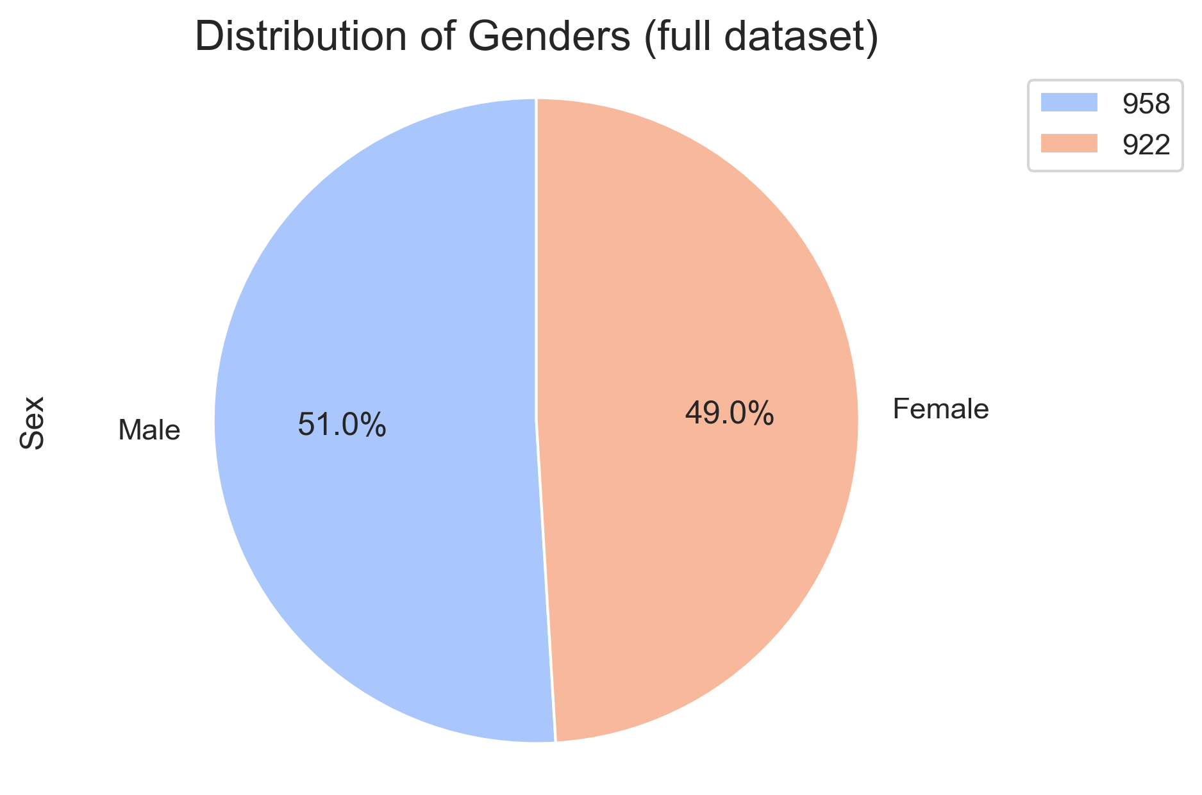

### Chart 4: Final Tumor outliers

### chart 5: tumor volume (3mm) timeline – mouse id: L509 – Capomulin

### chart 6: tumor weight/volume Scatter – mouse id: L509 – Capomulin

### chart 7: tumor weight/volume Regression – mouse id: L509 – Capomulin

