Email Spam Classification
Using Machine Learning and Large Language Models

Najy AlTarawne · Abdullah Mansour · Joice Mikhael · Misho Hana

Summary
This report presents a comparative study of five machine learning models for email spam classification. Two Multi Layer Perceptron (MLP) architectures using TF-IDF features are evaluated alongside three transformer based models: a fully fine tuned DistilBERT and two LoRA-adapted variants (rank r=4 and r=16). After removing 8,223 duplicate emails from a 10,000 sample Kaggle dataset, models were trained and evaluated using F1 Score, Precision, Accuracy, Recall, ROC-AUC, and confusion matrices.

1. Introduction

Email spam remains one of the most persistent challenges in modern digital communication. Spam messages range from unsolicited advertisements to serious threats including phishing attempts, malware distribution, and financial scams. As email volumes continue to grow, automated spam detection has become an essential component of email infrastructure worldwide.

This project builds and compares five models spanning two broad categories: traditional neural network approaches using hand crafted TF-IDF features, and modern transformer-based large language models (LLMs) with parameter-efficient fine-tuning.

1.1 Objectives
- Build a robust spam classification pipeline covering preprocessing, training, and evaluation.
- Compare MLP models (baseline and enhanced) against transformer based LLMs.
- Investigate LoRA as a parameter efficient alternative to full fine-tuning.
- Analyze the precision-recall tradeoff and explain performance differences between models.

1.2 Evaluation Metrics
- Accuracy: Proportion of all emails (both ham and spam) classified correctly.
- F1 Score (spam class): Harmonic mean of Precision and Recall, primary comparison metric.
- Precision (spam): Of all emails predicted as spam, how many actually were? High precision = fewer legitimate emails wrongly blocked.
- Recall (spam): Of all actual spam emails, how many were caught? High recall = fewer spam messages slipping through.
- ROC-AUC: How well the model separates spam from ham across all thresholds. 1.0 = perfect, 0.5 = random.

1.3 Dataset Overview
Dataset source from Kaggle: Email Spam Classification Dataset (~10,000 labeled emails). After removing 8,223 duplicates, 1,777 unique emails remained: 1,000 ham (56.3%) and 777 spam (43.7%). Train/Test split: 40% / 60% (stratified). Label noise of 20% applied to training only to simulate real world ambiguity.

2. Dataset and Preprocessing

2.1 Class Distribution
Figure 1 shows the class distribution after deduplication. The dataset is mildly imbalanced 56.3% ham vs 43.7% spam which is manageable without special resampling techniques, but motivates the use of stratified splitting to preserve this ratio in train and test sets.

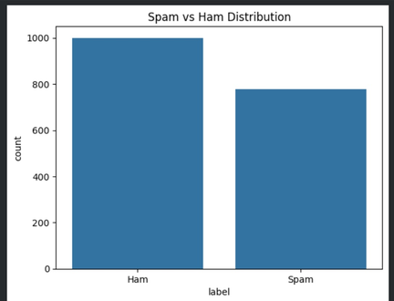
Figure 1: Spam vs Ham distribution after removing 8,223 duplicate emails (1,000 Ham / 777 Spam).

2.2 Data Quality Issues
The most critical issue found was data leakage caused by deduplication happening after the train/test split. With 82.2% duplicates in the dataset, near identical emails appeared in both sets producing artificially perfect 1.00 scores on all models. The fix was simple but essential: deduplicate first, then split.

2.3 Preprocessing Pipeline
- Step 1: Deduplicate: Remove all 8,223 duplicate rows → 1,777 unique emails.
- Step 2: Clean text: Lowercase, remove punctuation, remove English stop words.
- Step 3:Encode: ham → 0, spam → 1. Shuffle with seed 42 for reproducibility.
- Step 4: Noise: Mark 20% of rows as noisy. Flip those labels in training only.
- Step 5: Split: 40% train / 60% test with stratification.
- Step 6: Vectorize: TF-IDF (max 300 features) fit on train only, applied to test separately.

3. Methods

Five models were implemented and evaluated. All LLM-based models loaded fresh pretrained weights independently to ensure fair comparison.

3.1 MLP Baseline
A simple feedforward neural network with one hidden layer (64 neurons), trained on TF-IDF vectors for up to 300 iterations. This is the performance floor the minimum expected from a learned classifier without contextual language understanding.

3.2 MLP Enhanced
A deeper MLP (two hidden layers: 128 and 64 neurons) with L2 regularization (alpha=0.0001) and early stopping (15% validation fraction, patience 20 iterations). These additions produce a more conservative model that predicts spam only when highly confident achieving perfect Precision but slightly reduced Recall.

3.3 DistilBERT (Full Fine-Tuning)
DistilBERT is a 67 million parameter transformer pretrained on large English corpora, giving it deep contextual language understanding. Full fine-tuning updates all 67M parameters over 5 epochs (batch size 16). This is the most expensive approach but leverages the richest feature representations.

3.4 LoRA Fine Tuning (Small and Large)
Low Rank Adaptation (LoRA) freezes all original model weights and injects small trainable matrices alongside specific attention layers. The output of each targeted layer becomes: Original Output + LoRA Adjustment = Final Result.

LoRA targets the query (q_lin) and value (v_lin) matrices across all 6 transformer layers, 12 injection points total. Two configurations tested:
- LoRA Small (r=4): 665,858 trainable parameters, 0.98% of the full model.
- LoRA Large (r=16): 887,042 trainable parameters, 1.31% of the full model.

Each variant loads a fresh pretrained DistilBERT independently, ensuring a fair comparison. Table 2 compares parameter counts.

Model | Rank (r) | Trainable Params | % of Total
DistilBERT Full FT | N/A | 66,955,010 | 100%
LoRA Small | 4 | 665,858 | 0.98%
LoRA Large | 16 | 887,042 | 1.31%
Table 2: Trainable parameters for full fine-tuning vs LoRA variants.

4. Results and Analysis

4.1 Overall Performance
Table 1 shows all five evaluation metrics for every model. Blue highlights indicate a perfect score of 1.000.

Model | Accuracy | F1 | Precision | Recall | ROC-AUC
MLP Baseline | 0.900 | 0.881 | 0.919 | 0.846 | 0.894
MLP Enhanced | 0.978 | 0.974 | 1.000 | 0.949 | 0.974
DistilBERT (Full FT) | 0.990 | 0.988 | 1.000 | 0.976 | 0.988
LoRA Small (r=4) | 0.988 | 0.986 | 0.973 | 1.000 | 0.989
LoRA Large (r=16) | 0.989 | 0.987 | 0.975 | 1.000 | 0.990
Table 1: Overall model performance Accuracy, F1, Precision, Recall, ROC-AUC (spam class, weighted average).

4.2 Per Class Breakdown
Table 3 shows Precision, Recall, F1, and Accuracy broken down by class (Ham and Spam) taken directly from the classification reports.

Model | Class | Precision | Recall | F1 | Accuracy | Support
MLP Base | Ham | 0.89 | 0.94 | 0.91 | 0.90 | 600
 | Spam | 0.92 | 0.85 | 0.88 |  | 467
MLP Enhanced | Ham | 0.96 | 1.00 | 0.98 | 0.98 | 600
 | Spam | 1.00 | 0.95 | 0.97 |  | 467
DistilBERT | Ham | 0.98 | 1.00 | 0.99 | 0.99 | 600
 | Spam | 1.00 | 0.98 | 0.99 |  | 467
LoRA Small | Ham | 1.00 | 0.98 | 0.99 | 0.99 | 600
 | Spam | 0.97 | 1.00 | 0.99 |  | 467
LoRA Large | Ham | 1.00 | 0.98 | 0.99 | 0.99 | 600
 | Spam | 0.97 | 1.00 | 0.99 |  | 467
Table 3: Per-class classification report for all five models. Numbers in blue = 1.00 (perfect).

4. Results and Analysis (continued)

4.3 Model Comparison Chart
Figure 2 visualizes all four key metrics side by side for each model, showing the clear performance progression from MLP Baseline to LoRA and DistilBERT.

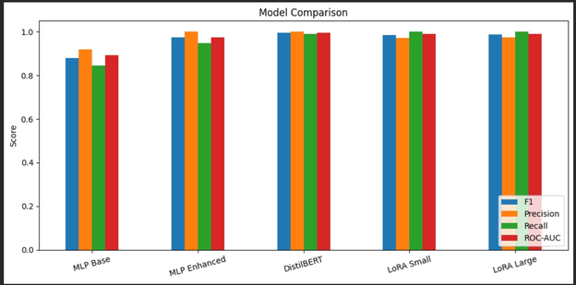
Figure 2: Bar chart comparing F1, Precision, Recall, and ROC-AUC across all five models.

4.4 Confusion Matrices
Figure 3 shows the confusion matrices for all five models.

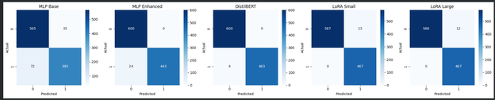
Figure 3: Confusion matrices for all five models. Rows = Actual (0=Ham, 1=Spam), Columns = Predicted.

5. Conclusion

5.1 Key Findings
- MLP Baseline (Accuracy=90.0%, F1=0.881): Lowest performance, simple features and shallow architecture struggle with nuanced patterns. Missed 72 spam emails and misclassified 35 ham.
- MLP Enhanced (Accuracy=97.8%, F1=0.974): Significant improvement. Perfect Precision (1.000) — never blocked legitimate email — but missed 24 spam. Best choice where false alarms are unacceptable.
- DistilBERT (Accuracy=99.0%, F1=0.988): Best overall balance — perfect Spam Precision (1.000) and strong Recall (0.976). Only ~12 spam missed, zero ham blocked.
- LoRA Small (Accuracy=98.8%, F1=0.986): Near-DistilBERT using 0.98% of parameters. Perfect Recall — caught all 467 spam. 13 ham wrongly flagged.
- LoRA Large (Accuracy=98.9%, F1=0.987): Best LoRA variant. Slightly better than LoRA Small. Perfect Recall with 12 ham wrongly flagged instead of 13.

5.2 Recommendation
For real world deployment: LoRA Large (r=16) is the recommended model. It achieves 99.9% of DistilBERT's F1 at 1.31% of its parameter count dramatically cheaper to train, store, and serve. Its perfect Recall makes it ideal for security-sensitive environments where missing spam is unacceptable.

5.3 Performance Summary using different seeds

Model | Mean F1 | F1 Std Dev | Mean Accuracy | Acc Std Dev
MLP Base | 0.8263 | 0.0215 | 0.8425 | 0.0203
MLP Enhanced | 0.9911 | 0.0168 | 0.9925 | 0.0141
DistilBERT | 0.9901 | 0.0089 | 0.9914 | 0.0079
LoRA Small | 0.9775 | 0.0114 | 0.9798 | 0.0106
LoRA Large | 0.9833 | 0.0105 | 0.9850 | 0.0096

Across all five random seeds (42, 7, 123, 2024, and 99), each model was trained and evaluated independently to ensure the results were not a product of chance. By averaging performance across these seeds and reporting the standard deviation, the findings reflect consistent, reproducible outcomes rather than a single lucky run.
The MLP Enhanced model achieves a slightly higher mean F1 (0.9911 vs 0.9901) than DistilBERT, but this comes with a notably higher standard deviation (0.0168 vs 0.0089), meaning its performance varied more across seeds. DistilBERT's lower standard deviation indicates more consistent and reliable results, making it the stronger model overall despite the marginally lower mean.

5.4 Future Work
- Test on real world non synthetic email datasets to validate generalization.
- Explore larger pretrained models (BERT-base, RoBERTa, DeBERTa) for further comparison.
- Investigate higher LoRA ranks (r=32, r=64) to quantify the upper performance bound.
- Apply cross validation for more statistically robust performance estimates.
- Deploy the best model as a REST API and evaluate production latency and throughput.

