# JSONparser Program

# By: Nikki Kudamik :)

# Date: 7/22/2024

# Description:

The purpose of this program is to take a JSON file of old tickets and make it more readable and navigable (aka parse and format the file).

## Table of Contents:

* [Installation]
* [Usage]

## Installation:

** some steps may look different in the pictures because the creator of this program already has this stuff installed, etc. **

** the IDE you choose to run this program is up to you. However, for the most basic setup and ease of use, I chose to use Windows Notepad and Command Prompt.

1. Install python on your terminal

First, see if you already have python installed on your machine. Type in your command prompt:

python --version

If the Python version does not show, you don’t have python installed. Which means you likely don’t have it downloaded, either. To download, go to your command prompt and type: python. It will then take you to the Microsoft store.

Download that and follow the installation instructions. Once that is completed, type:

Python --version

This should now show you the version of Python you have installed. It is recommended for this program that you use at least Python 3.

** for more detailed instructions: <https://learn.microsoft.com/en-us/windows/python/beginners>

<https://docs.python.org/3/using/windows.html>

1. Next make sure you have a text editor that you would like to open the files in. I use Notepad (not Notepad++). If you decide to use this option, make sure you select the Word Wrap option under the View tab.
2. To run this program, you will need to install the python libraries it uses. These are all imported at the very top of the python file. To install them, go to cmd and type:

pip install pandas | pip install orjson | pip install tqdm | pip install numpy | pip install tabulate

*Do not type this after typing ‘python’. If you are still in python mode, press ‘Ctrl + Z + Return’ to exit/go back to the regular command prompt.

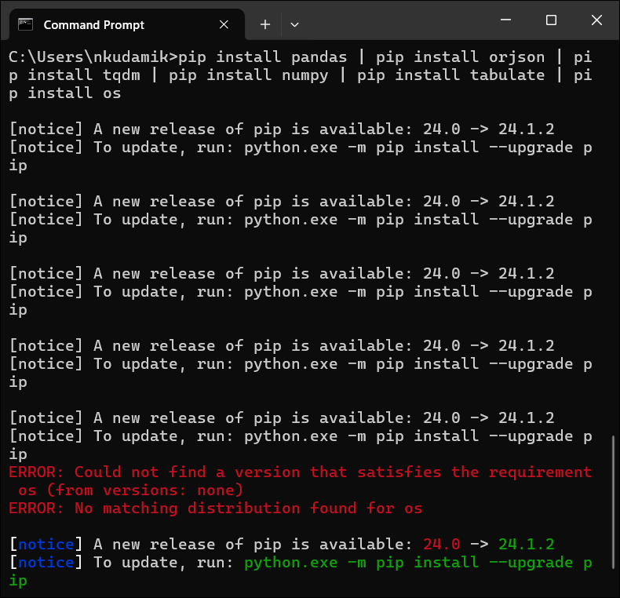

*Since I already have them downloaded, it doesn’t show each download process. If you find that the code snippet provided above does not work, try typing each command individually (i.e. ‘pip install orjson’).

1. Now everything should be downloaded and installed. What comes next is editing the .py file to include the absolute file address of the json file on your device.

What I would do is save the folder containing the .py program, the json file, and this README.txt onto your desktop (or wherever else you will remember it). Keep these three files in the same folder.

Open the .py file in a text editor (you could use Notepad if you would like – right click > Edit in Notepad). Find the first comment ‘#’. It tells you to insert your json file’s absolute file path (not the program’s .py file, it should be a .json file) between the “” assigned to the FILEPATH variable. Right click your json file > Copy as path, then paste that below. *DO NOT delete the r before the “”

1. That’s about it. Right click the .py file > Copy as path. Finally go to your command prompt to run the program and type:

python *insert the python file’s absolute address*



This will start running the program in your command prompt.

1. To make this into an executable file, go back to your command prompt and type:

pip install pyinstaller

Once that finishes, type:

pyinstaller *insert the python file’s absolute address*

Now, in file explorer find this address: C:\Users\*your username*\dist\*filename*

In my case: C:\Users\nkudamik\dist\JSONparser5.py

There you will find the .exe file. Create a shortcut to it on your desktop or wherever else you want to keep it. This should make it so that you can just click on it, and it will start running.

## Usage:

1. Once you start running the program and it loads all the data, a search mechanism will appear. You can type any phrase or number, and it will parse through the dataset and return any entry that contains your input.

*Important note: this search is case insensitive, so capital/lowercase letters do not matter during the search. Spacing between words does matter.

Rebecca == rebecca == rEbEccA

Performed a firewall update != Performed a firewall update

*When searching for the input, it always ends at ‘249/39737’ (or 1%). I would take out the loading bar, but I like to see how quickly it goes through the data.

*The table output does not change with window size (I tried). If you really want, you can change the subject column length in the .py file here:

… or just maximize the window. This is what it looks like:

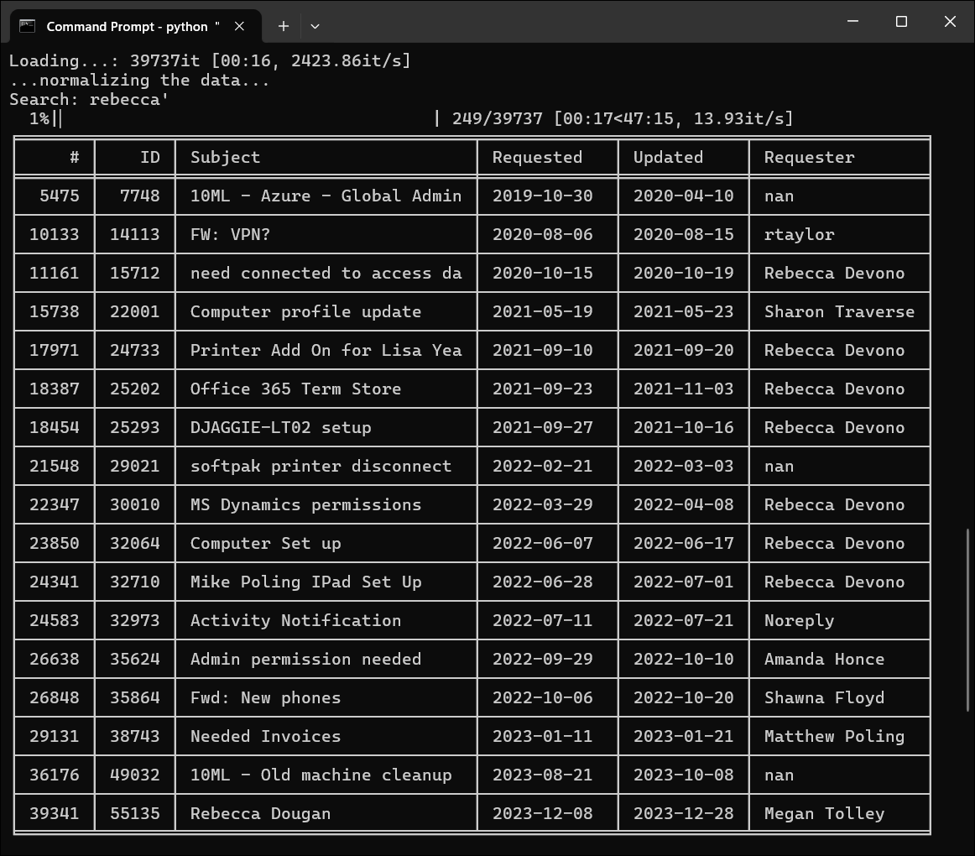

1. As of right now, you can maximize each ticket by typing in the ticket Index number (first column). For example, type ‘39341’ (the last value in the # col below):

*Typing in the Index number opens a text file containing that specific ticket’s ID number, Subject line, and any Comments made on it as well as whether those comments were public or kept internal. (more information can be added to this output in the print_tickets() function in the .py file)

*It’s annoying, but I just take a moment to align both app’s side by side, that way you can see the table and the individual ticket info simultaneously. This program has no GUI, so I thought this was the best way to search/see tickets all at once.

If you want to look at another ticket, just type in its Ticket Index number, the text doc will automatically update and display its information.

*BEWARE, for some reason, rather than just replacing the text in the current notepad, for each subsequent ticket you look at, another notepad tab will open. This can build up a lot of open tabs. You can change notepad to delete all unsaved tabs (notepad will open with any unsaved tabs by default unless you manually close them) by following this tutorial: [Turn On or Off Automatically Save Session State for Notepad in Windows 11 Tutorial | Windows 11 Forum (elevenforum.com)](https://www.elevenforum.com/t/turn-on-or-off-automatically-save-session-state-for-notepad-in-windows-11.17595/)

*This is for win11 only.

1. As the prompt suggests, you can either enter another ticket index, or you can enter 0 to search for another phrase. After that, if you wish to exit the program entirely, enter 0 again.

Goodbye!

*type ‘cls’ to clear the terminal.

*type ‘Ctrl+C+Return’ to interrupt the program.