**Demo: How to pass a binary file to/from OE REST Web Service?**

1. Import PDFHandler.cls into the AppServer folder of an OpenEdge REST project.
2. Right-click PDFHandler.cls in the Resources view and Select “Progress OpenEdge >> Define Service Interface”.
3. Select all three methods in PDFHandler.cls in the “ABL routines” list (Figure 1).

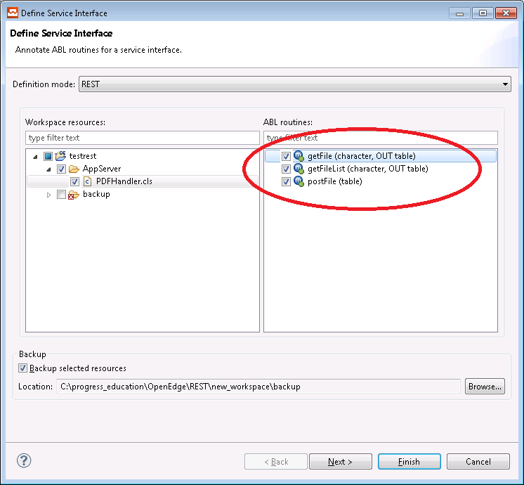

**Figure 1**

1. Create a new resource by clicking the green Plus button under Resources (Figure 2) and naming it /PDFHandler.

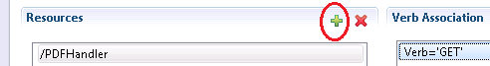

**Figure 2**

1. Add a Verb Association for the GET verb and map it to the getFileList method of PDFHandler.cls (Figure 3).

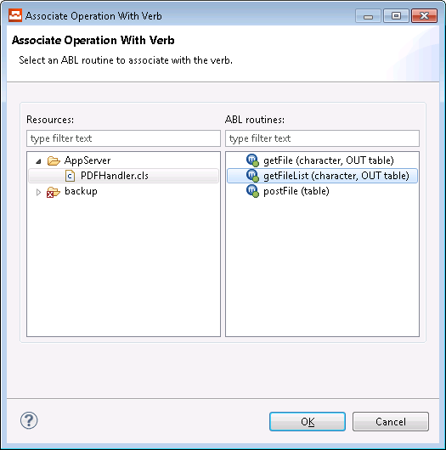

**Figure 3**

1. Map the Input parameter on the right, called pcURI, to Complete URL under the URL Parameters section on the left (Figure 4).

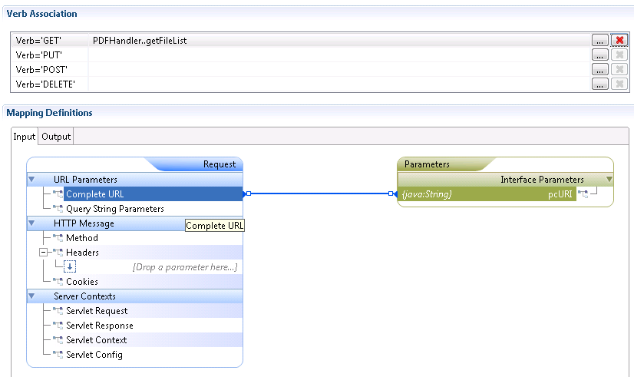

**Figure 4**

1. Select the Output tab and map the ttFileName temp-table parameter to the Response Body section (Figure 5).

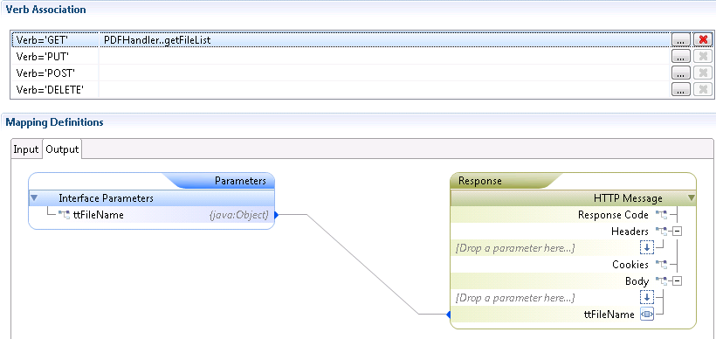

**Figure 5**

1. Add a Verb Association for the POST verb and map it to the postFile method of PDFHandler.cls (Figure 6).

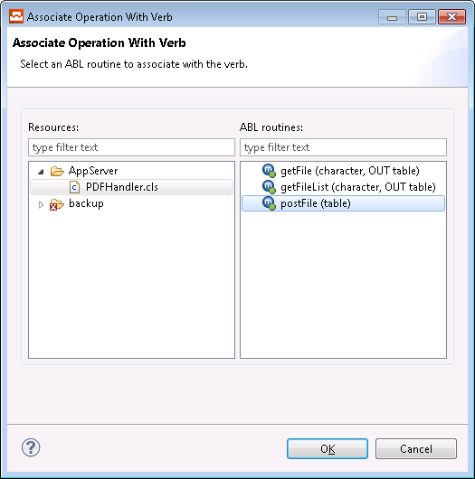

**Figure 6**

1. In the Input tab, map the ttFile (TABLE) parameter to the body of the HTTP Message on the left (Figure 7).

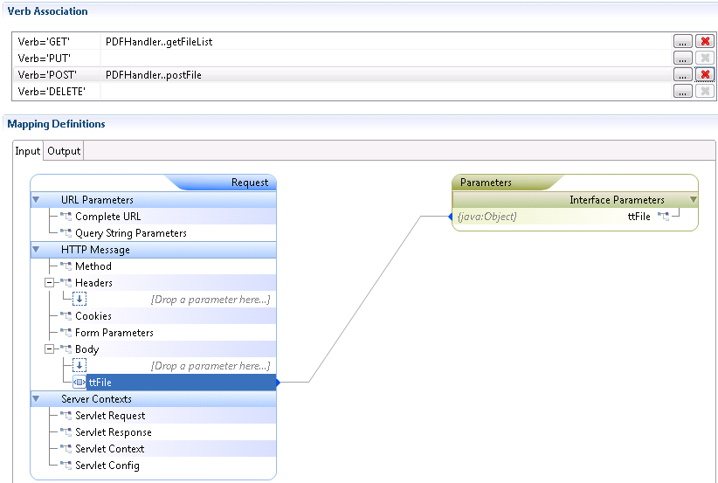

**Figure 7**

1. Add a new Resource named /PDFHandler/{pcFileName} (Figure 8).

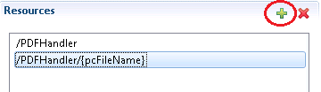

**Figure 8**

1. Add a Verb Association for the GET verb and map it to the getFile method of PDFHandler.cls (Figure 9).

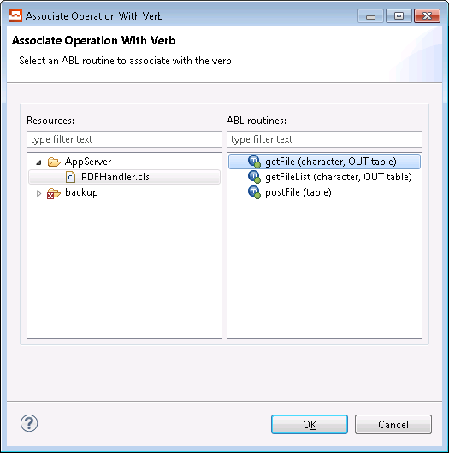

**Figure 9**

**NOTE:** The pcFileName parameter is mapped automatically (Figure 10).

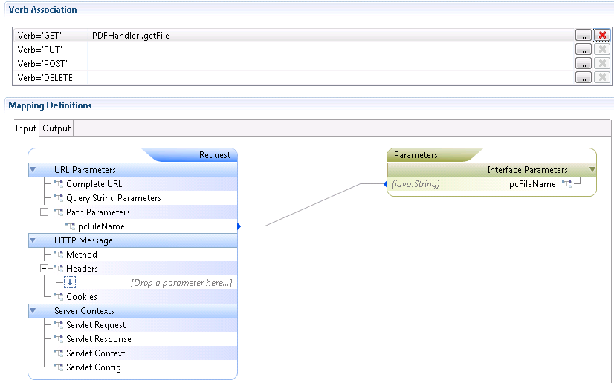

**Figure 10**

1. In the Output tab, map the ttFile (java:Object) parameter to the Response Body (Figure 11).

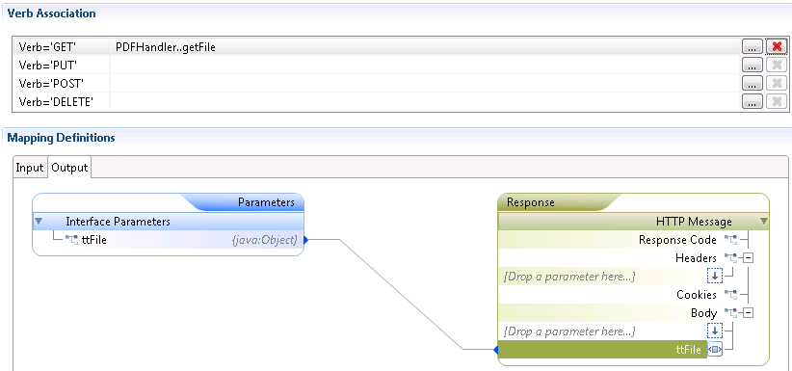

**Figure 11**

1. Save the changes made in the URI editor and Restart/Republish your AppServer and REST WebServer as appropriate.

**Testing**

**JSON Example Wrapper:**

Below is an example of the JSON input that is required to pass a file to the WebService. The value <payload> should be replaced with the base64 encoded representation of a file.

{"request":{"ttFile":{"ttFile":[{"tcFileName":"<filename>","tclbPayLoad":"<payload>"}]}}}

* Test this with the REST client of choice.

**Test Requests:**

* A GET request on the <restServiceURL>\PDFHandler operation will return a list of files that are available in the AppServer’s current working directory with one of the following extensions: “jpg,jpeg,gif,png,pdf,docx”. The output from the getFileList method is a TEMP-TABLE that references each file as a URL, using the URI of the REST service with the file name appended.

e.g.

[http://localhost:8980/testrestService/rest/testRestService/PDFHandler/<filename](http://localhost:8980/testrestService/rest/testRestService/PDFHandler/%3cfilename)>

When clicked, the generated URL will execute a GET request on the <restServiceUrl>/PDFHandler/{pcFileName} resource and return the file as a base64 encoded string.

* To push a file from the client to the AppServer, try a POST request on the <restServiceURL>/PDFHandler resource. Use the example JSON wrapper from above and pass a base64 encoded string representing a file in the Payload section of the Body of the Request, as Content-type application/json. This method takes the following parameters:
  + tcFileName (CHARACTER) – This is passed in the tcFileName element of the ttFile json array (replace <filename> in the example json above). This is the file name of the file that will be saved into the AppServer’s working directory.
  + tclbPayLoad (BASE64-Encoded string) – This is passed in the tclbPayLoad element of the ttFile json array (replace <payLoad> in the example json above). This is the Base64 Encoded file.

The attached progsoft.json file contains an example json string that represents a .bmp file. Open this file and copy the JSON string directly out of this file into the body of a POST request to the pdfHandler service then open the resultant progsoft.bmp file that got saved into the working directory of the AppServer to verify it’s a valid bitmap.

* For an example of how to base64 encode a file, see the code in the PDFHandler.getFile method.

e.g.

COPY-LOB FROM FILE pcFileName TO lpFile.

lcFile = BASE64-ENCODE(lpFile).