Team Grape

Checkin 3 Report

4/16/2015

Team Members: Nathan Kanekuni, Mark Bercasio, Kenneth Carroll

Lines of code developed as of 4/16/2015 10:54 HST PM: ~964

Number of Junit Asserts used: 19

LOC / Assert ratio = 964/19 = ~51

Images of Google calendar included on pages 2 and 3 respectively with

* Free times of two different people
* Free times of two different people and their mutual free times

Before mutual free times

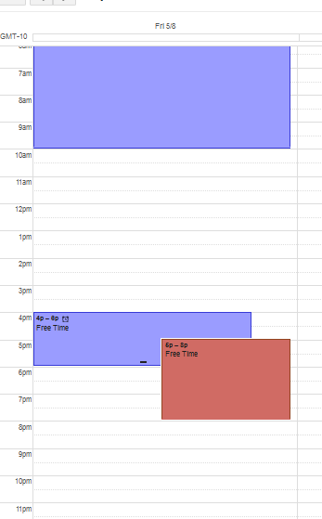

With mutual free times

