**Continuous Integration with Cruise Control.NET**

Browse to the following URL:

<http://localhost/ccnet/ViewFarmReport.aspx>

1. Dashboard showing 2 projects (Build and Deploy)

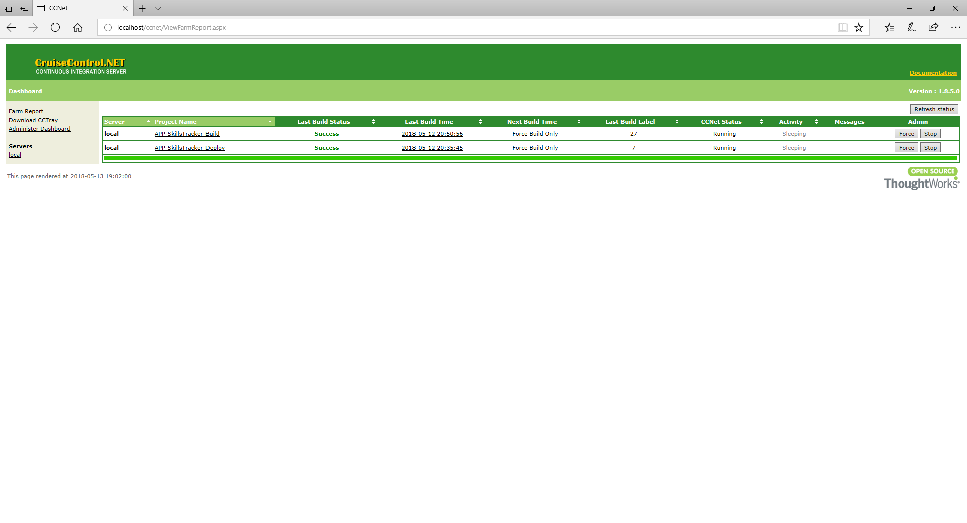

1. Hourly build set-up:

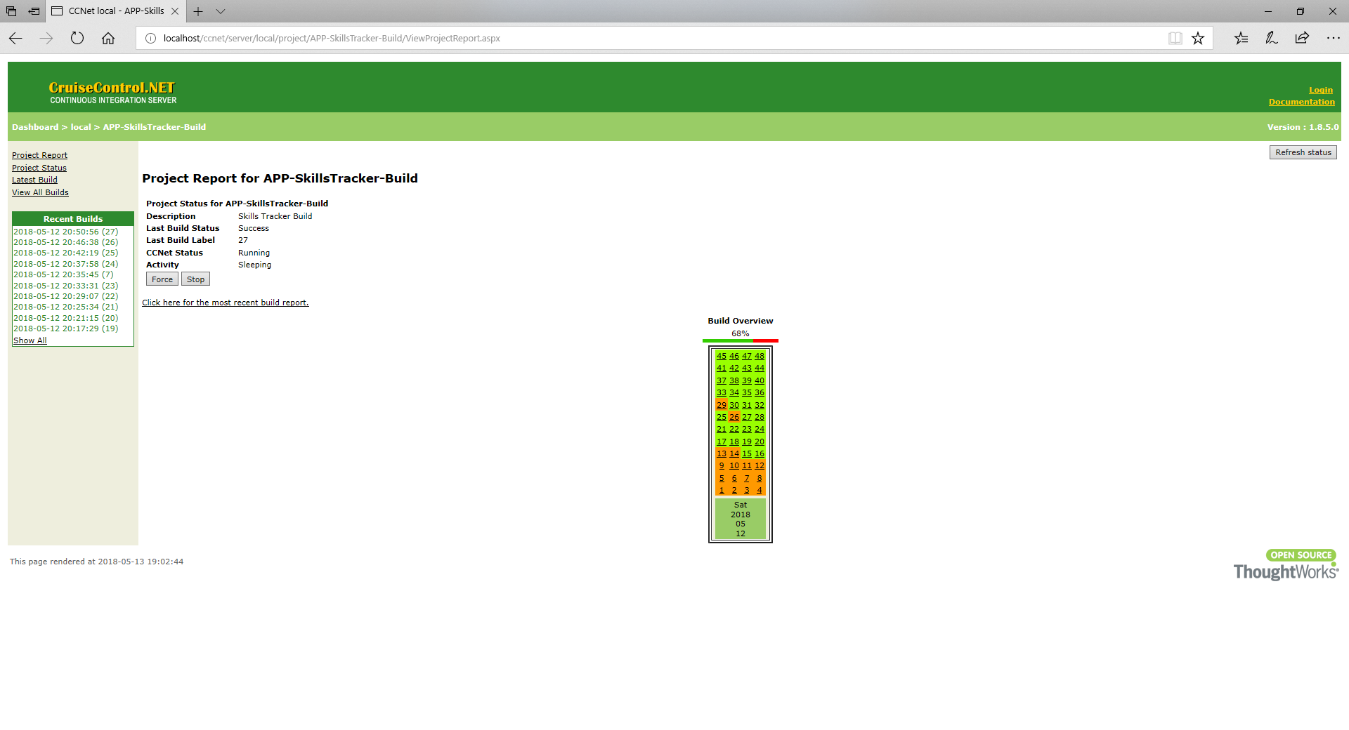

1. All Builds:

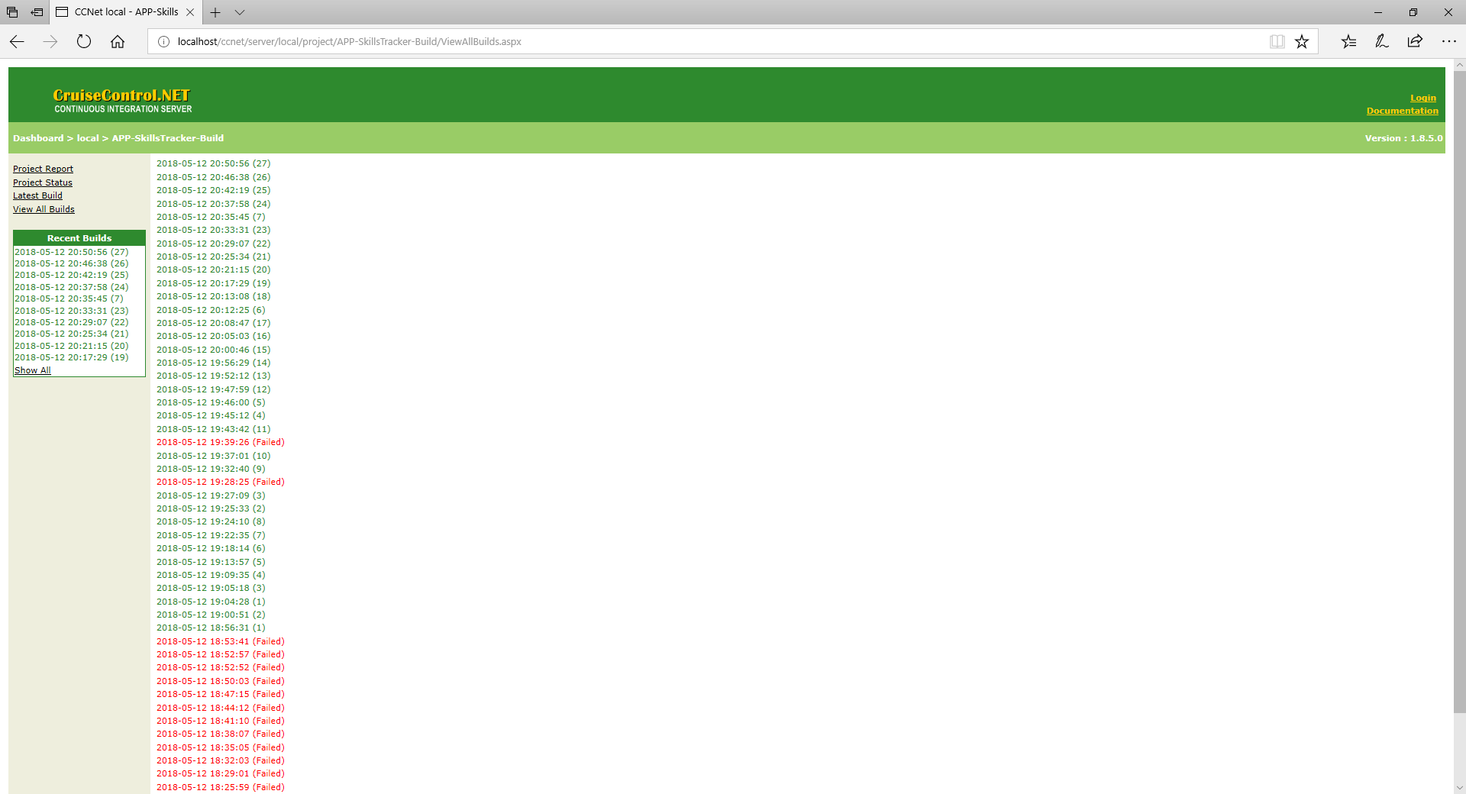

1. Build Log:

