1. View All Page

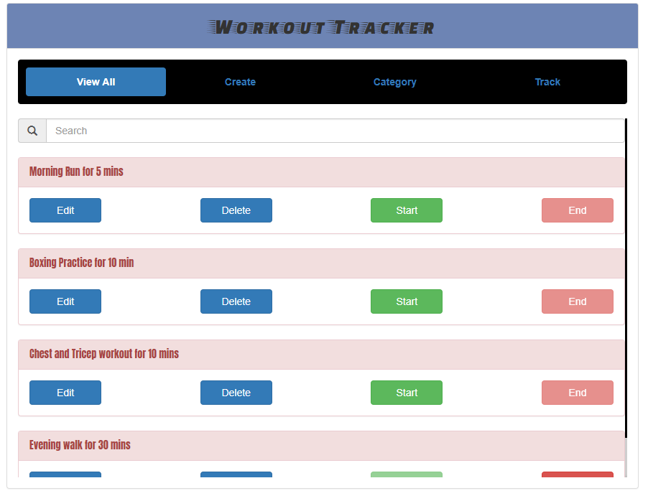

1. View All Page with filter

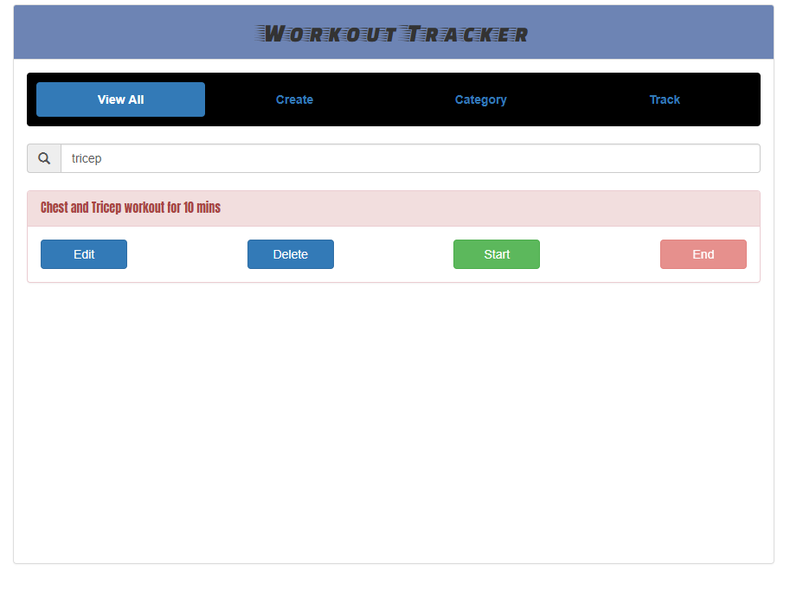

1. Starting a workout

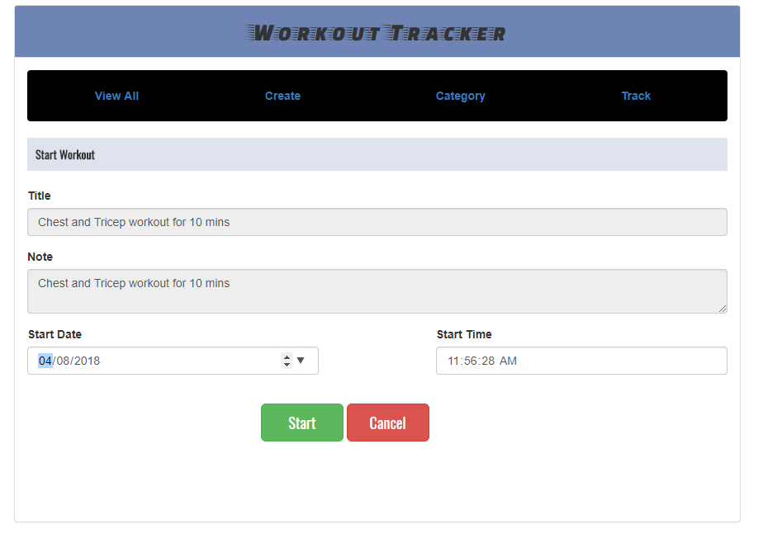

1. Ending a workout

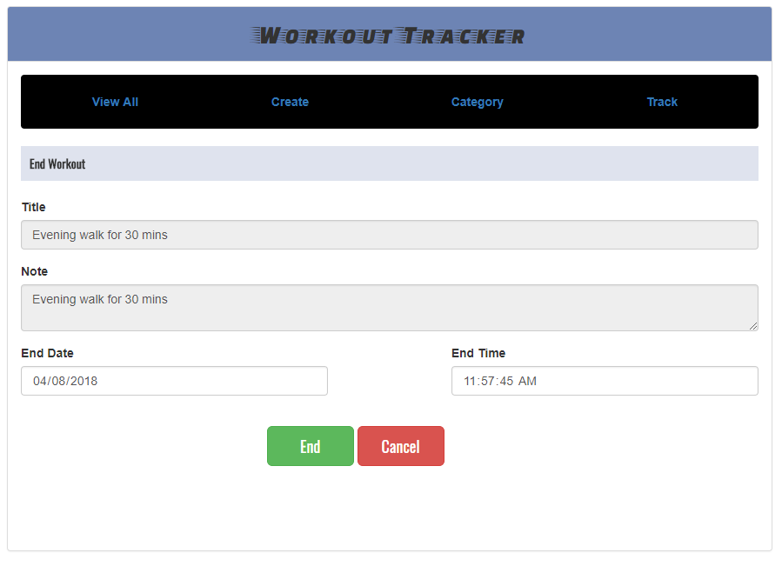

1. Editing a workout

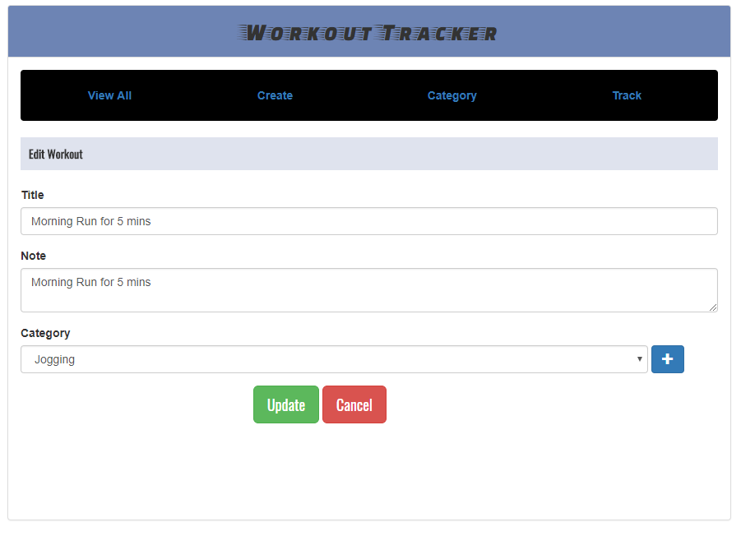

1. Creating a new workout (with validation messages)

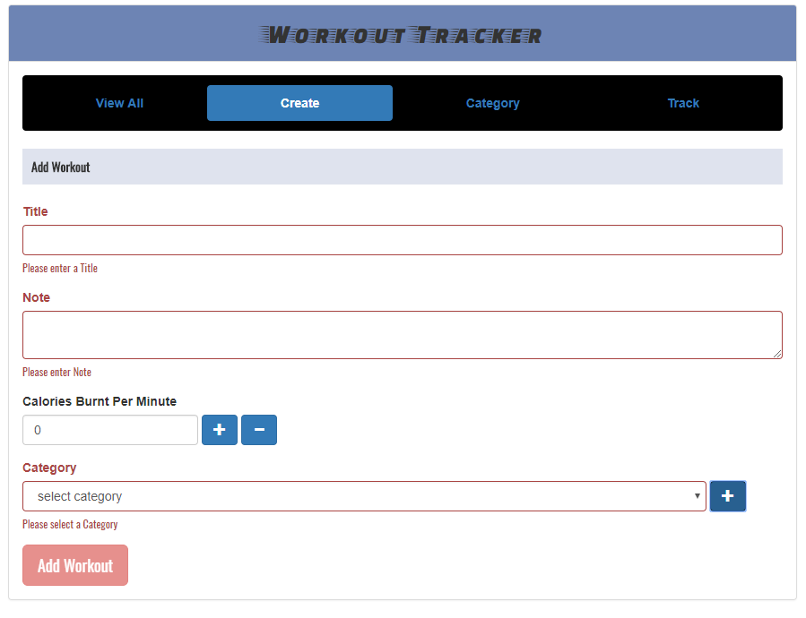

1. Calories Burnt Per Minute (Add or Subtract)

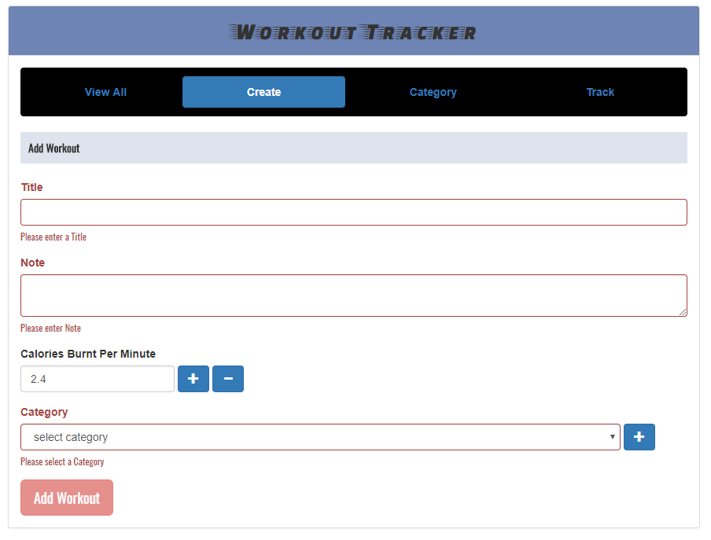

1. Adding a new Category with modal pop-up

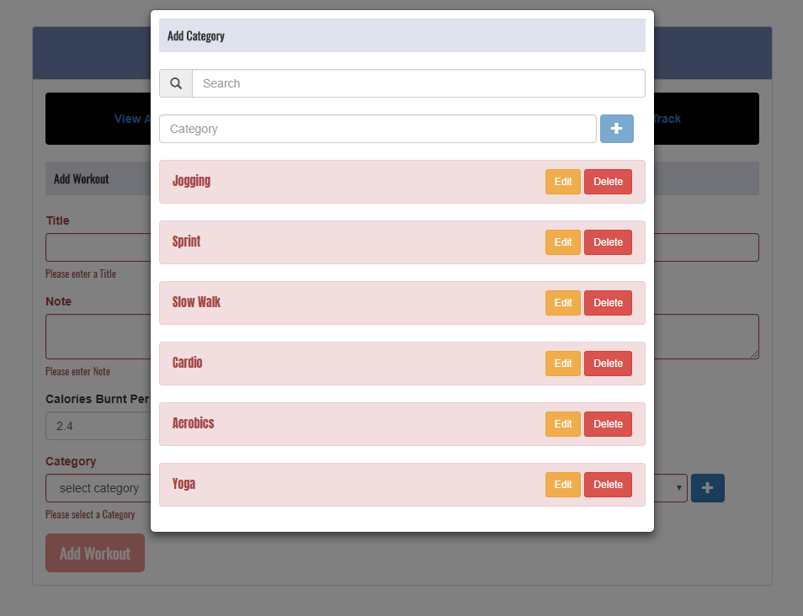

1. Adding new Category with its own view (validation and scrollable)

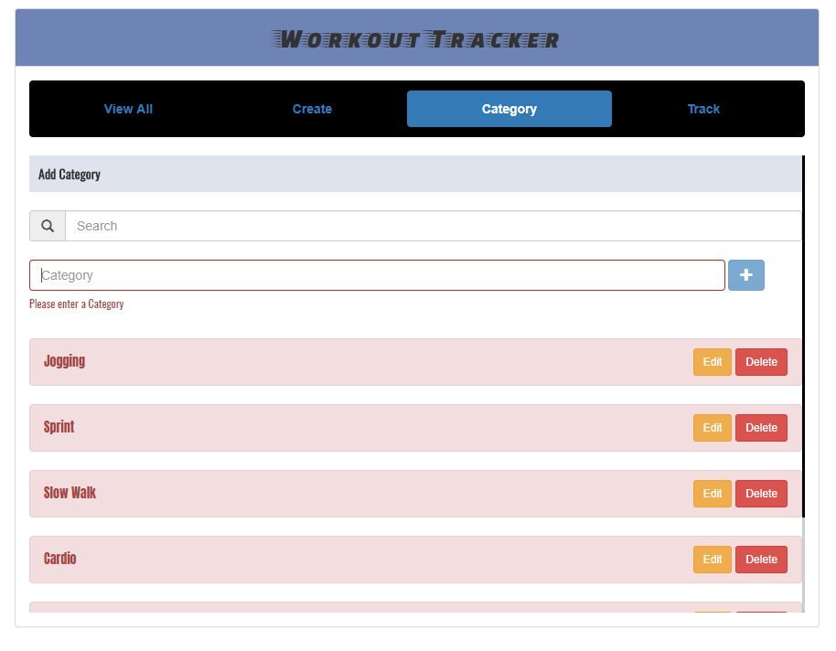

1. Category View with filter.

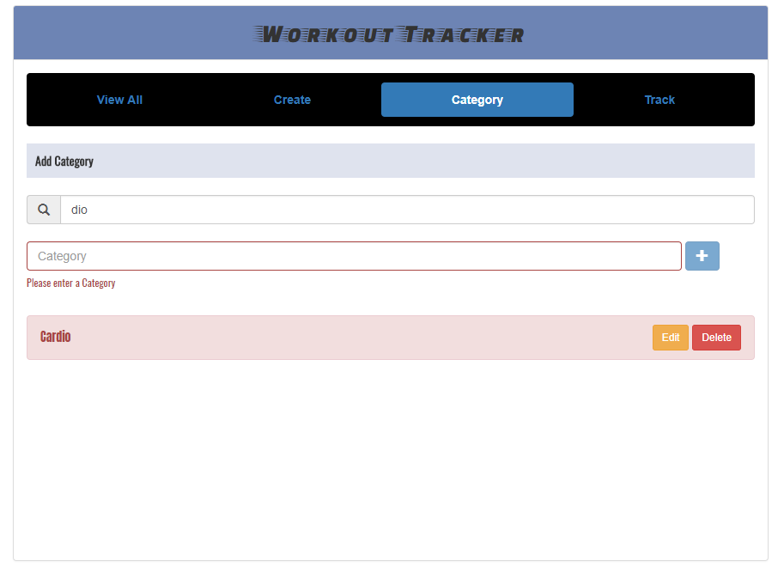

1. Updating Category with “contenteditable” attribute

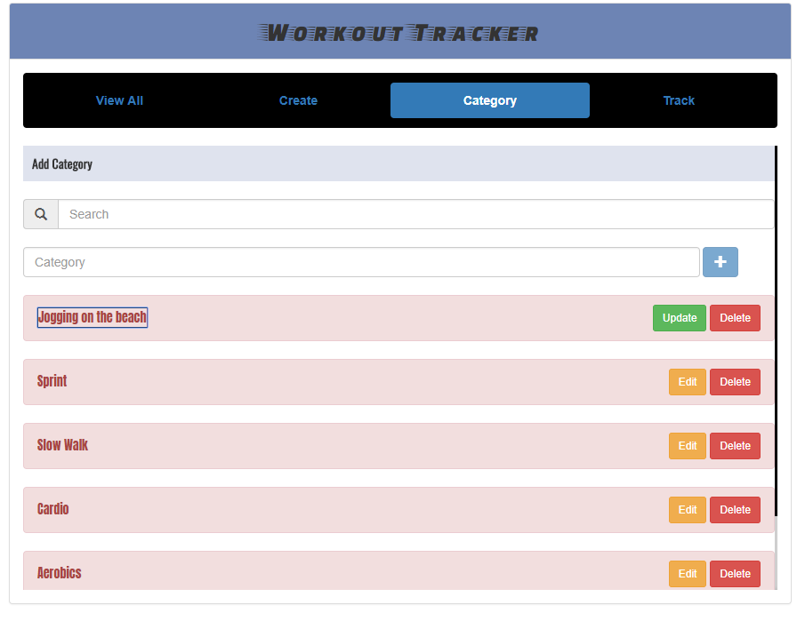

1. Track Page with total minutes.

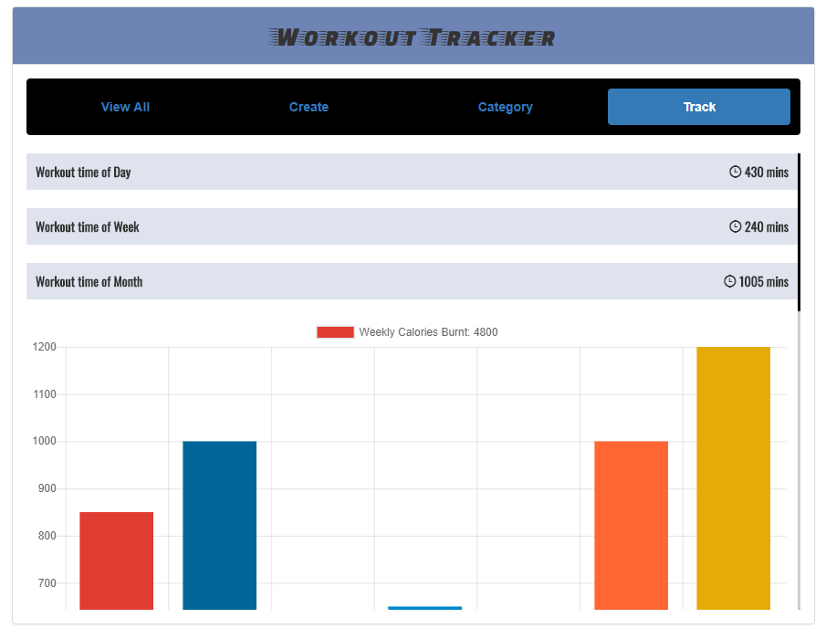

1. Track Page (scrollable) with “Weekly Calories Burnt” chart

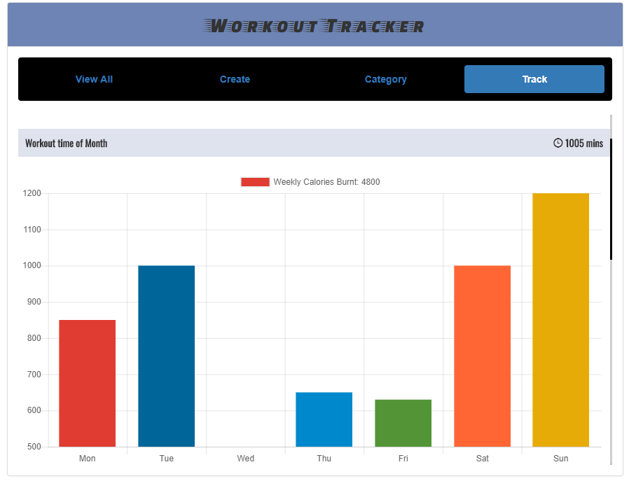

1. Track Page (scrollable) with “Monthly Calorie Burnt” chart

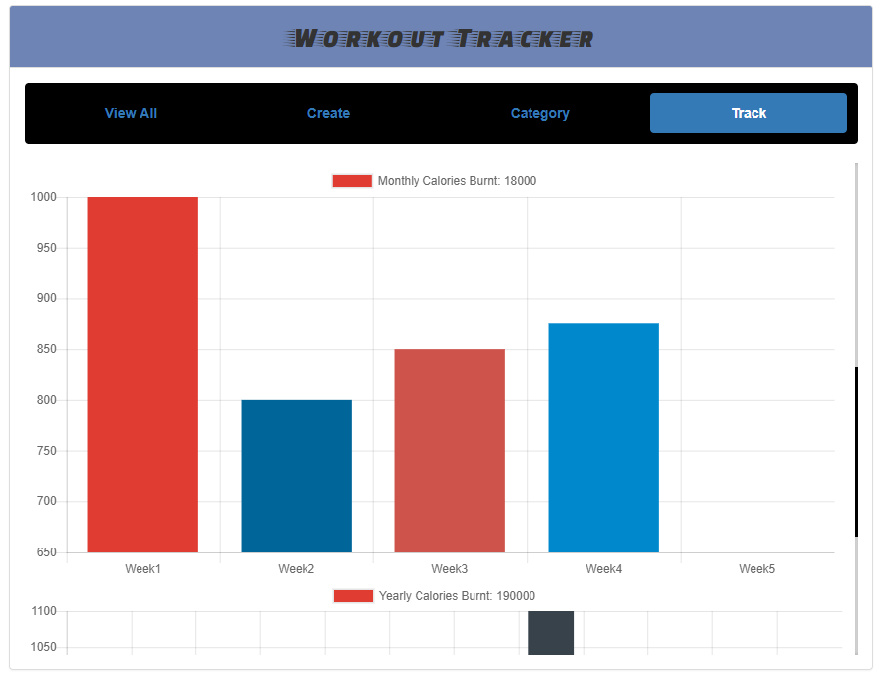

1. Track Page (scrollable) with “Yearly Calorie Burnt” chart.

