1. “View All” page

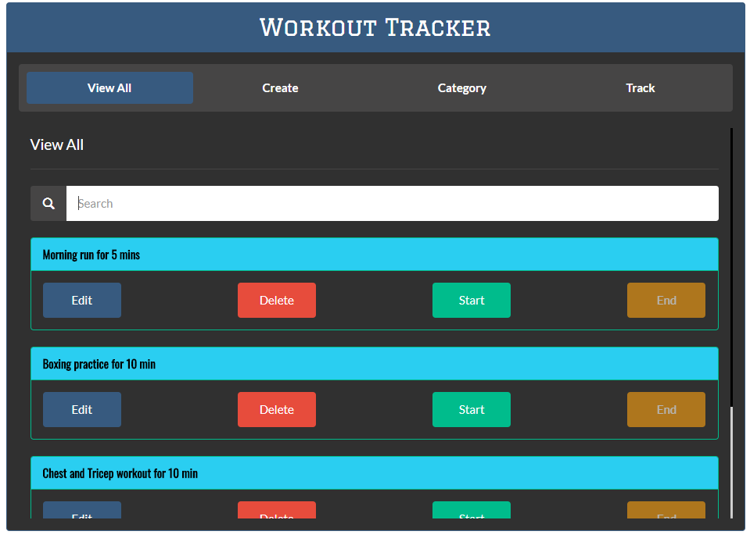

1. “View All” page with filter

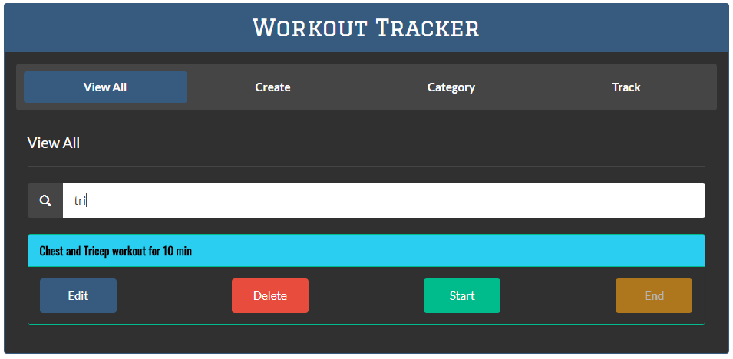

1. Starting a workout

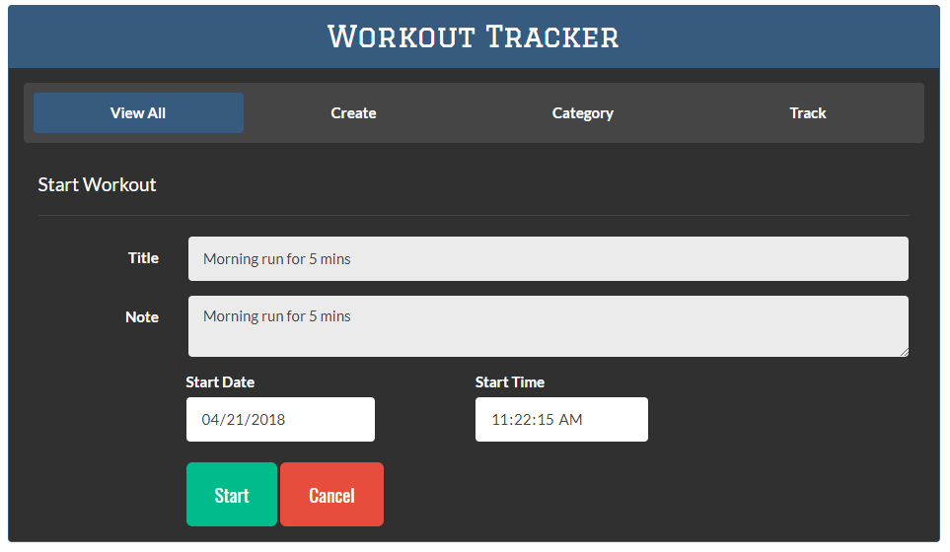

1. “Start” button disabled when workout is started

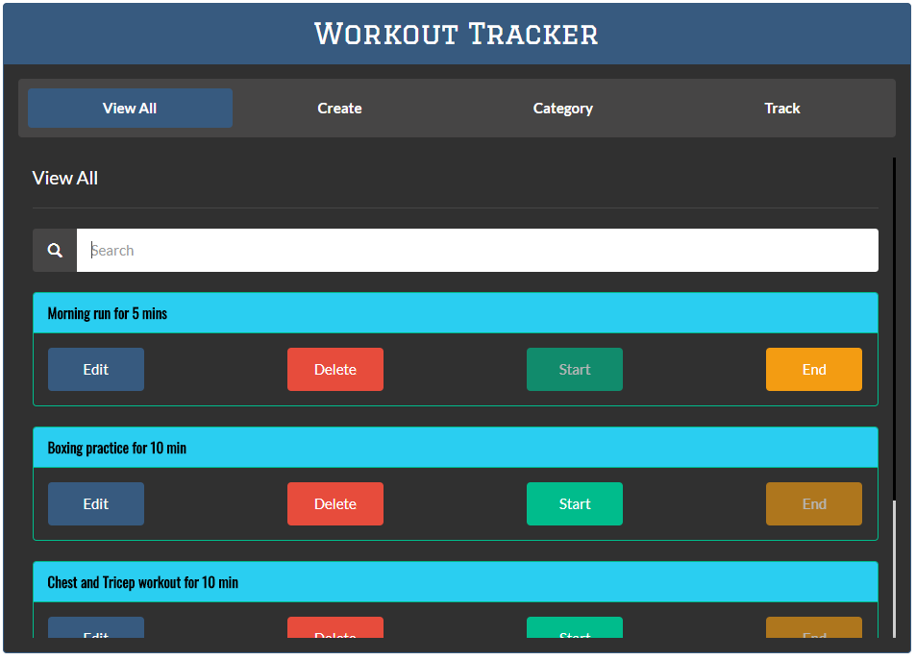

1. End Workout

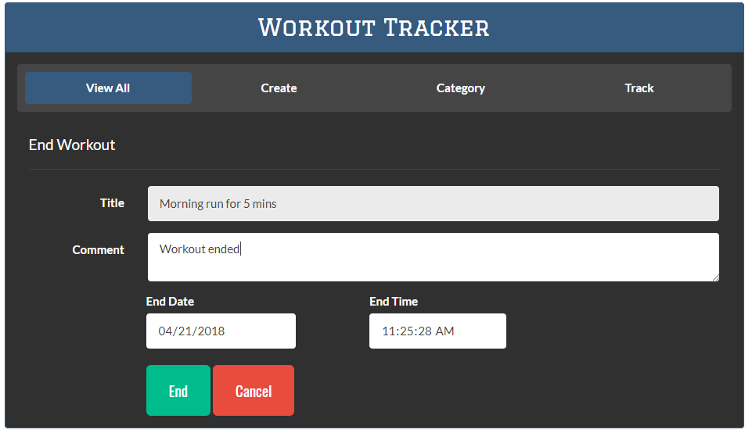

1. Update workout

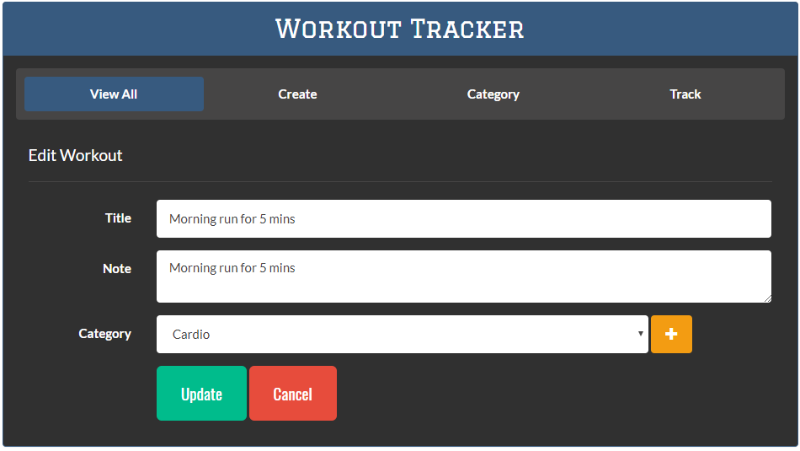

1. “Create” page.

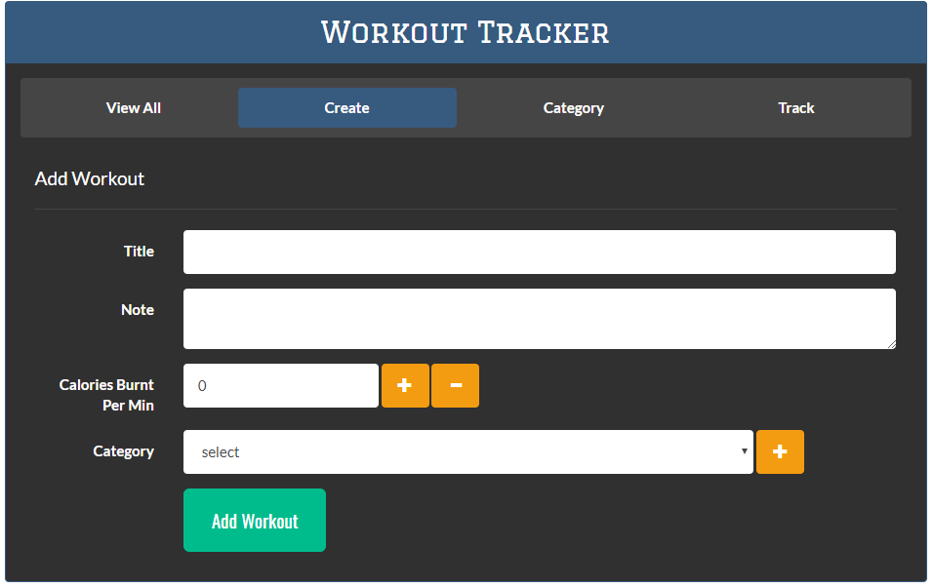

1. “Create” page with validation

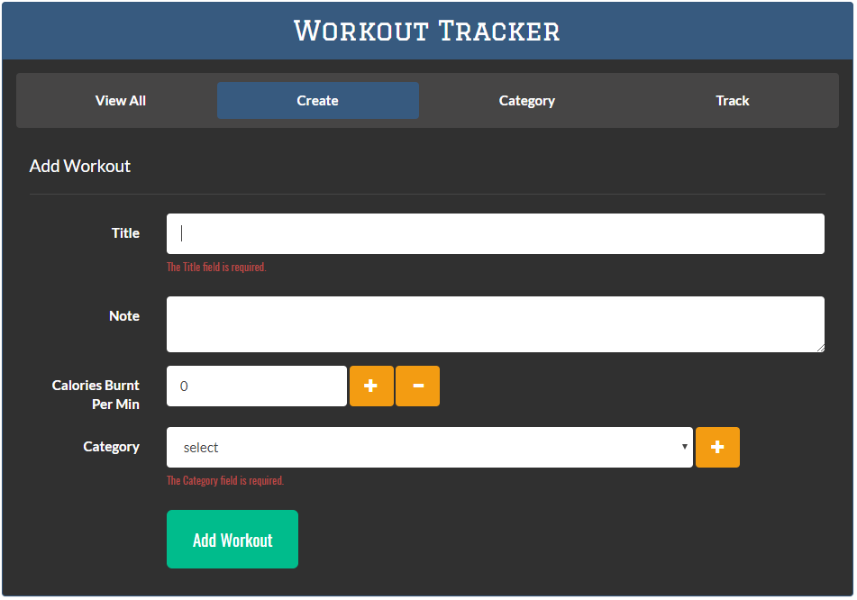

1. Adding and Subtracting calories

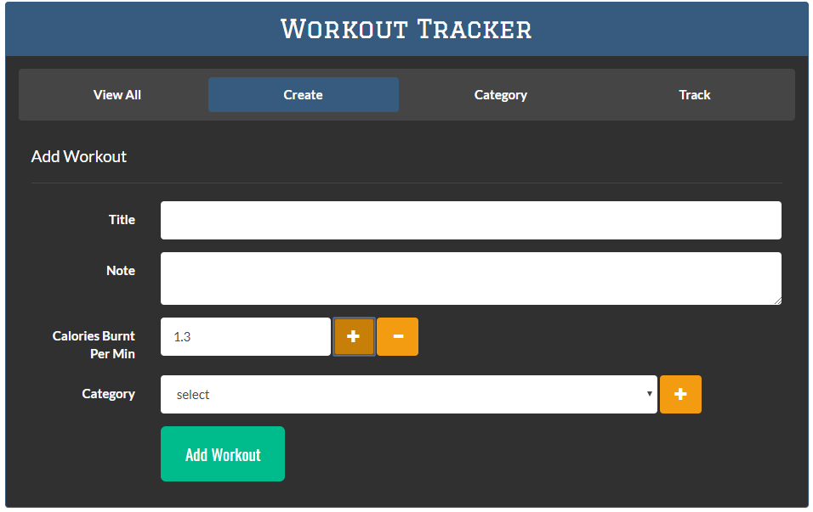

1. Adding new “Category” from “Create” page via Modal pop-up

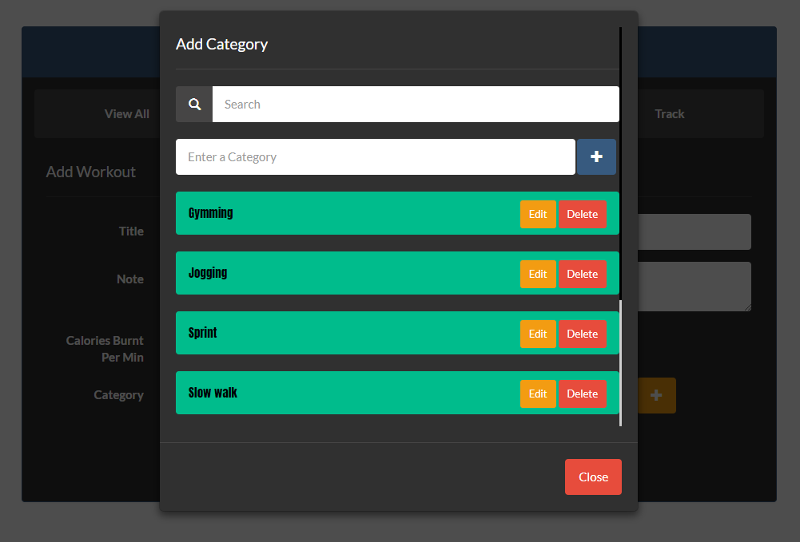

1. Adding “Category” via Category page

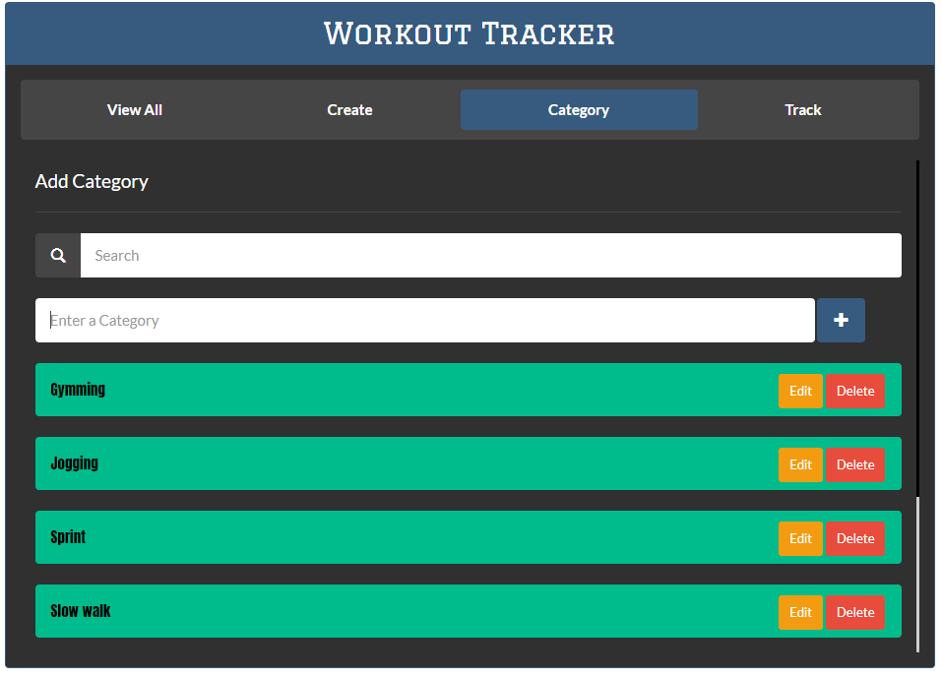

1. Category filter.

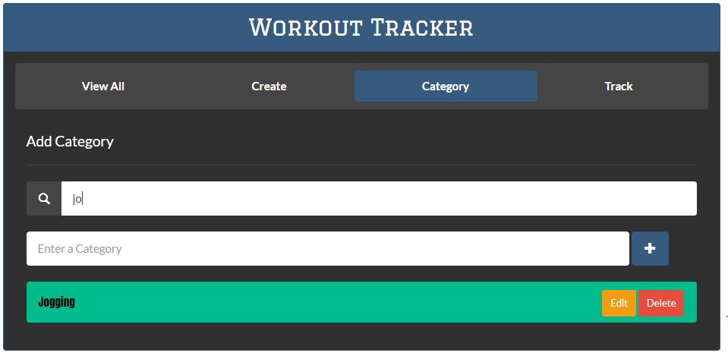

1. Updating categories with “contenteditable” attribute

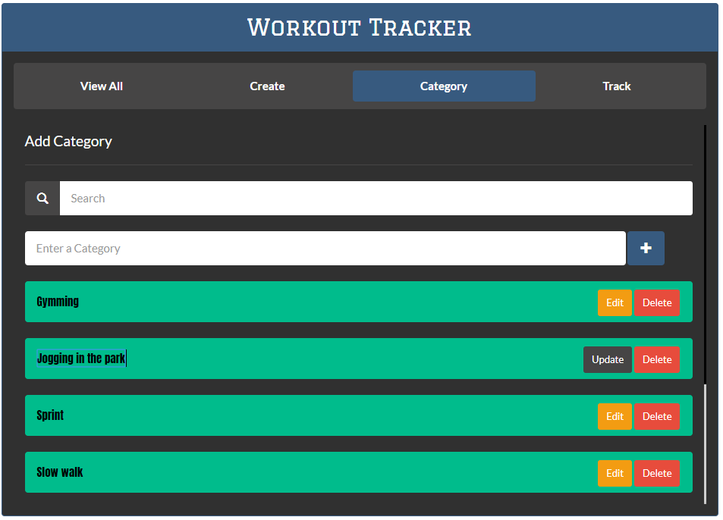

1. Track Page with Total Minute.

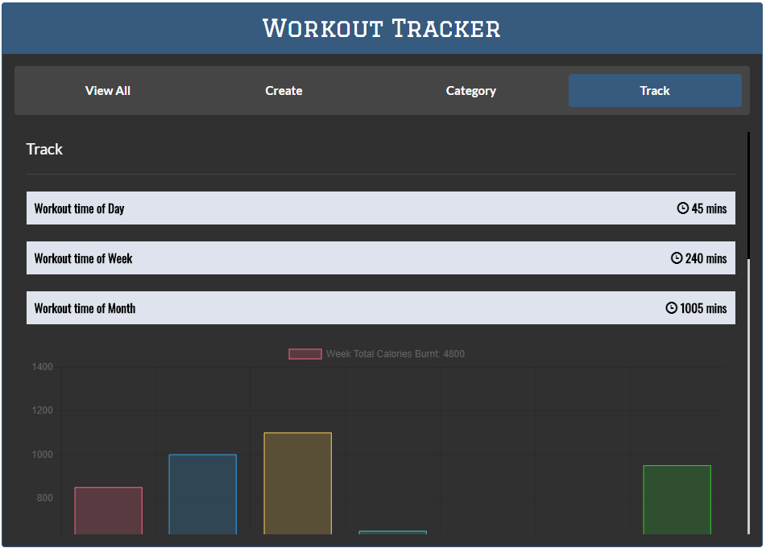

1. “Track” page (scrollable) with “Week Total Calories Burnt” chart

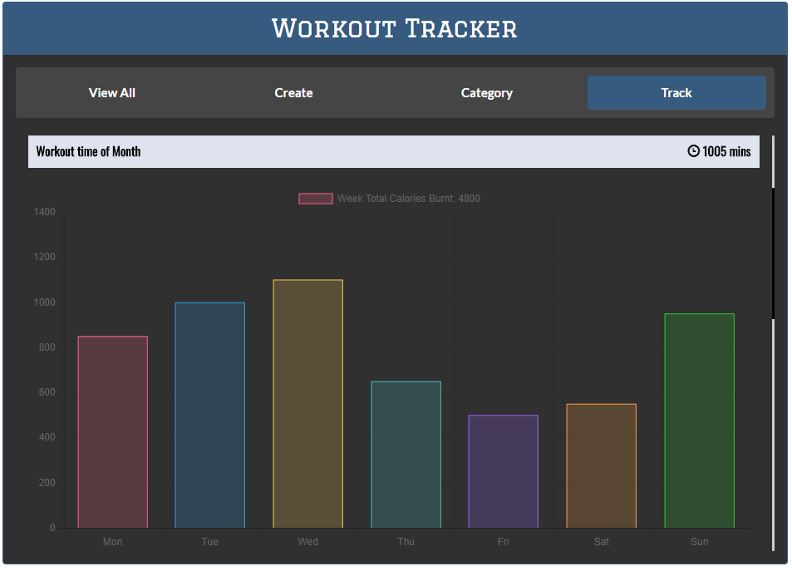

1. “Track” page (scrollable) with “Month Total Calories Burnt” chart

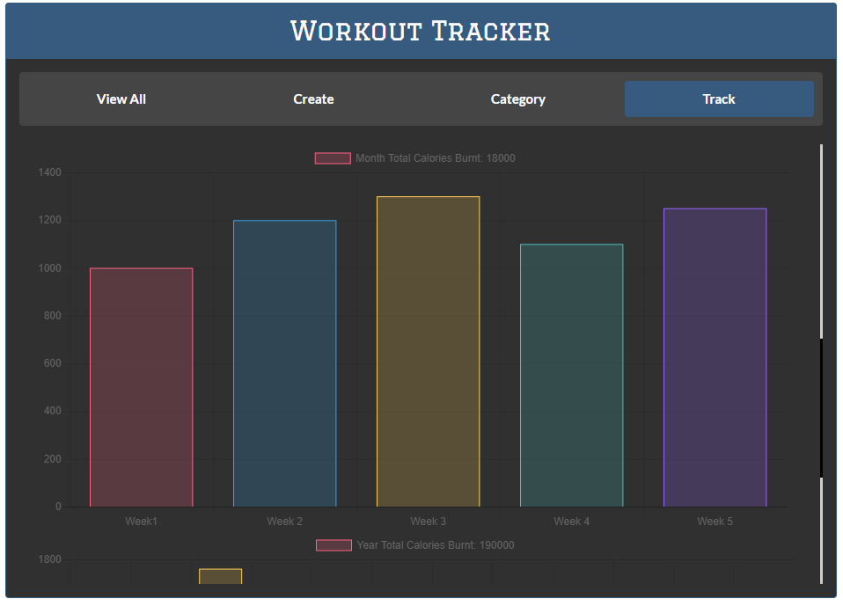

1. “Track” page (scrollable) with “Year Total Calories Burnt” chart

