Project: 3D Perception

## Exercise 1, 2 and 3 Pipeline Implemented

# Complete Exercise 1 steps. Pipeline for filtering and RANSAC plane fitting implemented.

The source code is

https://github.com/nakata0705/RoboND-Perception-Exercises/blob/master/Exercise-1/RANSAC.py

**The original point cloud**

Exercise-1/tabletop.pcd: x y z rgb data. 202,627 points

The original point cloud. There are more than necessary points.

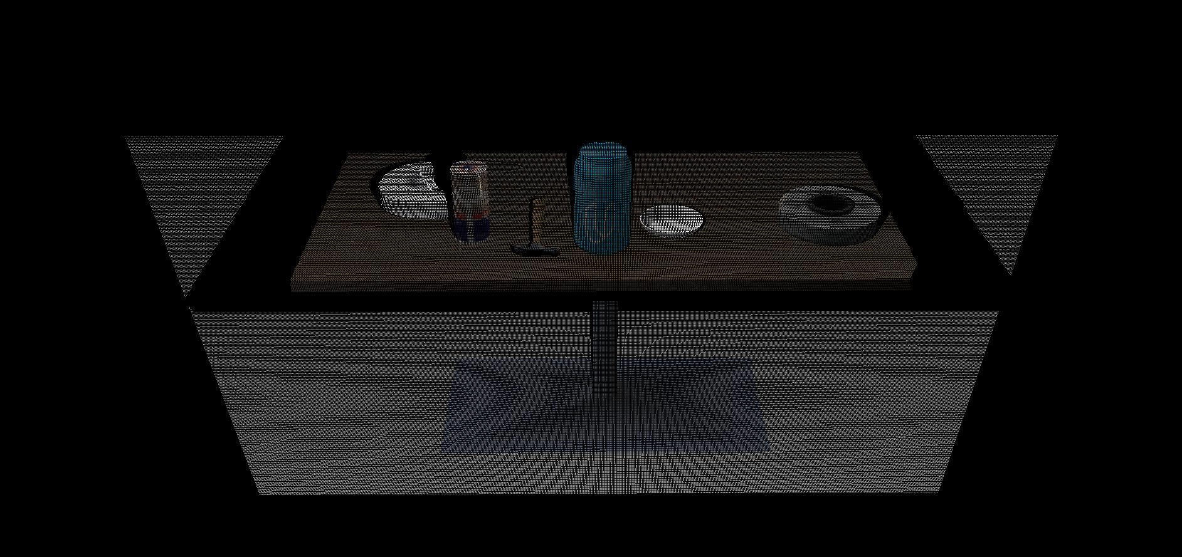

**The point cloud after voxel down sampling**

Exercise-1/voxel_downsampled.pcd: x y z rgb data. 55,336 points

Reduced the number of points by applying voxel filter with 1cm x 1cm x 1cm resolution.

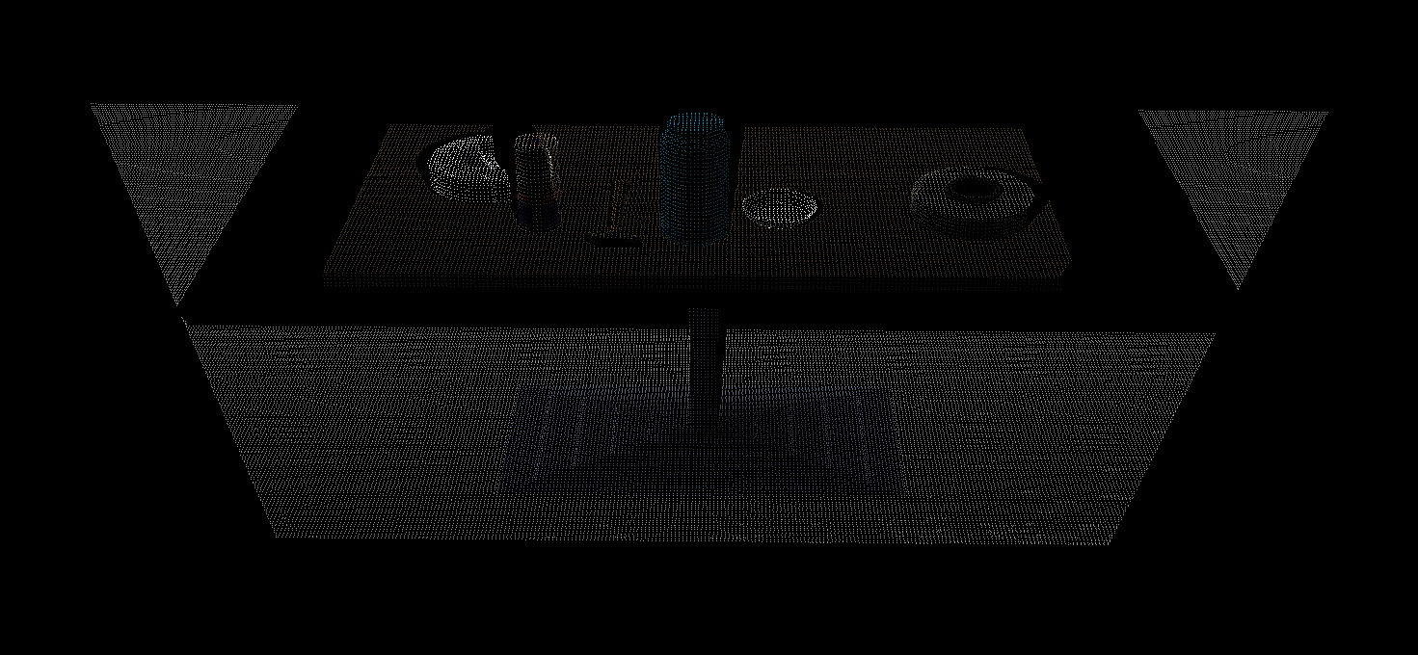

**The point cloud after pass through filter**

Exercise-1/pass_through_filtered.pcd: x y z rgb data. 16,302 points

Filtered further by extracting points with height between 0.6m and 1.1m.

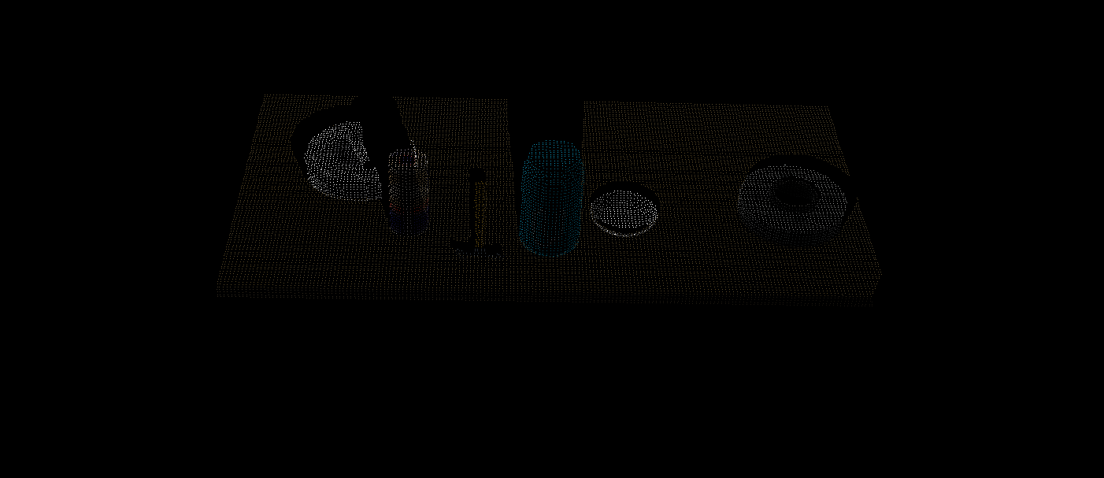

**The point cloud after RANSAC filter (inlier for SACMODEL_PLANE)**

Exercise-1/extracted_inliers.pcd: x y z rgb data. 11,881 points

Extracted the largest plane by using RANSAC filter with SACMODEL_PLANE parameter.

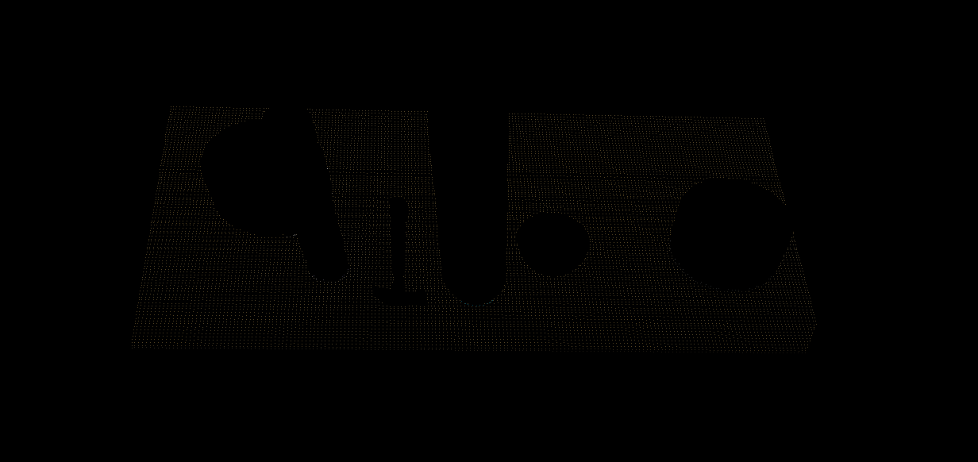

**The point cloud after RANSAC filter (outlier for SACMODEL_PLANE)**

Exercise-1/extracted_outliers.pcd: x y z rgb data. 4,421 points

The remaining points. Successfully extracted objects on the table.

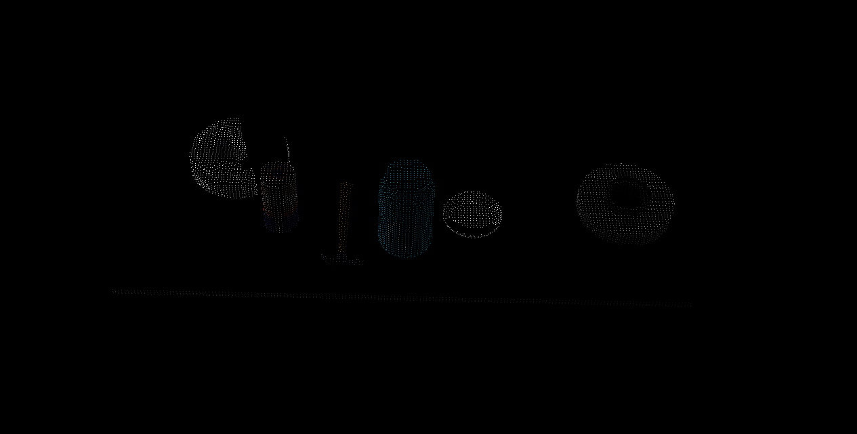

# Complete Exercise 2 steps: Pipeline including clustering for segmentation implemented.

The source code is

https://github.com/nakata0705/RoboND-Perception-Exercises/blob/master/Exercise-2/sensor_stick/scripts/segmentation.py

**The point cloud after RANSAC filter (outlier for SACMODEL_PLANE)**

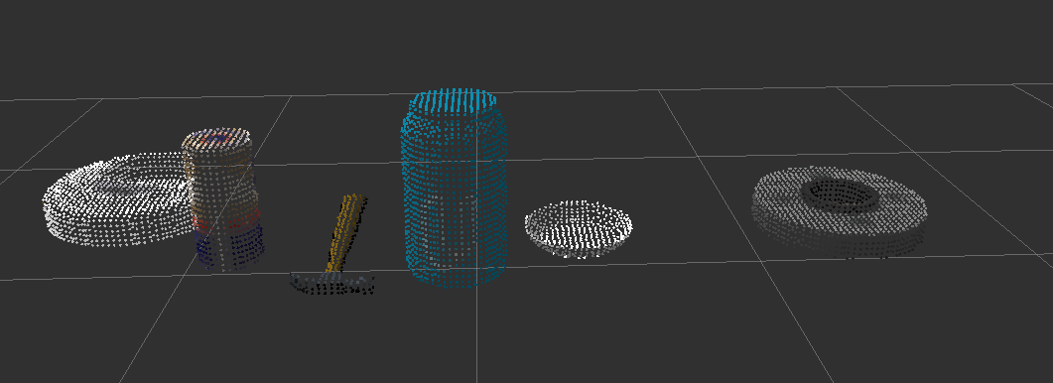

**The point cloud after clustering.**

The parameter for Euclidean clustering is as follows.

ec.set_ClusterTolerance(0.02)

ec.set_MinClusterSize(100)

ec.set_MaxClusterSize(10000)

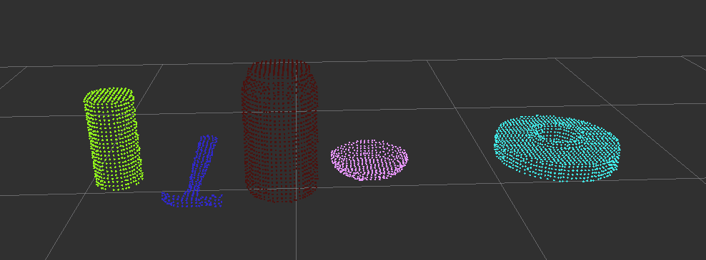

# Complete Exercise 3 Steps. Features extracted and SVM trained. Object recognition implemented.

The source code is

https://github.com/nakata0705/RoboND-Perception-Exercises/blob/master/Exercise-3/sensor_stick/scripts/capture_features.py

https://github.com/nakata0705/RoboND-Perception-Exercises/blob/master/Exercise-3/sensor_stick/scripts/train_svm.py

https://github.com/nakata0705/RoboND-Perception-Exercises/blob/master/Exercise-3/sensor_stick/scripts/object_recognition.py

https://github.com/nakata0705/RoboND-Perception-Exercises/blob/master/Exercise-3/sensor_stick/src/sensor_stick/features.py

The confusing matrix is as follows.

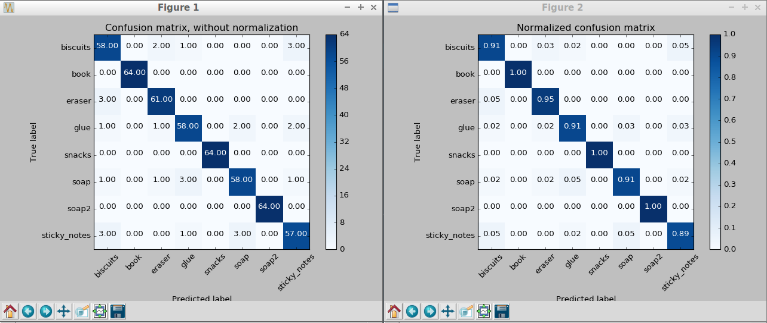

Calculation of the feature is very simple. It’s from line 146 to line 149 of object_recognition.py.

First the program calculates HSV color histograms. The programs uses bins=6 for color histogram and bins=8 for normal histogram. Then the program concatenate the two histograms and use it as feature vector.

# For all three tabletop setups (test*.world), perform object recognition, then read in respective pick list (pick_list_*.yaml). Next construct the messages that would comprise a valid PickPlace request output them to .yaml format.

The source code is as follows.

https://github.com/nakata0705/RoboND-Perception-Project/blob/master/pr2_robot/scripts/project_template.py

The output yaml files are as follows.

https://github.com/nakata0705/RoboND-Perception-Project/blob/master/pr2_robot/scripts/output_1.yaml

https://github.com/nakata0705/RoboND-Perception-Project/blob/master/pr2_robot/scripts/output_2.yaml

https://github.com/nakata0705/RoboND-Perception-Project/blob/master/pr2_robot/scripts/output_3.yaml

The successful recognition rate is 100% for world 1, 100% for world 2, and 87.5% (7/8). The success rate wasn’t stable. It seems those three results are impacted by the noise even after statistical outlier filtering.