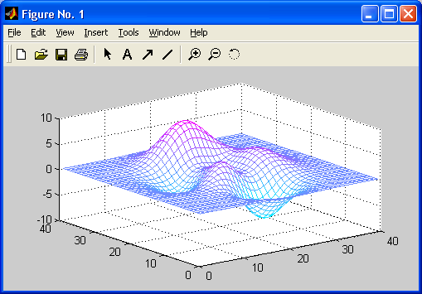 **TOPIC OF THE PROJECT:**  **3D designer** – мобилно приложение за проектиране на ефекти

**AUTHOR:** Naiden Kostov Naidenov, student from Х grade in SU "Vasil Levski" t. Valchi Dol

**CONSULTANT:** няма

**Goals:**  The mobile application **3D designer** is made to create pictures with abstract art forms.

**Description:**

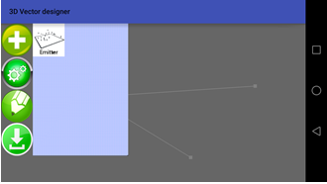The emitter object emits particles.

Every particle has its own position, color and next position. They can be drawn using only points or connected with lines or with sprites (your image on every particle). Every frame can be redrawn or saved so when you make a line it stays there after the next frame.

You can download the image you made using the last button in jpeg or png format.



**Realization:**

* **Java**



* **Android Studio 2.2.3**

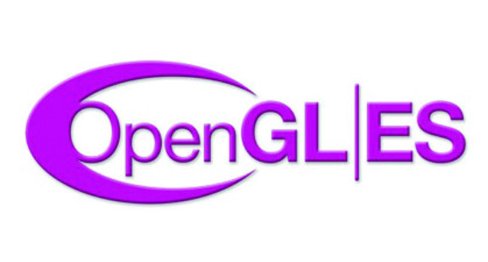

* **OpenGL ES**