Business and Data Understanding Report
MIMIC-IV ICU Analytics Project

1. Introduction
Regional Medical Center (RMC) is a 400-bed academic medical center with a 36-bed intensive care unit (ICU) serving a diverse metropolitan population. RMC has observed variation in ICU patient outcomes and resource use and wants a more systematic, data-driven understanding of the patient characteristics, clinical factors, and care patterns associated with these differences. The project uses deidentified electronic health record data to identify patterns that may support clinical practice, quality improvement, and operational decision-making.
This report documents the Business Understanding and Data Understanding phases of CRISP-DM. It defines the business problem, objectives, stakeholders, responsibilities, analytical goals, and project plan, then describes the MIMIC-IV Demo data, summarizes initial exploratory findings, and identifies data-quality considerations that will shape later data preparation and analysis.

2. Business Understanding

2.1 Business Problem and Objectives
RMC lacks a systematic understanding of the factors associated with variation in ICU patient outcomes, care delivery, and resource utilization. Clinical experience is essential for individual care, but analysis across patients and encounters can reveal broader patterns that are difficult to identify from individual cases alone.
The primary business objective is to improve RMC's understanding of ICU outcomes and care delivery so that clinical practice, quality improvement, and operational decisions can be supported by evidence. Supporting objectives are to:
- Identify patient and clinical characteristics associated with outcomes such as recovery, ICU length of stay, hospital length of stay, and mortality.
- Describe treatment and care patterns and examine how they vary across patients and outcomes.
- Characterize resource utilization, including length of stay, procedures, medication-related records, and transfers.
- Use the evidence generated to identify areas that may warrant further clinical or operational investigation.

2.2 Analytical Objectives
Table 1. Analytical Objectives, Focus Areas, and Key Measures.
Objective | Analytical focus | Key measures / questions
Patient outcomes | Examine associations between patient characteristics, clinical factors, and outcomes. | Age, gender, diagnoses, ICU/hospital LOS, mortality, discharge disposition.
Treatment and care patterns | Describe medications, procedures, interventions, and monitoring patterns and relate them to selected outcomes. | Medication records, hospital/ICU procedures, inputs, outputs, LOS and mortality.
Resource utilization | Identify variation in the duration and intensity of care and characteristics associated with higher utilization. | ICU/hospital LOS, procedure counts, prescription counts, transfers, ICU interventions.

The current phase is exploratory. Relationships identified in these data will be treated as associations rather than causal effects, and analytical questions may be refined as data quality and sample-size limitations become clearer.

2.3 Stakeholders and Success Criteria
The ICU Medical Director is the primary clinical stakeholder and is interested in evidence that can improve understanding of outcomes, care practices, and potential quality-improvement opportunities. Hospital Administration is primarily interested in operational performance, resource utilization, and quality metrics. Findings therefore need to be methodologically sound, clinically interpretable, and useful for operational planning without overstating what the data can establish.
Project success will be defined by the generation of meaningful, evidence-based insights using methods appropriate to the available data. Findings should be interpreted in the healthcare context, acknowledge limitations and potential bias, distinguish association from causation, and identify practical areas for further investigation. The primary deliverable is a healthcare analytics report suitable for review by hospital leadership and clinical staff.

2.4 Assessment of the Situation and Responsibility
The primary resource is the MIMIC-IV Clinical Database Demo, which contains deidentified hospital and ICU records for 100 patients. MIMIC-IV documentation and data dictionaries support interpretation of table structures, identifiers, coded variables, and deidentification. Python and common data-analysis and visualization libraries are used for preparation, exploration, statistical analysis, and visualization.
Important constraints include the small 100-patient sample, sparse observations in some tables or subgroups, missing data, the absence of free-text clinical notes, data from a single medical center, and the observational nature of the dataset. These limitations restrict generalizability and may prevent reliable subgroup analysis or complex modeling. If a proposed question is not adequately supported, the analysis will be narrowed rather than producing unsupported conclusions.
Because the project uses healthcare data, privacy and responsible interpretation are central. The dataset is deidentified and will be used only for the intended academic analysis; no attempt will be made to re-identify patients. Potential bias in patient representation, clinical practice, and data collection will be considered when comparing groups. Recommendations will be framed cautiously so that exploratory associations are not interpreted as evidence of causation or used to make unsupported conclusions about patient populations.

2.5 Data Science Goals and Project Plan
The technical goal is to use descriptive and exploratory analysis to characterize ICU outcomes, treatment patterns, and resource utilization, then evaluate selected relationships that can support the business objectives. Given the limited demo sample, the emphasis will remain on interpretable descriptive statistics, visualizations, and appropriately selected statistical methods rather than complex predictive modeling unless the data support it.
Table 2. Data Science Project Plan by CRISP-DM Phase.
CRISP-DM phase | Planned work
Data Preparation | Select relevant tables and variables; validate identifiers; join tables at the appropriate level; handle missing values; standardize categories; aggregate event-level records to the ICU-stay or admission level; create derived measures such as hospital LOS and utilization counts.
Modeling / Analysis | Examine selected relationships between patient characteristics, diagnoses, treatments, resource utilization, and outcomes using methods appropriate to sample size and variable type.
Evaluation | Assess statistical and practical relevance, robustness, data limitations, and alignment with clinical and operational objectives.
Deployment / Communication | Translate findings into a concise report for clinical and administrative stakeholders, with clear limitations and areas for further investigation.

3. Data Understanding

3.1 Data Source, Organization, and Inventory
The project uses the MIMIC-IV Clinical Database Demo, an open-access subset of the MIMIC-IV database derived from electronic health records collected during routine care at Beth Israel Deaconess Medical Center. The demo preserves the relational structure of the full database for 100 patients. Files were provided through the course materials in compressed CSV format, and official MIMIC-IV documentation and data dictionaries are used to interpret the data.
The data are organized primarily into HOSP and ICU modules. HOSP contains patient demographics, admissions, diagnoses, laboratory measurements, prescriptions, procedures, and transfers. ICU contains ICU stays and more granular clinical events such as charted measurements, inputs, outputs, and procedures. Records are linked through subject_id (patient), hadm_id (hospital admission), and stay_id (ICU stay).
Table 3. Data Inventory and Relevance to the Analysis.
Module / table | Records | Primary relevance
HOSP: patients | 100 | Patient demographics and patient-level linkage
HOSP: admissions | 275 | Hospital encounters, LOS, discharge disposition, mortality
HOSP: diagnoses_icd | 4,506 | Diagnoses and clinical conditions
HOSP: labevents | 107,727 | Laboratory measurements
HOSP: prescriptions | 18,087 | Medication-related treatment patterns
HOSP: procedures_icd | 722 | Hospital procedures and utilization
HOSP: transfers | 1,190 | Movement between hospital locations
ICU: icustays | 140 | ICU encounters and ICU LOS
ICU: chartevents | 668,862 | Vital signs and other charted observations
ICU: inputevents | 20,404 | Fluids, medications, and other ICU inputs
ICU: outputevents | 9,362 | Recorded patient outputs
ICU: procedureevents | 1,468 | ICU procedures and interventions

3.2 Data Description and Unit of Analysis
MIMIC-IV contains information at several levels: patient → hospital admission → ICU stay → clinical event. A patient may have multiple hospital admissions, an admission may include an ICU stay, and each stay or admission may contain many event-level records. The ICU stay is the primary unit of analysis for ICU-focused questions, while hospital-admission-level measures are used when the outcome or utilization measure is defined at the hospitalization level. Event-level data will be aggregated before comparisons when necessary to avoid treating repeated records as independent patients.
Table 4 presents the primary variables used in the analysis. Variable definitions and descriptions were informed by the official MIMIC-IV documentation (MIT Laboratory for Computational Physiology, 2023)
Table 4. Key Variables and Definitions Used in the Analysis.
Variable | Level | Role / interpretation
anchor_age, gender | Patient | Demographic characteristics
race, admission_type | Admission | Admission characteristics
hospital_expire_flag, discharge_location | Admission | Hospital outcomes
admittime, dischtime | Admission | Hospital LOS calculation
los | ICU stay | ICU LOS / utilization
icd_code | Admission | Diagnosis or procedure classification
drug | Admission | Medication-related treatment pattern
itemid / valuenum | Event | Clinical measurement, input, output, or ICU procedure

Initial descriptive statistics show a mean patient age of 61.75 years (median 63; range 21–91). Across 140 ICU stays, mean ICU LOS was 3.68 days and median LOS was 2.16 days. Across 275 hospital admissions, mean hospital LOS was 6.88 days and median LOS was 4.85 days. These differences between means and medians suggested right-skewed LOS distributions and motivated closer exploration.

3.3 Data Exploration Report
Exploratory analysis used Pandas for data manipulation and descriptive statistics and Matplotlib/Seaborn for visualization. The analysis focused on the project’s three analytical objectives and maintained the appropriate denominator for patient-, admission-, ICU-stay-, and event-level findings.

3.3.1 Patient Population and Clinical Characteristics
The 100-patient sample was primarily composed of middle-aged and older adults. Ages ranged from 21 to 91 years, with a mean of 61.75 and median of 63. The highest concentration occurred around the 60–70-year range. The sample included 57 male and 43 female patients. Race was recorded at the admission level rather than the patient level; White was the most frequently recorded category (170 of 275 admissions, 61.8%), followed by Black/African American (48, 17.5%). Several categories contained few observations, which limits reliable subgroup comparisons.
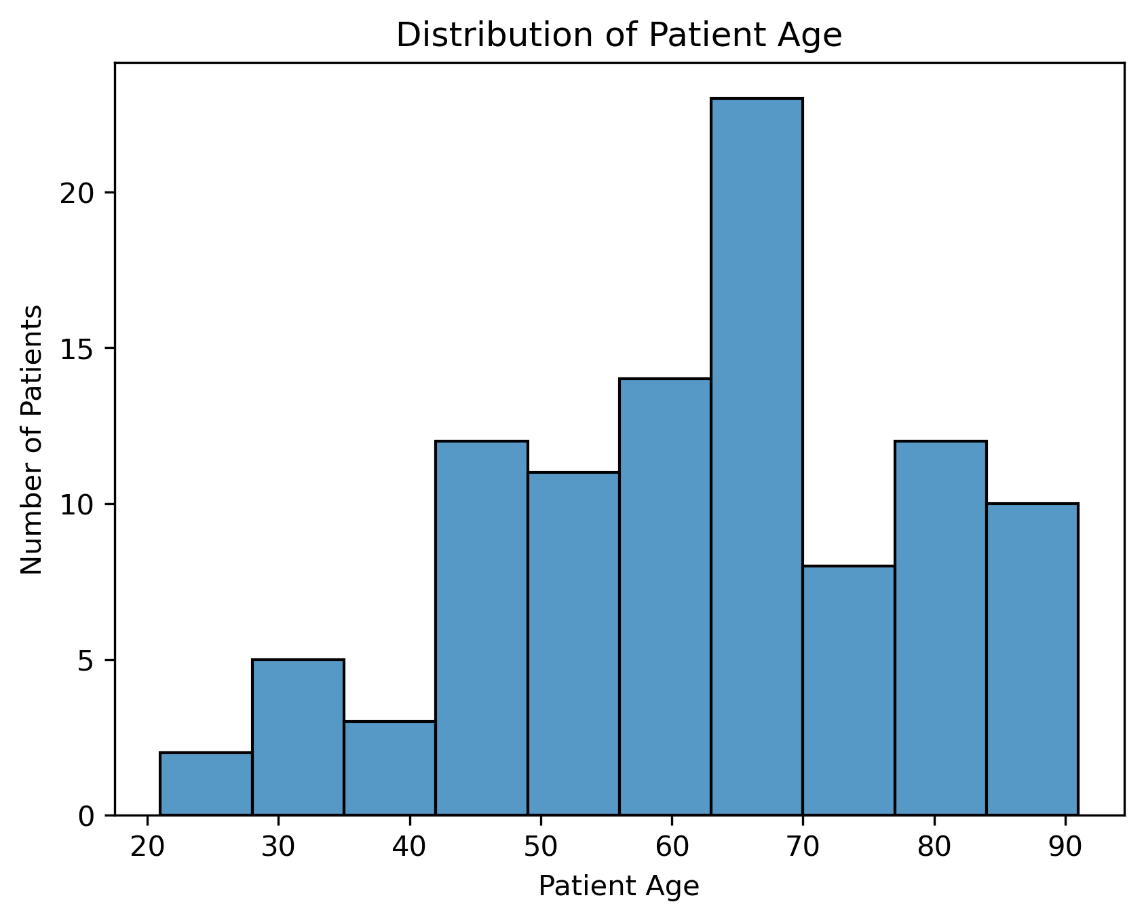
Figure 1. Distribution of patient age.
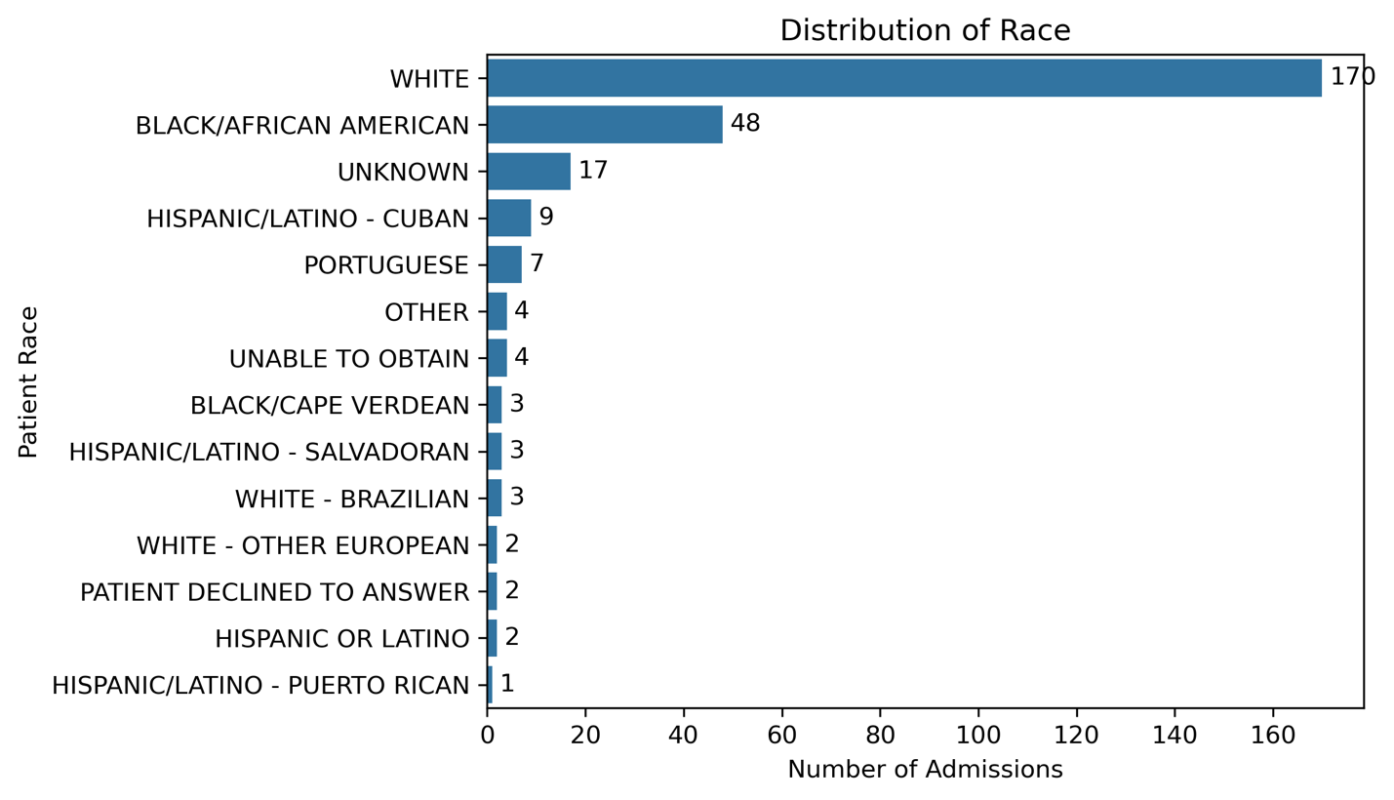
Figure 2. Recorded race across hospital admissions.
Hospital admissions were commonly emergency-related or observational. EW EMER. accounted for 104 admissions (37.8%), followed by Observation Admit (45), Urgent (38), and EU Observation (30). Diagnosis records reflected multiple conditions per admission; common diagnoses included hypertension, hyperlipidemia, acute kidney failure, hypothyroidism, obesity, and anemia. Approximately 31.16% of diagnosis descriptions contained “unspecified,” an important limitation for detailed clinical grouping.
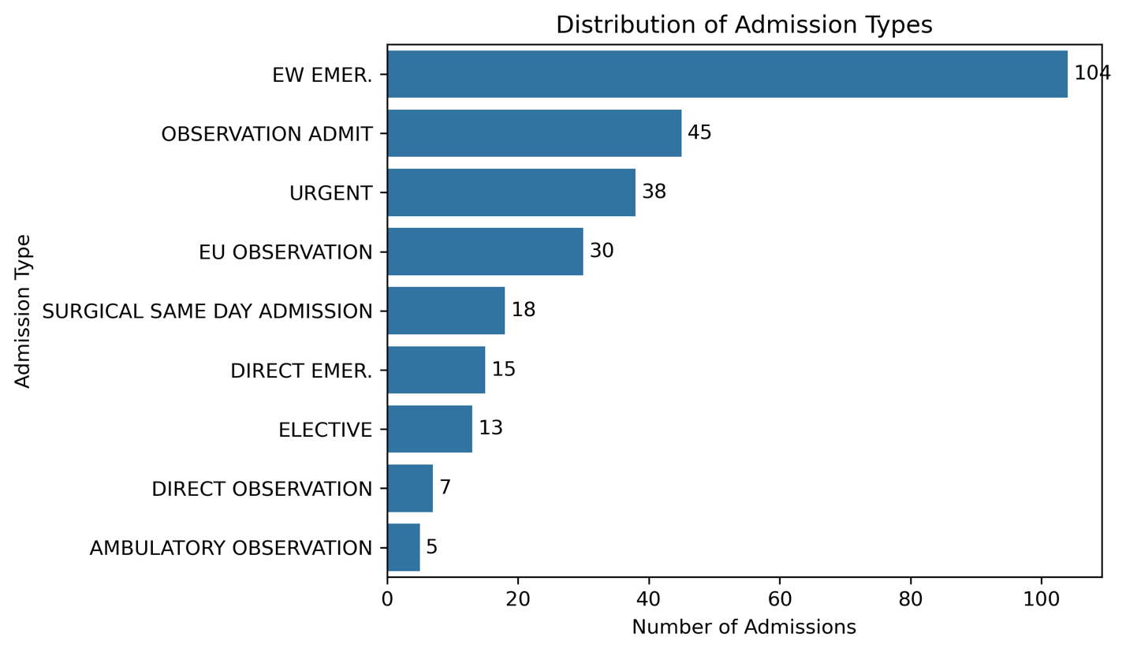
Figure 3. Distribution of hospital admissions by admission type.
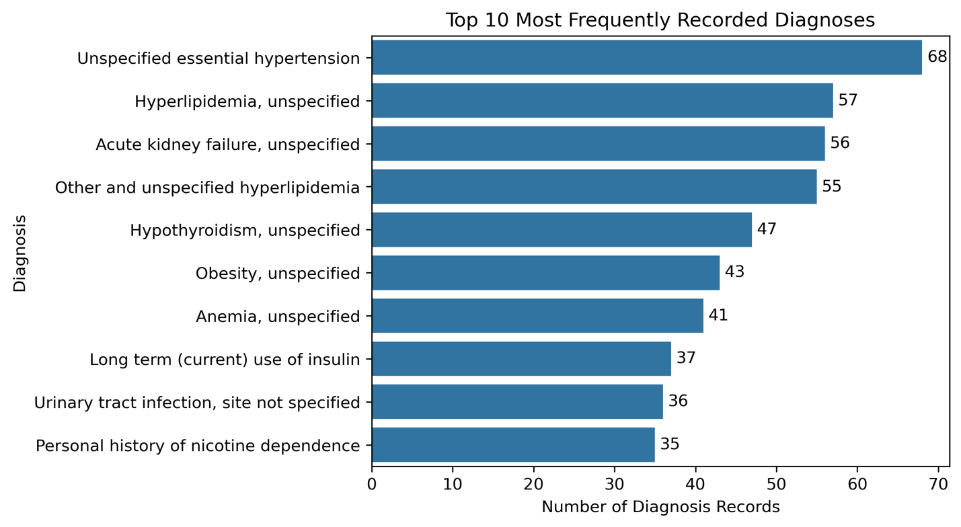
Figure 4. Ten most frequently recorded diagnoses.
Because patients may have multiple admissions and diagnoses, these counts should not be interpreted as patient prevalence. Subsequent analyses must preserve the correct denominator: 100 unique patients for patient-level characteristics, 275 admissions for admission-level characteristics, and 4,506 diagnosis records for diagnosis frequencies.

3.3.2 Patient Outcomes
Both ICU and hospital LOS were strongly right-skewed. ICU stays had a median of 2.16 days and mean of 3.68 days, with a maximum of 20.53 days. Hospital admissions had a median of 4.85 days and mean of 6.88 days, with a maximum of 44.93 days. Most stays were relatively short, while a smaller number of prolonged stays increased the mean and may represent comparatively high resource use.
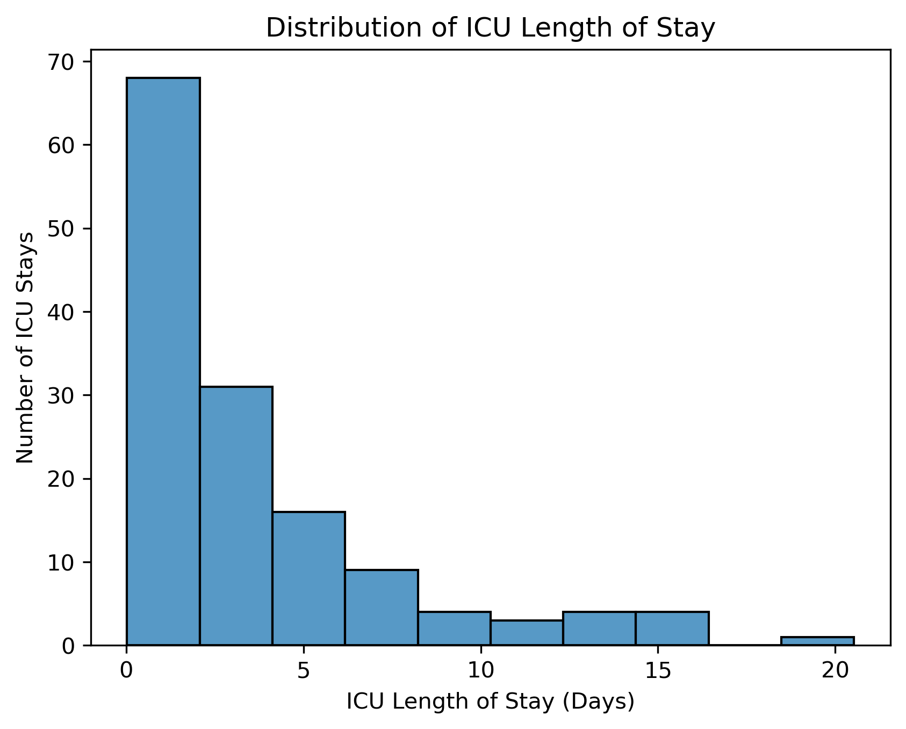
Figure 5. Distribution of ICU length of stay.
In-hospital mortality was uncommon: 15 of 275 admissions (5.45%) resulted in death and 260 (94.55%) did not. This strong imbalance limits mortality subgroup comparisons and may produce unstable estimates in small groups. Discharge disposition also varied: home health care (76) and home (72) together accounted for 53.8% of admissions, while other patients required skilled nursing, rehabilitation, long-term acute care, hospice, or other destinations.
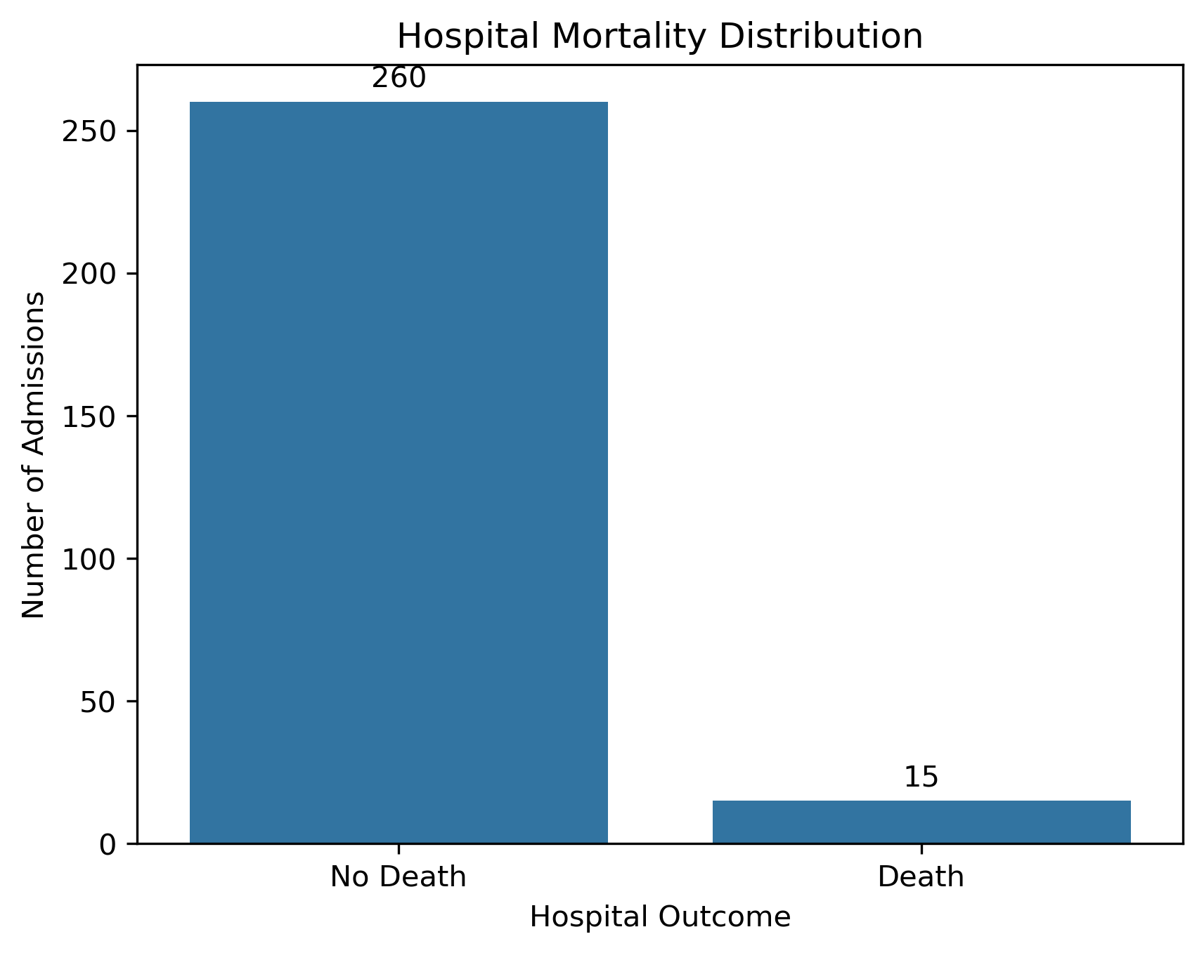
Figure 6. In-hospital mortality across hospital admissions.
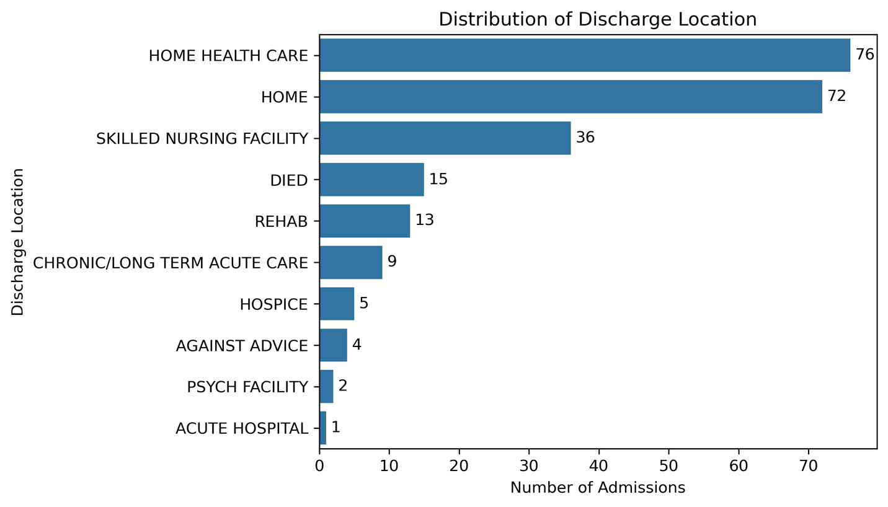
Figure 7. Discharge disposition across hospital admissions.

3.3.3 Treatment Patterns and Resource Utilization
Treatment records showed broad variation in care. At the hospital level, insulin was the most frequently recorded medication, while commonly documented procedures included vascular access, nutritional support, and mechanical ventilation. ICU procedure records frequently reflected vascular access, diagnostic imaging, cardiovascular monitoring, respiratory support, and catheter-related interventions. These frequencies represent clinical records rather than unique patients or stays and therefore require aggregation before outcome comparisons.
Resource utilization varied substantially across admissions. Hospital procedure counts ranged from 0 to 23 per admission (median 1), and 32.0% of admissions had no ICD procedure records. Prescription counts ranged from 0 to 348 per admission (median 48), with 9.09% of admissions having no prescription records. Transfer events ranged from 0 to 8 per admission (median 1); 36.36% of admissions had no recorded transfer events. These distributions were right skewed, indicating that a smaller number of hospitalizations accounted for comparatively high recorded utilization.
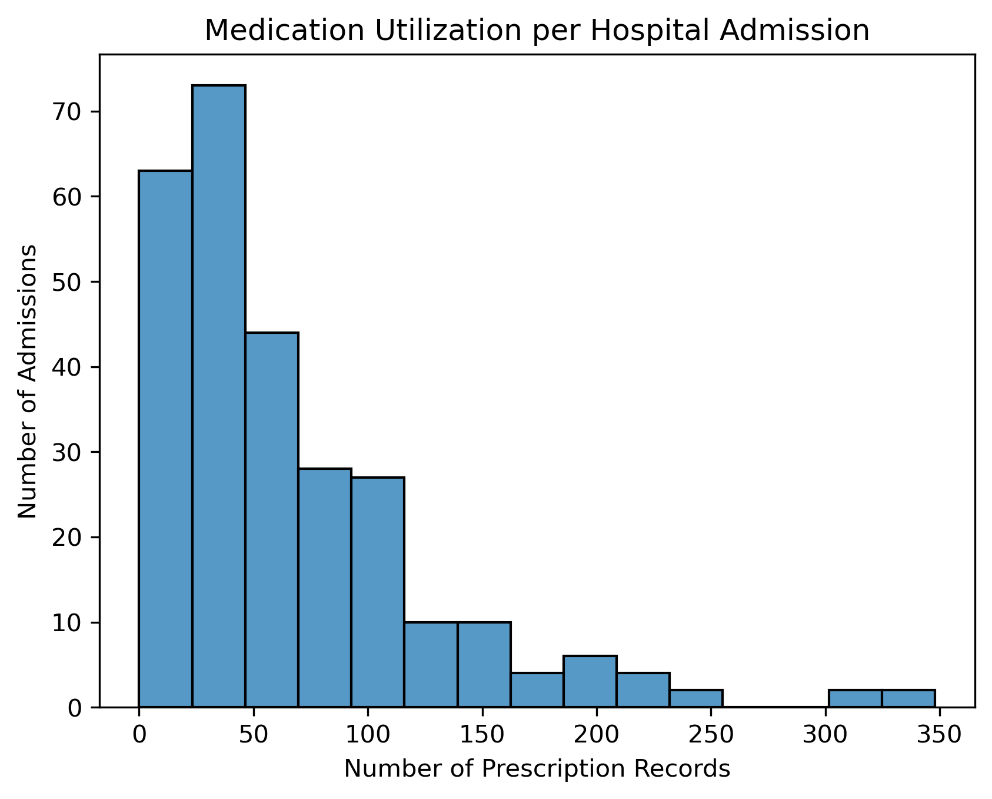
Figure 8. Medication-related utilization per hospital admission.
The exploration therefore identifies several priorities for later analysis: prolonged LOS, high-utilization admissions, differences in treatment intensity, and the relationship of these patterns to diagnoses and patient characteristics. Because the data are observational, treatment and utilization patterns may reflect underlying illness severity and should not be interpreted as causing outcomes.

3.4 Data Quality Assessment
Initial exploration identified several data-quality issues that directly affect the analytical strategy. The most important are limited sample size, repeated observations at multiple levels, sparse categories, deidentification, diagnostic specificity, and the need to distinguish a missing record from absence of clinical care.
Table 5. Data Quality Issues, Implications, and Planned Responses
Issue | Evidence observed | Implication / response
Small sample and rare outcomes | 100 patients; 15 in-hospital deaths across 275 admissions | Limit subgroup comparisons and complex modeling; emphasize descriptive/exploratory analysis.
Repeated observations | Patients may have multiple admissions; admissions/stays contain many diagnoses and events | Maintain patient/admission/stay denominators and aggregate event-level records before analysis.
Sparse demographic categories | Several race categories contain few admissions | Avoid unstable subgroup conclusions; combine categories only when analytically and ethically justified.
Inconsistent race records | 4 of 100 patients had inconsistent race classifications across admissions | Treat race as admission-level recorded information and document inconsistency.
Diagnosis specificity | 31.16% of diagnosis descriptions contain “unspecified” | Use caution when grouping or interpreting diagnoses.
Zero utilization records | 32.0% no ICD procedures; 9.09% no prescriptions; 36.36% no transfers | Do not equate absence in one table with absence of all care; verify related tables and definitions.
Deidentification | Dates and age-related fields are deidentified | Interpret temporal variables using MIMIC documentation; focus on within-record intervals where appropriate.

A complete missingness, identifier-integrity, validity, and outlier audit should be finalized before modeling. In particular, expected uniqueness of subject_id, hadm_id, and stay_id should be verified; ICU stays should link to valid admissions; important variables should be assessed for missingness; and extreme clinical values should be reviewed to distinguish legitimate observations from possible data-quality problems. These checks should be documented concisely in the final report rather than as separate pages of exploratory output.

3.5 Data Understanding Summary and Implications
The MIMIC-IV Demo provides interconnected patient, hospital, ICU, and event-level data that can support the project’s three analytical objectives, but the 100-patient sample requires a focused analytical scope. The population is largely middle-aged and older, admissions are frequently emergency-related, and common diagnosis records reflect substantial chronic disease and comorbidity. ICU and hospital LOS are right-skewed, mortality is rare, and treatment and resource-utilization records are unevenly distributed across hospitalizations.
These findings support continued analysis of patient outcomes, treatment/care patterns, and resource utilization, while also indicating that later work should prioritize interpretable methods and carefully selected comparisons. Data preparation will need to preserve the correct unit of analysis, aggregate event-level records, validate identifiers and joins, handle missingness and sparse categories, standardize coded variables, and create derived measures such as utilization counts and LOS where appropriate.

4. Conclusion
The Business Understanding phase established a clear need for evidence-based analysis of ICU outcomes, care patterns, and resource utilization at RMC. The Data Understanding phase showed that the MIMIC-IV Demo contains relevant information across linked hospital and ICU tables and revealed meaningful variation in length of stay, treatment activity, discharge outcomes, and recorded resource use. At the same time, the small sample, rare mortality events, repeated observations, sparse categories, and deidentification constrain the strength and generalizability of conclusions.
The next phase will therefore focus on preparing a well-defined analytical dataset at the appropriate level, resolving key data-quality issues, and selecting a limited number of relationships that directly address the analytical objectives. This focused approach will allow subsequent analysis to remain aligned with RMC’s clinical and operational goals while avoiding unsupported conclusions from the demo dataset.

Works Cited
MIT Laboratory for Computational Physiology. (2023, January 06). modules. Retrieved September 2026, from MIMIC: https://mimic.mit.edu/docs/iv/modules/

