CURRICULUM VITAE
October 2026
Nakbin Choi, Ph.D.  Research Assistant Professor  Department of Civil, Urban, Earth, and Environmental Engineering  Ulsan National Institute of Science and Technology (UNIST)  50 UNIST-gil, Ulju-gun, Ulsan 44919, Republic of Korea  nbchoi21@unist.ac.kr  (Korea) 010-4946-6138 | (US) +1 (703) 843-4060 | 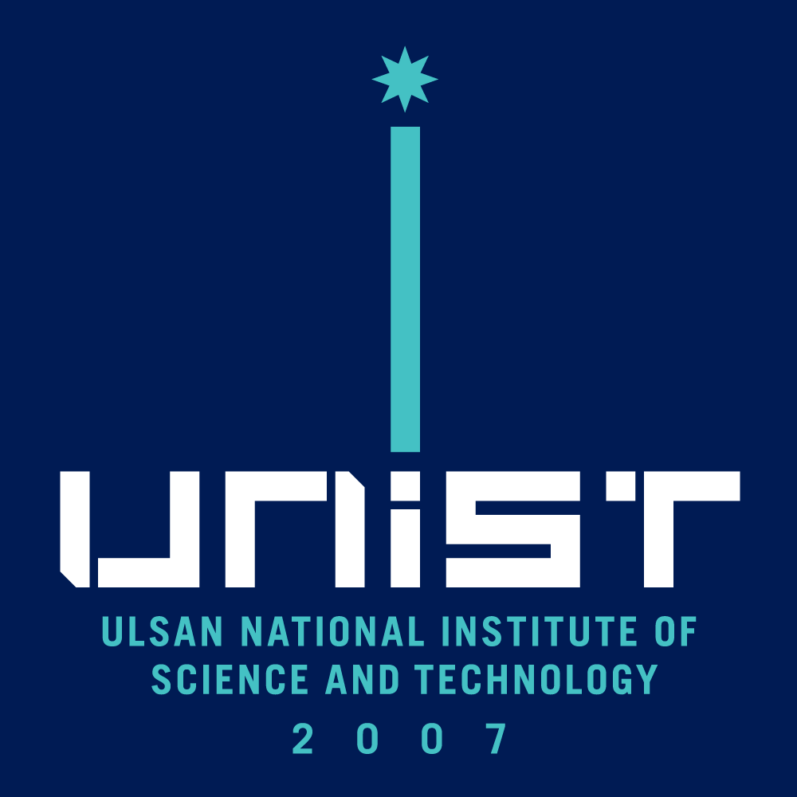
RESEARCH INTERESTS
1. Subseasonal-to-Seasonal Prediction and Predictability
• Predictability, forecast skill, and systematic biases in coupled prediction systems
• Evaluation and improvement of predictions across weather-to-climate timescales
2. Climate Dynamics, Teleconnections, and Extremes
• Tropical climate variability and tropical–extratropical interactions
• Large-scale atmospheric circulation, teleconnection processes, and climate extremes
3. Coupled Earth System Processes and Data Assimilation
• Atmosphere–ocean and land–atmosphere interactions
• Coupled data assimilation and initialization of Earth system prediction models
EDUCATION
2015.03 – 2021.02 | Ph.D. in Environmental Science and Engineering, UNIST, Korea  Dissertation: Development of a Coupled Data Assimilation System in the Fully Coupled Model and Its Implications for Seamless Prediction  Advisor: Prof. Myong-In Lee
2009.03 – 2015.02 | B.S. in Earth Science and Engineering, UNIST, Korea
EMPLOYMENTS
2025.09 - Present | Research Assistant Professor, UNIST
2023.06 – 2025.09 | Postdoctoral Research Fellow, George Mason University
2021.03 – 2023.06 | Postdoctoral Research Associate, UNIST
RESEARCH EXPERIENCE
2023.01 – 2023.05 | Visiting Scientist, Met Office Hadley Centre, UK
2017.02 | Visiting Researcher, NASA GSFC, Climate and Radiation Lab, USA
2013.06 – 2013.08 | Internship, NASA GSFC, GMAO, USA
PROFESSIONAL SERVICES
2024.10 – 2026.10 | Editor, Korean Atmospheric Scientists in America (KASA)

PUBLICATIONS
[19] Lee, B., Seo, E., Kim, D., Choi, N., & Moon, W. (2026). Understanding the physical mechanism of record-breaking 2025 Korea-Japan heatwave. Environmental Research Letters. 21, 194020.
[18] Lee, S., Lee, M.-I., Kim, K.-M., & Choi, N. (2026). Extratropical Rossby waves amplify central Siberian fire risk through subseasonal teleconnections. Agricultural and Forest Meteorology, 390, 111475.
[17] Choi, N., Quan, X-W., and Stan, C. (2026). Drivers of the Asymmetric ITCZ Bias in Climate Models, Scientific Reports.
[16] Lee, J., Lee, M. I., Kim, J., Bak, G., Choi, N., Lee, J., ... & Shin, B. (2026). Atlantic SST as a key source of subseasonal predictability in the April 2020 Siberian heatwave. npj Natural Hazards.
[15] Choi, N., Stan, C., Lee, B., & Seo, E. (2026). Potential sources of predictability for the surface air temperature over the CONUS during boreal winter. Journal of Climate, 39(16), 5005-5016.
[14] Choi, N., Stanczak, J., & Stan, C. (2026). The Role of Atmosphere–Ocean Coupling on the Prediction of Madden–Julian Oscillation. Journal of Climate, 39(13), 3669-3684.
[13] Kim, K., Lee, M. I., Lee, S., Choi, N., Jin, F. F., Min, S. K., & Kam, J. (2026). Local and remote drivers of increased variability in extreme wildfire conditions in Southeastern Australia. Agricultural and Forest Meteorology, 384, 111156.
[12] Lee, S., Lee, M. I., Lee, S., Jin, F. F., Choi, N., & Tak, S. (2025). Distinct Features of the Summer Arctic Oscillation. Journal of Climate, 38(21), 5983-5996.
[11] Choi, N., Lee, M. I., Ham, Y. G., Hyun, Y. K., Lee, J., & Boo, K. O. (2025). Reducing initialization shock by atmosphere-ocean coupled data assimilation and its impacts on the subseasonal prediction skill. Journal of Climate, 38(6), 1389-1401.
[10] Choi, N., Lee, M. I., Tak, S., Cha, D. H., & Watanabe, M. (2025). Siberian heat extremes caused by Eurasian atmospheric teleconnections and amplified by local land surface conditions. Environmental Research Letters, 20(3), 034029.
[9] Choi, N., & Stan, C. (2025). Large-Scale Surface Air Temperature Bias in Summer over the CONUS and Its Relationship to Tropical Central Pacific Convection in the UFS Prototype 8. Journal of Climate, 38(1), 117-129.
[8] Kim, H., Choi, N., Lee, M. I., Tak, S., Cha, D. H., & Min, S. K. (2024). Causes on the 2018 record-breaking heatwave in South Korea: compound impacts from recurrent large-scale atmospheric teleconnections. Environmental Research Letters, 19(12), 124064.
[7] Tak, S., Choi, N., Lee, J., & Lee, M. I. (2024). Probabilistic medium-range forecasts of extreme heat events over East Asia based on a global ensemble forecasting system. Weather and Climate Extremes, 45, 100694.
[6] Choi, N., & Lee, S. (2023). Comparison of the opposite behaviours of Korean heatwaves with extreme hot sea surface temperatures in August 2016 and 2022. International Journal of Climatology, 43(15), 6993-7002.
[5] Lee, S., Park, M. S., Kwon, M., Park, Y. G., Kim, Y. H., & Choi, N. (2023). Rapidly changing East Asian marine heatwaves under a warming climate. Journal of Geophysical Research: Oceans, 128(6), e2023JC019761.
[4] Yasunari, T. J., Nakamura, H., Kim, K. M., Choi, N., Lee, M. I., Tachibana, Y., & da Silva, A. M. (2021). Relationship between circum-Arctic atmospheric wave patterns and large-scale wildfires in boreal summer. Environmental Research Letters, 16(6), 064009.
[3] Choi, N., Lee, M. I., Cha, D. H., Lim, Y. K., & Kim, K. M. (2020). Decadal changes in the interannual variability of heat waves in East Asia caused by atmospheric teleconnection changes. Journal of Climate, 33(4), 1505-1522.
[2] Choi, N., Kim, K. M., Lim, Y. K., & Lee, M. I. (2019). Decadal changes in the leading patterns of sea level pressure in the Arctic and their impacts on the sea ice variability in boreal summer. The Cryosphere, 13(11), 3007-3021.
[1] Choi, N., & Lee, M. I. (2019). Spatial variability and long-term trend in the occurrence frequency of heatwave and tropical night in Korea. Asia-Pacific Journal of Atmospheric Sciences, 55, 101-114.

[4] Choi et al., Evolution of Boreal-Summer Quasi-Stationary Rossby Waves on Daily Time Scales. npj Climate and Atmospheric Science. Submitted.
[3] Tak et al., Incremental Contribution of Soil Moisture Data Assimilation to Sub-seasonal Prediction of the 2022 Central Eastern China Heatwave. Weather and Climate Extremes. In Review.
[2] Sohn et al., K-R2O in Action: Enhancing Operational Reliability through the Independent Testbed for National Climate Prediction System. Bulletin of the American Meteorological Society. In Review.
[1] Xavier, P., Willett, M., ..., Choi, N., ..., and Zhu, H.: Assessment of the Met Office Global Coupled model version 5 (GC5) configurations, Geoscientific Model Development Discussion. In Review.
PATENT
• Medium-Range Heatwave Forecasting System and Method (Domestic, South Korea, 2019)
AWARDS
• Young Atmospheric Scientist Award, Korean Meteorological Society (2025)
• Outstanding Poster Presentation Award, Korean Meteorological Society (2019)

