1. Test Execution and Setup

1.1 Test Description

Pulse ID: J050271

1.2 Test / Part Criteria
General Data
- Test Regulation Test performed according to the Stellantis test procedure B32-3210
- Sled Pulse [Number] Biltir: 26002Y018E008
- Test Object Test applicable on K0 complete front seat
- Test Fixture K0 front seat crash fixture for metal validation (simulating podium as rigid)
K0 footrest
K0 B-pilar
- Type of Dummy HIII 50% M
- Dummy Setup Information

Parameter | Coord. | Target | Actual
H-Point [mm] | X | 1163,97 < Hx < 1189,97 | 1182.29
 | Y | +/-380 | -416.65
 | Z | 614,38 < Hz < 640,38 | 631.32
Heel Point at the footrest [mm] | X | 566.5 | 490
 | Y | N.A. | N/A
 | Z | 275 | 276.3
Feet angle [°] at the footrest | / | 40.0 | 40.1
Pelvis Angle [°] | / | 22.5 ± 2.5 | 24.10
Head Angle [°] | / | 0 ± 2.5 around Y and X-axis | 1.55/0.70
Head COG [mm] | X | To record X-backset for info | Not necessary for this test
 | Z | To record Z-backset for info | Not necessary for this test

- Belt System | 1 - Original belt buckle for K0 project NAFTA variant  2 - Original PLP for K0 project NAFTA variant  3 - Original belt for K0 project with 600daN NAFTA variant Belt elongation = (Input from FEA required)
- Belt Coordinates D-Loop
D-loop fixing point:
X = 1480.7 mm
Y = + 721.1 mm
Z = 1276.3 mm
Retractor fixing point:
X = 1413.09 mm
Y = + 752.9 mm
Z = 388.7 mm
- Belt Coordinates Lower Outboard
PLP fixing point on Bpilar:
X = 1425.2 mm
Y = + 700.3 mm
Z = 251.7 mm
- Belt Force Sensor 1 - Diagonal belt sensor => Distance to the D-ring = 200mm
2 - Lap belt sensor outboard => Minimum distance to the outboard low fixation = 150mm
- Firing Time Pretensioner [ms] PLP = 20 ms
The PLP device shall be blocked (integrated in the Bpilar design)
- Firing Time Retractor [ms] Retractor = 10 ms
- Additional information Pull in force = (input to be filled by FEA)
pretensioner Pull in displacement = (input to be filled by FEA)

1.3 Execution
Test Setup
- Direction of Acceleration Forward direction
- Test Setup Description how to mount the fixture + Bpilar + foot rest on the sled (example of LH seat): 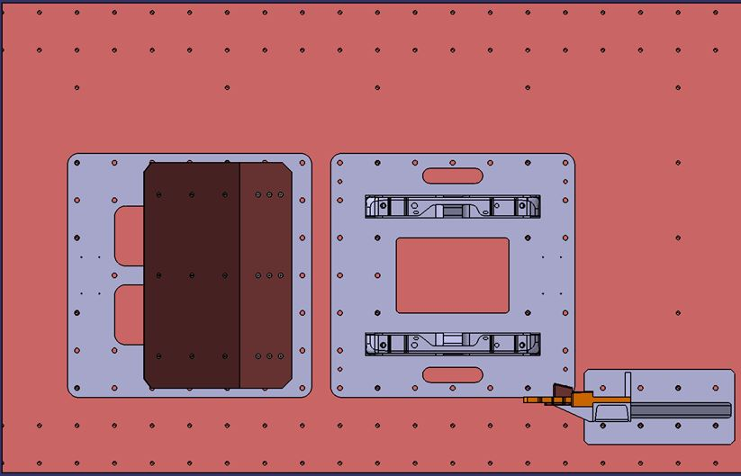
- Camera Setup Overview 1 - Mid Left 90° | 2 - Mid Right 90° |
- Camera Setup Detail 3 -Front Left 45° | 4 -Rear Right 45°
Test Position
- Adjust the tracks to 110mm forward form the fully rearward position
- For locking the tracks proceed to the below steps:
  - 1 - Fully rearward to put the screw IN
  - 2 - Fully forward to put the screw IN
  - 3 - Driving minimum 4 times between the end stops fully forward and fully rearward
  - 4 - Sliding the to the test position until locking
  - 5 - Shaking seat on tracks
  - 6 - Checking locking pin and mark it with white marker
- Cushion Height Position N/A
- Headrest Height Position 1 - Adjusted to the height of the head => Z-backset closest to 0mm
2 - Adjust the headrest in X to the fully rearward position
- Track Position 110mm forward from the fully rearward position
For locking the tracks proceed to the below steps:
1 - Fully rearward to put the screw IN
2 - Fully forward to put the screw IN
3 - Driving minimum 4 times between the end stops fully forward and fully rearward
4 - Sliding the to the test position until locking
5 - Shaking seat on tracks
6 - Checking locking pin and mark it with white marker
- Backrest Angle Backrest to be adjusted in design position=> angle from recliner pivot point to headrest bezel exit centre point = 14.5°
- Headrest Height Position 1 - Adjusted to the height of the head => Z-backset closest to 0mm
2 - Adjust the headrest in X to the fully rearward position
- Fastening Parts Original Renault / Nissan screw and reducing head diameter
to 17.8mm as per original screw drawing | | Torque = 35Nm for
each of the 4 screws | | Torque = 35Nm for each of the 4 screws
| | For belt buckle, use original screw + washer with a torque of 25Nm

- Test Procedure
- Preparations
  - 1- Mark the belt every 100mm from the D-loop to the retractor and further
  - 2 - Mark all the mechanisms with a white marker
  - 3 - Fix markers like described under "Additional Information Video Analyze" and measure Y-distance to the camera
  - 4 - At the buckle area, mark 15 points with interval of 10mm each on the cushion side-member and measure this points with faro arm
  - 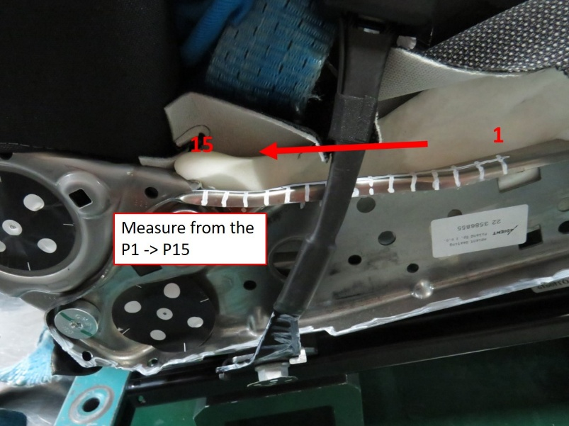
- Pre Test Measurements
  - 1 - Measure with faro arm the buckle fixing point coordinates X / Y / Z
  - 2 - At he buckle area, mark 15 points with interval of 10mm each on the cushion side-member and measure this points with faro arm the X / Y / Z coordinates as described in the test preparation section
  - 3 - Measure with faro arm the X-Y-Z coordinates at the IB and OB FSC side-member nose area.
  - 4 - Measure the unlocking force at the buckle
- Post Test Measurements
  - 1 - Measure with faro arm the buckle fixing point coordinates X / Y / Z and calculate gap to pre-test
  - 2 - At he buckle area, mark 15 points with interval of 10mm each on the cushion side-member and measure this points with faro arm the X / Y / Z coordinates as described in the test preparation section and calculate gap to pre-test
  - 3 - Measure with faro arm the X-Y-Z coordinates at the IB and OB FSC side-member nose area and calculate gap to pre-test
  - 4 - Measure the unlocking force at the buckle and calculate gap to pre-test
  - 5 - Take picture of the lap belt if still in contact with the Iliac bone area for submarining rating

Evaluation Method
Video Analysis
1 - Pelvis displacement in X and Z => Refer to "Sketch / Picture Test Setup.
2 - Headrest centre line x-tracking without untrimming headrest.

Additional Information Video Analysis
- Add the following targets on the dummy and measure the distance to the camera : 8 targets totally to be recorded.
=> Cog Head IB / OB
=> Shoulder IB / OB
=> Knee IB / OB
=> Ankle IB / OB
=> H-point IB / OB
=> Heel point IB / OB

- Add the following targets on the seat and measure the distance to the camera : (17 Targets totally to be recorded.)
=> Headrest IB / OB / TOP
=> Headrest rod IB / OB
=> Top of the back frame IB / OB as per below instruction (untrim locally to fix it on the frame) : 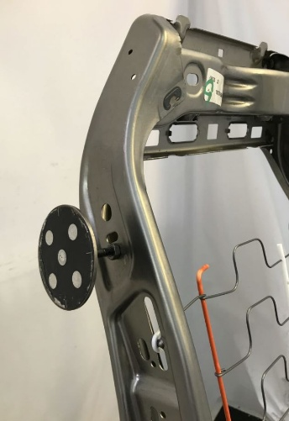
=> Recliner pivot point IB / OB (remove the OB side valence if necessary)
=> Cushion side-member nose area as per below description:

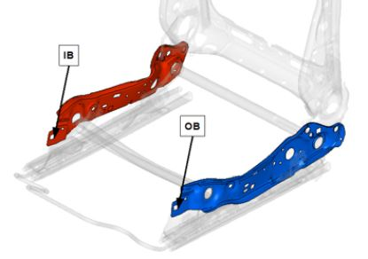

=> Buckle fixation point
=> Buckle

Calculating the pelvis H-point by tracking the femur:

Table 2 Calculation of the Pelvis H-point

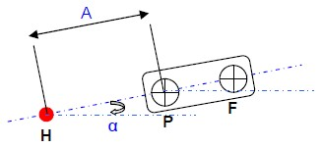 | 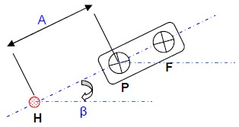
Initial position of the thigh model Maximum forward position of the thigh model

Before Test:
- Adjust the dummy in order to fullfill Hpoint and pelvis angle corridor.
- Attach on the femur plate the targets P and F in order that Hpoint + target.
- P + Target F are on one line.
- Measure the distance A between the H point and P femur pattern and angle alpha by recording with faro arm the Hpoint and target P and F coordinates.

After test:
By using tracking software;
- Measure on the first frame of the movie the angle Alpha formed by the straight line passing through the center of two femur patterns P and F and horizontal.
- Measure at the maximum advanced position of the pelvis the angle Beta formed by the straight line passing through the center of the two femur patterns P and F and horizontal.
- Measuring ΔXp at advanced X position of the point P.
- Measuring ΔZp at advanced Z position of the point P.

Calculate the coordinates of H advanced such as:

Hx= A cos α + ΔXP – A cos β
Hz= A sin α + ΔZP – A sin β

1.4 Setup
- Front seat mounted on rigid fixture with standard screws
- Fixture mounted on sled with standard screws
- Seat occupied with 50% HIII instrumented dummy
- Original belt system according to vehicle coordinates
- Footrest mounted on sled according to vehicle coordinates with standard screws

Table 3 Pre Test Adjustments
Seat Adjustments | LH/ pos. 01
Track position | Fully Rearward
Cushion angle | N/A
Backrest angle | 14.5°
Headrest height | Z-backset closes to 0

