1.3 Execution
Test Setup
- Direction of Acceleration Forward direction
- Test Setup Description how to mount the fixture + Bpilar + foot rest on the sled (example of LH seat): 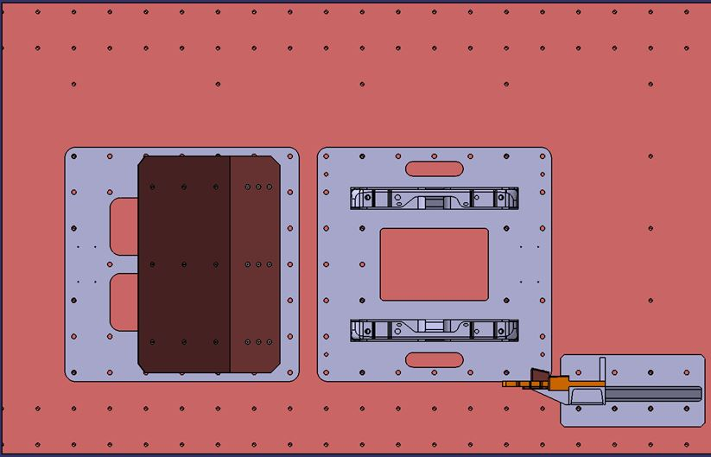
- Camera Setup Overview 1 - Mid Left 90° | 2 - Mid Right 90° |
- Camera Setup Detail 3 -Front Left 45° | 4 -Rear Right 45°
Test Position
- Adjust the tracks to 110mm forward form the fully rearward position
- For locking the tracks proceed to the below steps:
  - 1 - Fully rearward to put the screw IN
  - 2 - Fully forward to put the screw IN
  - 3 - Driving minimum 4 times between the end stops fully forward and fully rearward
  - 4 - Sliding the to the test position until locking
  - 5 - Shaking seat on tracks
  - 6 - Checking locking pin and mark it with white marker
- Cushion Height Position N/A
- Headrest Height Position 1 - Adjusted to the height of the head => Z-backset closest to 0mm
2 - Adjust the headrest in X to the fully rearward position
- Track Position 110mm forward from the fully rearward position
For locking the tracks proceed to the below steps:
1 - Fully rearward to put the screw IN
2 - Fully forward to put the screw IN
3 - Driving minimum 4 times between the end stops fully forward and fully rearward
4 - Sliding the to the test position until locking
5 - Shaking seat on tracks
6 - Checking locking pin and mark it with white marker
- Backrest Angle Backrest to be adjusted in design position=> angle from recliner pivot point to headrest bezel exit centre point = 14.5°
- Headrest Height Position 1 - Adjusted to the height of the head => Z-backset closest to 0mm
2 - Adjust the headrest in X to the fully rearward position
- Fastening Parts Original Renault / Nissan screw and reducing head diameter
to 17.8mm as per original screw drawing | | Torque = 35Nm for
each of the 4 screws | | Torque = 35Nm for each of the 4 screws
| | For belt buckle, use original screw + washer with a torque of 25Nm

