- Test Procedure
- Preparations
  - 1- Mark the belt every 100mm from the D-loop to the retractor and further
  - 2 - Mark all the mechanisms with a white marker
  - 3 - Fix markers like described under "Additional Information Video Analyze" and measure Y-distance to the camera
  - 4 - At the buckle area, mark 15 points with interval of 10mm each on the cushion side-member and measure this points with faro arm
  - 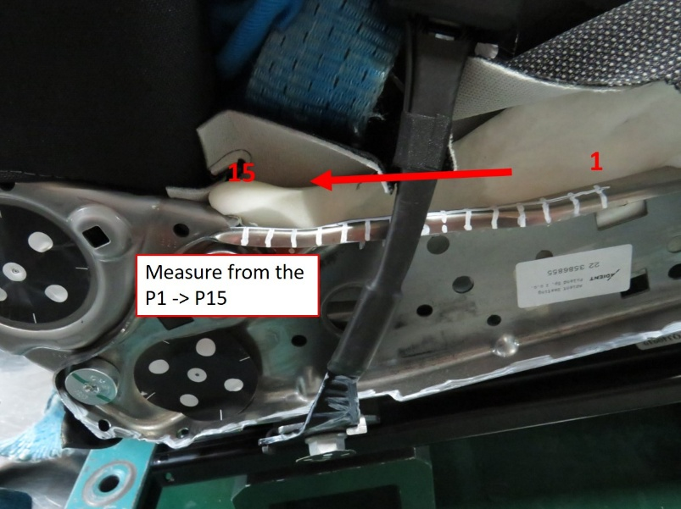
- Pre Test Measurements
  - 1 - Measure with faro arm the buckle fixing point coordinates X / Y / Z
  - 2 - At he buckle area, mark 15 points with interval of 10mm each on the cushion side-member and measure this points with faro arm the X / Y / Z coordinates as described in the test preparation section
  - 3 - Measure with faro arm the X-Y-Z coordinates at the IB and OB FSC side-member nose area.
  - 4 - Measure the unlocking force at the buckle
- Post Test Measurements
  - 1 - Measure with faro arm the buckle fixing point coordinates X / Y / Z and calculate gap to pre-test
  - 2 - At he buckle area, mark 15 points with interval of 10mm each on the cushion side-member and measure this points with faro arm the X / Y / Z coordinates as described in the test preparation section and calculate gap to pre-test
  - 3 - Measure with faro arm the X-Y-Z coordinates at the IB and OB FSC side-member nose area and calculate gap to pre-test
  - 4 - Measure the unlocking force at the buckle and calculate gap to pre-test
  - 5 - Take picture of the lap belt if still in contact with the Iliac bone area for submarining rating

