Evaluation Method
Video Analysis
1 - Pelvis displacement in X and Z => Refer to "Sketch / Picture Test Setup.
2 - Headrest centre line x-tracking without untrimming headrest.

Additional Information Video Analysis
- Add the following targets on the dummy and measure the distance to the camera : 8 targets totally to be recorded.
=> Cog Head IB / OB
=> Shoulder IB / OB
=> Knee IB / OB
=> Ankle IB / OB
=> H-point IB / OB
=> Heel point IB / OB

- Add the following targets on the seat and measure the distance to the camera : (17 Targets totally to be recorded.)
=> Headrest IB / OB / TOP
=> Headrest rod IB / OB
=> Top of the back frame IB / OB as per below instruction (untrim locally to fix it on the frame) : 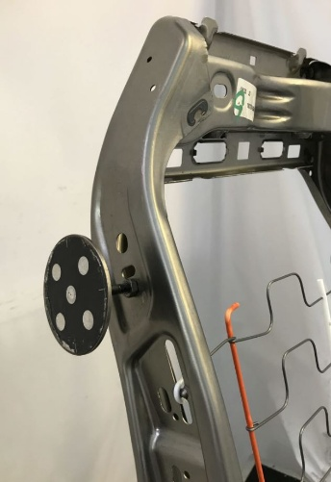
=> Recliner pivot point IB / OB (remove the OB side valence if necessary)
=> Cushion side-member nose area as per below description:

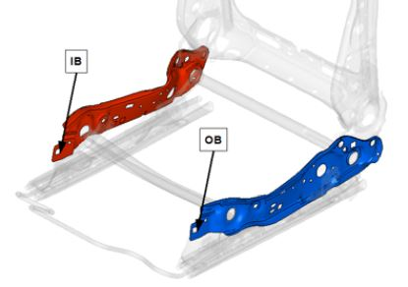

=> Buckle fixation point
=> Buckle

Calculating the pelvis H-point by tracking the femur:

Table 2 Calculation of the Pelvis H-point

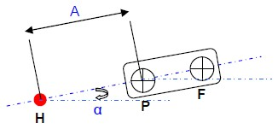 | 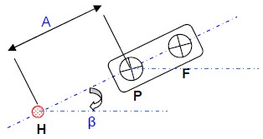
Initial position of the thigh model Maximum forward position of the thigh model

Before Test:
- Adjust the dummy in order to fullfill Hpoint and pelvis angle corridor.
- Attach on the femur plate the targets P and F in order that Hpoint + target.
- P + Target F are on one line.
- Measure the distance A between the H point and P femur pattern and angle alpha by recording with faro arm the Hpoint and target P and F coordinates.

After test:
By using tracking software;
- Measure on the first frame of the movie the angle Alpha formed by the straight line passing through the center of two femur patterns P and F and horizontal.
- Measure at the maximum advanced position of the pelvis the angle Beta formed by the straight line passing through the center of the two femur patterns P and F and horizontal.
- Measuring ΔXp at advanced X position of the point P.
- Measuring ΔZp at advanced Z position of the point P.

Calculate the coordinates of H advanced such as:

Hx= A cos α + ΔXP – A cos β
Hz= A sin α + ΔZP – A sin β

1.4 Setup
- Front seat mounted on rigid fixture with standard screws
- Fixture mounted on sled with standard screws
- Seat occupied with 50% HIII instrumented dummy
- Original belt system according to vehicle coordinates
- Footrest mounted on sled according to vehicle coordinates with standard screws

Table 3 Pre Test Adjustments
Seat Adjustments | LH/ pos. 01
Track position | Fully Rearward
Cushion angle | N/A
Backrest angle | 14.5°
Headrest height | Z-backset closes to 0

