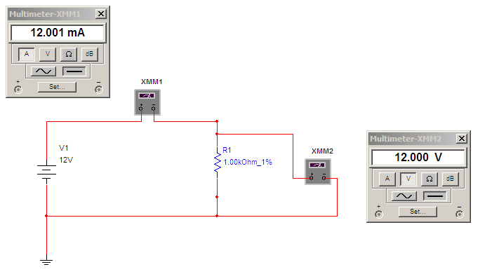

Multimeter(Voltage)

EMF = 12V, therefore Multimeter should read 12V as well

or

Ohm’s Law

V = I\*R

V=12.001mA\*1000Ohm=12V

Multimeter(Current)

Ohm’s Law

V = I\*R

I = V / R

I = 12V / 1000Ohm = 12mA