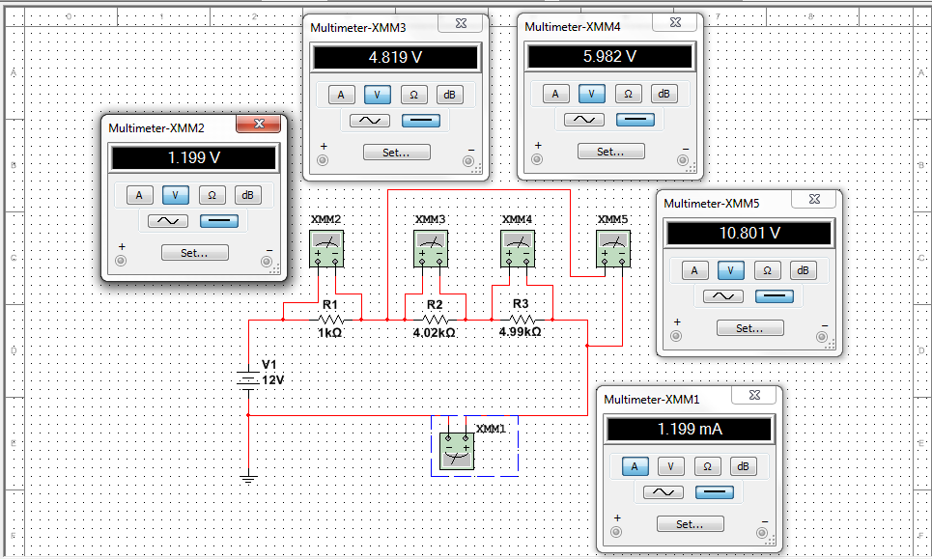

Multimeter #1

I = V / R

I = V1 / (R1 + R2 + R3)

I = 12V / (1kOhm + 4.02kOhm + 4.99kOhm)

I = 12V / (10.01kOhm)

I = 1.199mA

Multimeter #2

V = I \* R

V = I \* R1

V = 1.199mA \* 1kOhm

V = 1.199V

Multimeter #3

V = I \* R

V = I \* R2

V = 1.199mA \* 4.02kOhm

V = 4.820V

Multimeter #4

V = I \* R

V = I \* R3

V = 1.199mA \* 4.99kOhm

V = 5.983V

Multimeter #5

V = I \* R

V = I \* (R2 + R3)

V = 1.199mA \* (4.02kOhm + 4.99kOhm)

V = 10.803V