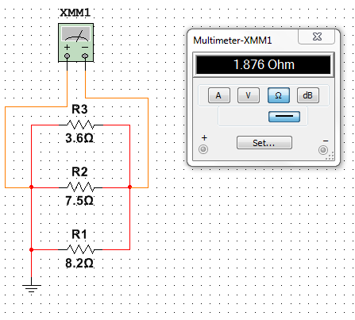

RT = (1/R1 + 1/R2 + 1/R3)-1

RT = (1/8.2Ohm + 1/7.5Ohm +1/3.6Ohm)-1

RT = 1.876Ohm

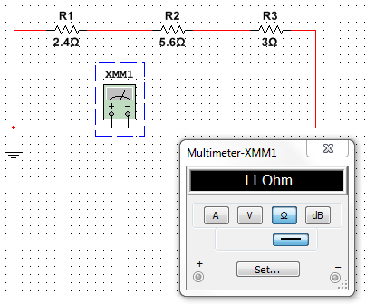

RT = R1 + R2 + R3

RT = 2.4Ohm + 5.6Ohm + 3Ohm

RT = 11 Ohm

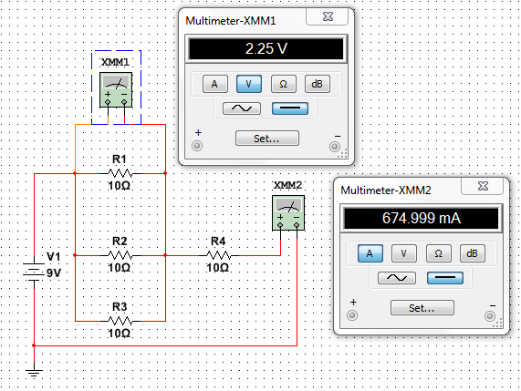

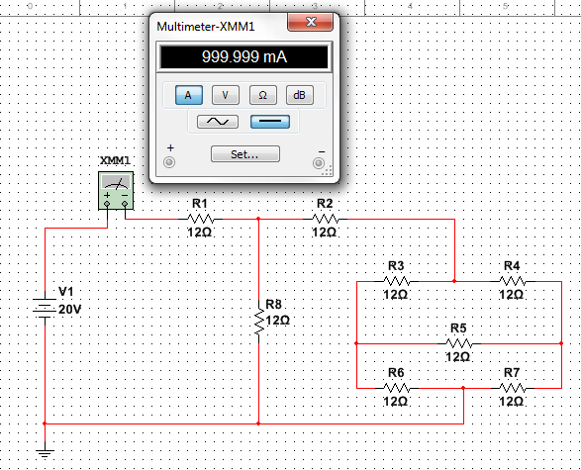

R = V / I

R = 20V / 999.999mA

R = 20A