1.

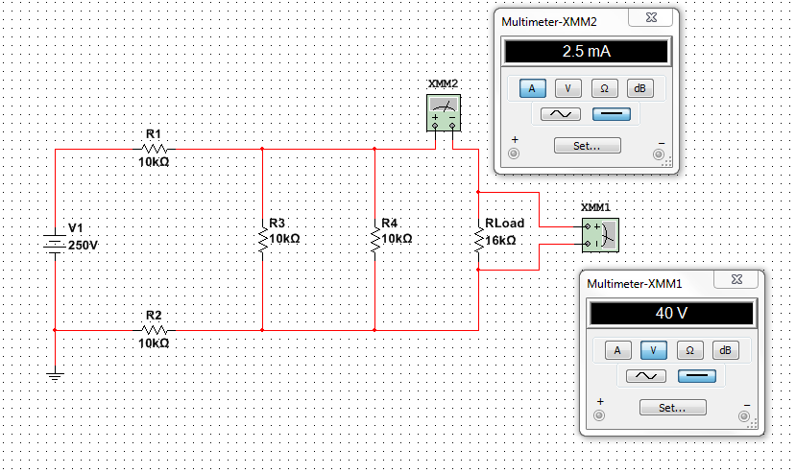

2.

R_T = R1 + R2 + (1/R3 + 1/R4 + 1/R_Load)^-1

R_T = 23.81kohm

I_T = V_1/R_T

I_T = 10.5mA

V_R1 = I_T*R1

V_R1 = 105V

V_R2 = I_T*R2

V_R2 = 105V

V_TH = (V_T - V_R1) - V_R2

V_TH = 40V

R_TH = (1/(R1+R2) + 1/R3 + 1/R4)^-1

R_TH = 4kOhm

I_TH = V_TH/R_TH

I_TH = 10mA

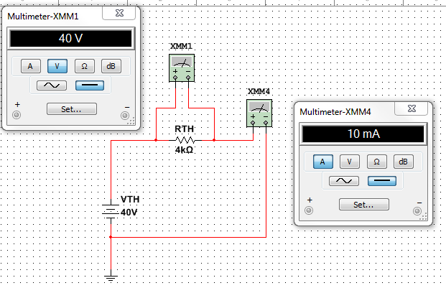

3.

R_T = (1/R_TH + 1/R_Load)^-1

R_T = 3.2kOhm

I_T = V_TH/R_T

I_T = 12.5mA

I_RLoad = I_T - I_TH

I_RLoad = 2.5mA

V_RLoad = I_T * R_Load

V_RLoad = 40V

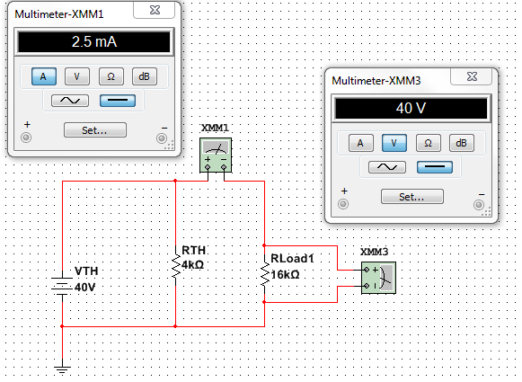

4.

Find I_N

Short from point A to B

R3 and R4 disappears

R_T = R1 + R2 = 20kOhm

I_N = V1/R_T = 12.5mA

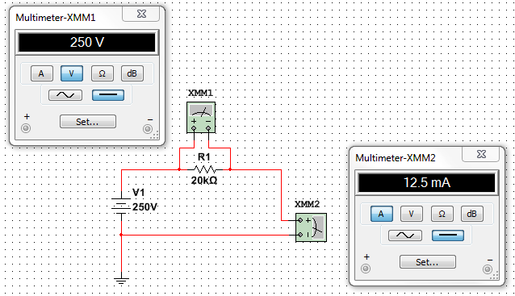

Find R_N

Short V1

R_N = R_TH = 4kOhm (see answer from problem #2)

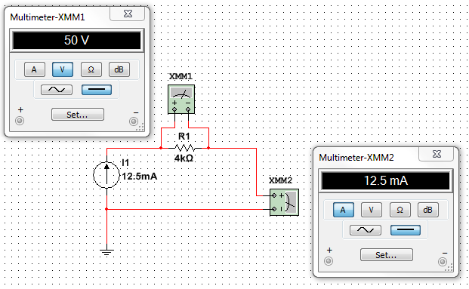

5.

