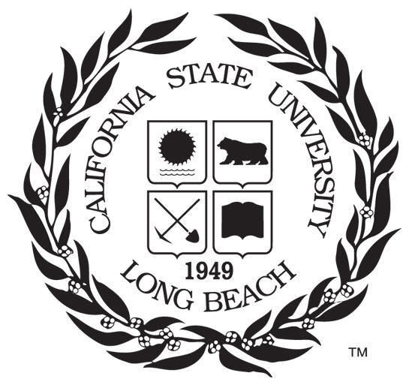

Term Project: Who Could be Rich?

Naoaki Takatsu

015746144

EE 381

Dr. Chaw-Long Chu

3, April 2018