

HDMI to VGA Converter

Final Report

Takatsu Naoaki 015746144

CECS 461 Spring 2019

14, May 2019

HDMI input to VGA output image processing through Zybo Zynq-7000 programming board

**Project Overview**

The basic feature of this project will be to convert HDMI input to VGA output. A live video feed will be inputted to the Zybo Zynq-7000 board through the HDMI input port. Then the board will convert the video feed in VGA format.

Basic Features:

-Supports HDMI display resolution of:

640x480, 800x600, 1280x720, 1280x1024, and1920x1080

-Establish frame rate of 60 FPS

-Display menu and status through UART serial terminal

-Use combination of push button and dip switch to switch through resolutions

Advanced Features:

-Pause/resume stream button

-Display color bar test screen button

-Take screenshot and invert frame color button

**Operation**

1. Establish UART connection and open serial terminal.
2. Program FPGA to Zybo board and run the software application as GDB in Xilinx SDK.
3. Connect HDMI and VGA cables respectively from source to board.
4. View serial terminal for available options and press respective button to execute one of the following:

|  |  |
| --- | --- |
| Push Button | Menu |
| 0 | Pause/resume stream |
| 1 | Capture frame and invert color/resume stream with original color |
| 2 | Change display resolution with respect to dip switch value |
| 3 | Display/hide color bar test screen to hide stream |

1. Enter one of the following to change the HDMI display resolution:

|  |  |
| --- | --- |
| Dip Switch Value | HDMI Resolution |
| 1 | 640x480 |
| 2 | 800x600 |
| 3 | 1280x720 |
| 4 | 1280x1024 |
| 5 | 1920x1080 |
| 0 | No change |
| Other | Display error message |

**Video Link**

<https://youtu.be/nEYDwaY5AS4>

**Theory**

HDMI (High-Definition Multimedia Interface) connector is a two row 19 pin connector which can pass video, audio, and ethernet data from one device to another. Combination of three 8-bit registers red, green, and blue will add up to a total of 6,777,215 output colors to choose from. The figure below describes the pinout of a typical HDMI type A cable.

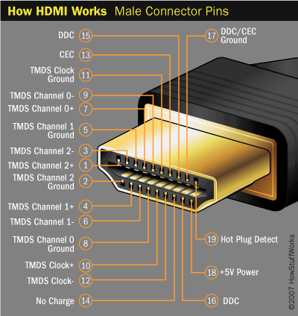

A VGA (Video Graphics Array) connector is a three row 15 pin connector which is used to pass video footage from one device to another. Combination of three 6-bit registers, red, green, and blue will add up to a total of 262,144 output colors to choose from. The figure below describes the pinout of the VGA cable.

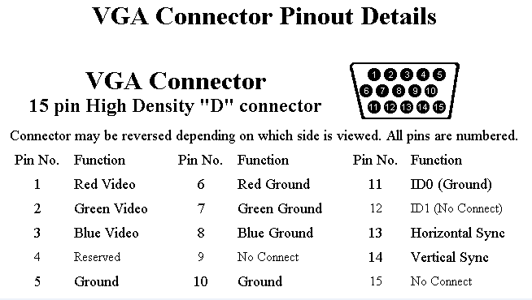

Both HDMI and VGA video timings will be controlled by horizontal and vertical syncs. Depending on whether if it’s a positive edge or negative edge logic, these synq signals will generate a high or low pulse when the pixel location is in between the front porch and back porch. Front porch and Back porch are located outside of the visible area and mainly serves the role of meeting timing requirements. Once the synq pulse returns to its original state, the pixel will either move to the next line or return to the beginning if its position is on the last pixel. However, for HDMI, there will be an additional signal called TMDS clock which will also serve an important role in timing requirements since it represents transmission frequency.

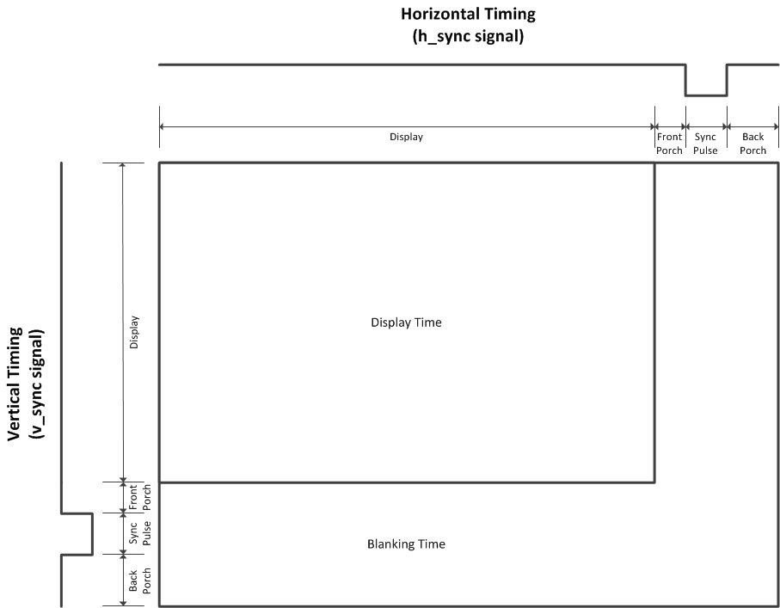

**Software Flowcharts**

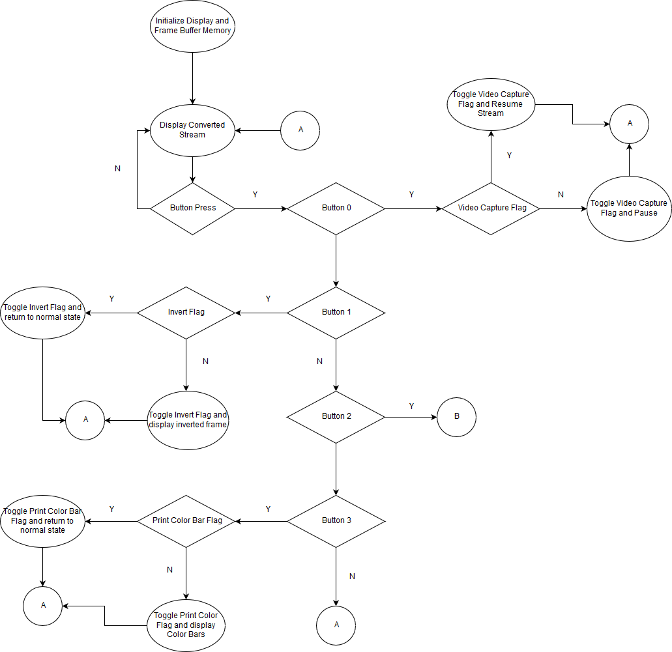

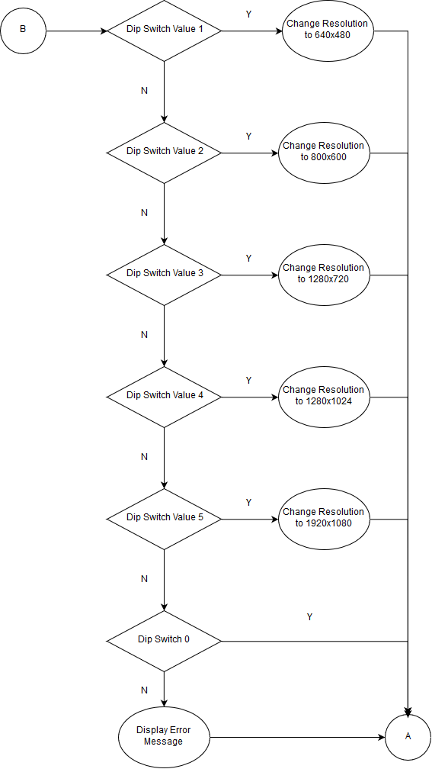

**Conclusion**

Failures:

-Various tutorials have failed to work properly due to version differences, IP mismatch, and lack of software code.

- 2018.3 version HDMI input demo posted on Digilent’s forum did not work properly

Successes

-By researching countless online sources and forums, I have managed solve platform issues and made the project to work on Vivado 2016.4 version

-Understood ins and outs of VGA timing due to past experiences