

Department of Computer Science & Mathematics
CSC 463 – Introduction to Data Science

NYC 311 SERVICE REQUEST ANALYSIS
Team Name: NYC Analysts
Instructor: Dr. Seifedine Kadry

Nakhoul Nehra
Hisham Saad
Charbel Farhat

Date: 11/05/2025

Executive Summary

The City of New York receives millions of service requests each year through its 311 system, where residents report issues ranging from noise complaints to infrastructure problems. These requests provide a rich source of data that can be used to assess city operations, uncover trends, and identify areas requiring additional attention or resources.
In this project, we analyzed a large subset of the NYC 311 service request dataset to better understand the nature of citizen complaints and evaluate the city’s responsiveness. We implemented a complete end-to-end data pipeline, starting from raw data extraction and cleaning to database integration, analysis, and visualization. The data was standardized and stored in a PostgreSQL database, enabling efficient querying and spatial analysis across boroughs and zip codes.
Our approach focused on processing and categorizing complaint types, measuring response times, and identifying complaint hotspots through geospatial analysis. This allowed us to derive insights that could help city officials prioritize enforcement efforts, allocate resources more effectively, and improve service response strategies.
Our exploratory, geospatial, and statistical analyses reveal several important patterns in NYC 311 service request behavior. Brooklyn and Queens report the largest overall complaint volumes, while the Bronx records the highest level of noise complaints (~111K cases) based on our filtered dataset and borough-level aggregation; this means that Bronx borough should have the most funding for noise enforcement. Average response times vary by borough: Queens shows the fastest mean closure times, whereas Staten Island and Manhattan exhibit slower response patterns. Temporal trends indicate consistent weekday peaks, identifiable anomaly spikes around holidays/events, and long-tailed response distributions across hours and days. Predictive modeling achieved a strong ROC-AUC of 0.95, showing that borough, category, and time-related features meaningfully explain closure likelihood within 48 hours.

Data and Methods Description

Data source:

The dataset used in this project was obtained from the NYC Open Data portal, which contains millions of records and includes fields such as complaint type, timestamps, geolocation, and agency responses. To extract the data, we developed a Python-based automated pipeline using the official Socrata Open Data API (SODA). The script was configured to retrieve the most recent six months of data using time-based filters in SOQL (Socrata Query Language).
Key Technical Features of the Extraction Pipeline:
- Retry and backoff logic to avoid crashing on transient failures:
  - Automatically retries failed API calls up to 5 times
  - Exponential backoff to prevent hammering the server
- Structured logging for transparency and debugging:
  - All API interactions, failures, retries, and chunk saves are logged to both console and file
- Paginated chunk-based fetching:
  - Each chunk is offset by 50,000 records to allow stable pagination across the 6-month window
  - Uses created_date ordering for deterministic results and no overlaps
Output Format for Efficient Processing:
- Each chunk of data is saved as a compressed .parquet file:
  - Enables memory-efficient and parallel processing using Dask

Cleaning Steps and Analytical Methods

The following steps were applied during the cleaning process:
- Column normalization and alias mapping:
  - All columns were converted to standardized snake_case format.
  - Aliases such as "createddate" or "zipcode" were mapped to canonical names like "created_date" and "incident_zip".
- Schema enforcement and type conversions:
  - Required columns like "unique_key" and "created_date" were enforced and validated.
  - Timestamps were parsed to UTC using New York City timezone logic.
  - Columns were coerced to appropriate types (e.g., numeric for latitude and longitude).
- String hygiene and cleanup:
  - All string fields were stripped of whitespace and normalized.
  - Common empty tokens such as "N/A" or "null" were converted to actual missing values.
  - Borough and city names were uppercased, and zip codes were extracted in five-digit format.
- Deduplication with priority logic:
  - If multiple entries shared the same unique key, we kept the most complete one using a priority order:
    - Closed records preferred over open
    - More recent resolution updates
    - Longer resolution description
  - This ensured one record per request, resolved deterministically.
- Date validation and range filtering:
  - Rows with invalid or missing creation dates were removed.
  - Future-dated records were discarded.
  - Closed dates earlier than created dates were sanitized.
- Feature engineering:
  - Status was derived as either OPEN or CLOSED based on closed_date presence.
  - Response time was computed in hours.
  - Optionally, we extracted time-based features such as year, month, day of week, hour, and whether the request was made on a weekend.
- Geospatial validation:
  - Latitude and longitude were checked for bounds that fall within New York City.
  - A has_geo Boolean column was added for quick spatial filtering.
- Missing data policy:
  - No arbitrary imputation was applied.
  - In some cases, missing agency_name values were backfilled when there was a one-to-one mapping with agency code in the same batch.
- Optional outlier flagging:
  - Response time outliers were flagged per complaint type using the 1st and 99th percentiles.
- Final output: The cleaned dataset was saved as one CSV file per month. All cleaning steps were executed using Dask, allowing for parallel processing.

Database Layer and Tool Justification

As part of our end-to-end data pipeline, the goal of the database layer was to store the cleaned NYC 311 service request data in a format that supports efficient querying, analysis, and geospatial operations. After cleaning the data using Python and Dask, we needed a way to persist it in a structured environment where we could run SQL queries, apply spatial filters, and allow the rest of the team to explore trends across time, location, and complaint types.
We chose PostgreSQL with the PostGIS extension as our database system for several reasons:
- The NYC 311 dataset is highly structured and tabular. Each row represents one service request with fixed columns like timestamps, coordinates, and complaint types.
- PostgreSQL allows us to define a strict schema and enforce data types and constraints, which helps prevent data quality issues and supports reliable querying.
- PostGIS extends PostgreSQL with spatial types (like Point) and functions, allowing us to filter complaints by location and compute distances while building spatial indecies.
To manage and query the database, we used:
- pgAdmin 4 to create tables, write and test SQL queries, and visually inspect the data.
- Python 3 with the libraries pandas, psycopg2, and numpy.
After finalizing the cleaned monthly CSV files, we developed a Python script to automate the process of loading this data into our PostgreSQL database. The script connects to the local PostgreSQL server, iterates through each CSV file, applies final cleaning steps, and inserts the records into the service_requests table in bulk. Once inserted, it also populates the PostGIS geometry column using the latitude and longitude of each record.
This script allowed us to standardize the loading process and avoid manual database entry. It also helped ensure that any leftover formatting or data type issues were handled consistently across all files.
The loading pipeline performs the following key steps:
- Connects to the PostgreSQL database using psycopg2, with the connection parameters specified at the top of the script.
- Iterates over every .csv file in the cleaned data folder.
- For each file:
  - Reads the data using pandas.
  - Cleans common formatting problems:
    - Converts boolean to actual Boolean types instead of Strings. Converts numeric columns with invalid values coerced to NaN.
    - Drops any rows missing latitude or longitude.
    - Replaces leftover values like empty strings with proper nulls.
  - Saves the cleaned file temporarily and uses PostgreSQL's COPY command
  - Runs an UPDATE query to populate the geom column using PostGIS:
    - The geom column is built with ST_MakePoint(longitude, latitude). This allows us to use geospatial functions later.
We ran a set of validation and analysis queries using pgAdmin:
- Noise complaints by ZIP code
  - We filtered for complaints that begin with "Noise" and have valid geolocation.
  - ZIP code 10466 had the highest number of noise-related complaints with over 32,000 cases.
- Monthly complaints by borough
  - We grouped records by created_year, created_month, and borough.
  - Brooklyn consistently showed the highest volume (e.g., 19,436 in May), followed by Queens, Manhattan, and the Bronx.
  - This revealed patterns over time and helped compare borough activity month by month.
- Total complaints per borough
  - A simple group-by-borough query showed that Brooklyn had the most requests overall, followed by Queens and Manhattan.
  - Staten Island had the lowest volume.
- Top complaint types per borough
  - We used a window function to find the top five complaint types in each borough.
  - "Noise - Residential" was the most reported issue across nearly all boroughs.
  - Other common complaints included "Illegal Parking", "HEAT/HOT WATER", and "Blocked Driveway".
To support collaboration, we made the PostgreSQL database accessible to other team members over the LAU WiFi network.
- The server machine was configured with:
  - listen_addresses = '*' in postgresql.conf
  - a rule in pg_hba.conf to allow connections from the 10.x.x.x subnet
- Port 5432 was opened in the Windows Defender firewall.
- Teammates found the IP address using ipconfig and connected via pgAdmin.
Once connected, the database tree looked like this:
Databases
└─ nyc311
└─ Schemas
└─ public
└─ Tables
└─ service_requests

Results and Interpretations:

In this phase we will show visual interpretations of the data and explaining their meaning. more visualizations (and the exact Python/DuckDB code that generated them) are attached with the project.

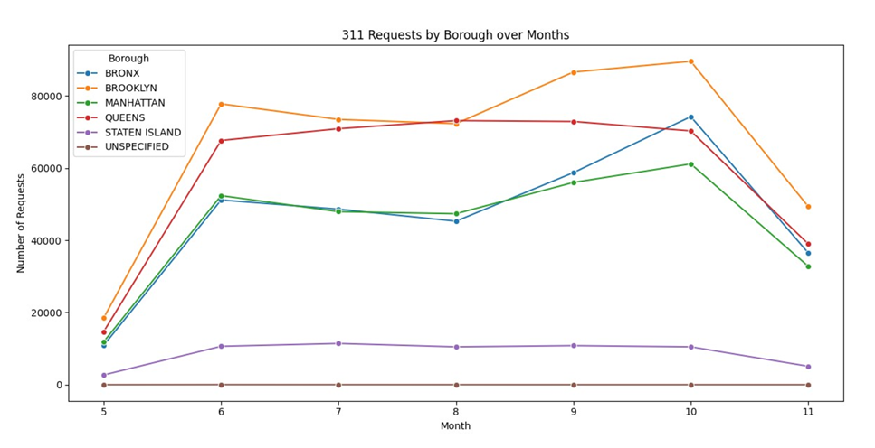

Figure 1: 311 Requests by Borough over Months (May–Nov)
- How we produced it: From the cleaned table Grouped by borough and created month (5–11), counted rows, plotted monthly lines (pandas group by → size(); Matplotlib).
- What it shows: Brooklyn and Queens carry the highest monthly volumes; Bronx and Manhattan are mid-high; Staten Island is consistently lowest; “Unspecified” is near zero. Clear seasonality bumps around Sep–Oct, relevant for staffing and outreach.
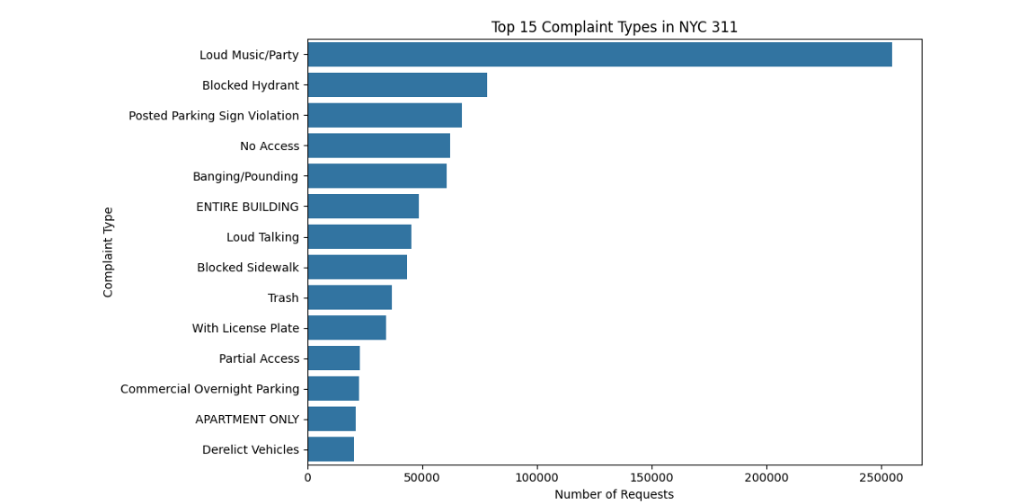
Figure 2: Top 15 Complaint Types
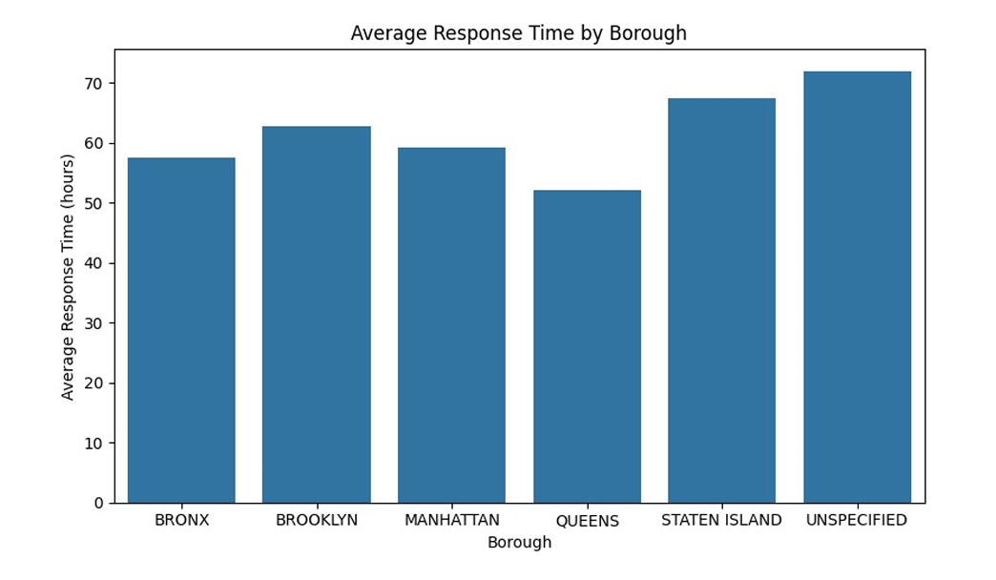
Figure 3: Average Response Time by Borough
- How we produced it: Computed response hours = (closed − created) in hours; filtered out null dates and extreme tails (> 60 days); grouped by borough and averaged.
- What it shows: Queens shows the lowest mean closure time; Brooklyn/Manhattan are higher; Staten Island is among the slowest; Generally, boroughs have a close average response time.
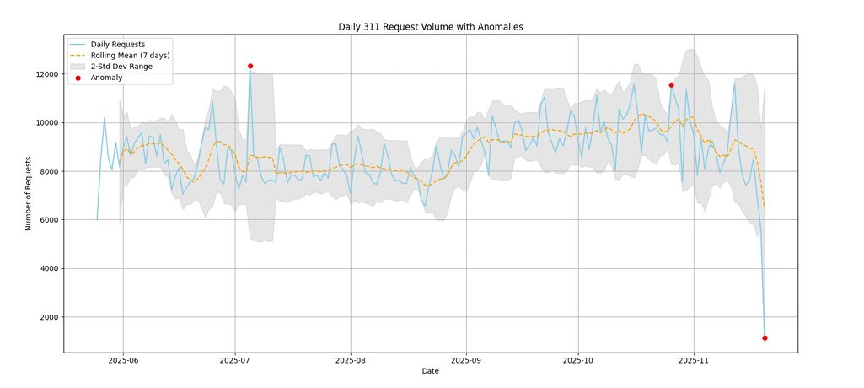
Figure 4: Request Volume with Anomalies
- How we produced it: Aggregated daily counts by created_date (date floor). Computed a 7-day rolling mean and rolling standard deviation; flagged anomalies where the day’s count lies outside ±2σ of the rolling mean; plotted line + band with anomaly points.
- What it shows: A stable weekday–weekend rhythm with clear spikes/dips (red markers) that likely map to holidays, storms, or major events. Useful for alerting and surge staffing.
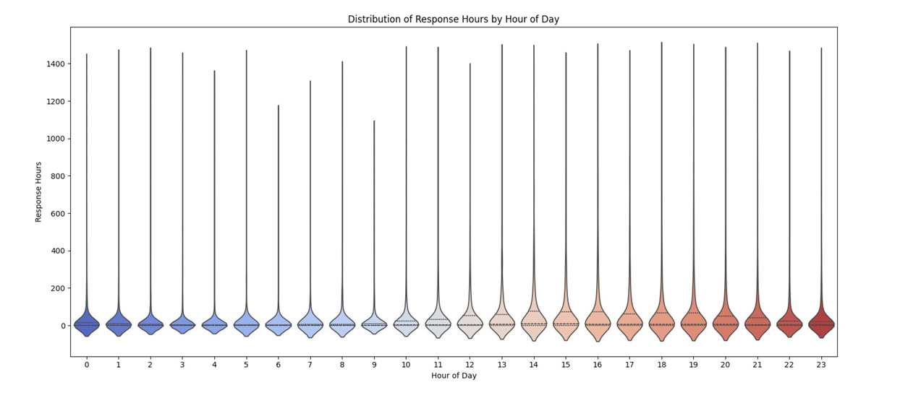
Figure 5: Violin Plot: Response Hours by Hour of Day
- How we produced it: For each created_hour, plotted the kernel density of response_hours (clipped ≤ 60 days) with median/IQR markers.
- What it shows: All hours exhibit long right tails, most cases close quickly, but a small share takes much longer. Hour-of-creation alone does not dominate outcomes; category and location interactions matter more.
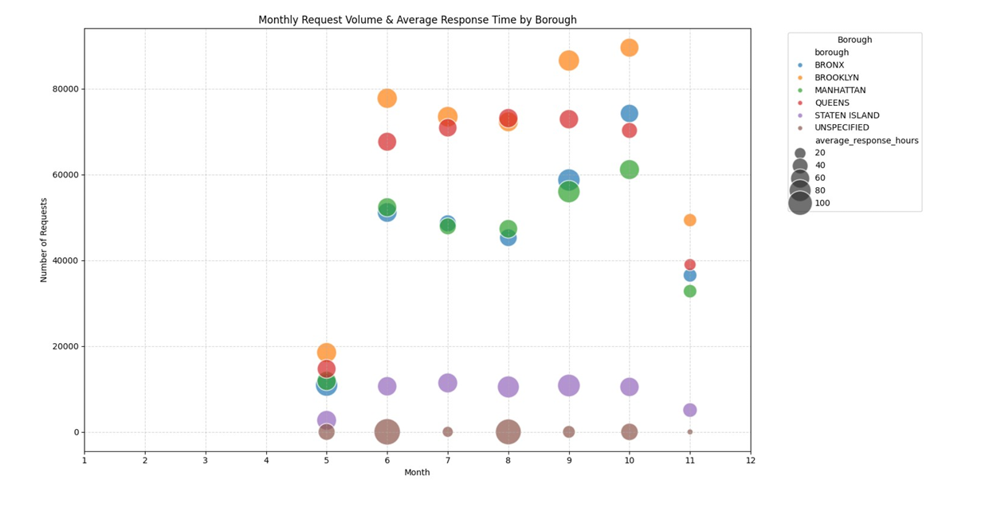
Figure 6: Bubble Chart: Monthly Volume vs Avg Response (by Borough)
- How we produced it: For each borough–month pair, computed total requests (y-axis) and mean response_hours (bubble size); x-axis is month number (5–11).
- What it shows: Lets you scan capacity strain: months with higher volumes often show larger bubbles (slower means) for some boroughs. It is an at-a-glance way to spot when/where surges coincide with slower service.
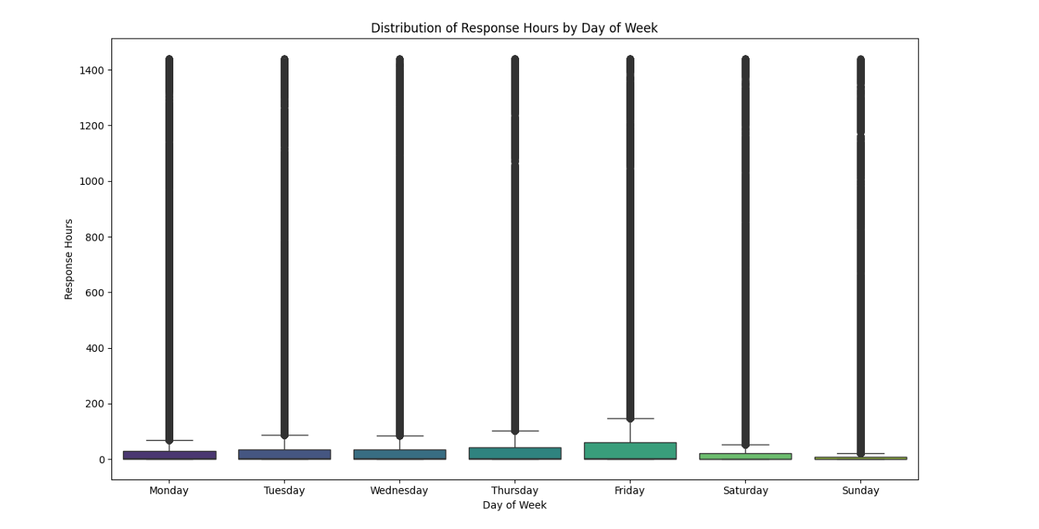

Figure 7: Box Plot: Response Hours by Day of Week

- How we produced it: Box-and-whisker for response_hours (≤ 60 days) by created_dow. Outliers retained to reflect tail behavior.
- What it shows: Medians are relatively close across days, but the whiskers/outliers are substantial, again confirming heavy-tailed service times. Friday shows a slightly wider spread, suggesting backlog carry-over risk into weekends.

Conclusion and decision making

The six-month analysis of NYC 311 service requests reveals clear geographic and temporal patterns that help explain where demand is concentrated and how effectively the city responds. Brooklyn and Queens report the highest overall volume, while the Bronx shows the greatest number of noise-related complaints, making it the primary candidate for additional noise-enforcement resources. Response times vary across boroughs, with Queens generally closing cases faster and Manhattan and Staten Island showing slower performance. Temporal plots and anomaly detection also highlight predictable cycles, weekend effects and occasional spikes linked to holidays and major events.
A statistical comparison between Manhattan and the Bronx confirms significant differences in average response times. The predictive model for identifying requests closed within 48 hours performs strongly, indicating that borough, complaint type and timing features carry meaningful information about service delays.
Limitations of the analysis include the restricted six-month window, inconsistencies in some fields, the presence of outlier behavior in response times and the lack of external operational factors—such as staffing or weather—in the predictive model.
Based on all findings, the following recommendations are supported:
- Increase noise-enforcement resources in the Bronx to address the highest noise-complaint burden.
- Improve operational support in Manhattan and Staten Island, where response speeds are relatively slower.
- Use anomaly detection outputs to prepare for short-term surges in complaint volume.
- Integrate the predictive model into the city’s workflow to flag cases at risk of delayed closure.
- Align staff schedules with weekday and hourly complaint patterns.
- Improve data consistency where possible, especially complaint categories and geolocation fields.
These insights together present a concise, actionable understanding of NYC’s 311 system, enabling more effective planning and resource allocation.

Code and GitHub

- All the code used for our research analysis on the NYC311 service request data will be present on GitHub, accessible through this link: nakhoulnehra/NYC311-Project
- In the same repository, the user will find a ReadMe file that explains how to set up everything including the database, the dataset, and the codes/queries to run.
- The user will also have access to the Google Collab notebook that contains a well-documented code and the statistical analysis result graphs.

