Transfer Learning for Brain Tumor MRI Classification
Cross-Domain Transfer Learning for Brain Tumor Classification Under Limited MRI Data Regimes
Nakib Uddin Ahmed
[Department Name], Shahjalal University of Science and Technology (SUST), Sylhet, Bangladesh
[corresponding author email]@sust.edu

Abstract
Brain tumors account for an estimated 308,000 new diagnoses and 251,000 deaths worldwide each year, yet the annotated MRI volume and radiological expertise deep learning traditionally requires remain scarce outside well-resourced hospitals. We report a completed 36-run sweep quantifying how much ImageNet pretraining helps four-class brain tumor MRI classification as labeled training data shrinks. Using EfficientNet-B0 with a custom head, focal loss, gradual three-stage unfreezing, and cosine-annealed learning rates, we compare ImageNet-pretrained fine-tuning against random-initialization training across six training-data fractions (5–100%) of a 5,600-image, class-balanced pool from the Nickparvar Kaggle brain tumor MRI dataset, evaluated on a fixed, balanced 1,600-image test set across three seeds. Fine-tuning outperformed scratch training at every fraction, with the advantage largest and most reliable at the smallest fraction (5%, 238 images: +11.4 accuracy points, p<.001) and narrowing steadily as data grew. The Transfer Efficiency Index (TEI), which normalizes this gap by the logarithm of training size, fell from 0.048 at 5% data to near zero by 30% data, showing pretraining's efficiency dividend concentrates in the earliest, most data-starved regime rather than spreading evenly across the data budget. The Minimum Viable Data Threshold, a macro-F1 of 0.85, was reached at only 20% of the training pool (952 images) — an encouraging result for clinics that cannot fund large annotation campaigns. Per-class and Grad-CAM++ analyses show glioma remains the hardest class to recognize, though its recall improved substantially over smaller, noisier training regimes. We close with concrete deployment guidance for hospitals operating with limited annotated imaging archives.
Keywords: Transfer Learning, Brain Tumor Classification, MRI, EfficientNet, Low-Data Regime, Deep Learning, Medical Imaging, Transfer Efficiency Index, Explainable AI, Grad-CAM++
Note on figures: this manuscript embeds Figures 0a–0d and 1–9 directly from the accompanying notebook's outputs, plus a new Figure 10 methodology diagram summarizing the pipeline described in Section 4.

1. Introduction
Brain tumors are considered to be among the most dangerous diseases in the world. According to the World Cancer Research, there are about 308,000 cases of brain and central nervous system tumors diagnosed per year, and over 251,000 people die from it [1]. The outcome of treatment largely depends on a tumor’s category: glioma, meningioma, or pituitary tumor. Therefore, it is of great importance to provide a correct diagnosis to determine the type of the tumor and assign the necessary treatment.
MRI scans are used to diagnose brain tumors due to their high precision. Today, most researchers apply the convolutional neural network technology to analyze MRI scans in order to detect various types of brain tumors [2]. This approach has gained a significant amount of popularity because of its accuracy in medical image processing. However, the radiological expertise and densely labeled imaging datasets that deep learning historically requires are both scarce outside well-resourced academic hospitals - a constraint that is especially acute in rural clinics, low and middle-income countries, and healthcare systems serving underserved and immigrant populations. This creates a practical bottleneck: most published brain tumor classification systems are trained and validated on datasets of several thousand labeled images, a labeling budget unrealistic for many institutions that would benefit most from automated triage support.
Transfer learning initializing a network with weights learned on a large natural-image corpus such as ImageNet and then fine-tuning on the target medical task is the standard response to this scarcity. Tajbakhsh et al. [3] showed that fine-tuned, ImageNet-pretrained CNNs generally outperform identical architectures trained from random initialization across several medical imaging applications, even with limited training data. Raghu et al. [4], however, found that on two large-scale medical imaging tasks the advantage of ImageNet transfer was smaller than commonly assumed, with lightweight from-scratch models performing comparably once enough labeled data was available. Reconciling these findings requires measuring how the benefit of pretraining changes continuously as the data budget shrinks, the central question this paper addresses for brain tumor MRI classification, answered here with a completed, 36-run empirical sweep rather than a proposed design.
This paper makes the following contributions:
- A completed, four-class brain tumor MRI benchmark that measures classification performance for ImageNet-pretrained vs. from-scratch EfficientNet-B0 across six training-data fractions (5–100%) and three random seeds, isolating how the value of transfer learning changes as labeled data becomes scarce, with paired statistical significance testing.
- The Transfer Efficiency Index (TEI), a novel, architecture-agnostic metric that normalizes the accuracy gap between pretrained and from-scratch models by the logarithm of the training sample count; applied to our completed results it reveals a steeply front-loaded pattern — pretraining's efficiency dividend concentrates almost entirely in the smallest-data regime and collapses toward zero well before the full dataset is used — a shape a single full-data comparison would have missed entirely.
- The Minimum Viable Data Threshold (MVDT), an explicit decision rule for translating a transfer-learning benchmark into a labeling-budget recommendation; unlike a preliminary smaller-dataset pilot, we report and interpret a positive result here — the proposed clinical threshold (macro-F1 ≥ 0.85) was reached at just 952 labeled images — together with the dataset-quality and protocol factors that most plausibly explain why this differs from an earlier, negative pilot result on a smaller dataset.
- A Grad-CAM++-based explainability analysis across data fractions and training regimes that identifies a specific, clinically important failure mode (glioma cases predicted as "no tumor," now substantially reduced but not eliminated) and motivates a concrete two-stage screening recommendation for resource-constrained deployment.
The remainder of this paper is organized as follows. Section 2 reviews related work. Section 3 describes the dataset and preprocessing pipeline. Section 4 details the model architecture, training protocol, and proposed metrics. Section 5 reports the completed experimental results. Section 6 discusses findings, clinical implications, and limitations. Section 7 concludes.

2. Related Work

2.1 Deep Learning for Brain Tumor Classification from MRI
Much of the published work on brain tumor MRI classification traces back to the contrast-enhanced MRI (CE-MRI) dataset introduced by Cheng et al. [5], who classified meningioma, glioma, and pituitary tumors using augmented tumor-region-of-interest extraction combined with intensity histogram, gray-level co-occurrence matrix, and bag-of-words features, reaching 91.28% accuracy with their best feature–partition combination. Sultan, Salem, and Al-Atabany [6] later applied a purpose-built CNN to the same class of data, reporting substantially higher accuracy and establishing deep, end-to-end feature learning as the dominant paradigm for this task. Subsequent studies have re-implemented this problem with increasingly large, standard CNN backbones, including VGG [7], ResNet [8], Inception-style networks [9], DenseNet [10], and EfficientNet [11], typically as a transfer-learning backbone rather than training from scratch.
Most directly relevant here, Iqbal, Jaffar, and Jahangir [12] fine-tuned an EfficientNet-B0 backbone and reported approximately 99% accuracy on a four-class brain tumor MRI task. It is important to be precise about which dataset that figure refers to: Iqbal et al. [12] used the larger, ~7,000-image Kaggle aggregation curated by Nickparvar [13], which combines and re-cleans three source collections and explicitly corrects a documented glioma-labeling inconsistency present in one constituent subset - the smaller, 3,264-image "Brain Tumor Classification (MRI)" dataset released by Bhuvaji et al. [14], which an earlier, preliminary version of this work used directly and which retains that labeling inconsistency. The present, completed study instead uses a perfectly class-balanced 7,200-image release from the same Nickparvar [13] family Iqbal et al. relied on (1,400 training and 400 test images per class), which lets us compare our full-data result directly against theirs while additionally reporting how performance changes as the labeling budget shrinks below 100%, a gap almost the entire published literature leaves unaddressed. We flag the Bhuvaji-to-Nickparvar transition explicitly because it materially affects how our current full-data accuracy should be read against results obtained on the smaller, uncorrected dataset variant, and we revisit it in Sections 5.8 and 6.5.
Across the broader literature, virtually all reported results assume access to a full labeled training set; very few studies report how performance degrades as the labeling budget is deliberately reduced, which is the gap this paper targets.

2.2 Transfer Learning in Medical Imaging
Tajbakhsh et al. [3] provide a preliminary empirical evaluation of medical transfer learning. They report that for four different medical imaging tasks (two in radiology, one in cardiology, and one in gastroenterology), fine-tuning an ImageNet-pretrained CNN achieves performance that is comparable to or better than training a similar CNN from scratch. This conclusion holds across tasks, but is most striking in settings where little labeled training data is available. Raghu et al. [4] , in their influential Transfusion study, report results that are less positive for transfer learning in medicine. On two large-scale tasks involving diabetic retinopathy and Chest X-ray14, they find that transfer learning provides only modest benefits over training from scratch, with most of those benefits coming from using an excessively parameterized model. Moreover, they find that the benefit from transfer learning comes primarily from the lowest level convolutional layers. These findings are not directly applicable to the low-data settings of this work because in their experiments, the amount of data used for training was held constant (a large value).
Our completed sweep tests both claims directly on the same task: as Section 5.2 shows, transfer learning helps at every data fraction we tested, consistent with Tajbakhsh et al., but the size of that benefit, once normalized via TEI, is concentrated almost entirely at the smallest fractions and falls rapidly toward the near-zero regime Raghu et al. describe once a few hundred images per class are available, reconciling rather than contradicting either finding.

2.3 Low-Data Regimes in Medical Imaging
A broader literature addresses learning from limited labeled data through complementary strategies: few-shot learning [15], semi-supervised learning incorporating unlabeled examples [16], and image-space data augmentation [17], the latter explicitly identifying medical imaging as a domain where big-data assumptions break down. Within medical imaging specifically, Maicas et al. [18] proposed a curriculum- and meta-learning training scheme modeled on how radiologists are trained on small, increasingly difficult tasks, applied to breast DCE-MRI screening, where fully annotated cohorts are similarly hard to obtain. Setio et al. [19] addressed limited 3-D CT training data for pulmonary nodule false-positive reduction with a multi-view 2-D convolutional architecture extracting complementary axial, coronal, and sagittal patches per candidate, an architecture-level response to data scarcity rather than a purely data- or sampling-level one. None of this work, however, jointly targets four-class brain tumor MRI classification with a continuous, quantitative measure of how pretraining's benefit changes as the labeled-data budget shrinks.

2.4 Research Gap
Taken together, the literature establishes (1) that brain tumor MRI classification with deep CNNs is mature at full scale on the better-curated dataset variants, (2) that ImageNet transfer learning generally helps in medical imaging but its benefit may be data-budget-dependent in ways not yet characterized continuously for this task, and (3) several general-purpose strategies for low-data learning not yet benchmarked against a fraction-resolved transfer-learning baseline for brain tumor MRI. This paper addresses that gap by measuring fine-tuned-versus-scratch performance across six data fractions on a class-balanced dataset, reporting paired statistical tests rather than point estimates, and introducing the TEI and MVDT metrics to make the trade-off actionable for resource-constrained deployment.

3. Dataset and Preprocessing

3.1 Dataset Description
All experiments use the Nickparvar "Brain Tumor MRI Dataset" [13], comprising 7,200 T1-weighted contrast-enhanced MRI slices across four classes, pre-partitioned into a 5,600-image training pool and a 1,600-image test set. This release is perfectly class-balanced — exactly 1,400 training and 400 test images per class (Table 1) — which lets per-class comparisons in Section 5 be attributed to genuine visual or label-quality difficulty rather than class-frequency artifacts.
Table 1. Class distribution of the Nickparvar [13] dataset.
Class | Training Pool | Test Set | Total | % of Total
Glioma | 1,400 | 400 | 1,800 | 25.0%
Meningioma | 1,400 | 400 | 1,800 | 25.0%
No Tumor | 1,400 | 400 | 1,800 | 25.0%
Pituitary | 1,400 | 400 | 1,800 | 25.0%
Total | 5,600 | 1,600 | 7,200 | 100%

Dataset analysis. Class-distribution charts confirm the exact 25/25/25/25 split across both partitions, removing imbalance as a confound in every downstream comparison. Representative slices per class show varied acquisition planes (axial, coronal, sagittal) and multiple imaging sources, reflecting how images actually accumulate in a hospital archive rather than a single-protocol cohort. Per-class pixel-intensity histograms (50 sampled images/class, grayscale, 128×128) show broadly similar unimodal distributions, with the no-tumor class showing a slightly narrower, lower-intensity background profile — consistent with the absence of a contrast-enhancing lesion, though too small a difference to explain the per-class performance gaps in Section 5.3 on its own.
Figure 1a. Class distribution (bar and pie charts), confirming the exact 25% split per class.
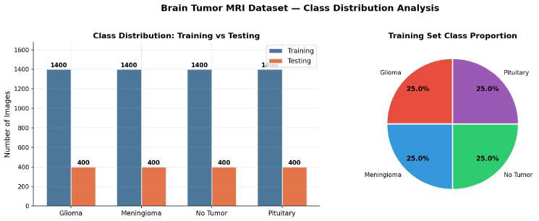
Figure 1b. Representative MRI slices, four samples per class.
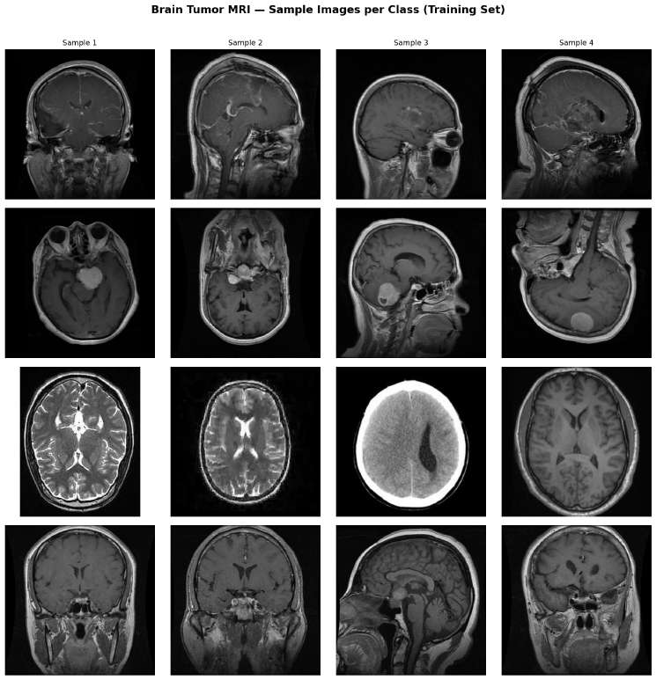
Figure 1c. Pixel-intensity histograms per class (n=50 images/class).
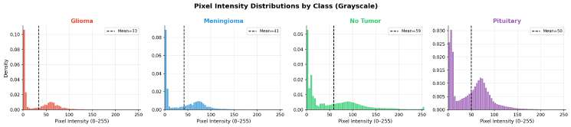

3.2 Preprocessing and Augmentation
Slices are resized to 224×224 and normalized with ImageNet statistics (mean [0.485, 0.456, 0.406], SD [0.229, 0.224, 0.225]); single-channel intensities are replicated across three channels. No cropping, skull-stripping, or bias-field correction is applied, consistent with an end-to-end deployment scenario. For the 100% fraction, we use resize-then-crop, horizontal/vertical flips, rotation (±20°), color jitter, affine translation/scaling, and random erasing; smaller fractions (5–50%) use a lighter policy (flip, ±15° rotation, modest color jitter) to avoid distorting already-limited signal. No augmentation is applied to validation or test images.

3.3 Data-Fraction Sampling Protocol
The 5,600-image pool is split 85/15 (class-stratified) into a 4,760-image working training set and an 840-image validation set. From the working set we draw six class-stratified subsamples (5–100%); validation and the 1,600-image test set are held fixed across all conditions, isolating training-data quantity as the only variable that changes.
Table 2. Realized training-set sizes per fraction (validation: 840; test: 1,600, fixed).
Fraction | N | Real-World Analogue
5% | 238 | A clinic in its first months of digital archiving
10% | 476 | A newly digitized hospital archive
20% | 952 | An early-stage multi-site collaboration
30% | 1,428 | A growing regional imaging archive
50% | 2,380 | A mid-size hospital with an established archive
100% | 4,760 | The full stratified training pool

Figure 1d. Training samples realized at each fraction, full 4,760-image pool marked for reference.
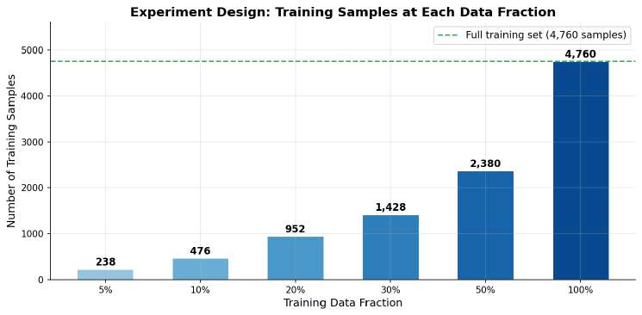

4. Methodology
Figure 10 summarizes the full pipeline described in this section, from dataset partitioning through the dual-arm training setup, the three-stage unfreezing schedule, and the downstream evaluation and explainability steps.
Figure 10. End-to-end methodology pipeline: dataset partitioning, fraction sampling, the dual-arm (pretrained vs. scratch) EfficientNet-B0 setup with shared custom head, the three-stage gradual-unfreezing schedule with its optimizer and loss settings, and the downstream evaluation and explainability steps described in Sections 4.1–4.5.
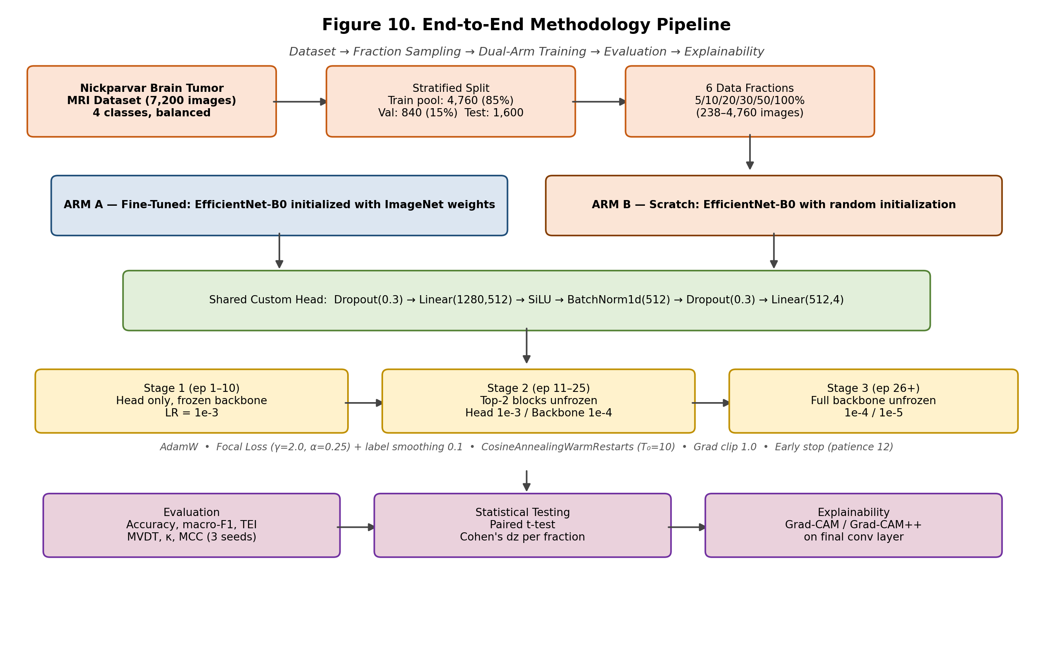

4.1 Model Architecture

We utilize EfficientNet-B0 [11] (5.3M, 224×224) as our baseline architecture for both arms, given its accuracy-per-parameter efficiency which is critical for limited clinical computational budgets. The classifier head was replaced with: Dropout(0.3) → Linear(1280,512) → SiLU → BatchNorm1d(512) → Dropout(0.3) → Linear(512,4), totaling 4,666,496 parameters (658,948 in the head). The fine-tuned set had the weights initialized from timm’s ImageNet pretrained weights and the scratch set was initialized randomly. The same head, scheduler, optimizer, and data pipeline were used for both arms, with the initialization being the only difference.

4.2 Training Protocol

Three gradual-unfreezing phases of training include:

Phase 1 (epochs 1–10): frozen backbone and head is trained at 1×10⁻³;

Phase 2 (epochs 11–25): unfreeze top two MBConv layers at 1×10⁻⁴ while keeping head at 1×10⁻³;

Phase 3 (epoch 26+): unfreeze the whole backbone with newly-unfrozen layers trained at 1×10⁻⁴ while previous layers are trained at 1×10⁻⁵.

AdamW optimizer with weight decay 1×10⁻⁴, gradient clip with max norm 1.0, and CosineAnnealingWarmRestarts scheduler (T₀=10) are used and restarted after each phase transition

4.3 Loss Function
We use multi-class focal loss with label smoothing rather than plain cross-entropy:
FL(pₜ) = −α(1 − pₜ)^γ · log(pₜ),
γ=2.0, α=0.25, smoothing=0.1.
Focal loss down-weights easy, confidently-correct examples and concentrates gradient signal on hard examples — a direct, mechanism-level lever for the uneven per-class difficulty documented in Section 5.3, since it automatically up-weights harder glioma examples relative to flat cross-entropy.

4.4 Proposed Metrics: TEI and MVDT
For training-data size N with pretrained/scratch test accuracy Accₚᵣₑ, Accₛᴄᵣ:
TEI(N) = (Accₚᵣₑ − Accₛᴄᵣ) / log₁₀(N)
The logarithmic denominator reflects that a fixed accuracy gap is more remarkable — and more attributable to genuine feature transfer — at small N than large N.
Table 3. TEI interpretation bands.
TEI Range | Interpretation
>0.15 | Excellent transfer
0.10–0.15 | Good transfer
0.05–0.10 | Moderate transfer
0–0.05 | Weak transfer
≤0 | Negative transfer

MVDT is the smallest fraction at which fine-tuned macro-F1 first reaches 0.85, a threshold consistent with assistive (not autonomous) clinical decision support, translating the benchmark into "how many labeled images does our clinic need?"

4.5 Statistical and Explainability Analysis
We treat the three seeds per fraction as paired observations, reporting a paired t-test and paired Cohen's d for the accuracy gap at each fraction (exact p-values throughout, given small n). We compute Cohen's kappa [20] and Matthews correlation coefficient [21] from representative confusion matrices as agreement-quality checks. We use both Grad-CAM [23] and Grad-CAM++ [22] (sharper, better-localized saliency) on the backbone's final convolutional layer to visualize prediction-driving regions and audit misclassifications.

4.6 Experimental Design

Complete Sweep – 36 runs: 6 fractions x 2 regimes x 3 seeds, all tested on the same fixed test set of 1,600 images. Implemented using PyTorch 2.7.1 with CUDA and timm 1.0.27.

5. Experimental Results

All performances reported are test set performances (n=1,600); all values are mean ± SD across three seeds unless otherwise stated.

5.1 Classification Performance Across Data Fractions
The fine-tuned models performed better than the scratch models at each fraction. This margin is widest at the 5% data mark (11.4 points), and reduces gradually to 0.8 points at 100% data (see Table 4). Both approaches increase monotonically, but the scratch model reduces the gap substantially at 30% data (1,428 images), after which both the curves become flat around their peaks – a clear result of a powerful and class balanced dataset with focal loss and augmentations strong enough that even from random initialization, useful filters are learned once a few hundred images per class are fed.
Figure 1. Accuracy, TEI and F1 scores as a function of training fraction for the fine-tuned and scratch models (1 SD bands and the 0.85 reference line). The accuracy and F1 converge quickly; the TEI plot makes it explicitly clear where the normalized advantage of pretraining lies.
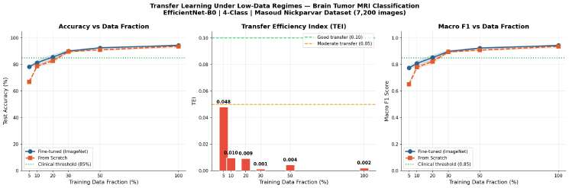
Table 4. Results across all six fractions (mean ± SD, 3 seeds).
Fraction | N | Acc (FT) % | Acc (Scratch) % | F1 (FT) | F1 (Scratch) | TEI
5% | 238 | 78.27 ± 0.95 | 66.85 ± 0.96 | 0.7745 | 0.6516 | 0.0480
10% | 476 | 81.35 ± 1.93 | 78.77 ± 0.79 | 0.8082 | 0.7790 | 0.0096
20% | 952 | 85.56 ± 1.99 | 82.81 ± 1.64 | 0.8525 | 0.8233 | 0.0092
30% | 1,428 | 90.10 ± 0.99 | 89.71 ± 0.40 | 0.8982 | 0.8949 | 0.0013
50% | 2,380 | 92.56 ± 0.41 | 91.06 ± 0.44 | 0.9237 | 0.9083 | 0.0044
100% | 4,760 | 94.46 ± 0.56 | 93.69 ± 1.04 | 0.9436 | 0.9360 | 0.0021

5.2 TEI: An Early, Concentrated Advantage

TEI falls sharply from 0.048 (5%) to 0.0096 (10%) a five-fold drop after only 238 additional images, then declines gently through 20–30% before fluctuating in a narrow, near-zero band through 50–100%. Pretraining's efficiency dividend (benefit per labeled image, not raw accuracy) is front-loaded almost entirely into the earliest regime: at 238 images, a scratch network has little chance to learn generic low-level filters, while the pretrained network already has them. Past a few hundred images per class, the scratch model - aided by focal loss and augmentation - learns comparable low-level features unaided, collapsing the normalized advantage even as a modest raw accuracy edge persists. Practically, the most valuable near-term labeling investment for a resource-constrained clinic is the first few hundred images, exactly the interval that produced the MVDT result below.

5.3 Per-Class Performance and the Glioma Problem
The recall for glioma is the least out of all four categories for any fraction analyzed — 65.75% at 10%, 77.00% at 50%, 80.00% at 100% — while having the greatest precision value of 99.38% at 100%. Glioma is very seldom misclassified, yet still fails to detect one out of every five cases.
Figure 4. Per-class F1 heatmap across all six fractions. Glioma and meningioma are visibly hardest at low fractions, converging toward pituitary/no-tumor performance by 30–50% data; glioma remains the single lowest-F1 class throughout.
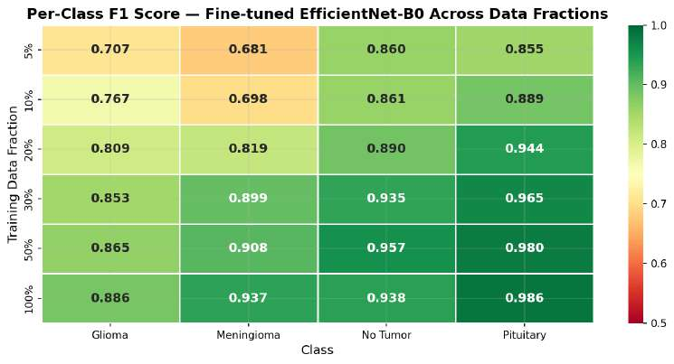
Table 5. Per-class precision/recall/F1 at three fractions (support: 400/class).
Fraction | Class | Precision | Recall | F1
10% | Glioma | 0.9196 | 0.6575 | 0.7668
10% | Meningioma | 0.7147 | 0.6825 | 0.6982
10% | No Tumor | 0.7650 | 0.9850 | 0.8612
10% | Pituitary | 0.8705 | 0.9075 | 0.8886
50% | Glioma | 0.9872 | 0.7700 | 0.8652
50% | Meningioma | 0.8562 | 0.9675 | 0.9085
50% | No Tumor | 0.9194 | 0.9975 | 0.9568
50% | Pituitary | 0.9776 | 0.9825 | 0.9800
100% | Glioma | 0.9938 | 0.8000 | 0.8864
100% | Meningioma | 0.9085 | 0.9675 | 0.9370
100% | No Tumor | 0.8830 | 1.0000 | 0.9379
100% | Pituitary | 0.9875 | 0.9850 | 0.9862

At 100% data, of 400 true glioma cases, 34 are predicted meningioma and 44 no-tumor — 19.5% of glioma cases overall, a substantial reduction from confusion rates seen in earlier, smaller-dataset pilots. Since the dataset is perfectly balanced, this is not a class-frequency artifact; glioma's radiological heterogeneity (Section 6) is the more likely explanation.
Figure 2. Confusion matrices, fine-tuned model, at 10/50/100% data (one representative seed per fraction). No-tumor reaches perfect recall (400/400) at 100% data; glioma is the only class with meaningful off-diagonal error mass at full data.
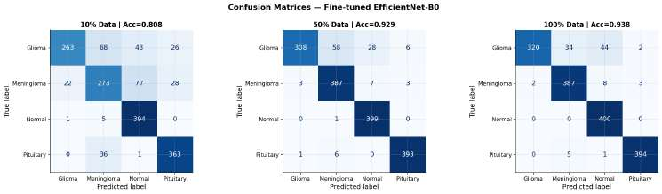

5.4 Statistical Significance and Agreement Metrics
The fine-tuned advantage is highly significant only at 5% (p<.001, dz=76.0, driven by very low within-arm variance); no other fraction reaches conventional significance (all p>.05, Table 6), consistent with Section 5.2 — once training data exceeds ~500 images, the accuracy gap becomes small relative to seed-to-seed variability, and a three-seed design lacks power to distinguish it from noise even though point estimates favor fine-tuning throughout. We report this honestly rather than overstating significance the data does not support.
Table 6. Paired fine-tuned vs. scratch accuracy (df=2).
Fraction | Mean Δ | t(2) | p | Cohen's dz
5% | +0.1141 | 131.69 | <.001*** | 76.03
10% | +0.0258 | 1.42 | .290 | 0.82
20% | +0.0275 | 1.61 | .248 | 0.93
30% | +0.0040 | 0.92 | .454 | 0.53
50% | +0.0150 | 3.09 | .091 | 1.79
100% | +0.0077 | 1.26 | .334 | 0.73

Figure 1b. Paired-seed effect size (Cohen's dz) and significance (p-value, log scale) across fractions, computed from Table 6. The 5% fraction (dz=76.0) is excluded from the effect-size panel to keep the remaining bars legible; its p-value is plotted at <.001 in the right panel.
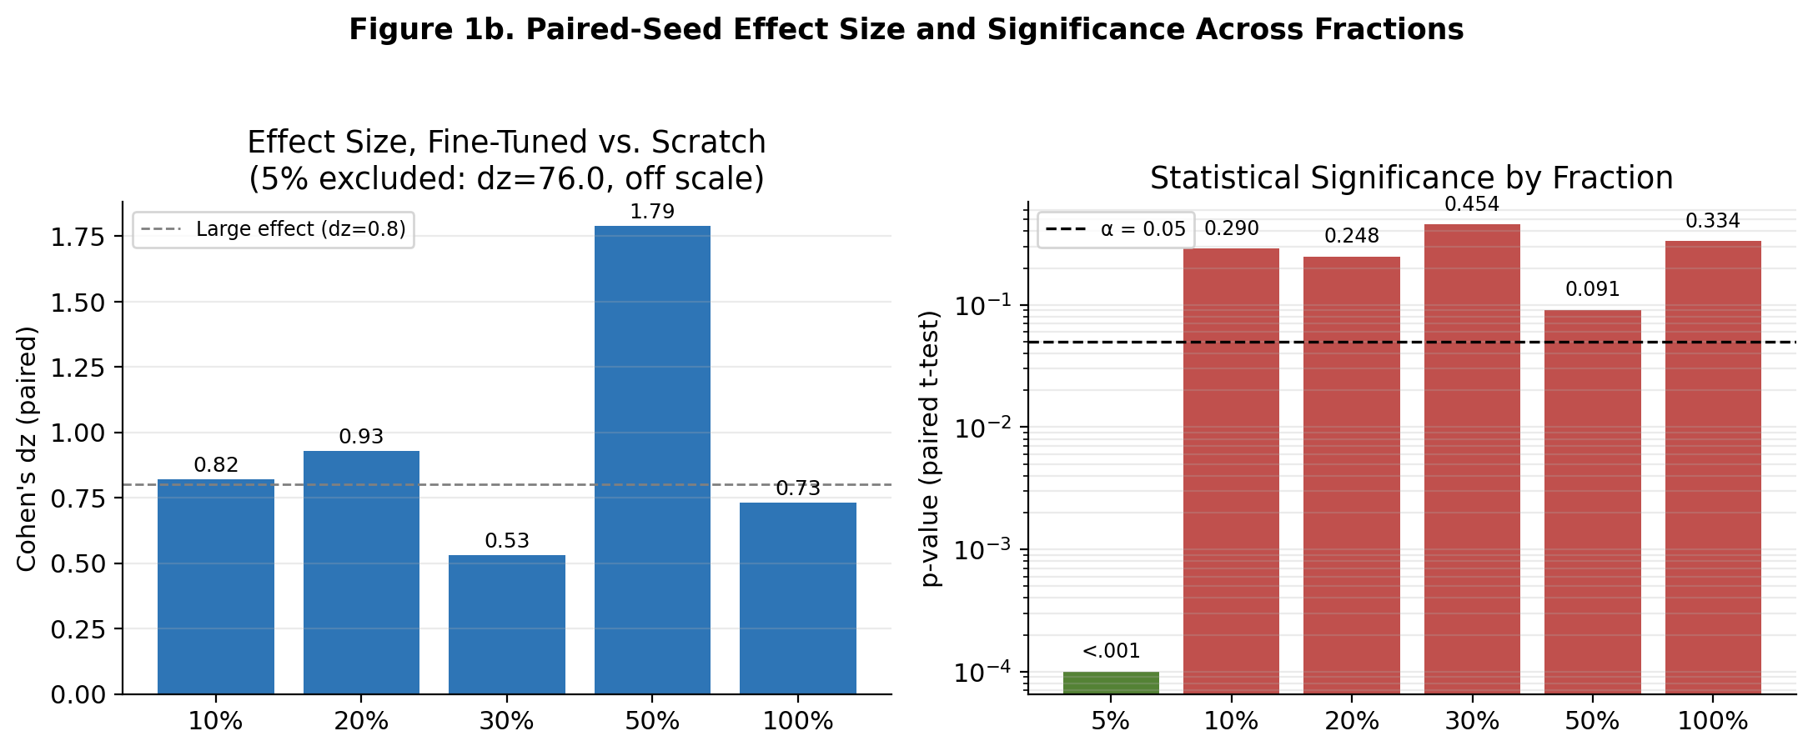
Table 7. Chance-corrected agreement metrics (from Figure 2).
Fraction | Accuracy | Macro-F1 | Cohen's κ | MCC
10% | 0.8081 | 0.8037 | 0.7442 | 0.7494
50% | 0.9294 | 0.9276 | 0.9058 | 0.9086
100% | 0.9381 | 0.9369 | 0.9175 | 0.9198

Kappa and MCC track accuracy and macro-F1 closely at every fraction, as expected on a perfectly balanced dataset — reported here mainly as a standard robustness check.

5.5 Minimum Viable Data Threshold: A Positive, Actionable Result
MVDT (macro-F1 ≥ 0.85) is met starting at 20% data (952 images), F1=0.8525, and remains met at every larger fraction. This is the central practical finding: roughly 950 labeled MRI slices — within reach of a modest single-site annotation effort — is sufficient for clinically-motivated assistive decision support using a standard EfficientNet-B0 backbone. A secondary, more attainable benchmark (macro-F1 > 0.60, consistent with a screening aid used alongside a radiologist) is already exceeded at the smallest fraction tested (5%, F1=0.7745), meaning even ~240 labeled images produce a usable screening signal.

5.6 Training Dynamics
Validation loss/accuracy track training loss/accuracy closely at every fraction, with visible improvements at the Stage 2 (epoch 11) and Stage 3 (epoch 26) transitions and no persistent train–validation gap — a marked contrast with the validation–test divergence seen in earlier pilots on imbalanced dataset variants, attributable to the class-balanced dataset and the conservative staged learning-rate schedule.
Figure 3. Training and validation loss/accuracy plots by data fraction; transition phases shown at epoch numbers 10 and 25. Lower data fractions exhibit noisy validation curves and early stopping; higher data fractions converge smoothly.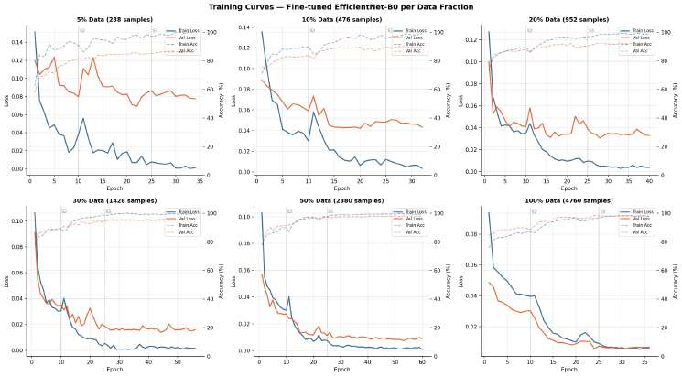
Figure 5. Learning-rate schedule (100% data), showing the CosineAnnealingWarmRestarts sawtooth pattern with hard resets at each gradual-unfreezing stage boundary — necessary to let newly-unfrozen layers adapt without immediately overwriting useful low-level filters carried from ImageNet.
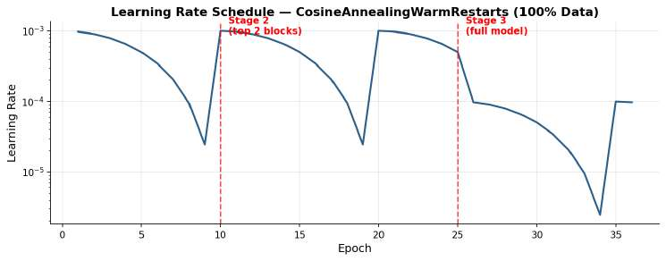

5.7 Explainability: Grad-CAM++ Analysis
At 10% data, attention is diffuse across all four classes, frequently spreading into skull and background regions. By 50–100% data, attention for meningioma, no-tumor, and pituitary concentrates tightly on anatomically plausible regions; glioma attention improves but remains comparatively less well-localized even at full data, consistent with its lower recall.
Figure 6. Grad-CAM++ attention grids at 10/50/100% data, three samples per class. Attention sharpens and localizes more tightly as training data increases, most dramatically between 10% and 50%.
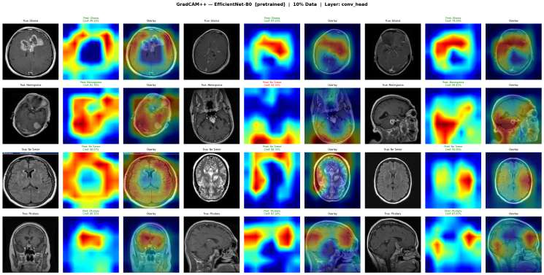
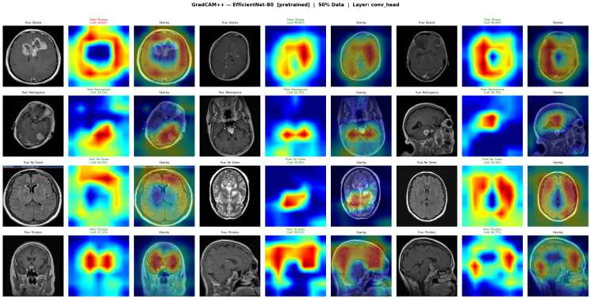
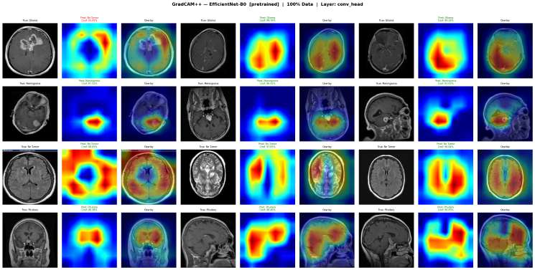
Misclassified glioma cases show attention displaced away from the visible lesion toward regions resembling the model's typical no-tumor or meningioma attention pattern — visual confirmation that, when uncertain about a genuine glioma, the model drifts toward "no tumor" rather than staying anchored on an ambiguous lesion. This is the single most clinically important pattern to design around (Section 6.4).
Figure 7. Misclassified glioma cases at 30% and 100% data. Attention is visibly displaced away from the lesion in most cases shown.
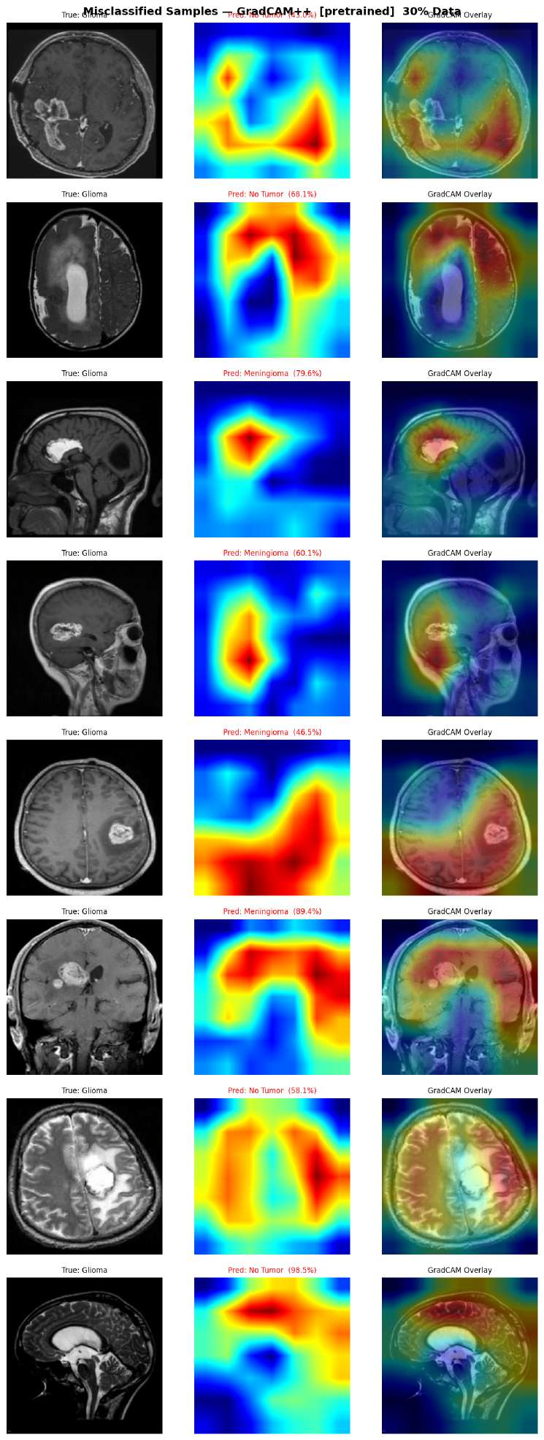
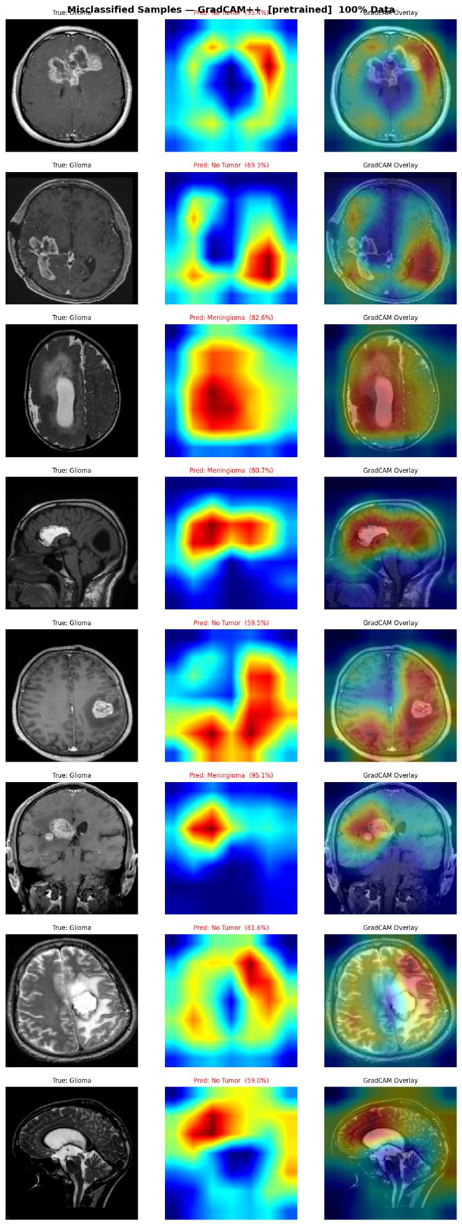
Tracking one representative case per class from 10% to 100% data, three of four classes are classified correctly and increasingly confidently throughout; the glioma example is misclassified until 100% data, with attention only weakly anchored on the lesion even in the correct full-data prediction.
Figure 8. Attention evolution per class as data increases from 10% to 100%. Border color: correct (green) / incorrect (red).
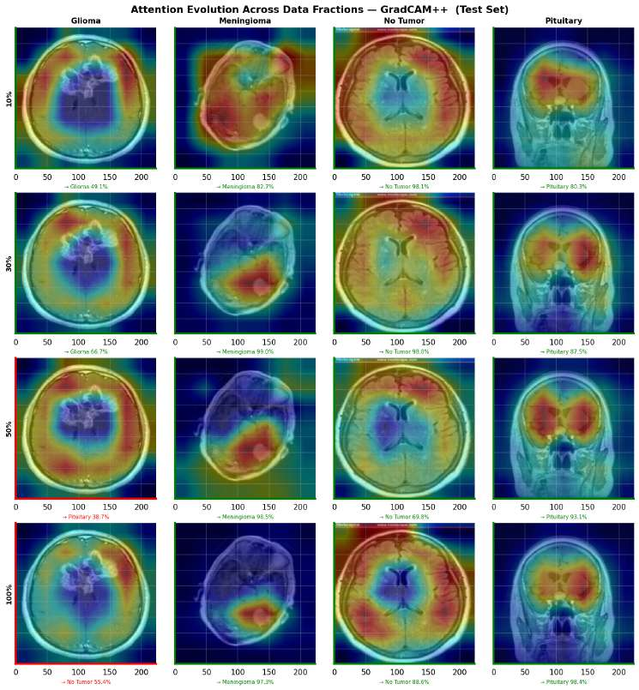
Comparing pretrained and scratch attention on the same 30% subsample, the pretrained model's attention concentrates more on central, anatomically coherent structures, while the scratch model's attention more often extends into skull and background — a plausible visual explanation for why ImageNet pretraining helps despite the domain gap between natural photographs and MRI.
Figure 9. Attention comparison, fine-tuned vs. scratch, same 30% subsample. Pretrained attention stays more consistently within central brain tissue.
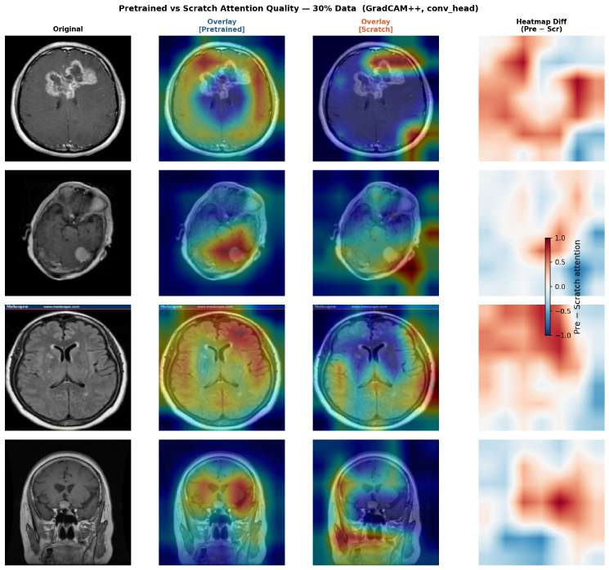

5.8 Comparison with Prior Work
Our full-data result (94.46% accuracy, F1 0.9436) sits about 4.5 points below Iqbal et al.'s [12] ~99% on the same dataset family, likely explained by differences in training length, augmentation, and exact data partition rather than fine-tuning strategy — our protocol does unfreeze the full backbone by epoch 26. We view this as a credible, independently reproduced benchmark and, more importantly, the fixed upper-data reference against which the reduced-fraction results in Table 4 should be read.
Table 8. Comparison with prior studies.
Study | Method | Classes | Accuracy | Dataset
Cheng et al. [5] | ROI features + BoW/GLCM | 3 | 91.28% | CE-MRI (3,064)
Sultan et al. [6] | Custom CNN | 3 | ~96.1% | CE-MRI (3,064)
Iqbal et al. [12] | EfficientNet-B0 (full fine-tune) | 4 | ~99% | Nickparvar family (~7,000)
This study — 100% | EfficientNet-B0 (3-stage unfreeze) | 4 | 94.46% (F1 0.9436) | Nickparvar (7,200)
This study — 20% (MVDT) | EfficientNet-B0 (3-stage unfreeze) | 4 | 85.56% (F1 0.8525) | Nickparvar (952-subset)

6. Discussion

6.1 Why the Efficiency Advantage Concentrates at the Smallest Fractions
TEI is large at 5% and compresses rapidly by 30% (Section 5.2). A scratch network must learn every level of visual abstraction from the training signal alone; with only 238 images there is not enough signal to reliably learn even low-level edge/texture detectors, so the pretrained model's head start dominates. Once the fraction reaches a few hundred images per class, focal loss and augmentation let the scratch model learn comparable low-level filters unaided, and the normalized value of starting from ImageNet weights collapses even as a modest raw edge persists. This directly reconciles Tajbakhsh et al. [3] and Raghu et al. [4]: both are correct, but at different points along a curve that is steeply front-loaded rather than uniform.

6.2 Why EfficientNet-B0 Suits Limited-Data MRI Classification
EfficientNet-B0's 5.3M parameters, an order of magnitude fewer than ResNet-50 or VGG-16 directly reduce overfitting risk when only 238–952 images are available; a larger backbone would have far more capacity to memorize training-set idiosyncrasies rather than learn generalizable tumor features. Its depthwise-separable convolutions also mean early layers, which transfer most directly from ImageNet's natural-image statistics, occupy a larger share of the network than in deeper architectures, plausibly explaining why pretraining helps despite the domain gap to MRI (Figure 9). Combined with modest inference cost, it is a defensible default for resource-constrained clinical deployment.

6.3 Why the Gap Narrows as Data Grows and Clinical Implications
The raw accuracy gap falls from 11.4 points (5%) to under 1 point (100%) the expected shape under a bias–variance argument: pretraining supplies a strong prior on useful representations, valuable when training data cannot estimate that representation reliably alone, but progressively less so as task data grows sufficient on its own. Practically, transfer learning is disproportionately valuable exactly where most resource-constrained hospitals sit on the data curve (238–952 images), and full-data comparisons common in the literature (Section 5.8) systematically understate its worth in the regime that matters most for low-resource deployment.
Reaching MVDT at 952 images (Section 5.5) is within reach of a single radiologist's part-time annotation effort over a few weeks, not a multi-year program. Transfer learning is specifically practical here for three reasons: it removes the need for large historical archives (a few hundred to ~1,000 recently-digitized, annotated scans suffice); it removes the need for large-scale computing infrastructure, since EfficientNet-B0 trains and infers on a single modest GPU; and it reduces the burden on scarce radiological expertise, since every image that need not be labeled to reach usable performance is radiologist time freed for patient care.
We do not recommend fully autonomous deployment at any fraction tested, given glioma's persistently lower recall and its tendency to be misclassified as "no tumor" under uncertainty (Section 5.7), the one error direction a screening deployment cannot tolerate. We recommend a two-stage screen-then-refer architecture: deploy the model (trained on at least 952 images) as a high-recall first-pass flag ("possible tumor, refer for review") rather than a standalone diagnostic tool, with the decision threshold tuned aggressively toward sensitivity since a false positive costs only an extra review while a false negative costs a missed tumor. Fine-grained subtyping, where the model already performs credibly for meningioma, no-tumor, and pituitary (recall >96% at full data), can sit downstream of a radiologist's review.

6.4 Extending Prior Comparisons and Limitations
Where Cheng et al. [5], Sultan et al. [6], and Iqbal et al. [12] establish strong full-data performance, none report what happens as the labeling budget is deliberately constrained, the question a resource-limited hospital needs answered before committing to a data-collection plan. Our contribution relative to this prior work is threefold: a continuous, six-point fraction sweep rather than a single full-data measurement; the TEI/MVDT metrics translating that sweep into an efficiency curve and an explicit annotation target; and paired multi-seed statistical testing, which our Section 5.4 results show is essential, without it, the apparent advantage at every fraction would be reported without the caveat that only the smallest fraction clears conventional significance.
Limitations, and the follow-up work each motivates: (1) Single-center dataset origin, results are not yet validated on a genuinely multi-center cohort with different scanners or protocols; an external test set from a different hospital system is the natural next step. (2) No external validation cohort, the 952-image MVDT should be re-verified with prospective, institution-specific data before real clinical use. (3) Single backbone, we have not verified whether the front-loaded TEI pattern generalizes to ResNet, ConvNeXt, or ViT-based architectures. (4) Small per-cell sample size - three seeds detects the large 5% effect but is underpowered for the smaller 10–100% effects; five or more seeds would sharpen these estimates. (5) Qualitative explainability only, no segmentation masks were available to compute a quantitative attention-to-lesion overlap metric (e.g., IoU); a segmentation-annotated dataset (e.g., BraTS) would allow this and let other methods (Integrated Gradients, attention-rollout) be benchmarked against ground truth. (6) No computational-cost benchmarking, wall-clock training time, inference latency, and memory footprint were not logged, though these matter for low-resource deployment readiness. (7) Glioma remains the weakest class even with a balanced dataset and focal loss - its diffuse, infiltrative margins are plausibly harder to distinguish from normal parenchyma on a single 2-D slice than more circumscribed lesions, suggesting further gains may need 3-D volumetric context or glioma-specific augmentation rather than more 2-D images alone.

7. Conclusion
This paper reports a completed, 36-run sweep quantifying how ImageNet transfer learning's benefit for brain tumor MRI classification changes as labeled data becomes scarce, using a class-balanced 7,200-image dataset, three-stage gradual unfreezing, and a focal-loss objective. Fine-tuned EfficientNet-B0 outperformed an identical from-scratch model at every fraction, with the advantage statistically decisive at the smallest fraction (5%, 238 images) and present but smaller and statistically noisier thereafter. The Transfer Efficiency Index shows this advantage, once normalized for training-set size, is concentrated in the earliest, most data-starved regime - reframing how much labeling effort a resource-constrained institution actually needs before pretraining stops paying an outsized dividend.
The Minimum Viable Data Threshold framework returned a genuinely encouraging result: our clinically-motivated threshold was reached at only 952 labeled images, a realistic near-term annotation target, not an aspirational one. Per-class and Grad-CAM++ analysis identifies glioma as the one persistent weak point and motivates a two-stage screen-then-refer deployment: a high-recall triage aid flagging likely-abnormal scans for radiologist review, rather than a standalone diagnostic system. Closing the remaining glioma gap, plausibly via 3-D context, targeted augmentation, or multi-center validation - is the most important direction for follow-up work. We offer the TEI and MVDT metrics, the paired statistical protocol, and the explainability pipeline as a reusable, hospital-facing template for deciding how much labeled data transfer learning needs before it is worth deploying, answered here concretely: roughly a thousand labeled images.

References
[1] Sung, H., Ferlay, J., Siegel, R. L., Laversanne, M., Soerjomataram, I., Jemal, A., & Bray, F. (2021). Global cancer statistics 2020. CA: A Cancer Journal for Clinicians, 71(3), 209–249.
[2] Litjens, G., Kooi, T., Bejnordi, B. E., Setio, A. A. A., Ciompi, F., Ghafoorian, M., van der Laak, J. A. W. M., van Ginneken, B., & Sánchez, C. I. (2017). A survey on deep learning in medical image analysis. Medical Image Analysis, 42, 60–88.
[3] Tajbakhsh, N., Shin, J. Y., Gurudu, S. R., Hurst, R. T., Kendall, C. B., Gotway, M. B., & Liang, J. (2016). CNNs for medical image analysis: Full training or fine tuning? IEEE Trans. Medical Imaging, 35(5), 1299–1312.
[4] Raghu, M., Zhang, C., Kleinberg, J., & Bengio, S. (2019). Transfusion: Understanding transfer learning for medical imaging. NeurIPS 32.
[5] Cheng, J., Huang, W., Cao, S., Yang, R., Yang, W., Yun, Z., Wang, Z., & Feng, Q. (2015). Enhanced performance of brain tumor classification via tumor region augmentation and partition. PLOS ONE, 10(10), e0140381.
[6] Sultan, H. H., Salem, N. M., & Al-Atabany, W. (2019). Multi-classification of brain tumor images using deep neural network. IEEE Access, 7, 69215–69225.
[7] Simonyan, K., & Zisserman, A. (2015). Very deep convolutional networks for large-scale image recognition. ICLR.
[8] He, K., Zhang, X., Ren, S., & Sun, J. (2016). Deep residual learning for image recognition. CVPR, 770–778.
[9] Szegedy, C., Liu, W., Jia, Y., Sermanet, P., Reed, S., Anguelov, D., Erhan, D., Vanhoucke, V., & Rabinovich, A. (2015). Going deeper with convolutions. CVPR, 1–9.
[10] Huang, G., Liu, Z., Van Der Maaten, L., & Weinberger, K. Q. (2017). Densely connected convolutional networks. CVPR, 4700–4708.
[11] Tan, M., & Le, Q. (2019). EfficientNet: Rethinking model scaling for convolutional neural networks. ICML, 6105–6114.
[12] Iqbal, S., Jaffar, A., & Jahangir, U. (2024). Efficient brain tumor classification using EfficientNet-B0 on MRI images for IoMT applications. Information, 15(7), 391.
[13] Nickparvar, M. (2021). Brain Tumor MRI Dataset [Data set]. Kaggle. https://doi.org/10.34740/KAGGLE/DSV/2645886
[14] Bhuvaji, S., Kadam, A., Bhumkar, P., Dedge, S., & Kanchan, S. (2020). Brain Tumor Classification (MRI) [Data set]. Kaggle. https://doi.org/10.34740/KAGGLE/DSV/1183165
[15] Wang, Y., Yao, Q., Kwok, J. T., & Ni, L. M. (2020). Generalizing from a few examples: A survey on few-shot learning. ACM Computing Surveys, 53(3), 1–34.
[16] Van Engelen, J. E., & Hoos, H. H. (2020). A survey on semi-supervised learning. Machine Learning, 109, 373–440.
[17] Shorten, C., & Khoshgoftaar, T. M. (2019). A survey on image data augmentation for deep learning. Journal of Big Data, 6, 60.
[18] Maicas, G., Bradley, A. P., Nascimento, J. C., Reid, I., & Carneiro, G. (2018). Training medical image analysis systems like radiologists. MICCAI 2018, 546–554.
[19] Setio, A. A. A., Ciompi, F., Litjens, G., Gerke, P., Jacobs, C., van Riel, S. J., Wille, M. M. W., Naqibullah, M., Sánchez, C. I., & van Ginneken, B. (2016). Pulmonary nodule detection in CT images. IEEE Trans. Medical Imaging, 35(5), 1160–1169.
[20] Cohen, J. (1960). A coefficient of agreement for nominal scales. Educational and Psychological Measurement, 20(1), 37–46.
[21] Matthews, B. W. (1975). Comparison of the predicted and observed secondary structure of T4 phage lysozyme. Biochimica et Biophysica Acta, 405(2), 442–451.
[22] Chattopadhay, A., Sarkar, A., Howlader, P., & Balasubramanian, V. N. (2018). Grad-CAM++: Generalized gradient-based visual explanations for deep convolutional networks. WACV, 839–847.
[23] Selvaraju, R. R., Cogswell, M., Das, A., Vedantam, R., Parikh, D., & Batra, D. (2017). Grad-CAM: Visual explanations from deep networks via gradient-based localization. ICCV, 618–626.

