Synchronization of Distributed Mobile Databases in a Mobile Application

Huang Donghao
donghao.huang@gmail.com
Heney S Panicker
heney@heney.com
Yam Wye Kede, Jerel
g0605749@nus.edu.sg

ABSTRACT
In this paper, we will describe a prototype of a mobile application that is used assist people diagnosed with autism to cope with learning environments and real life situations. This application employs distributed and mobile databases by leveraging on Microsoft SQL Server 2005 and SQL Server CE edition to centrally manage and distribute content to the mobile devices as well as to collect and analyze progress of the autistic patients.
Categories and Subject Descriptors
H.2.4 [Database Management]: Systems – Distributed Databases
General Terms
Experimentation.
Keywords
Distributed Database, Mobile computing.

INTRODUCTION
People suffering from autism find difficulty in coping with changing environmental conditions. As such, routine and order are paramount to helping autistic patients function normally. We are proposing a mobile application that can be used to assist autistic patients with their daily routines. The mobile application can display custom content for each user and it is stored in the mobile database as tables. A central server, running MS SQL Server 2005, distributes the contents across multiple mobile clients according to the profile of the users. As the user interacts with the application, the mobile application makes use of the Microsoft SQL Server Compact Edition (SQLCE) to store and keep track of the progress of the users’ activities. Synchronization of data is accomplished when the mobile clients connect to the network and pushes/pulls the data to/from the central SQL server. The aggregated data in the SQL Server can then be used to generate graphs and statistics.

PURPOSE OF THE PROTOTYE STUDY
Performing tasks such as wiping a table, feeding a pet or brushing teeth may seem simple to us. Autistic children, however, have difficulty completing these seemingly routine tasks. Oftentimes, we think these children are unmotivated or are refusing to finish the task, when actually they may be trying to recall what to do next.
The use of task organizers helps autistic children who may be unsure of the steps of an activity. Task organizers are visual cues that show the steps of an activity. They provide a visual representation of each part of a task so a child always knows the next step. Pictures and/or written instructions (similar to a recipe) can be used to help children complete the sequence of a task in the right order.

Figure 1. An autistic child is using task organizer to follow the steps in brushing his teeth etch
Figure 1 shows the usage of a paper-based task organizer in the real life. This is an autistic child using his task organizer to follow the steps in brushing his teeth. Short sentences describing each step are paired with a small symbol.
The purpose of this prototype study is to implement a system to enable the autistic children to use mobile devices, instead of paper, for task organizers.

Overview of System
The system comprises of a central server to which the mobile clients, running the Windows Mobile operating system, connect. The central server is running Microsoft SQL server 2005 and Microsoft IIS server. The Microsoft IIS is required as the synchronization mechanism between the mobile client and the SQL server is done through HTTP. The SQLCE is installed on the mobile device on which the application runs. Through an SQLCE agent, the mobile application is able to synchronize its data with the SQL Server on the central server. Figure 2 shows the architecture of the different components involved in the system.
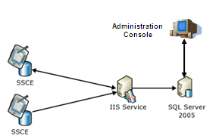
Figure 2. Overview of the system architecture.

Database Schema
There are six tables in the database that are involved in the synchronization process, namely Activity, Category, Device, Schedule, Symbol and User. Figure 3 shows the schema of the database pertaining to these six tables.
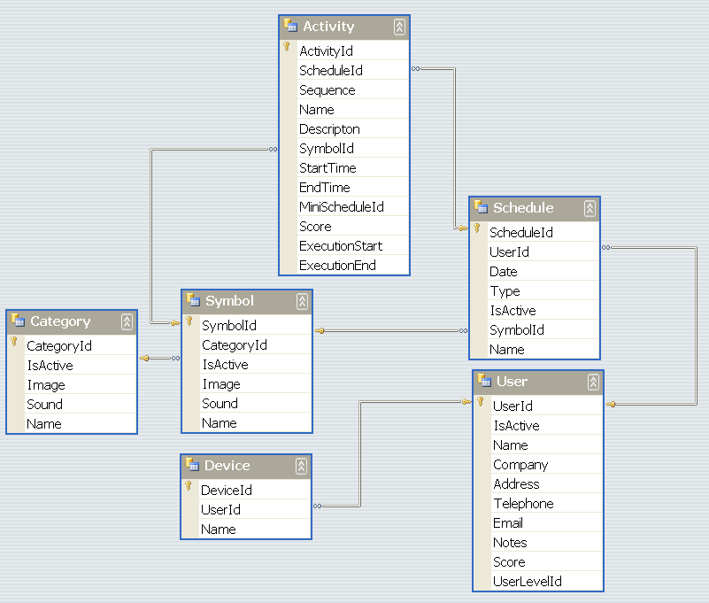
Figure 3. Tables that are involved in the synchronization process.
How each table is used is explained as follows:
- Activity table: The mobile application assists the autistic patient by presenting on the mobile device a list of activities for the patient to carry out. Each activity has a picture, a name and a description associated with it. It also has a sequence number which represents its place in a list of activities. The activity table stores all the information described above including other state information such as the activity start and end times. Examples of activities include brushing of teeth or wearing a shirt.
- Symbol table: Since most autistic people think visually, pictures are used to represent the activities that the patients are instructed to carry out. The symbol table stores data such as the name of the symbol and its image. Figure 4 show examples of the symbols used in the mobile application.
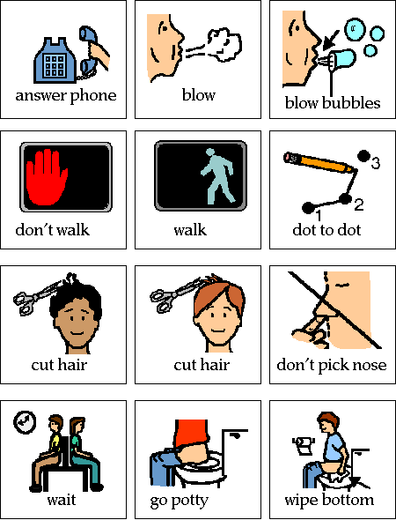
Figure 4. Example of symbol images.
- Category table: Symbols are grouped into categories and each category will have an image associated with it as well. Data related to a category, such as its name and image, are stored in the category table.
- Schedule table: Activities can be ordered into a sequence of tasks called a schedule. For example, a schedule for cleaning the house could comprise of the following ordered activities – mopping the floor, followed by wiping the table, followed by cleaning the window. Schedules can be unique and custom made for each individual user. Data related to a schedule, such the UserId for which the schedule was made, are store in the schedule table.
- User table: This tables stores details of the autistic patient who will be using the mobile device.
- Device table: This table stores the information of the mobile device that an instance of the mobile application is running on. The DeviceId will used during synchronization to differentiate between mobile devices so that the right set of data will be received by the mobile client. The system supports one user having multiple devices.

System Components
A description of the various components is given here. There are two sets of applications, those hosted on the mobile device and those hosted on the administration consoles. The following two tables describe the functionality of each component in the two applications.
Table 1. Table showing the components running on the administration console.
Component | Description
Control Center | The control centre provides an interface for the administrator to manage the mobile devices and their users. This includes create user profiles and prepping the mobile device with the autistic mobile application.
Symbol Manager | The symbol manager provides the administrator with an interface to insert a symbol into the system. Once inserted, the symbol can then be received by the mobile clients during synchronization.
Task Organizer | The task organizer provides an interface to create, modify or remove schedules and activities.
Analyzer | This component analyzes the data stored on the SQL server to track the progress of the autistic patients.

Table 2. Table showing the components running the mobile device.
Component | Description
Synchronization | This component does the synchronization of data between the SQLCE on the mobile device and the SQL Server 2005 on the central server.
Task Organizer | This component provides an interface on the mobile device for the autistic patients to interact with the application. It displays various symbols that represent different schedules. Once the patient taps on the symbol, he/she can begin the activities associated with that schedule. This component also stores the state of the activities that are attempted by the patient. State information includes the start and completion of an activity as well as the time taken to complete an activity.

Program Flow
The following describes the flow of the program:
- Using the Control Centre, the administrator logs into the system and assigns a mobile device to a user;
- Using the Symbol Manager, the administrator creates the symbols that represents an activity;
- After which, the administrator groups the activities into tasks using the Task Organizer;
- Once the mobile device is connected to the server, the Synchronization component will pull the tasks data from the SQL server;
- The autistic patient uses the Task Organizer on the mobile device to execute their tasks. The Task Organizer will record the start and end times of each activity;
- Upon reconnection to the network, the Synchronization component on the mobile device pushes the records saved by the Task Organizer to the SQL Server;
- The Analyzer in the Administration Console can be used to analyze the data and generate reports.
The program flow diagram is shown in figure 5.
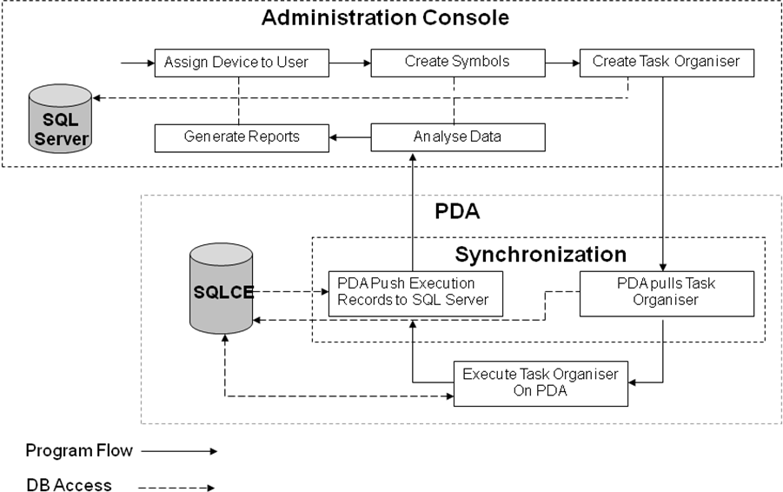
Figure 5. Program Flow

Synchronization MECHANISM
The SQLCE provides a synchronization mechanism called Merge Replication. Combining merge replication with a custom filter, it allows tuples to be pushed and pulled to and from the mobile device through a HTTP connection to the central SQL server. Tables that have been enabled for replication are called publications. A mobile application can be set as a target to receive the publications by creating a subscription. When an application creates a subscription, an initial snapshot of the tables (schema and data) is downloaded to the device from a distributor (which is an instance of the SQL Server that is used to store the snapshots, history, and statistics) by the server agent, and the tables are created in SQLCE by the client agent. The SQLCE database can then be updated by the mobile application even while the mobile device is not connected to the SQL server. When the mobile device reconnects to the network, the mobile application can trigger synchronization. The synchronization is done via telling the client agent to extract all the modified rows in the tables on the mobile database and send them to the server agent. Figure 6 shows the merge replication architecture.
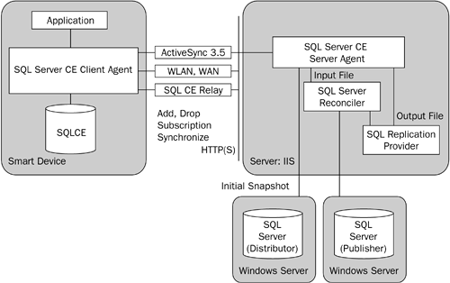
Figure 6. Merge Replication architecture ^{[1]}.
To assist with the merge replication, every tuple in the database has a column called rowguid. The rowguid allows the records from each mobile device to be uniquely identified and makes synchronization of records from multiple mobile databases possible. Figure 7 shows how the tuples of the mobile database look like with the rowguid.
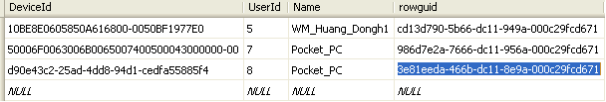
Figure 7. Tuples on the mobile database with the rowguid column.

The synchronization takes place as follows:
- The mobile device connects to Server;
- The mobile device pushes modified rows to server;
- The mobile device pulls new data from server - this includes new schedules, symbols and categories;
- The mobile device removes all data that have been pushed to the server.

DYNAMIC FILTERING for HORIZONTAL PARTITIONING
There could potentially be many users of the system and each user could have more than one mobile device. Hence, the system horizontally partitions the tuples of the User and Device table to the different mobile devices according to the DeviceID.
Only records that are pertaining to the user of the mobile device should be pulled into the mobile client’s database by the mobile application, as all other records are not relevant. This helps to conserve network bandwidth as well as reduce the time taken to synchronize the rows. In order to achieve this filtering of pertinent records during the synchronization, a feature called “dynamic filtering” of the merge replication is used. For example, the following filter string is used to filter away records in the Device table that are not related to the user of the device that is currently doing the synchronization:
SELECT <published_columns> FROM [dbo].[Device] WHERE [DeviceId]=HOST_NAME()
The important point to note about the filter is that it relies on the HOST_NAME() Transact-SQL function in the WHERE clause to evaluate which rows are created in the initial snapshot and subsequently updated on the subscriber. This value is populated by the HostName property of the SqlCeReplication class on the device, thereby allowing dynamic views of the article. In our case, we use the Device ID (UUID of the mobile device) to populate the HostName property.

ConclusiON
We have successfully implemented a prototype system that is able to synchronize multiple mobile databases with a central database in an efficient and scalable manner. Using horizontal partitioning and dynamic filtering, we were able to reduce the number records that needed to be stored in the mobile device, thereby making the storage requirements of our solution more efficient.

REFERENCES
- Dan Fox, Jon Box, Addison Wesley 2003. Building Solutions with the Microsoft .NET Compact Framework: Architecture and Best Practices for Mobile Development.

