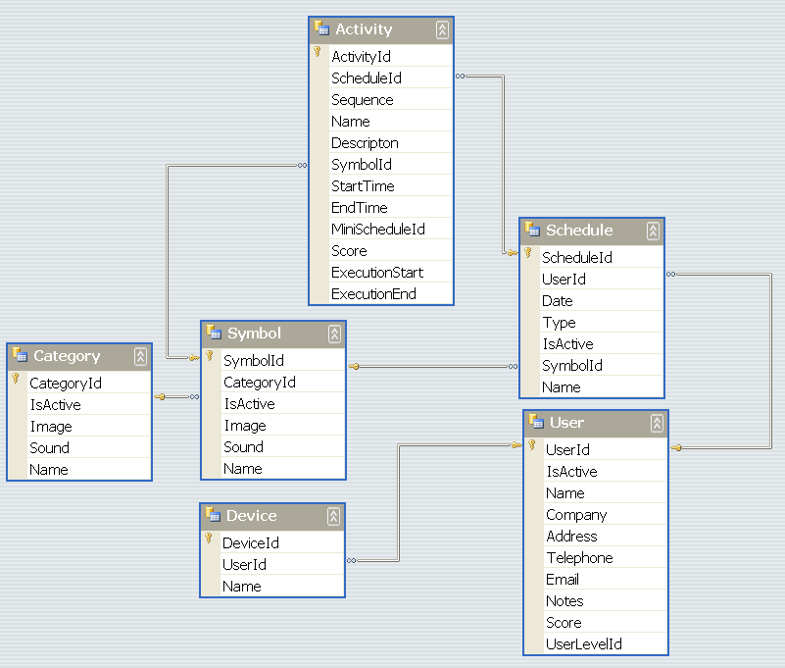

Application | OS | Description | Assigned To
Control Centre | Windows | Maintain data in Device and User tables | Heney
Symbol Manager | Windows | Maintain data in Category and Symbol tables | Heney
Work System | Windows | Maintain data in Schedule and Activity tables | Jerel
Analyzer | Windows | Analyze data in Schedule and Activity tables | Donghao
Synchronization Pocket PC | Windows Mobile | Synchronize data between SQL compact edition and SQL server 2005 | Donghao
Work System Pocket PC | Windows Mobile | Execute work system and maintain data in Schedule and Activity tables in SQL compact edition | Jerel

