

UGANDA INSTITUTE OF INFORMATION AND COMMUNICATIONS
TECHNOLOGY
PROJECT PROPOSAL
AIR PURIFIER SYSTEM
PREPARED BY;
NAME | REG NO
GULERE DERICK | 2024/DEE/DAY/1800/G
NKATTA EMMANUEL | 2024/DEE/DAY/1211/G
OMEGA MOSES | 2024/DEE/DAY/1601
ATUHEIRE RONYX | 2024/DEE/DAY/1304/G
NAKIRIJJA MARY NAAVA | 2024/DEE/DAY/O831
BISUTI CONRAD ALINANGE | 2024/DEE/DAY/0385
PROJECT CODE: 16
A PROJECT PROPOSAL SUBMITTED TO THE DEPARTMENT OF INFORMATION AND COMMUNICATIONS TECHNOLOGY AND ENGINEERING IN PARTIAL FULFILMENT OF THE REQUIREMENT FOR THE AWARD OF A DIPLOMA IN ELECTRICAL AND ELECTRONICS ENGINEERING OF UGANDA INSTITUTE OF INFORMATION AND COMMUNICATION TECHNOLOGY.
NOVEMBER, 2025

DECLARATION
We, the undersigned students hereby declare that this project is a result of our original work and effort. Any material that is not our own has been acknowledged and appropriately referenced.
NAME | REG NO | SIGN
GULERE DERICK | 2024/DEE/DAY/1800/G
NKATTA EMMANUEL | 2024/DEE/DAY/1211/G
OMEGA MOSES | 2024/DEE/DAY/1601
ATUHEIRE RONYX | 2024/DEE/DAY/1304/G
NAKIRIJJA MARY NAAVA | 2024/DEE/DAY/O831
BISUTI CONRAD ALINANGE | 2024/DEE/DAY/0385

APPROVAL
This is to certify that this project report has been done by Group 16 Members of registration numbers 2024/DEE/DAY/1800/G, 2024/DEE/DAY/1211/G, 2024/DEE/DAY/1601, 2024/DEE/DAY/1304/G, 2024/DEE/DAY/O831, and 2024/DEE/DAY/0385. The report has been presented in accordance with the guideline governing the award of Diploma in Electrical and Electronics Engineering at Uganda Institute of Information and Communication Technology (UICT).
Mr Lubega Jamil ………………………….. ………………………………
(UICT) supervisor Date

DEDICATION
This special project proposal is dedicated to our family members and supervisors who have been supportive towards our educational journey especially our supervisor Mr Lubega Jamil.

ACKNOWLEDGMENT
We thank the almighty ALLAH for the precious gift of life He has given to us. His spiritual guidance and protection has enabled us reach this far in our academic journey that we never knew we would achieve.
We also acknowledge our entire families for the great support provided to us during our research. Their financial support, encouraging words and prayers have enabled us complete the research in time.
Special thanks go to our supervisor Mr Lubega Jamil who has mentored us through the research process to reach this milestone.
We also thank ourselves for the togetherness and team work exhibited throughout the research process. This has enabled us learn through interactions and discussions.

TABLE OF CONTENTS

DECLARATION i
APPROVAL ii
DEDICATION iii
ACKNOWLEDGMENT iv
TABLE OF CONTENTS v
LIST OF FIGURES viii
LIST TABLES ix
Chapter 1 1
1.1Introduction. 1
1.2 Background to the study. 1
1.3 Statement of the Problem 2
1.4 General Objective (Purpose of the study) 2
1.5 Specific Objectives. 2
1.6 Scope 2
1.6.1 Technical Scope 3
1.6.2 Geographical Scope. 3
1.6.3 Time Scope 3
1.6.4 Sample Size 3
1.6.5 Financial Scope 3
1.7 Significance of the study 3
1.8 Business model and canvas 4
1.9 Justification 5
Chapter 2: Literature Review 6
2.1 Introduction 6
2.2 Theoretical review 6
2.3 State of practice 7
2.4 similar existing technologies 7
2.4.1 Mechanical filtration (High-Efficiency Particulate Air (HEPA) filters) 7
2.4.2 Electrostatic Precipitator (ESP ionizer) 7
2.4.3 Hybrid Mechanical filter 8
2.5 Comparative evaluation 8
Chapter 3: Methodology 10
3.1 Introduction 10
3.2 Study the mobility methods of the visually impaired people 10
3.3 Component selection and design of the Air Purifier System 11
3.3.1 Component selection 11
3.4 Construction of the Air Purifier System 11
3.4.1 Tools that were used 11
3.4.2 Components to be used to assemble the prototype 11
3.5 Tests and validation of the system 12
3.5.1 Testing Procedure and Validation Method 12
3.5.2 Test Data Matrix 12
CHAPTER 4: PROTOTYPE DESIGN AND CONSTRUCTION 14
4.1 Introduction 14
4.2 Block diagram 14
3.5.3 How Components, Blocks, Programs and prototype were tested 16
References 17
Appendices 18

LIST OF FIGURES
Figure 1: Showing mode of operation of air purifier 9
Figure 2: Showing the design of an air purifier system 11

LIST TABLES
Table 1: Showing existing technologies and their system functionalities 9
Table 2: Showing the description of components 12
Table 3: Showing test data matrix 13
Table 4: Showing project budget 16
Table 5: Showing Project Work plan 17

Chapter 1

1.1Introduction.
In the recent years, increasing levels of air pollution have emerged as a critical concern affecting public health and environmental quality. Rapid urbanization, industrial activities, vehicle emissions and indoor pollutants such as dust, smoke and volatile organic compounds [VOCs] have significantly degraded the air breathe. Poor air quality is linked to a range of health issues including respiratory problems, allergies and other chronic health issues.
The air purifier project aims to develop an efficient and affordable solution to improve indoor air quality. The system is designed to filter out harmful particles such as PM2.5, bacteria and allergens while neutralizing odors and chemical pollutants. By combining advanced filtration technologies such as use of HEPA filters, the project aims to ensure a healthy indoor environment suitable for homes, offices, schools and health facilities.

1.2 Background to the study.
According to world health organizations (WHO), 7M premature death occur per year and 99% of the world’s population are exposed to unhealthy air. https://www.who.int/news-room/fact-sheets/detail/household-air-pollution-and-health
In the present scenario, air pollution has become very serious because of;
- Industrial activities. Factories and other industrial facilities emit pollutants like chemicals, volatile organic compounds during manufacturing and processing
- Vehicle emissions. Cars, trucks, buses release pollutants like carbon monoxide, nitrogen oxide and particulate matter through exhaust which leads to smog formation.
- Indoor air pollution. Many daily household activities contribute to poor indoor air quality like smoke from burning fuel (wood, gas) used for cooking in poorly ventilated spaces.
In Uganda, the most affected areas exposed to air pollution include Kampala and Jinja with high levels of fine particulate matter (PM2.5) from vehicle emission, industrial processes and indoor cooking.

1.3 Statement of the Problem
Indoor air pollution has become a major health threat due to increasing levels of dust, smog, smoke and harmful gases in residential, commercial and industrial environment. Prolonged exposure to poor indoor air quality causes respiratory diseases, allergies and reduces over wellbeing of especially vulnerable groups like children, elderly and individuals with asthma.
Existing ventilation systems are often insufficient, expensive and energy insufficient, making it difficult for many households and individuals to maintain health air standards. Most of the air purifiers on the market today are made with one time use filters that eventually end up in landfills. Therefor there is a need for an affordable, efficient and user-friendly air purifier system that effectively removes pollutants and ensures a safer indoor environment.

1.4 General Objective (Purpose of the study)
To design, develop and implement an efficient, affordable and eco-friendly air purifier that effectively removes air pollutants such as smoke, dust, PM2.5, allergens and harmful gases so as to improve air quality and promote a healthier environment in targeted places.

1.5 Specific Objectives.
To analyze and identify common indoor air pollutants and their effects on human health
To design a multi stage filtration system for optimal purification
To develop a prototype that is energy efficient and user friendly.
To test and evaluate the purifier’s performance in different indoor environments

1.6 Scope
Our project scope defined the Design and Implementation of an Air Purifier for Indoor air purification. It outlined the boundaries of the investigation to ensure the project remains focused, manageable, and achievable within the set constraints.

1.6.1 Technical Scope
The project focused on design, construction and testing of a low cost, energy efficient air purifier that removes dust, smoke and other airborne pollutants. The system consisted of filters, sensors and a fan mechanism controlled by a microcontroller to monitor and purify indoor air quality. The prototype was designed for small-to-medium indoor environments like classrooms, offices, homes and hospitals.

1.6.2 Geographical Scope.
The project was carried out within Uganda Institute of Information and Communication Technology and surrounding areas in Kampala, Uganda. Testing and demonstrations took place in different indoor environments to assess the purifier’s efficiency in local air quality conditions.

1.6.3 Time Scope
The project was completed within a period of 7 months from November 2025 to May 2026, covering all stages from research, design, and prototype development to testing and final reporting.

1.6.4 Sample Size
The project developed and tested the functional prototype of the air purifier. The prototype went through performance testing in at least three different indoor environments to evaluate its efficiency and reliability.

1.6.5 Financial Scope
The estimated total cost for the project was UGX 1,350,000, covering materials, tools, testing, and miscellaneous expenses.

1.7 Significance of the study
This project contributed to a healthier environment and promotes educational research. The air purifier developed through this project was not only a practical solution to a growing problem but also a meaningful step toward sustainable living.
- Health and Environmental Significance
The air purifier directly contributed to improving respiratory health and overall well-being by reducing exposure to airborne pollutants. It helped to prevent common health issues such as asthma, allergies, and other respiratory illnesses, making it especially valuable for vulnerable groups like children and the elderly. Furthermore, the system promotd environmental awareness and encourages sustainable indoor living practices.
- Educational and Research Significance
For students and researchers, the project provided hands-on experience in design, engineering, environmental science, and product evaluation. It encouraged innovation and critical thinking in developing technologies that address real-world issues such as pollution and sustainability.

1.8 Business model and canvas
- Key partners: The project collaborated with component suppliers, academic institutions for testing and environmental organizations for outreach. Such partnerships enhance credibility, reduce costs and improve access to potential markets
- Key activities: Main activities included designing, assembling, testing the air purifier, conducting market research and engaging in demonstrations. Hence ensuring high product quality.
- Key resources: Skilled engineers and technicians, Capital and supplier networks were the resources of the project. Access to engineering knowledge and low cost materials ensures efficient prototype development and assembly
- Customer segments: The project targeted individuals and institutions affected by poor indoor air quality such as homes, hospitals, Offices, Schools
- Value proposition: The project provided a locally made, affordable and energy efficient air purifier that reduced dust and harmful particles. It was designed using readily available materials and adapted to local environment conditions.
- Distribution channels: The air purifier will be distributed through local electronics stores. Demonstrations in schools, offices helped raise awareness.
- Customer relationships: The project was planned to emphasize trust and long term relationships through after-sales support and warranty services.
- Cost structure: Included raw materials and component costs, manufacturing and assembly costs, marketing and advertising costs, research and development costs. The project minimized production expenses by using locally sourced raw materials.
- Revenue streams: The project identified potential income sources, which were intended to include direct sales of air purifier, service and maintenance contracts

1.9 Justification
The project was justified as a necessity to develop a low cost, energy-efficient and locally manufactured solution to improve indoor air quality. While the imported purifiers that exist on market are often expensive, not easily maintainable and unsuitable for local conditions. This project bridged a gap by designing a product that meets community needs using readily available materials.
If this project was not undertaken, the continued exposure to polluted indoor air could lead to rise in health complications especially among children, elderly and people with respiratory issues.

Chapter 2: Literature Review

2.1 Introduction
This chapter provides overview of existing studies, technologies and concepts related to air purification systems. It examines previous research on methods of purification and provides comparison among current techniques and previous ones. According to “A study on Air Quality Monitoring and Purification Devices’’ from International Journal of Innovative Research in Computer Science & Technology (IJIRCST), ISSN:234J-5552, Volume-8, Issue-4, July 2020.

2.2 Theoretical review
The operation of an air purifier based on scientific theories that explain how air can be cleaned and purified to make it safe for breathing. These theories form the foundation for the design and operation of the air purifier. The main theories include filtration, adsorption, ionization and airflow.
- Filtration Theory
It explains how filters trap solid particles such as dust, pollen and smoke when air passes through them. The filter material has very tiny pores that allow air to pass but block harmful particles. HEPA filters are widely used because they can remove up to 99.97% improving indoor air quality.
- Adsorption Theory
According to this theory, gases and odors in the air can stick to the surface of certain materials. In air purifiers, activated carbon was used because it has a large surface area that attracts and holds harmful gases. This made air cleaner for breathing.
- Ionization Theory
It explains how air purifiers use electricity to produce charged particles (ions) that attach themselves to dust and smoke in the air. Once charged, these particles become heavy an fall on the metal plates inside the purifier. This process helped to remove very small particles that filters might miss.
- Airflow Theory
It ensures that dirty air passes through the cleaning sections (filters or purifying chambers) and exits as clean air. Proper airflow improves the purifier’s efficiency and reduces power consumption

2.3 State of practice
Currently, air purifiers are widely used to improve air quality by removing dust, smoke, odors and harmful particles. The most common air purifiers on market today use filtration technology like HEPA filer purifiers, adsorption technology like activated carbon air purifier type and purification technologies such as UV purifier systems.
Most modern air purifiers are electrically powered and are designed for use in homes, offices, hospitals and industrial areas. They usually have fans that draw in air through series of filters to trap particles and then release clean air for breathing. Some advanced models include ionizers that release negative ions to attract and remove pollutants. However the existing air purifiers are energy inefficient and have one time use filters that need to be replaced with time which makes them costly and expensive to maintain.

2.4 similar existing technologies
To setup a foundation for our design, we compared three air purification technologies that are currently available on market according to their functionality

2.4.1 Mechanical filtration (High-Efficiency Particulate Air (HEPA) filters)
They are current air purifiers. They use a multi stage process involving a pre-filter to capture large particles like dust, HEPA filter as the primary filtration media that traps microscopic particles like PM2.5 and a fan which draws air through these filters and circulates the purified air back into the room. However HEPA filters are consumable and need regular replacement (every 6-12 months) incurring a recurring cost for the user

2.4.2 Electrostatic Precipitator (ESP ionizer)
It uses high voltage, collecting electrode and electricity is generated by creating electrostatic field. In the presence of electrostatic fields, contaminants are ionized and with collision, they continue the chain of ionization. Due to influence of electric field forces, charged particles flow in the direction of electric field and are collected on collecting electrode. Hence electrodes need to be charged or maintained to improve functionality. However this process generates smell with ozone generation that may hamper IAQ.

2.4.3 Hybrid Mechanical filter
It consists of a pre-filter, fan and casing. Its purification process is diffusion. Its efficiency is affected by the fan speed, filter material characteristics and structure of air purifier. Mainly porous fibrous material is preferred as a filter.

2.5 Comparative evaluation
 | System Functionalities
Existing technologies studied | Effectiveness on gaseous pollutants (VOCs, Odor) | Efficiency (particle removal) | Effectiveness on microbial contaminants | Maintenance (filter replacement) | Power consumption
Mechanical filtration (HEPA) | Limited | Excellent (99.97%) | Limited; traps but doesn’t kill microbes | 6-8 months | 30-100W
Electrostatic precipitator | Moderate | Good (80-90%) | Moderate | Plates need cleaning regularly | 20-160W
Hybrid mechanical filtration | High | Excellent (99.99%) | High | 6-8 months | 50-200W
Our new air purifier | High | Excellent (expected to be >99.99%) | Very high | 8-12 months | 20-50W
Table 1: Showing existing technologies and their system functionalities

Conclusion: Our newly developed air purifier integrated the advantages of the existing technologies while minimizing their weakness. It therefore demonstrated a significant improvement over conventional technologies.
Mode of operation

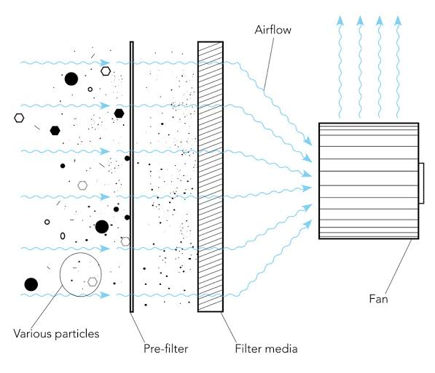
Figure 1: Showing mode of operation of air purifier

Chapter 3: Methodology
To analyze and identify common indoor air pollutants, we used real time monitoring and observation method directly from the LCD display to observe the level of the indoor pollutants like PM2.5 and bacteria. Tools corresponding to these methods included air quality monitors, PM sensors.
We used pre-filtration, HEPA and activated carbon filtration method to design a multi stage filtration system because such methods give a comprehensive purification that addresses various pollutant types and sizes. The tools corresponding to such methods included gas sensors and dust sensors.
Our group members used the user centered design, interview method to design a prototype that is energy efficient and user friendly. The user centered design ensured that the prototype is intuitive and easy to use. Tools corresponding to such methods included interview guide, prototyping platforms like arduino.
To test and evaluate the purifier performance in different indoor environments, we used sampling, real time monitoring method because it’s easier to assess the purifier performance in various indoor environments and conditions. The tools corresponding to such methods included air quality monitors, data loggers.

3.1 Introduction
This chapter presents the methodology adopted for the design, development and evaluation of the air purifier system. It outlines the systematic procedures, techniques and tools used to achieve the project objectives. The methodology serves as a framework that guides the project from the conceptual stage to the final implementation.

3.2 Study the mobility methods of the visually impaired people
The most suitable data collection methods were observation and interview methods because they allow collection of both practical and essential personal information. Tools such as interview guides, observation checklists and audio recorders were used to gather rich and reliable data. The procedure for collecting data will include; preparation stage where we collected data instruments to be used, selection of participants who are familiar with the appliance, data collection process and lastly data analysis.

3.3 Component selection and design of the Air Purifier System

3.3.1 Component selection
- Suction fun: For sucking in unpurified air and pushing out for purification
- Filters: For filtering Particulate Matter (PM)
- Dust sensors: To detect dust levels, triggering the device to turn on or adjust fan speed.
- Circuit board: It acts as the control center, ensuring that the device automatically senses air quality, processes data and adjusts operation efficiently.
- Power source: Provides energy for the system operation

3.4 Construction of the Air Purifier System

3.4.1 Tools that were used
- Soldering iron and solder wire: For assembling electronic components into circuit board.
- Digital Multimeter (DMM): For testing voltage, current and continuity in the circuit.
- Screwdrivers: For assembling mechanical parts and housing.
- Pliers: To cut wires.

3.4.2 Components to be used to assemble the prototype
Components | Description
Arduino UNO | Main microcontroller
MQ-135 Gas Sensor | One for indoor and one for outdoor air quality
ZPH01 Dust Sensor | Measures indoor PM2.5 in µg/m³
16x2 12C LCD module | Displays IAQ and PM2.5 levels
Buzzer | Gives alerts if air quality becomes poor
12V DC fan | As the sunction fan
Relay Module (5V/12V) | Controls the fan power supply according to sensor data
Power supply (Battery 12V) | Powers the system components
Jumper wires and breadboard | For circuit connections
Solar Panel 10W | For charging the battery
Regulators (12V and 5V) | To regulate steady voltage
Capacitors and Resistors | 25V/50µx2, 1KΩx2
Table 2: Showing the description of components

3.5 Tests and validation of the system

3.5.1 Testing Procedure and Validation Method
- Functional testing: Each component (sensor, relay, LCD display, and fan) was tested to confirm if it performs its intended function.
- Integration testing: Individual modules (sensor, control, output) was connected together to test the overall system operation.
- Software testing: The Arduino program was tested using serial monitor to ensure correct sensor reading and control logic.
- Performance testing: The complete purifier was tested under different air quality conditions to verify its performance.
- Validation. The proposed air purifier was compared with the existing systems.

3.5.2 Test Data Matrix
Input test data | Expected output
Clean air (no smoke or dust) | Sensor reading was low (good air quality), fan OFF, LED indicator = Green
High air pollution (dense smoke or dust) | Sensor reading HIGH, fan ON, buzzer sounds, LED indicator= Red
12V DC adapter input | Input=12V, output= stable 5V, system powers microcontroller and sensors safely
Air quality sensor readings | Correct air quality values and system status in real time
Varying air quality levels in code | Microcontroller processes sensor data correctly, adjust fan speed, update display, trigger buzzer as expected
Arduino sends digital HIGH/LOW signal | Relay activates the fan when signal is HIGH and fan turns off when signal is LOW.
varying air pollution in room | System detects pollution changes, control fan speed, update display and LED signals appropriately
Table 3: Showing test data matrix

CHAPTER 4: PROTOTYPE DESIGN AND CONSTRUCTION

4.1 Introduction
System Design is the process of developing the structure components and operation of a system so that it meets the intended objectives efficiently and reliably. For Air Monitoring and Purification system, the design integrated hardware and software components to detect air pollutants, display air quality information and automatically purify the surrounding air when pollution exceeds the predefined thresholds.
The system was built with an Arduino Uno microcontroller which receives data from air quality sensors such as MQ135 gas sensor and M501A dust sensor. The microcontroller processed the sensor readings and determined the air quality status. The measured values were displayed on the LCD to provide real time status of available air to users. When poor air quality was detected, the Arduino activated a relay to switch on the fan that sucked the polluted air. A buzzer and Red LED were also used to alert users about the bad air.
The system was powered by a rechargeable 12V battery supported by a 7W solar panel and a voltage regulator that provided the required 5V supply to the electronic components. This design ensured continuous operation while reducing dependence on grid.

4.2 Block diagram

INPUT
OUTPUT
PROCESS
Figure 2: showing block diagram
- Input stage
Under this stage, the gas and dust sensors continuously detected air pollution by sending analog signals to the microcontroller.
- Process stage
This stage was handled by the ATmega328P Microcontroller which read the analog signals from the MQ135 gas and DSM501A dust sensors into digital values. It compared the measured values with the predefined threshold limits programmed in the system and also made decisions based on the comparison results.
- Output Stage
Under this stage, there consisted of a number of devices that informed the user and improve air quality. For example;
- Fan. It automatically turned ON when the gas or dust concentration exceeded the threshold.
- Buzzer. It alerted the users when poor air was detected by producing an audible alarm.
- Red LED. It indicated poor air quality.
- Green LED. It indicated good air quality.
- LCD Display. It displayed real time gas and dust readings.

4.3 Circuit diagram
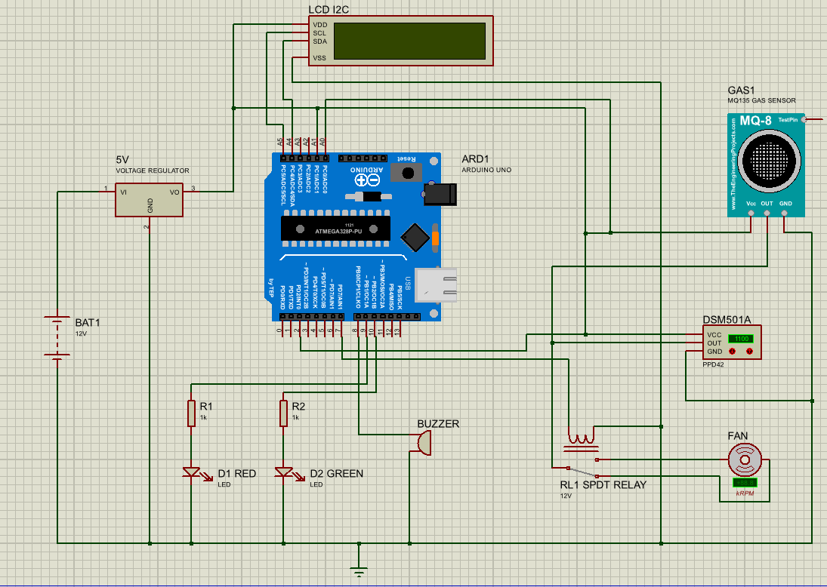
Figure 3: Showing circuit diagram
The circuit diagram illustrates the electrical connection between the various components of the system. It shows how the Arduino Uno board embedded with ATmega328P microcontroller interfaces with sensors, display, LED indicators, buzzer, relay and fan to monitor and improve air quality.
It consists of the following parts:
- Power Supply. The system is powered by a 12V battery (BAT1). Since the Arduino and most electronic components require 5V supply, the battery output is connected to a 5V voltage regulator. The regulator converts the 12V input into a stable 5V output which powers the electronic components.
- Arduino Uno (ATmega328P). It serves as the central control unit of the system. It receives data from the gas and dust sensors, processes the information according to the programmed threshold values and controls the output devices.
- MQ135 gas sensor. It is connected to the Arduino’s analog input pin. It detects harmful gases and volatile organic compounds (voc) in the surrounding air. The sensor outputs analog voltage proportional to the gas concentration which is read and processed by the Arduino.
- DSM501 Dust sensor. It is also connected to the Arduino analog input pins. It measures the concentration of airborne dust particles and sends the readings to the microcontroller for analysis.
- LCD Display. A 16x2 I²C LCD is connected to the Arduino using the SDA and SCL communication lines. The LCD displays real-time gas and dust readings as well as the current air quality status, allowing users to monitor the surrounding environment continuously.
- LED indicators. The circuit contains two LEDs connected through 1kΩ current-limiting resistors (R1 and R2). The Red LED turns ON when poor air quality is detected, indicating that pollutant levels exceed the safe limit. The Green LED turns ON when the air quality is within the acceptable limits.
- Buzzer. It is connected to one of the Arduino digital output pins. It sounds an alarm whenever the gas or dust concentration exceeds the present threshold, alerting users to unsafe air conditions.
- Relay Module. It is connected to the Arduino digital output pins. The Arduino controls the SPDT relay, which acts as an electrical switch.
- DC Fan. It is connected to the Arduino through the relay contacts. When poor air is detected, the Arduino energizes the relay, causing the fan to switch ON. The fan circulates air through the output vent containing HEPA and carbon filters for removing pollutants. Once the air quality returns to a safe, the Arduino deactivates the relay, switching the fan OFF.

4.4 Program Flowchart
Good Air Quality:
- Turn OFF Fun
- Turn OFF Buzzer
- Turn ON Green LED
Poor Air Quality
- Turn ON Fun
- Turn On Buzzer
- Turn ON Red Led
Calculation Gas & Dust Concentrations
Read Gas & Dust Sensors (MQ135 & DSM501A)
Initialize System (LCD, Sensors, Relay, LEDs)
START
Gas > Threshold
or
Dust > Threshold
YES
NO

Figure 4: Showing program flowchart

Below is a schematic explanation of how the program runs based on the flowchart;
- Start. This is when the program begins when the air purifier is powered on.
- Initializing the system. Here, the Arduino initializes all connected components. All devices are prepared for normal operation.
- Read Gas and Dust sensors. The Arduino reads data from MQ135 and DSM501A sensors.
- Calculate Gas and Dust concentrations. The sensor readings are processed and converted into gas and dust concentration values. Then these values are compared with preset threshold limits stored in the program.
- Decision: Are Gas or Dust levels Above the Threshold? Here, the system checks whether gas and dust concentrations are greater than the preset threshold.
- If YES (Poor Air Quality). If either gas or dust exceeds the safe limit, the system identifies the air as poor quality. Then the system turns ON the fan through the relay to purify the air, activates the buzzer to alert users
- If NO (Good Air Quality). If both gas and dust levels are below the threshold, the system identifies the air as good quality and it turns OFF the fan and buzzer, then turns ON the green LED to indicate safe air quality.
Finally, the process runs continuously and the system repeatedly reads the sensors, checks air quality and updates the outputs in real time.

3.5.3 How Components, Blocks, Programs and prototype were tested
      - Component Testing
- Sensors. Were exposed to clean, moderate and high pollution to verify correct readings
- Fan and relay. Fan turned ON/OFF with manual signal from microcontroller
- Display and buzzer. Test display of sensor shown readings and alert sounds in case of pollution
      - Block Testing
- Power supply block. Voltage regulation and stability were checked.
- Control block (Arduino). It verified input-output logic using serial monitor
- Output block (Fan/Relay/buzzer). They confirmed correct actuations based on control signals
      - Program Testing
- Simulate air quality brought a change in code and check response.
- Debugging using serial monitor verified sensor reading, fan speed adjustment and alert triggers.
      - Final Prototype Testing
- All blocks were assembled.
- The purifier was operated in a room with varying pollution levels.
- Fan response, LED/buzzer signals, display updates and sensor readings were recorded.
- Actual output to expected output in the test data matrix were compared.

References
[1] P. Thakran and N. Chakaraya, “A study on Air Quality Monitoring and Purification Devices,” International Journal of Innovative Research in Computer Science & Technology (IJIRCST), ISSN:234J-5552, Volume-8, Issue-4, July 2020.
[2] J.P.Pineda, C.J.D.Cruz, M.M.Tumonong, and B.Joel , “Project Lingap Langhap: Low-cost 3D printed air purifier system using agricultural waste-based activated carbon filter,” International Journal of Engineering Research & Technology (IJERT), vol. 9, no. 6, pp. 250–255, Jun. 2020. [Online]. Available: https://www.ijert.org/project-lingap-langhap-low-cost-3d-printed-air-purifier-system-using-agricultural-wastebased-activated-carbon-filter
[3] M.K. Delvi, M.Raifhan & I.Mokashi., “Design and fabrication of a low-cost air purifier,” Journal of Advancement in Machines, vol. 7, no. 2, pp. 45–53, 2025. https://matjournals.net/engineering/index.php/JoAM/article/view/1434
[4] World Health Organization (WHO), Household Air Pollution and Health, Geneva, Switzerland, 2023. [Online]. Available: https://www.who.int/news-room/fact-sheets/detail/household-air-pollution-and-health

Appendices

