Knock

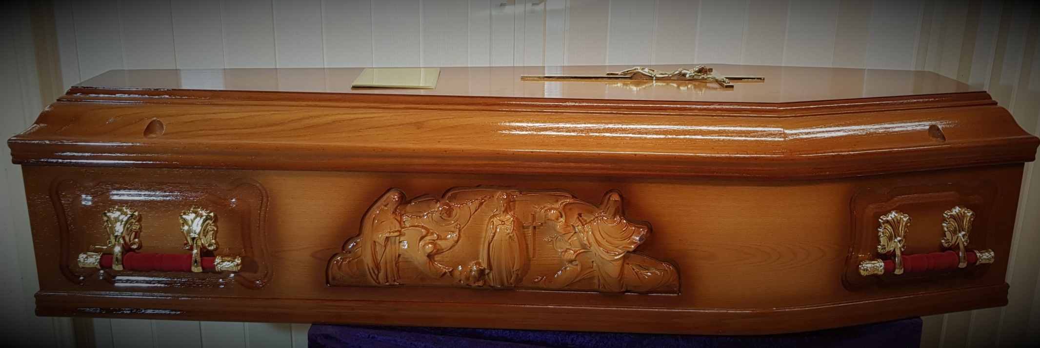

Lady of Knock two tone medium oak coffin with burgundy handles